AI-POWERED CUSTOMER SUPPORT PLATFORM
A Retrieval-Augmented Multi-Channel Support System
Mobile Application · Web Staff Console · REST + WebSocket Backend

Submitted by
Sabeeh Waheed · Muhammad Aoun · Hammad Mehmood

Field | Detail
Project Title | AI-Powered Customer Support Platform
Student Names | Sabeeh Waheed; Muhammad Aoun; Hammad Mehmood
Registration / Roll Numbers | [TO BE ADDED]
Supervisor Name | [TO BE ADDED]
Department | [TO BE ADDED]
University / Institution | [TO BE ADDED]
Degree / Program | [TO BE ADDED]
Submission Date | [TO BE ADDED]
Academic Year | [TO BE ADDED]
Industry Partner | Laurel Software Company

Declaration
We hereby declare that the project entitled “AI-Powered Customer Support Platform” submitted in partial fulfilment of the requirements for the award of the degree of [TO BE ADDED] is a record of original work carried out by us under the supervision of [TO BE ADDED]. The work presented in this report has not been submitted, in whole or in part, to any other institution for the award of any other degree or diploma. All external sources of information and third-party libraries used in the development of this system have been duly acknowledged in the References section.

Team Member | Component Owned | Signature | Date
Sabeeh Waheed | Backend Services and Database
Muhammad Aoun | Mobile Application (Flutter)
Hammad Mehmood | Web Application and System Integration

Approval
This is to certify that the project report described above has been examined and approved as meeting the requirements of the department.

Role | Name | Signature | Date
Supervisor | [TO BE ADDED]
Internal Examiner | [TO BE ADDED]
External Examiner | [TO BE ADDED]
Head of Department | [TO BE ADDED]

Acknowledgement
We wish to express our sincere gratitude to our supervisor, [TO BE ADDED], for continuous guidance, constructive criticism and encouragement throughout the duration of this project. Their insistence on verifying behaviour against a running system, rather than against assumptions, materially shaped the engineering discipline reflected in this report.
We are grateful to Laurel Software Company for proposing the problem statement, for providing the functional brief that defined the scope of the platform, and for the opportunity to develop a system against realistic operational requirements.
We also acknowledge the Department of [TO BE ADDED] at [TO BE ADDED] for providing the academic environment and infrastructure that made this work possible, and the maintainers of the open-source projects listed in the References section, without which a system of this scope could not have been delivered within the available time.
Finally, we thank our families and peers for their patience and support during the development and testing of this project.

Abstract
Customer support organisations face a recurring operational problem: a large proportion of inbound requests are repetitive questions whose answers already exist in internal documentation, yet these requests consume the same human agent capacity as genuinely complex cases. The result is long queue times for customers and low-value workload for agents.
This project presents an AI-Powered Customer Support Platform that addresses the problem by placing a retrieval-augmented artificial intelligence assistant as the first responder on every customer conversation, while preserving an unambiguous path to a human agent. The system is composed of three deployable components: a Flutter mobile application used by customers, a Next.js web console used by support agents and administrators, and a FastAPI backend that exposes 55 REST endpoints and 2 WebSocket endpoints over a shared relational database.
The assistant does not answer from parametric memory alone. Every customer question is embedded locally using the BAAI/bge-small-en-v1.5 sentence-embedding model and matched by cosine similarity against a knowledge base of 115 support documents divided into 417 text chunks. The highest-scoring passages are supplied to a large language model as grounding context, and the resulting answer is returned together with its classified intent, a confidence score, and citations of the knowledge-base articles used. When the provider is unavailable or rate-limited, the system degrades to a local extractive answerer rather than failing.
A deliberate architectural separation distinguishes the pure-AI assistant surface from the live-support surface: the assistant thread is never converted into a human support session, and the artificial intelligence remains on duty in a support ticket until an agent explicitly takes the conversation over. Real-time consistency between the mobile application and the web console is achieved through room-based WebSocket broadcasting, so that messages, escalations and status changes propagate without polling.
The delivered system passes an automated suite of 62 backend tests covering authentication, role-based access control, ticket lifecycle, retrieval quality, intent classification and real-time delivery. Retrieval latency was reduced from approximately 300 milliseconds to approximately 80 milliseconds through an index-caching optimisation. The project demonstrates that a grounded, citation-bearing assistant can be integrated into a conventional ticketing workflow without removing human control.

Keywords: Retrieval-Augmented Generation, Customer Support Automation, Intent Classification, Vector Similarity Search, FastAPI, Flutter, Next.js, WebSocket.

Table of Contents
Declaration / Approval
Acknowledgement
Abstract
List of Figures
List of Tables
Chapter 1 — Introduction
1.1 Background
1.2 Problem Statement
1.3 Proposed Solution
1.4 Project Objectives
1.5 Scope of the Project
1.6 Target Users
1.7 Significance of the Project
1.8 Project Components
1.9 Team Contributions
Chapter 2 — Requirements Analysis
2.1 Functional Requirements
2.2 Non-Functional Requirements
2.3 User Roles
2.4 Hardware Requirements
2.5 Software Requirements
2.6 Development Environment
Chapter 3 — System Design
3.1 Overall System Architecture
3.2 Component Architecture
3.3 Data Flow
3.4 User Flow
3.5 Navigation Structure
3.6 Database Design
Chapter 4 — Technologies and Tools
Chapter 5 — Mobile Application Implementation
Chapter 6 — Backend Implementation
Chapter 7 — Web Application Implementation
Chapter 8 — Database Design
Chapter 9 — Testing
Chapter 10 — Results and Screenshots
Chapter 11 — Challenges and Solutions
Chapter 12 — Limitations
Chapter 13 — Future Enhancements
Chapter 14 — Conclusion
References
Appendix A — Mobile Application Screenshots
Appendix B — API Documentation
Appendix C — Database Schema
Appendix D — Important Code Snippets
Appendix E — Additional Diagrams

Note: page numbers should be generated in Microsoft Word via References → Table of Contents once the document is opened.

List of Figures
Figure | Title | Section
Figure 1 | Overall system architecture | 3.1
Figure 2 | Retrieval-augmented generation request flow | 3.3
Figure 3 | Mobile application navigation structure | 3.5
Figure 4 | Entity relationship diagram | 3.6 / 8.5
Figure 5 | Mobile — Login screen | 5.5.1
Figure 6 | Mobile — Login screen with credentials entered | 5.5.1
Figure 7 | Mobile — Home dashboard | 5.5.2
Figure 8 | Mobile — Ticket list | 5.5.3
Figure 9 | Mobile — Ask AI assistant (initial state) | 5.5.5
Figure 10 | Mobile — Ask AI grounded answer with citation | 5.5.5
Figure 11 | Mobile — Live Agent conversation | 5.5.6
Figure 12 | Mobile — Profile and account screen | 5.5.7
Figure 13 | Backend — Interactive OpenAPI documentation | 6.5
Figure 14 | Web — Staff sign-in page | 7.5.1
Figure 15 | Web — Operations dashboard | 7.5.2
Figure 16 | Web — Ticket queue | 7.5.3
Figure 17 | Web — Ticket detail and reply thread | 7.5.4
Figure 18 | Web — Conversation list | 7.5.5
Figure 19 | Web — Conversation detail with AI citations | 7.5.6
Figure 20 | Web — Customer directory | 7.5.7
Figure 21 | Web — Knowledge base management | 7.5.8
Figure 22 | Web — AI analytics | 7.5.9
Figure 23 | Web — Agent management | 7.5.10
Figure 24 | Web — User administration | 7.5.11

List of Tables
Table | Title | Section
Table 1 | Team contributions and responsibilities | 1.9
Table 2 | Functional requirements — Mobile application | 2.1.1
Table 3 | Functional requirements — Backend | 2.1.2
Table 4 | Functional requirements — Web application | 2.1.3
Table 5 | Non-functional requirements | 2.2
Table 6 | User roles and permissions | 2.3
Table 7 | Hardware requirements | 2.4
Table 8 | Software requirements | 2.5
Table 9 | Technologies and tools | 4.1
Table 10 | Mobile application project structure | 5.3
Table 11 | Mobile application screen inventory | 5.5
Table 12 | Mobile application API integration | 5.7
Table 13 | Backend router inventory | 6.4
Table 14 | Backend REST endpoint reference | 6.8
Table 15 | Rate limiting policy | 6.12
Table 16 | Web application route inventory | 7.5
Table 17 | Database entities | 8.2
Table 18 | Database relationships | 8.4
Table 19 | Automated test inventory | 9.2
Table 20 | System test cases | 9.4

Chapter 1 — Introduction

1.1 Background
Customer support is a cost centre whose workload is dominated by repetition. In a typical software support organisation, a substantial share of inbound contacts consists of questions that have already been answered in a help centre article, an onboarding guide or an internal troubleshooting document. Because these requests arrive through the same channel as complex, account-specific problems, they occupy the same finite pool of human agents.
Laurel Software Company proposed the development of a support platform that reduces this avoidable load without degrading the quality of service offered to customers whose problems genuinely require a human. The requirement was explicitly multi-channel: customers were to be served through a mobile application, while support staff were to work through a web console, with both surfaces operating on a single shared source of truth.
Large language models are an obvious candidate for automating repetitive answers, but a general-purpose model used naively will produce fluent text that is not grounded in the organisation's actual policies. The project therefore adopted retrieval-augmented generation, in which the model is constrained to answer from passages retrieved from a curated knowledge base and is required to disclose the articles it relied upon.

1.2 Problem Statement
The problem addressed by this project can be stated as follows:
- Queue saturation by repetitive requests. Human agents spend a disproportionate amount of time answering questions whose answers already exist in written documentation, which increases waiting time for all customers.
- Absence of grounding and traceability. An automated assistant that cannot cite its source is not auditable; support organisations cannot accept answers whose provenance is unknown.
- Loss of human control. Automation that cannot be overridden by a human agent at any moment is unacceptable in a customer-facing support context.
- Channel fragmentation. When the customer-facing application and the staff console do not share a single data model, conversations, tickets and history diverge and the customer must repeat information.
- Lack of real-time propagation. If updates are visible only on manual refresh, an agent replying in the web console and a customer waiting in a mobile application observe two different states of the same conversation.

1.3 Proposed Solution
The proposed solution is a three-component platform built around a single relational database and a single backend service.
- Grounded first-line automation. Each customer message is embedded locally and matched against the knowledge base by cosine similarity. Retrieved passages are supplied to a large language model as grounding context, and the answer is returned with its intent classification, confidence score and article citations.
- Explicit and reversible escalation. The assistant remains the first responder on a support ticket until an agent explicitly takes the conversation over from the web console. The action is reversible through a hand-back operation that returns control to the assistant.
- A protected pure-assistant surface. The Ask AI conversation is architecturally separated from live support. It is identified by the absence of a linked ticket, is never converted into a support session, and cannot be silenced by an agent takeover.
- Shared state across channels. The mobile application and the web console consume the same REST API and the same database, so a ticket raised on the mobile device is immediately part of the agent queue.
- Real-time delivery. Room-based WebSocket channels push new messages and status changes to every connected client, eliminating polling and keeping both surfaces consistent.
- Graceful degradation. If the language model provider is unavailable or rate-limited, the system falls back to a local extractive answerer that still uses retrieved knowledge-base content, rather than returning an error.

1.4 Project Objectives

1.4.1 Primary Objectives
- To design and implement a retrieval-augmented assistant capable of answering customer support questions from a curated organisational knowledge base.
- To classify the intent of each customer message and to attach a confidence score and source citations to every generated answer.
- To implement a complete support ticket lifecycle covering creation, assignment, threaded correspondence, status transition and resolution.
- To deliver a native-quality mobile application through which customers interact with the assistant and manage their tickets.
- To deliver a web console through which agents and administrators triage tickets, monitor conversations, manage the knowledge base and administer users.
- To guarantee that a human agent can assume control of any live support conversation at any time, and can return it to the assistant.

1.4.2 Secondary Objectives
- To secure the platform using token-based authentication, password hashing, role-based access control and request rate limiting.
- To propagate messages and status changes in real time to all connected clients without client-side polling.
- To keep the retrieval pipeline responsive as the knowledge base grows.
- To validate the delivered behaviour through an automated regression suite.
- To produce deployment artefacts enabling the platform to be run as a containerised stack.

1.5 Scope of the Project

1.5.1 Included in Scope
- Customer registration and authentication on the mobile application.
- An assistant conversation surface backed by retrieval-augmented generation.
- A live support conversation surface with human takeover and hand-back.
- Support ticket creation, listing, threaded replies and status management.
- Internal agent notes that are withheld from the customer's view.
- A staff web console providing dashboards, ticket triage, conversation monitoring, customer directory, knowledge base management and user administration.
- Knowledge base ingestion, text chunking, local embedding generation and similarity search.
- Real-time updates over WebSocket for conversations and tickets.
- An automated backend test suite and containerised deployment configuration.

1.5.2 Excluded from Scope
- Payment processing, billing and subscription management.
- Voice, telephony and video support channels.
- Multilingual support; the knowledge base and the assistant operate in English.
- Push notifications delivered through Firebase Cloud Messaging or Apple Push Notification service; in-application alerts are derived from ticket state instead.
- Single sign-on through external identity providers.
- Automated agent performance appraisal and workforce scheduling.
- Production hosting on public cloud infrastructure; the deliverable is a locally reproducible and containerisable stack.

1.6 Target Users
User Type | Interface | Primary Activities
Customer | Mobile application | Ask questions of the assistant, raise and track support tickets, reply to agent correspondence, request a human agent.
Support Agent | Web console | Triage the ticket queue, claim unassigned tickets, reply to customers, add internal notes, take over and hand back conversations.
Administrator | Web console | All agent activities, plus user administration, role assignment, account activation and deactivation, knowledge base curation and analytics review.

1.7 Significance of the Project
From a practical standpoint, the platform demonstrates a deployable pattern for reducing first-line support workload while retaining human authority. The assistant is not positioned as a replacement for agents but as a filter that resolves documented questions and escalates the rest with the conversation history already attached, so that the agent begins with context rather than with a blank thread.
From an academic standpoint, the project integrates several distinct areas of software engineering within a single system: information retrieval through dense vector embeddings, applied natural language processing through intent classification and grounded generation, distributed real-time communication through WebSocket broadcasting, relational data modelling, cross-platform mobile development, modern web application development and secure API design. It further demonstrates engineering practices that are often absent from student projects, including automated regression testing, database migration management, measured performance optimisation and defensive degradation under third-party service failure.

1.8 Project Components
The system consists of three independently developed but tightly integrated components.

1.8.1 Mobile Application — Muhammad Aoun
A Flutter application targeting Android, iOS and the web, serving as the customer-facing channel. It implements authentication, the assistant conversation, the live support conversation, ticket creation and tracking, threaded ticket correspondence, in-application alerts and profile management. State is managed with the BLoC pattern and credentials are held in platform secure storage.

1.8.2 Backend — Sabeeh Waheed
A FastAPI service exposing 55 REST endpoints and 2 WebSocket endpoints over a relational database accessed through SQLAlchemy. It implements authentication and role-based authorisation, the ticket and conversation domain logic, the retrieval-augmented generation pipeline, knowledge base ingestion and indexing, real-time broadcasting, rate limiting and security middleware.

1.8.3 Web Application and System Integration — Hammad Mehmood
A Next.js staff console providing the operations dashboard, ticket queue and detail views, conversation monitoring, customer directory, knowledge base management, analytics and user administration. The same member was responsible for system integration: connecting the mobile application to the backend, establishing consistent behaviour of the assistant across both surfaces, and verifying end-to-end flows across the three components.

1.9 Team Contributions
Table 1 summarises the division of responsibility. Each member owned the design, implementation and testing of their component.
Team Member | Responsibility | Major Contribution
Sabeeh Waheed | Backend Services and Database | FastAPI application structure; SQLAlchemy data model and Alembic migrations; JWT authentication and role-based access control; ticket and conversation domain logic; retrieval-augmented generation service; knowledge base ingestion and indexing; WebSocket connection manager; rate limiting and security middleware; automated backend test suite.
Muhammad Aoun | Mobile Application (Flutter) | Complete Flutter application; BLoC state management; authentication and secure token storage; assistant and live-agent chat interfaces; ticket creation, listing and threaded correspondence; in-application alerts; profile management; navigation shell and user interface design system.
Hammad Mehmood | Web Application and System Integration | Complete Next.js staff console including dashboard, ticket triage, conversation monitoring, customer directory, knowledge management, analytics and user administration; TanStack Query data layer and WebSocket client; design system and theming; integration of the mobile application with the backend API; cross-surface verification of the assistant, escalation and real-time behaviour; shared project documentation and deliverables.

Chapter 2 — Requirements Analysis

2.1 Functional Requirements
Functional requirements are grouped by the component in which they are implemented. Each requirement is identified by a code for traceability to the test cases documented in Chapter 9.

2.1.1 Mobile Application Requirements
ID | Requirement | Priority
FR-M-01 | A customer shall be able to register a new account by providing name, email address and password. | High
FR-M-02 | A customer shall be able to sign in with an email address and password and remain signed in across application restarts. | High
FR-M-03 | The application shall present an assistant conversation in which the customer can ask support questions in natural language. | High
FR-M-04 | The application shall display, for each assistant answer, the classified intent, the confidence score and the knowledge-base articles cited. | High
FR-M-05 | The application shall restore the customer's previous assistant conversation when the application is reopened. | Medium
FR-M-06 | The customer shall be able to start a new assistant conversation. | Medium
FR-M-07 | The customer shall be able to create a support ticket specifying subject, description, category and priority. | High
FR-M-08 | The customer shall be able to view a list of their tickets with current status and priority. | High
FR-M-09 | The customer shall be able to open a ticket and view its threaded correspondence. | High
FR-M-10 | The customer shall be able to post a reply to a ticket thread. | High
FR-M-11 | The customer shall not be shown internal agent notes. | High
FR-M-12 | The customer shall be able to request a human support agent. | High
FR-M-13 | The application shall indicate whether the assistant or a human agent currently owns the conversation. | Medium
FR-M-14 | The application shall receive new messages and status changes in real time without manual refresh. | Medium
FR-M-15 | The application shall present alerts derived from the customer's actual ticket activity. | Medium
FR-M-16 | The customer shall be able to view and update profile details and change their password. | Medium
FR-M-17 | The customer shall be able to sign out, which clears the stored session and conversation state. | High

2.1.2 Backend Requirements
ID | Requirement | Priority
FR-B-01 | The system shall authenticate users and issue signed access tokens with a bounded lifetime. | High
FR-B-02 | The system shall store passwords only as Argon2 hashes. | High
FR-B-03 | The system shall enforce role-based authorisation for customer, agent and administrator roles. | High
FR-B-04 | The system shall retrieve relevant knowledge-base passages for a customer question using dense vector similarity search. | High
FR-B-05 | The system shall generate an answer grounded in the retrieved passages and return the intent, confidence and citations. | High
FR-B-06 | The system shall fall back to a local extractive answerer when the language model provider fails or is rate-limited. | High
FR-B-07 | The system shall maintain the assistant conversation as a pure-assistant surface that cannot be taken over by an agent. | High
FR-B-08 | The system shall keep the assistant as first responder on a ticket conversation until an agent explicitly takes over. | High
FR-B-09 | The system shall allow an agent to take over a live conversation and to hand it back to the assistant. | High
FR-B-10 | The system shall support the full ticket lifecycle including creation, assignment, replies, internal notes and status change. | High
FR-B-11 | The system shall mirror ticket correspondence into the linked conversation so both surfaces remain consistent. | High
FR-B-12 | The system shall broadcast new messages and status changes to connected WebSocket clients in the relevant room. | High
FR-B-13 | The system shall authenticate WebSocket connections and reject access to conversations and tickets not owned by the caller. | High
FR-B-14 | The system shall support ingestion of knowledge documents, text chunking, embedding generation and reindexing. | High
FR-B-15 | The system shall provide aggregate statistics and analytics for the administrative dashboard. | Medium
FR-B-16 | The system shall rate-limit authentication and assistant endpoints per client address. | Medium

2.1.3 Web Application Requirements
ID | Requirement | Priority
FR-W-01 | A staff member shall be able to sign in with an email address and password. | High
FR-W-02 | The console shall present an operations dashboard summarising ticket and conversation activity. | High
FR-W-03 | The console shall list all tickets with status, priority, customer and assignment. | High
FR-W-04 | A staff member shall be able to open a ticket, read the thread, reply to the customer and add an internal note. | High
FR-W-05 | A staff member shall be able to change ticket status, priority and assignment. | High
FR-W-06 | The console shall list conversations and allow a staff member to open and read them. | High
FR-W-07 | The console shall display the knowledge-base citations attached to each assistant answer. | Medium
FR-W-08 | A staff member shall be able to take over a live conversation and hand it back to the assistant. | High
FR-W-09 | The console shall present a customer directory with individual customer detail views. | Medium
FR-W-10 | A staff member shall be able to upload, edit, archive and reindex knowledge-base documents. | High
FR-W-11 | An administrator shall be able to list users, change roles and activate or deactivate accounts. | High
FR-W-12 | The console shall present assistant analytics including intent distribution and confidence. | Medium
FR-W-13 | The console shall update ticket and conversation views in real time when the underlying data changes. | Medium
FR-W-14 | The console shall support light and dark presentation themes. | Low

2.2 Non-Functional Requirements
ID | Category | Requirement | Realisation in the System
NFR-01 | Performance | Knowledge-base retrieval shall remain responsive as the corpus grows. | The normalised embedding matrix is cached in memory and keyed on a corpus signature; measured retrieval latency improved from approximately 300 ms to approximately 80 ms.
NFR-02 | Performance | Frequently executed list queries shall be supported by appropriate indexes. | Seven composite indexes were added matching the filter-and-order shapes used by the list endpoints.
NFR-03 | Security | Passwords shall never be stored or transmitted in plaintext. | Argon2 hashing via the pwdlib library; the password hash is excluded from every API response.
NFR-04 | Security | API access shall require a valid signed token. | JSON Web Tokens signed with HS256 and a configurable expiry of 60 minutes.
NFR-05 | Security | Users shall not be able to access records belonging to other users. | Ownership checks on every customer-scoped endpoint and on the WebSocket handshake; verified by dedicated access-control tests.
NFR-06 | Security | The service shall resist brute-force and abuse. | Sliding-window rate limiting of 15 requests per minute on authentication and 30 per minute on assistant messaging, per client address.
NFR-07 | Security | Responses shall carry standard protective headers. | X-Content-Type-Options, X-Frame-Options, X-XSS-Protection and Referrer-Policy applied by middleware.
NFR-08 | Reliability | Failure of the external language model provider shall not fail the request. | Provider exceptions and unparseable responses degrade to a local extractive answerer that still uses retrieved context.
NFR-09 | Reliability | Internal errors shall not disclose stack traces to the client. | A central exception handler logs the error and returns a generic message.
NFR-10 | Usability | The customer shall be able to judge the trustworthiness of an answer. | Every assistant answer displays its intent, confidence percentage and the knowledge-base articles cited.
NFR-11 | Scalability | The data layer shall not be tied to a single database engine. | SQLAlchemy with SQLite for development and PostgreSQL for the containerised deployment; embeddings stored as portable JSON.
NFR-12 | Maintainability | Behaviour shall be protected against regression. | An automated suite of 62 backend tests covering authentication, access control, ticket lifecycle, retrieval, intent classification and real-time delivery.
NFR-13 | Maintainability | Schema evolution shall be version-controlled. | Alembic migrations with a linear revision chain.
NFR-14 | Compatibility | The customer application shall run on multiple platforms from one codebase. | Flutter targeting Android, iOS and the web; the API base address resolves per platform at runtime.

2.3 User Roles
The system defines three roles as an enumerated type on the user record. Authorisation is enforced on the server for every protected operation.
Role | Assistant | Own Tickets | All Tickets | Takeover | Knowledge Base | User Admin
Customer | Yes | Create, read, reply | No | Request only | No | No
Agent | Read | N/A | Read, reply, update, claim | Yes | Manage | No
Administrator | Read | N/A | Full control | Yes | Manage | Yes

2.4 Hardware Requirements
Component | Minimum | Recommended
Development workstation | Dual-core processor, 8 GB RAM, 15 GB free disk | Quad-core processor, 16 GB RAM, 30 GB free disk
Server (backend host) | 1 vCPU, 2 GB RAM | 2 vCPU, 4 GB RAM (embedding model held in memory)
Customer device | Android 6.0 or iOS 12, 2 GB RAM | Android 10 or later, iOS 15 or later
Staff workstation | Any modern browser, 1366 × 768 display | 1920 × 1080 display
Network | Broadband connection | Stable connection supporting WebSocket

2.5 Software Requirements
Category | Requirement
Operating system (development) | Windows 11 (development was carried out on Windows 11 Pro Education)
Backend runtime | Python 3.12
Web runtime | Node.js with npm
Mobile toolchain | Flutter 3.47.2 with Dart 3.13.2
Database | SQLite for development; PostgreSQL for containerised deployment
Containerisation | Docker and Docker Compose (deployment configuration provided; see Section 6.13)
Version control | Git
Browser | A current version of Chrome, Edge or Firefox
Language model access | An API key for a supported provider; the system also runs in an offline mock mode

2.6 Development Environment
Aspect | Detail
Backend framework | FastAPI served by Uvicorn 0.34.0
Backend port | 8000
Web console framework | Next.js 16.3.4 (App Router) with React 19.2.8
Web console port | 3000
Mobile application | Flutter; run on the web target at port 8080 for development and demonstration
Python environment | Virtual environment located at backend/.venv
Database file (development) | backend/customer_support.db
Configuration | Environment variables loaded from backend/.env, which is excluded from version control
Automation scripts | run_all.bat and run_all.ps1 start the full stack; stop_all.bat and stop_all.ps1 terminate it
Testing framework | pytest with FastAPI TestClient

Chapter 3 — System Design

3.1 Overall System Architecture
The platform follows a three-tier client-server architecture. Two independent client applications communicate with a single backend service, which is the sole component with access to the database. No client connects to the database directly, and no business rule is enforced only on a client.
Two transport mechanisms operate in parallel. Request-and-response interactions use REST over HTTP; server-initiated updates use WebSocket connections. This division is deliberate: REST provides validation, status semantics and self-describing documentation for ordinary operations, while WebSocket supplies the push capability that request-and-response cannot.
+---------------------------+ +-----------------------------+
| Mobile Application | | Web Staff Console |
| Flutter / Dart | | Next.js / React |
| Customer channel | | Agent + Administrator |
+-------------+-------------+ +--------------+--------------+
| |
REST + WebSocket REST + WebSocket
| |
+-------------v-------------------------------------v-------------+
| FastAPI Backend Service |
| Middleware : rate limiting, security headers, error handling |
| Routers : auth, users, conversations, messages, tickets, |
| agents, admin, knowledge, websocket |
| Services : ai_service (generation) knowledge_service (RAG) |
| Realtime : ConnectionManager (conversation / ticket rooms) |
+-------------+-----------------------------------+---------------+
| |
SQLAlchemy ORM local embedding model
| BAAI/bge-small-en-v1.5
+-------------v-------------+ +--------v-------------+
| Relational Database | | LLM Provider |
| SQLite (development) | | OpenAI-compatible |
| PostgreSQL (container) | | endpoint |
+---------------------------+ +----------------------+
Figure 1: Overall system architecture.

[INSERT SYSTEM ARCHITECTURE DIAGRAM HERE — a rendered version of the structure shown above may be substituted.]

3.2 Component Architecture

3.2.1 Mobile Application
The mobile application uses a feature-first layered organisation. Each feature directory contains three layers: a presentation layer of Flutter widgets, a business logic layer implemented with the BLoC pattern, and a data layer of repositories and models. Cross-cutting infrastructure — the HTTP client, the WebSocket service and secure token storage — resides in a separate core directory. Repositories are the only components that perform network access, so the user interface never contains an endpoint address.

3.2.2 Backend
The backend is organised by responsibility. Routers under the api package define the HTTP surface and perform authorisation; the database package holds the declarative models and the session factory; the services package contains the two domain services that carry the intelligence of the system, namely the generation service and the knowledge service. A separate module holds the WebSocket connection manager, and another holds the middleware. This separation keeps the retrieval and generation logic independent of the HTTP layer, which allowed it to be tested directly.

3.2.3 Web Application
The web console uses the Next.js App Router. Authenticated pages are grouped under a route group that shares a single layout providing the navigation shell. A typed API client wraps fetch and attaches the bearer token; a query layer built on TanStack Query provides caching, background refetching and mutation handling; a WebSocket hook subscribes to the relevant room and invalidates the affected queries when an event arrives. Because the socket triggers a refetch rather than mutating a local cache directly, the console cannot display a message twice.

3.3 Data Flow
The most significant data path in the system is the handling of a customer question. The sequence below describes the complete flow for a message sent to the assistant.
- The customer composes a message in the mobile application. The repository issues an authenticated POST request to the conversation messages endpoint.
- Middleware verifies the rate limit for the client address. The router resolves the caller from the bearer token and confirms ownership of the conversation.
- The customer message is persisted and immediately broadcast to the conversation room, so that a staff member observing the conversation sees the question before the answer has been produced.
- The knowledge service embeds the question with the local sentence-embedding model, computes cosine similarity against the cached normalised matrix of chunk embeddings, and returns the highest-scoring passages above the configured threshold.
- The generation service composes a system prompt containing the retrieved passages and the recent conversation history, and requests a structured response from the language model provider.
- The response is parsed into an answer, an intent and a confidence value. If parsing fails or the provider is unavailable, the local extractive answerer produces a grounded answer instead.
- The answer is persisted with its intent, confidence and citations, then broadcast to the conversation room and returned in the HTTP response.
- The mobile application reconciles the response with the message it displayed optimistically and renders the answer together with its intent badge, confidence percentage and source citations.
Customer question
|
v
[ rate limit ] -> [ authenticate ] -> [ authorise conversation ]
|
v
persist customer message ---------> broadcast to room (WebSocket)
|
v
embed query (384-dim, local)
|
v
cosine similarity vs cached chunk matrix -> top-k passages (k = 4,
min score = 0.5)
|
v
prompt = system rules + retrieved passages + recent history
|
v
LLM provider ---- failure / unparseable ----> local extractive answerer
| |
+---------------------+------------------------+
v
answer + intent + confidence + citations
|
v
persist -> broadcast to room -> HTTP response to client
Figure 2: Retrieval-augmented generation request flow.

3.4 User Flow

3.4.1 Customer Journey
- The customer registers or signs in on the mobile application and arrives at the home dashboard, which summarises their open tickets and offers an entry point to the assistant.
- The customer opens the Ask AI surface and asks a question. The assistant answers from the knowledge base and discloses the articles used.
- If the answer is sufficient, the interaction ends without consuming agent time.
- If it is not, the customer either raises a support ticket or requests a live agent. Requesting a live agent opens a separate support conversation and an associated ticket; the assistant thread is left intact.
- While the customer waits, the assistant continues to answer in the support conversation, so the customer is not left unattended.
- When an agent takes the conversation over from the web console, the assistant withdraws and the customer's messages are delivered to the agent.
- The customer follows the ticket to resolution, receiving agent replies in the ticket thread and in the conversation.

3.4.2 Staff Journey
- The agent signs in to the web console and reviews the operations dashboard.
- The agent opens the ticket queue, filters or claims an unassigned ticket, and opens it to read the customer's description and the correspondence to date.
- The agent replies to the customer, or records an internal note that the customer cannot see.
- Where a live conversation is attached, the agent takes it over, which suspends the assistant for that thread.
- The agent updates status, priority and assignment as the case progresses, and may hand the conversation back to the assistant once the human intervention is complete.
- An administrator additionally curates the knowledge base and administers user accounts and roles.

3.5 Navigation Structure
The mobile application uses a persistent bottom navigation bar with four primary destinations, hosted by a navigation shell that preserves the state of each destination. Secondary screens are presented above the shell.
Authentication Gate
|-- Login Screen <--> Registration Screen
|
+-- Main Navigation Shell (bottom navigation bar)
|-- Home : dashboard, ticket summary, assistant entry
| |-- Notifications (alerts derived from ticket state)
| +-- Profile and Account
|-- Tickets : ticket list
| |-- Create Ticket
| +-- Ticket Detail (threaded correspondence)
|-- Ask AI : pure assistant conversation
+-- Live Agent : live support conversation
(assistant answers until agent takeover)
Figure 3: Mobile application navigation structure.

3.6 Database Design
The database comprises seven application tables holding sixty columns in total. The design separates conversational data from ticketing data while permitting a link between them, and keeps the knowledge base in a document-and-chunk pair so that retrieval operates on chunks while administration operates on documents. The complete schema is documented in Chapter 8.
+--------------------+
| users |
+--------------------+
^ ^ ^ ^
customer_id | | | | sender_id
+------------+ | | +---------------+
| assigned_agent_id| |
+-------+--------+ +-------+--------+ +-------+---------+
| conversations | | tickets | | ticket_messages |
+----------------+ +----------------+ +-----------------+
| ^ ^ | ^
| | ticket_id | | conversation_id | ticket_id
| +------------------+ +------------------+
| (application-maintained links)
| conversation_id
+-------v--------+ +---------------------+ +----------------+
| messages | | knowledge_documents |<------| knowledge_chunks|
+----------------+ +---------------------+ +----------------+
document_id
Figure 4: Entity relationship diagram.

[INSERT FORMAL ER DIAGRAM HERE — the machine-readable schema export in Appendix C may be used to generate one.]

Chapter 4 — Technologies and Tools

4.1 Technology Inventory
Table 9 lists every technology used in the delivered system. Version numbers correspond to those recorded in the project's dependency manifests.
Technology / Tool | Version | Purpose | Used In
Flutter | 3.47.2 | Cross-platform user interface toolkit for the customer application | Mobile
Dart | 3.13.2 | Programming language of the mobile application | Mobile
flutter_bloc | 8.1.6 | Predictable state management using the BLoC pattern | Mobile
equatable | 2.0.5 | Value equality for states and events | Mobile
Dio | 5.4.3 | HTTP client with interceptors and timeout control | Mobile
flutter_secure_storage | 9.2.2 | Platform-backed encrypted storage of authentication tokens | Mobile
web_socket_channel | 3.0.2 | WebSocket client for real-time updates | Mobile
image_picker | 1.2.3 | Selection of images from the device | Mobile
Python | 3.12 | Backend programming language | Backend
FastAPI | — | Asynchronous web framework and automatic OpenAPI generation | Backend
Uvicorn | 0.34.0 | ASGI server hosting the backend | Backend
SQLAlchemy | 2.0.36 | Object-relational mapper and query construction | Backend
Alembic | — | Database schema migration management | Backend
Pydantic | v2 | Request validation and settings management | Backend
pwdlib (Argon2) | — | Password hashing | Backend
PyJWT | 2.13.0 | Signing and verification of JSON Web Tokens | Backend
fastembed | — | Local generation of sentence embeddings without a deep learning framework | Backend
BAAI/bge-small-en-v1.5 | — | 384-dimensional sentence-embedding model used for retrieval | Backend
NumPy | — | Vector arithmetic and cosine similarity computation | Backend
SQLite | — | Development database | Backend
PostgreSQL | — | Database for the containerised deployment | Backend
Next.js | 16.3.4 | React framework using the App Router | Web
React | 19.2.8 | User interface library | Web
TypeScript | 5 | Statically typed language for the web console | Web
Tailwind CSS | 4 | Utility-first styling and design tokens | Web
TanStack Query | 5.102.8 | Server-state caching, refetching and mutations | Web
lucide-react | 1.39.0 | Icon set | Web
Recharts | 3.10.1 | Charting for the analytics views | Web
pytest | — | Automated backend testing | Backend
Playwright | 1.63.0 | Browser automation used to capture interface evidence | Web / Mobile
Docker Compose | — | Container orchestration of the deployment stack | Deployment
Git | — | Version control | All

4.2 Rationale for Key Technology Choices

4.2.1 Flutter for the Customer Application
Flutter was selected because a single Dart codebase produces Android, iOS and web builds. In the context of a time-bounded team project this removed the need to maintain parallel native implementations, and the web build in particular allowed the customer application to be demonstrated and verified in a browser alongside the staff console.

4.2.2 FastAPI for the Backend
FastAPI provides request validation derived from Python type annotations and generates an OpenAPI specification automatically. The generated interactive documentation served as the integration contract between the three team members, and native support for both asynchronous request handling and WebSocket endpoints allowed REST and real-time transport to be hosted by one service.

4.2.3 Local Embeddings via fastembed
Retrieval quality depends on the embedding model, but a conventional deep learning framework would have imposed a large dependency and significant memory cost. The fastembed library executes the BAAI/bge-small-en-v1.5 model through ONNX runtime, producing 384-dimensional vectors locally without requiring a heavyweight framework. Embedding therefore incurs no per-query monetary cost and no dependency on network availability, which also means retrieval continues to function when the language model provider is unreachable.

4.2.4 Provider-Independent Generation
The generation service is written against an OpenAI-compatible chat interface and selects its provider from configuration. Supported values are a deterministic offline mock, Google Gemini, Groq, OpenRouter, OpenAI and Anthropic. This indirection allowed the entire system, including the automated test suite, to run without any API key, and permitted the provider to be changed without modifying application code.

4.2.5 TanStack Query for the Web Console
The console is dominated by server state rather than local state. TanStack Query supplies caching, request deduplication, background refetching and mutation invalidation, which removed the need for a general-purpose client state container and provided a clean mechanism for reacting to WebSocket events by invalidating the affected queries.

Chapter 5 — Mobile Application Implementation
Component owner: Muhammad Aoun. This chapter documents the customer-facing mobile application as implemented.

5.1 Mobile Application Overview
The mobile application is the customer channel of the platform. It is the only surface through which a customer interacts with the system, and it therefore carries the whole customer journey: account creation and authentication, conversation with the assistant, escalation to a human agent, creation and tracking of support tickets, threaded correspondence, alerts and profile management.
The application is written in Dart using the Flutter toolkit and is built from a single codebase for Android, iOS and the web. During development and for the purposes of demonstration it was executed as a web build served on port 8080, which permitted verification against the live backend alongside the staff console.

5.2 Mobile Application Architecture
The application follows a feature-first, three-layer architecture. Every feature is a self-contained directory containing its own presentation, business logic and data layers, and cross-cutting infrastructure is placed in a shared core directory.
- Presentation layer. Flutter widgets that render the interface and dispatch user intent. Widgets do not construct requests or hold endpoint addresses.
- Business logic layer. Components implemented with the BLoC pattern, which receive events, invoke repositories and emit immutable states. The authentication and ticket features use this pattern.
- Data layer. Repositories that own all network access and map JSON payloads onto Dart models. The repository is the only place in the application that knows the shape of the API.
- Core infrastructure. The HTTP client, the WebSocket service and secure token storage, shared by all features.
Dependencies are injected at application start-up. Repositories are constructed once and supplied through a repository provider, and the business logic components are supplied through a multi-provider, so that any screen may obtain them from the widget tree without global state.

5.3 Project Structure
Table 10 describes the actual directory structure of the application source tree.
Path | Contents
lib/main.dart | Application entry point; constructs the HTTP client, secure storage, WebSocket service and repositories, wires the providers and defines the authentication gate.
lib/core/network/api_client.dart | Configured Dio instance; resolves the API base address per platform and applies timeouts and the authorisation header.
lib/core/network/websocket_service.dart | WebSocket client with connection lifecycle, JSON event stream, reconnection with exponential backoff and a retry ceiling.
lib/core/storage/token_storage.dart | Encrypted persistence of the access token using platform secure storage.
lib/features/auth/ | Authentication feature: BLoC, events and states; repository; user model; login and registration screen.
lib/features/chat/ | Conversation feature: chat repository, chat model, assistant and live-agent chat screen, live-agent waiting sheet, and the chat BLoC.
lib/features/tickets/ | Ticketing feature: ticket BLoC, events and states; ticket repository and model; ticket list screen and create-ticket screen.
lib/features/dashboard/ | Shell and supporting screens: main navigation shell, home dashboard, alerts, profile and knowledge screens; dashboard model.
lib/features/knowledge/ | Knowledge repository used by the knowledge screen.
test/ | Widget and unit tests for the authentication BLoC, the ticket BLoC and the ticket model.

5.4 User Interface Design
The interface follows a single design system expressed through a consistent set of tokens. The brand colour is an indigo tone applied to primary actions, active navigation states and assistant identity; neutral surfaces use a cool slate palette. Ticket status is encoded by colour as well as by text, so that state is legible at a glance: blue for open, amber for in progress, violet for waiting on the customer, emerald for resolved and slate for closed. The same palette was subsequently adopted by the web console so that the two surfaces present one visual identity.
Layout is card-based with generous spacing and rounded corners. Assistant answers are distinguished from customer messages by alignment and colour, and each answer carries three metadata elements beneath it: an intent badge, a confidence percentage and one or more source citations. This disclosure is a deliberate design decision: it allows the customer to judge how much weight to place on an automated answer.

5.5 Screens
Table 11 lists the implemented screens. Each is documented in the subsections that follow.
# | Screen | Source File
1 | Login and Registration | features/auth/presentation/login_screen.dart
2 | Home Dashboard | features/dashboard/presentation/dashboard_screen.dart
3 | Ticket List | features/tickets/presentation/ticket_list_screen.dart
4 | Create Ticket | features/tickets/presentation/create_ticket_screen.dart
5 | Ask AI Assistant | features/chat/presentation/ai_chat_screen.dart
6 | Live Agent Conversation | features/chat/presentation/ai_chat_screen.dart (live-agent mode)
7 | Profile and Account | features/dashboard/presentation/profile_screen.dart
8 | Notifications and Alerts | features/dashboard/presentation/alerts_screen.dart
9 | Knowledge | features/dashboard/presentation/knowledge_screen.dart
10 | Navigation Shell | features/dashboard/presentation/main_navigation_screen.dart

5.5.1 Login and Registration Screen
Purpose: To authenticate an existing customer or to create a new customer account. This screen is the entry point of the application and the gate to every other surface.
UI Components: Branded header; email and password fields with a visibility toggle; a primary sign-in action; a switch between the sign-in and registration modes; additional registration fields for full name, phone number and city or country; inline validation messages; a loading indicator during submission.
Functionality: On submission the screen dispatches an authentication event. The authentication component invokes the repository, which posts the credentials to the backend. A successful response yields an access token and the user record; the token is written to secure storage and the application transitions to the navigation shell.
Backend / API Interaction: Sign-in posts to /auth/login as an OAuth2 password-flow form submission with username and password fields. Registration posts a JSON body to /auth/register. Both responses contain an access token and the authenticated user object.
Navigation: On success the authentication gate replaces the login screen with the main navigation shell. There is no back navigation to the login screen while a session is active.
Validation and Error Handling: The email address is validated for shape and the password for minimum length before submission. Server-side rejections are surfaced from the response detail field, so that a duplicate email address or an incorrect password produces a specific message rather than a generic failure. Registration additionally enforces the password policy applied by the backend, namely a minimum of eight characters including upper case, lower case and a digit.
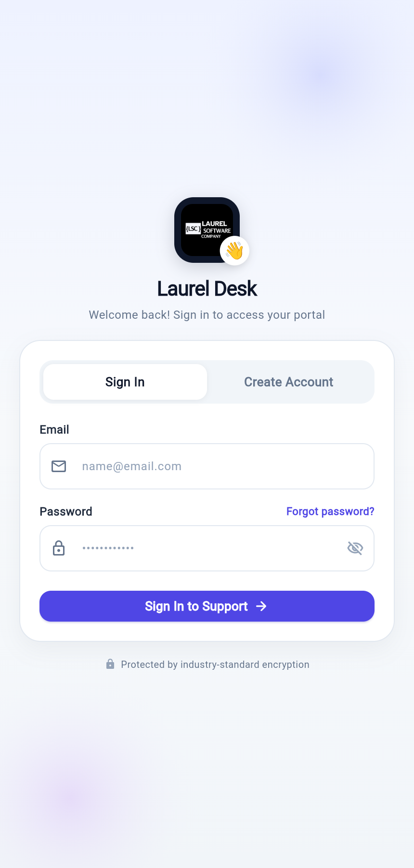
Figure 5: Mobile — Login screen.
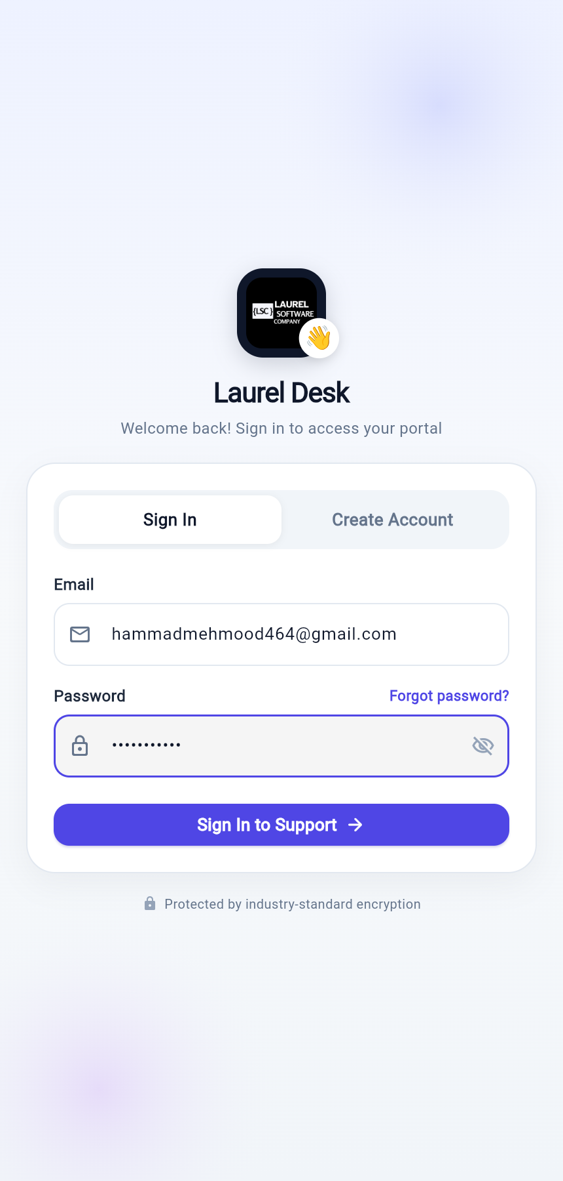
Figure 6: Mobile — Login screen with credentials entered.

5.5.2 Home Dashboard
Purpose: To orient the customer on entry by summarising the current state of their support activity and to provide the primary route into the assistant.
UI Components: A personalised header displaying the signed-in customer's name and a notifications control; a prominent assistant call-to-action card; a support overview presenting counts of open, in-progress and resolved tickets; a list of active support tickets showing reference number, subject, category and status; an assistant continuation entry; and a knowledge base section.
Functionality: The ticket counts and the active ticket list are derived from the ticket state held by the ticket business logic component, which loads the customer's tickets from the backend. The screen therefore reflects real data rather than static content.
Backend / API Interaction: Ticket data is obtained from GET /tickets/my. The assistant entry point navigates to the Ask AI destination, which resolves the customer's assistant conversation on entry.
Navigation: The avatar opens the profile screen; the bell opens notifications; the assistant card switches to the Ask AI destination; a ticket card opens the corresponding ticket detail.
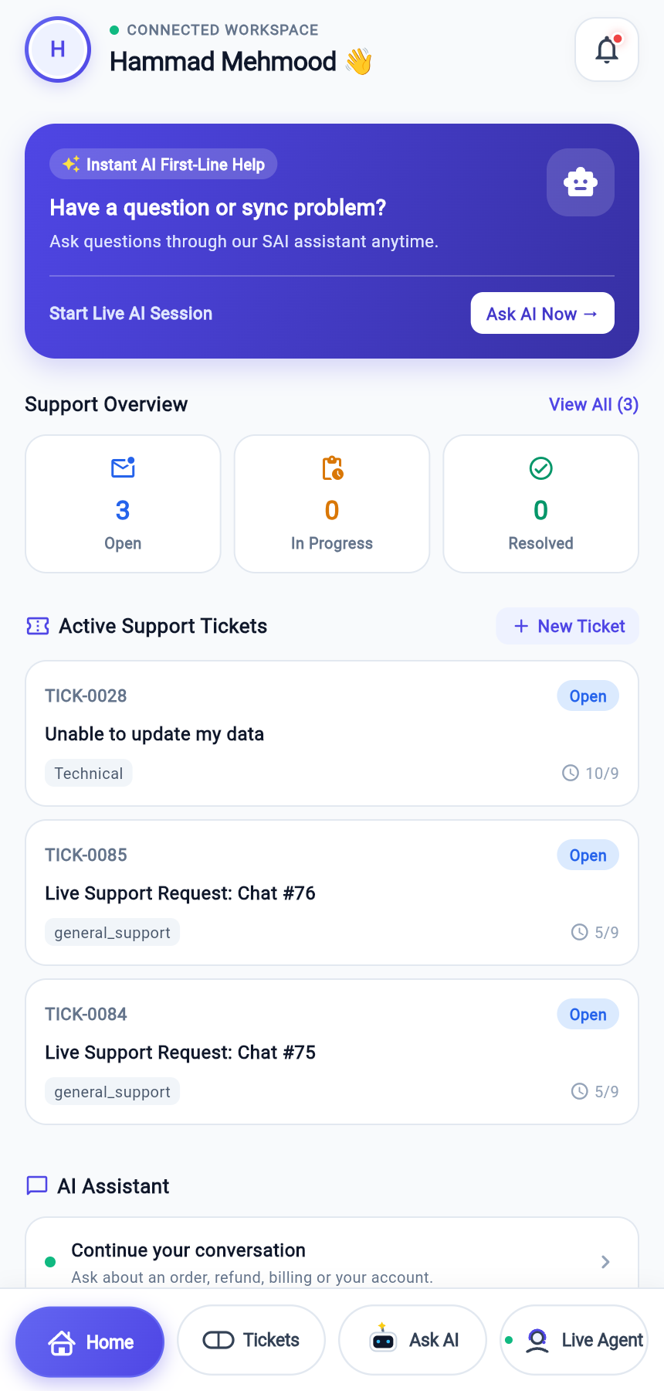
Figure 7: Mobile — Home dashboard.

5.5.3 Ticket List Screen
Purpose: To list the customer's support tickets and to provide access to the correspondence for each.
UI Components: A scrollable list of ticket cards, each showing the ticket reference number, subject, category, priority and a colour-coded status badge; a control to create a new ticket; and a detail view containing the ticket header, a chronological timeline and the message thread with a reply composer.
Functionality: Ticket state is managed by the ticket business logic component. Opening a ticket loads its correspondence from the backend. The timeline is derived strictly from facts recorded on the ticket, namely its creation, an actual agent assignment where one exists, and the current status.
User Interaction: The customer may open a ticket, read the thread and post a reply. A reply is transmitted to the backend and appended to the thread on confirmation.
Backend / API Interaction: GET /tickets/my lists the tickets; GET /tickets/{id}/messages loads the thread; POST /tickets/{id}/messages posts a reply. Internal agent notes are created through a separate endpoint and are never returned to a customer.
Validation and Error Handling: An empty reply is rejected before transmission. Network failures are reported through a transient message and leave the thread unchanged.
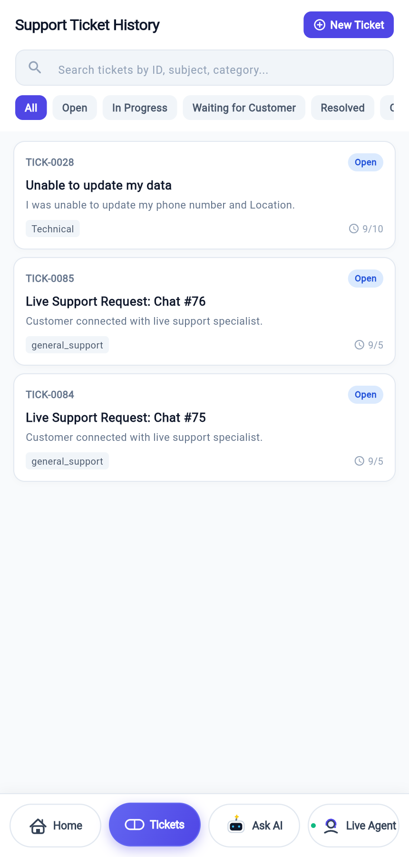
Figure 8: Mobile — Ticket list.

5.5.4 Create Ticket Screen
Purpose: To allow a customer to raise a new support ticket.
UI Components: Subject field; multi-line description field; category selector; priority selector; submission control; validation messages.
Functionality and Backend Interaction: On submission the repository posts the ticket to POST /tickets/, translating the human-readable priority and category into the values expected by the API. The backend creates the ticket together with an initial message containing the description, so that the thread is never empty. The new ticket appears in the ticket list and on the home dashboard.
Validation and Error Handling: Subject and description are mandatory. On success a confirmation is shown that states only what actually occurred; the screen does not claim an agent assignment that has not taken place.
[INSERT SCREENSHOT HERE — Create Ticket screen]

5.5.5 Ask AI Assistant Screen
Purpose: To provide a conversation with the retrieval-augmented assistant. This surface is guaranteed to be answered by the assistant at all times; it is never converted into a human support session.
UI Components: A header identifying the assistant and indicating that answers are grounded in the knowledge base; a scrolling message list; customer messages aligned to the trailing edge in the brand colour; assistant messages presented as cards with an intent badge, a confidence percentage and one or more source citations; a composer with a send control; a control to raise a ticket from the conversation.
Functionality: On entry the screen restores the customer's existing assistant conversation and replays its history, including the metadata attached to previous answers. A submitted question is displayed immediately, then reconciled with the persisted record when the response arrives.
Backend / API Interaction: GET /conversations/ask-ai resolves or creates the assistant conversation; GET /conversations/{id}/messages replays the history; POST /conversations/{id}/messages submits a question and returns the answer with its intent, confidence and citations; POST /conversations/ask-ai/new begins a fresh conversation.
Validation and Error Handling: Empty input is rejected. Because retrieval and generation together may take several seconds, the receive timeout of the HTTP client was raised to sixty seconds; a shorter value caused the client to abandon requests that the server had in fact completed. Failures are reported without discarding the customer's message.
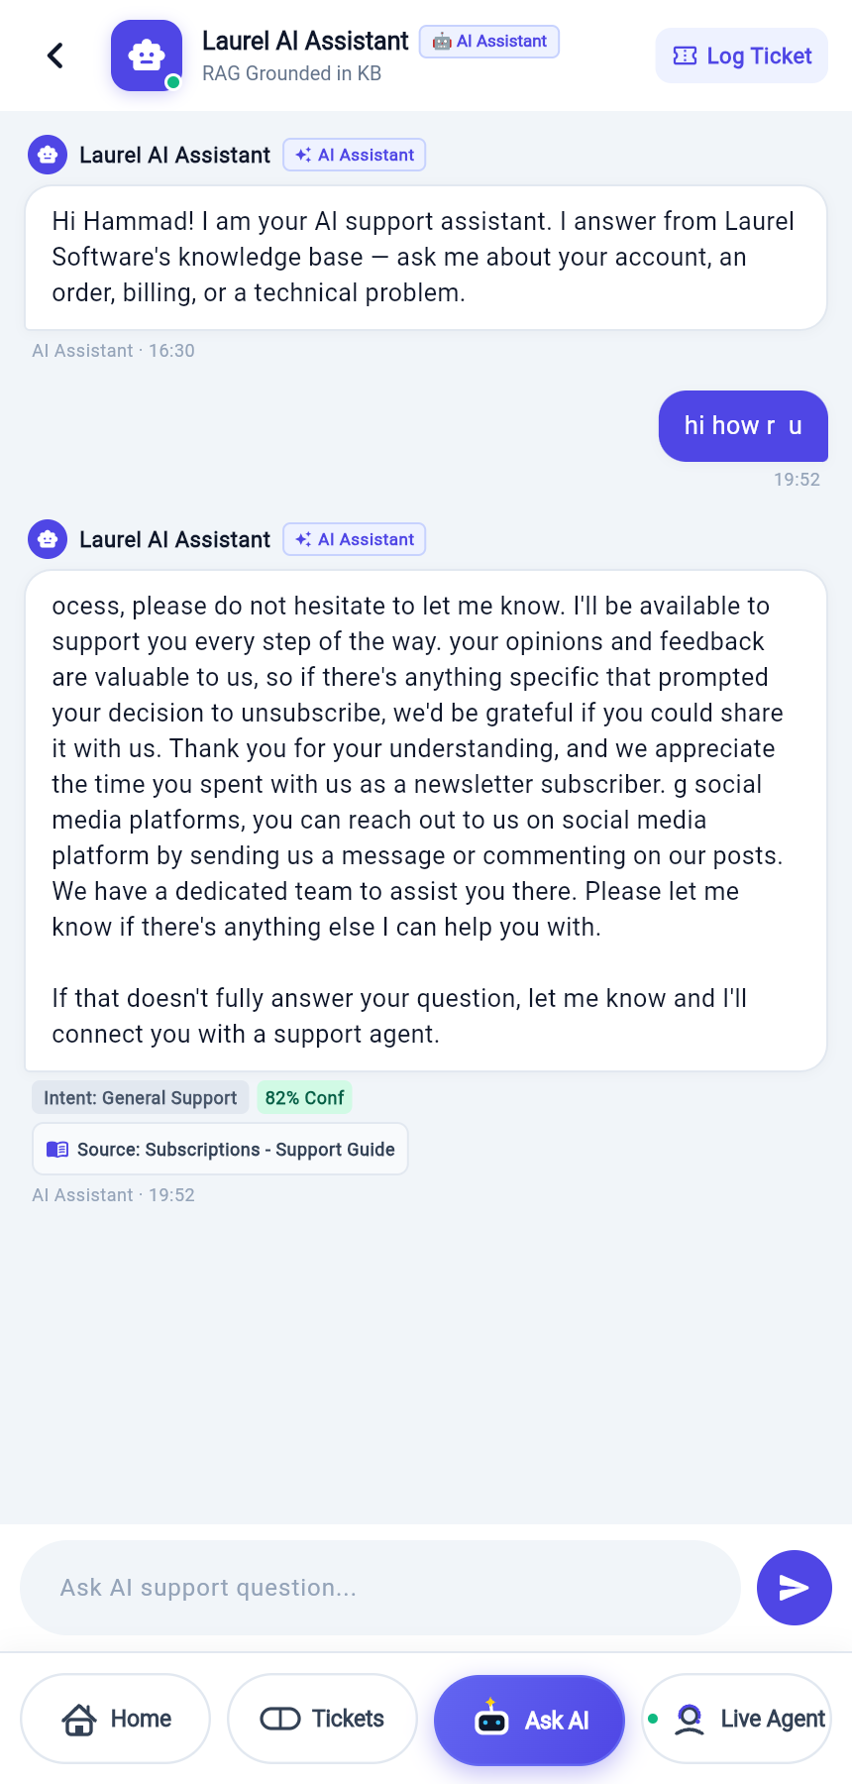
Figure 9: Mobile — Ask AI assistant (initial state).
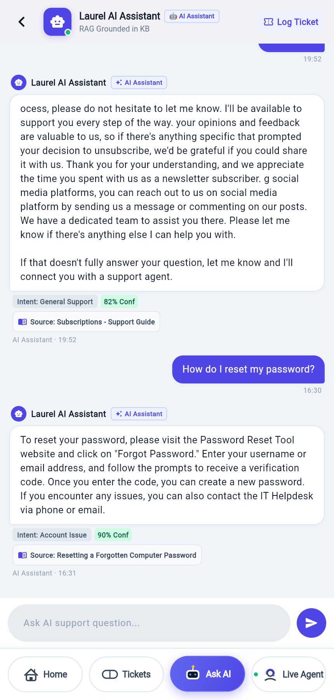
Figure 10: Mobile — Ask AI grounded answer showing intent, confidence and knowledge-base citation.

5.5.6 Live Agent Conversation Screen
Purpose: To provide a support conversation that is linked to a ticket and that may be taken over by a human agent.
UI Components: A header identifying the live support session and the ticket under discussion; a control to open the associated ticket; the message thread; a composer; and a waiting sheet presented while a session is being established.
Functionality: Selecting the live agent destination opens or resumes a support conversation that is distinct from the assistant conversation and that has an associated ticket. Until an agent explicitly takes the conversation over, the assistant continues to answer, so the customer is not left waiting without response. Once an agent takes over, the customer's messages are delivered to the agent and the assistant withdraws.
Backend / API Interaction: POST /conversations/live-agent/session opens or resumes the support conversation and returns both the conversation and its ticket; POST /conversations/{id}/request-agent registers a request for a human; POST /conversations/{id}/messages carries the customer's messages. A status change delivered over the WebSocket informs the application when ownership moves between the assistant and a human agent.
Navigation: Accessible from the bottom navigation bar and from the assistant screen when the customer requests a human.
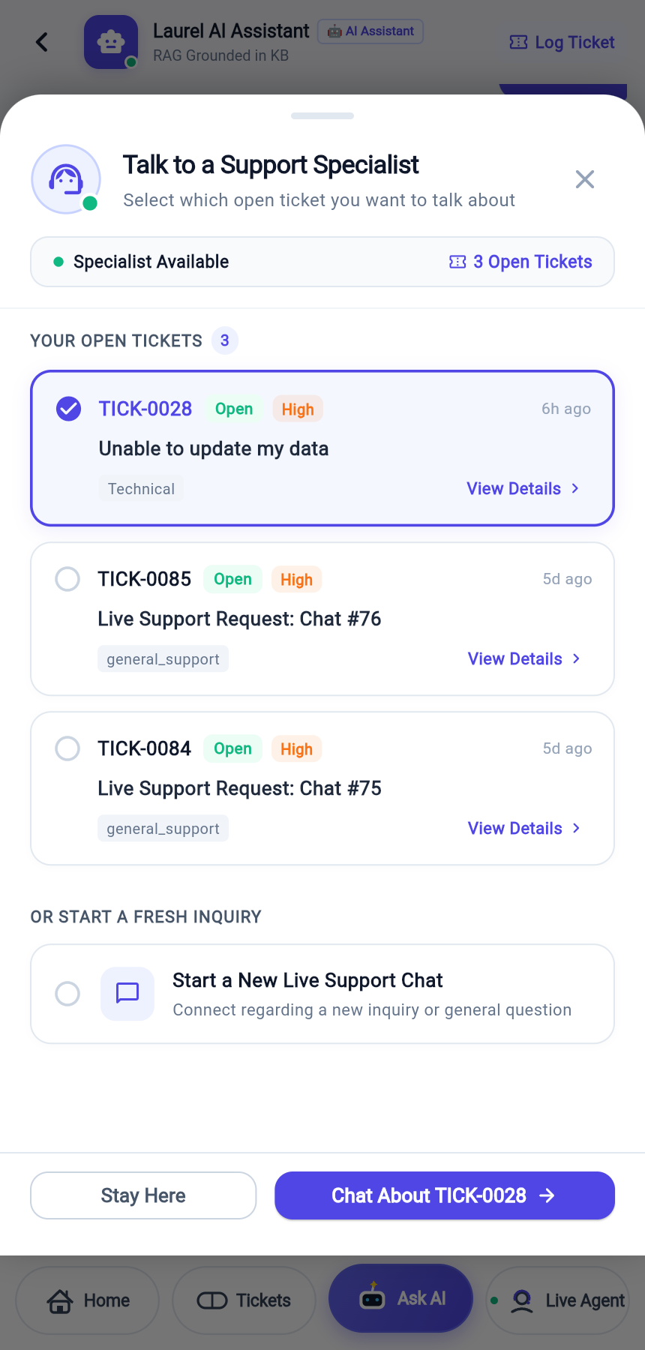
Figure 11: Mobile — Live Agent conversation.

5.5.7 Profile and Account Screen
Purpose: To display the signed-in customer's account information, to allow amendment of profile details and password, and to provide sign-out.
UI Components: Identity header with avatar, name, email address and account status; controls to edit the profile and to update the password; an information panel listing organisation, role, phone number and city or country; a sign-out control.
Backend / API Interaction: GET /auth/me returns the current profile; PUT /auth/profile submits amendments; POST /auth/change-password performs a password change with verification of the existing password.
Validation and Error Handling: The password dialogue enforces a policy of at least eight characters including an upper-case letter, a digit and a symbol, and requires the new password to differ from the current one. Sign-out clears the stored token and resets the conversation state held by the chat repository, so that a subsequent sign-in on the same device does not inherit the previous account's conversation.
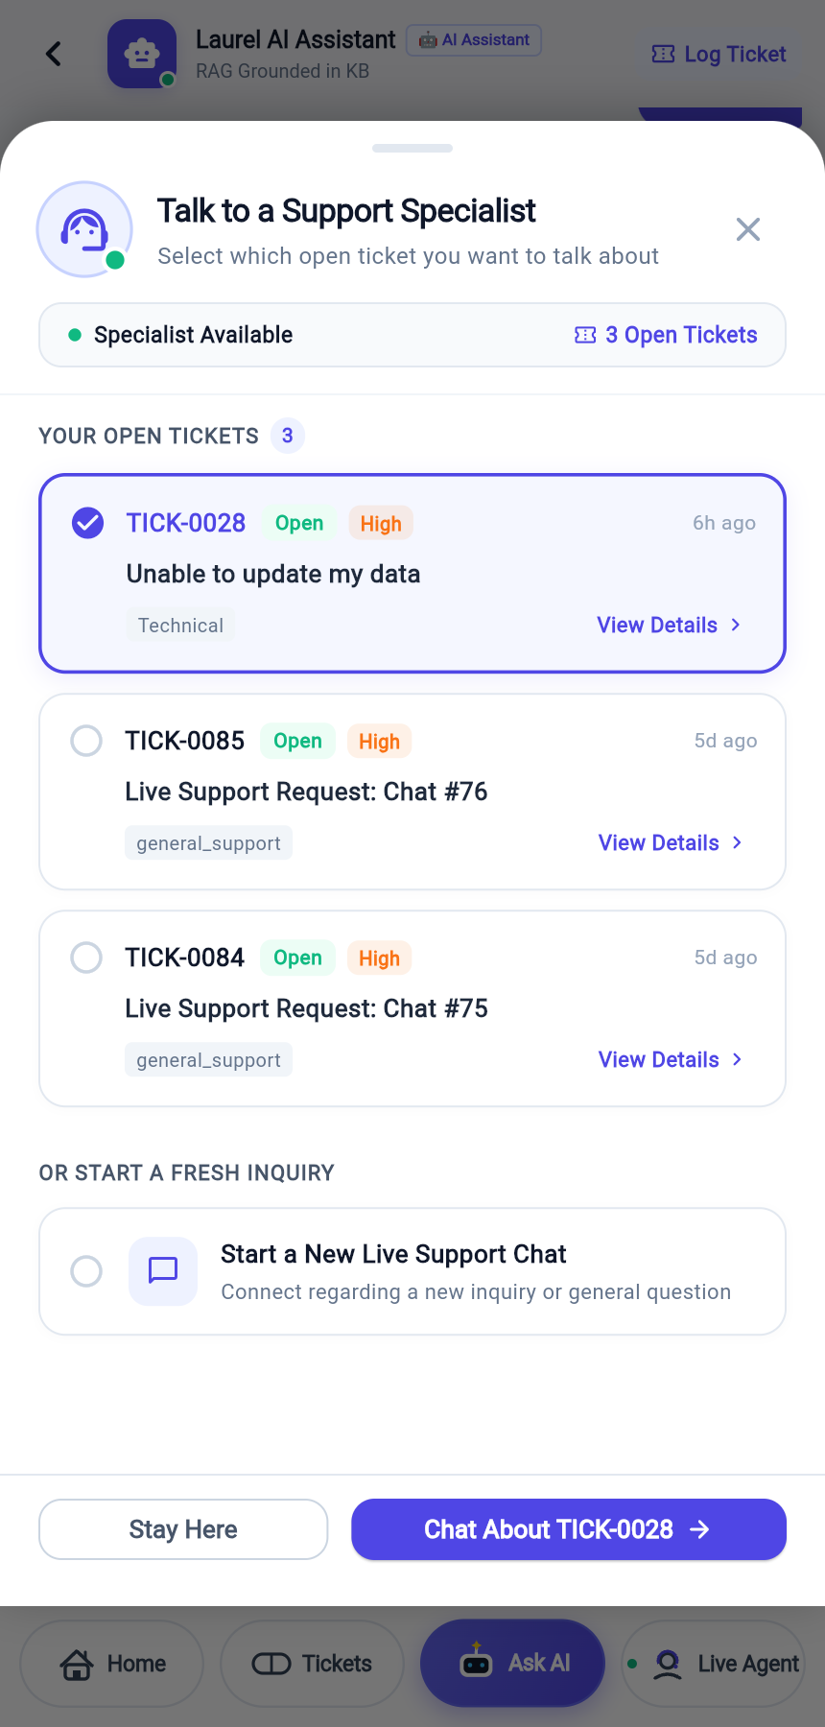
Figure 12: Mobile — Profile and account screen.

5.5.8 Notifications and Alerts Screen
Purpose: To present notifications arising from the customer's own support activity.
Functionality: Notifications are derived from the ticket state held by the ticket business logic component. Resolved and closed tickets produce a status notification; tickets in progress or awaiting the customer produce an update notification; tickets modified after creation produce an activity notification. Entries are ordered by recency and may be marked as read. Where no qualifying activity exists, an empty state is presented rather than placeholder content.
Navigation: Selecting a notification navigates to the associated destination.
[INSERT SCREENSHOT HERE — Notifications screen]

5.5.9 Knowledge Screen
Purpose: To present knowledge-base material to the customer for self-service reading.
Backend / API Interaction: Knowledge content is obtained through the knowledge repository from the backend knowledge endpoints.
[TO BE ADDED — screenshot and the final content inventory of the knowledge screen.]

5.5.10 Main Navigation Shell
Purpose: To host the four primary destinations and preserve their state as the customer moves between them.
UI Components: A persistent bottom navigation bar containing Home, Tickets, Ask AI and Live Agent, with the active destination indicated by a filled pill in the brand colour and a status indicator on the Live Agent destination.
Functionality: The shell retains the state of each destination so that returning to a conversation does not reload it from the beginning, and exposes a programmatic navigation callback used by the alerts screen and the home dashboard.

5.6 Authentication
Authentication is token-based. The application obtains a JSON Web Token from the backend and stores it in platform secure storage. The HTTP client attaches the token as a bearer credential to every subsequent request.
On start-up the application does not merely test for the presence of a token. It calls the current-user endpoint and restores the session only if the server confirms the token, so that an expired or revoked token returns the customer to the login screen rather than producing an application in an apparently signed-in but non-functional state. Where the server responds with an unauthorised or forbidden status, the stored token is discarded.
Sign-out clears the stored token and resets in-memory conversation state.
// Sign-in: the backend exposes an OAuth2 password flow, which expects a
// form-encoded body rather than JSON.
final response = await apiClient.dio.post(
'/auth/login',
data: {'username': email, 'password': password},
options: Options(contentType: Headers.formUrlEncodedContentType),
);
return await _persistSession(response.data);

5.7 API Integration
All network access is performed by repositories through a single configured Dio instance. The base address is resolved at runtime according to the platform on which the application is executing, and may be overridden at build time. This resolution is necessary because an Android emulator reaches the host machine at a different address from a desktop or web build.
static const String _override = String.fromEnvironment('API_BASE_URL');
static String get baseUrl {
if (_override.isNotEmpty) return _override;
if (kIsWeb) return 'http://127.0.0.1:8000/api/v1';
if (defaultTargetPlatform == TargetPlatform.android) {
return 'http://10.0.2.2:8000/api/v1'; // emulator loopback to host
}
return 'http://127.0.0.1:8000/api/v1';
}
Table 12 records the backend operations consumed by the mobile application.
Method | Endpoint | Purpose | Request | Response
POST | /auth/register | Create a customer account | name, email, password (JSON) | access token and user object
POST | /auth/login | Authenticate | username, password (form-encoded) | access token and user object
GET | /auth/me | Restore the session and profile | bearer token | user object
PUT | /auth/profile | Amend profile details | profile fields (JSON) | updated user object
POST | /auth/change-password | Change password | current and new password (JSON) | confirmation
POST | /auth/logout | End the session | bearer token | confirmation
GET | /conversations/ask-ai | Resolve the assistant conversation | bearer token | conversation object
POST | /conversations/ask-ai/new | Begin a new assistant conversation | bearer token | conversation object
GET | /conversations/my | List the customer's conversations | bearer token | array of conversations
GET | /conversations/{id}/messages | Replay a conversation | conversation identifier | array of messages with metadata
POST | /conversations/{id}/messages | Send a message and obtain an answer | content (JSON) | customer message, assistant message, sources, escalation flag
POST | /conversations/{id}/request-agent | Request a human agent | conversation identifier | conversation and ticket
POST | /conversations/live-agent/session | Open or resume live support | bearer token | conversation and ticket
GET | /conversations/ticket/{id} | Resolve a ticket's conversation | ticket identifier | conversation and ticket
POST | /tickets/ | Create a support ticket | subject, description, category, priority (JSON) | ticket and initial message
GET | /tickets/my | List the customer's tickets | bearer token | array of tickets
GET | /tickets/{id}/messages | Load a ticket thread | ticket identifier | array of ticket messages (internal notes excluded)
POST | /tickets/{id}/messages | Reply to a ticket | content (JSON) | created ticket message
WS | /ws/conversations/{id} | Receive live conversation events | token as query parameter | JSON events: new_message, status_change

5.8 State Management
The application uses the BLoC pattern for feature state. Events are dispatched from the presentation layer, the component invokes a repository, and an immutable state is emitted which the interface renders. The authentication feature emits initial, loading, authenticated and unauthenticated states, and the ticket feature emits loading, loaded and error states carrying the ticket collection.
Conversation state is held by the chat repository rather than by a screen. The repository owns the message collection and publishes it on a broadcast stream to which the chat screen subscribes. This arrangement was adopted because two sources contribute messages to the same conversation: the HTTP response to a submitted message, and events arriving over the WebSocket. With a single owning collection, an incoming event can be reconciled against what is already displayed. Messages are identified by their server-assigned identifier, and a message displayed optimistically before the server assigned an identifier is replaced in place when its persisted form arrives, so that no message can be rendered twice.

5.9 Local Storage
The application stores the access token using flutter_secure_storage, which delegates to the Keystore on Android and the Keychain on iOS. No customer data, message content or ticket content is persisted on the device; all such data is retrieved from the backend on demand, which keeps the server the single source of truth and limits the consequences of device loss. Conversation state is held only in memory for the duration of a session and is cleared on sign-out.

5.10 Notifications
Push notification services were not integrated; this was excluded from scope. In-application notifications are implemented instead and are derived from the customer's real ticket state as described in Section 5.5.8. Real-time awareness while the application is open is provided by the WebSocket connection rather than by a push service.

5.11 Permissions
Permission | Purpose | Status
Internet access | All communication with the backend over HTTP and WebSocket | Required
Secure storage (Keystore / Keychain) | Encrypted persistence of the access token | Required
Photo library / camera | Declared through the image_picker dependency for attachment selection | Declared

[TO BE ADDED — the final platform manifest permission list for the release Android and iOS builds.]

5.12 Error Handling
- Server-supplied messages. Repositories inspect the response body and surface the detail field returned by the backend, so that the customer sees the actual reason for a rejection rather than a generic failure.
- Non-blocking failures. Errors are reported through transient messages and do not discard input that the customer has composed.
- Timeouts matched to workload. The receive timeout was set to sixty seconds because assistant responses involve embedding, retrieval and generation; the original fifteen-second value caused the client to abandon requests that the server completed successfully.
- Session expiry. Unauthorised and forbidden responses during session restoration clear the stored token and return the customer to the login screen.
- Bounded reconnection. The WebSocket client stops reconnecting on close codes that indicate a permanent condition, and applies a ceiling to consecutive attempts, so that a rejected connection cannot produce an indefinite retry loop.

5.13 Security Considerations
- The access token is held in platform-encrypted storage rather than in plain preferences.
- No password is retained on the device after authentication.
- The application enforces the backend password policy at the point of entry, while the authoritative check remains on the server.
- Authorisation is never assumed by the client; every protected operation is validated by the backend against the caller's identity and role.
- The WebSocket connection is authenticated on handshake and is refused for conversations and tickets the caller does not own.
- Sign-out clears both the stored token and the in-memory conversation state, preventing a subsequent user of the same device from inheriting the previous session's context.

5.14 Important Implementation Logic

5.14.1 Reconciling Optimistic Messages with Server Events
When a customer sends a message it is displayed immediately, before the server has assigned an identifier. The same message subsequently returns over the WebSocket in its persisted form. Reconciliation is performed on the server-assigned identifier, with a fallback that replaces a pending optimistic entry having the same sender and text, rather than appending a second copy.
// Already holding the persisted copy - nothing to do.
if (_currentMessages.any((m) => m.id == msg.id)) return;
// Otherwise replace the optimistic entry in place.
final pending = _currentMessages.indexWhere((m) =>
m.id.startsWith('temp-') &&
m.sender == msg.sender &&
m.text == msg.text);
if (pending != -1) {
final merged = [..._currentMessages];
merged[pending] = msg;
_currentMessages = merged;
} else {
_currentMessages = [..._currentMessages, msg];
}

5.14.2 Interpretation of Server Timestamps
The backend records timestamps in Coordinated Universal Time without a zone designator. Parsed naively, such a value is interpreted as local time, which displaces every server-originated timestamp by the device's offset from Coordinated Universal Time. The application therefore appends the zone designator when none is present before parsing, and converts to local time for display.
final hasZone = text.endsWith('Z') ||
RegExp(r'[+-]\d{2}:?\d{2}$').hasMatch(text);
final parsed = DateTime.tryParse(hasZone ? text : '${text}Z');
return parsed?.toLocal() ?? fallback ?? DateTime.now();

5.14.3 Conversation Resumption
The identifier of the assistant conversation is not retained on the device. On entry the application resolves the conversation from the server and replays its history, including the intent, confidence and citations attached to previous answers. This ensures that the conversation observed by the customer is the same conversation observed by staff in the web console, and that history survives application restarts.

Chapter 6 — Backend Implementation
Component owner: Sabeeh Waheed. The content of this chapter has been compiled from the delivered backend source tree and the generated OpenAPI specification of the running service. Sections marked for completion require detail that is not derivable from the code.

6.1 Backend Overview
The backend is the only component with access to the database and is the authoritative implementation of every business rule in the platform. It serves both client applications, exposing 55 REST endpoints for request-and-response interaction and 2 WebSocket endpoints for server-initiated updates. It additionally hosts the intelligence of the system: the retrieval pipeline and the generation service.

6.2 Backend Architecture
The service is layered by responsibility. An inbound request passes through middleware, is dispatched to a router, is authorised against the caller's identity and role, and is then executed against the data layer, calling into a domain service where intelligence is required.
HTTP request
|
[ RateLimitMiddleware ] sliding window per client address
|
[ SecurityHeadersMiddleware ] OWASP response headers
|
[ CORSMiddleware ] configured origins + localhost regex
|
[ Router ] auth | users | conversations | messages
| tickets | agents | admin | knowledge | ws
|
[ Dependency: get_current_user ] decode JWT -> load user -> check role
|
[ Domain service ] ai_service | knowledge_service
|
[ SQLAlchemy session ] ORM models -> relational database
|
[ BackgroundTasks ] WebSocket broadcast after the response

6.3 Technology Stack
Layer | Technology
Language | Python 3.12
Web framework | FastAPI
Server | Uvicorn 0.34.0 (ASGI)
Object-relational mapper | SQLAlchemy 2.0.36 with typed declarative models
Migrations | Alembic
Validation and settings | Pydantic v2 and pydantic-settings
Password hashing | pwdlib with the Argon2 algorithm
Tokens | PyJWT 2.13.0, HS256
Embeddings | fastembed executing BAAI/bge-small-en-v1.5 (384 dimensions)
Vector arithmetic | NumPy
Database | SQLite (development), PostgreSQL (containerised deployment)
Testing | pytest with the FastAPI TestClient

6.4 Project Structure
Path | Responsibility
app/main.py | Application construction, middleware registration, router mounting under /api/v1, lifespan hook and health endpoint.
app/config.py | Typed settings loaded from environment and .env, covering the database address, token parameters, provider selection and retrieval parameters.
app/middleware.py | Rate limiting, security headers and the central exception handler.
app/api/auth.py | Registration, sign-in, current user, profile amendment, password change and sign-out.
app/api/users.py | Staff directory lookup and administrative user creation.
app/api/conversations.py | Conversation lifecycle: assistant conversation resolution, ticket conversation resolution, live support sessions, takeover and hand-back.
app/api/messages.py | Message submission and retrieval; the retrieval and generation pipeline is orchestrated here.
app/api/tickets.py | Ticket creation, listing, threaded messages, internal notes, takeover, hand-back and updates.
app/api/agents.py | Agent workspace: assigned and unassigned queues, claiming, filtering, search, workload and statistics.
app/api/admin.py | Administrative user and agent management, ticket oversight, dashboard statistics and assistant analytics.
app/api/knowledge.py | Knowledge document upload, listing, amendment, archival and reindexing.
app/api/ws_routes.py | WebSocket endpoints for conversations and tickets, including handshake authentication and authorisation.
app/websocket_manager.py | Connection manager maintaining conversation and ticket rooms and broadcasting JSON events.
app/services/ai_service.py | Provider-independent answer generation, intent classification, confidence handling and the local fallback answerer.
app/services/knowledge_service.py | Text extraction, chunking, embedding, index caching, similarity search and context assembly.
app/database/ | Declarative base, engine and session factory, and the seven ORM models.
app/seed.py | Demonstration data: accounts, tickets, conversations and knowledge documents.
scripts/build_kb.py | Knowledge base construction from the source datasets.
alembic/versions/ | Ordered schema migrations.
tests/ | Automated regression suite.

6.5 API Architecture
Every endpoint is mounted under the version prefix /api/v1. FastAPI derives an OpenAPI specification from the route signatures and type annotations, and serves interactive documentation at /docs. This specification acted as the integration contract between the three components: the mobile and web developers worked against the published schema rather than against informal description.
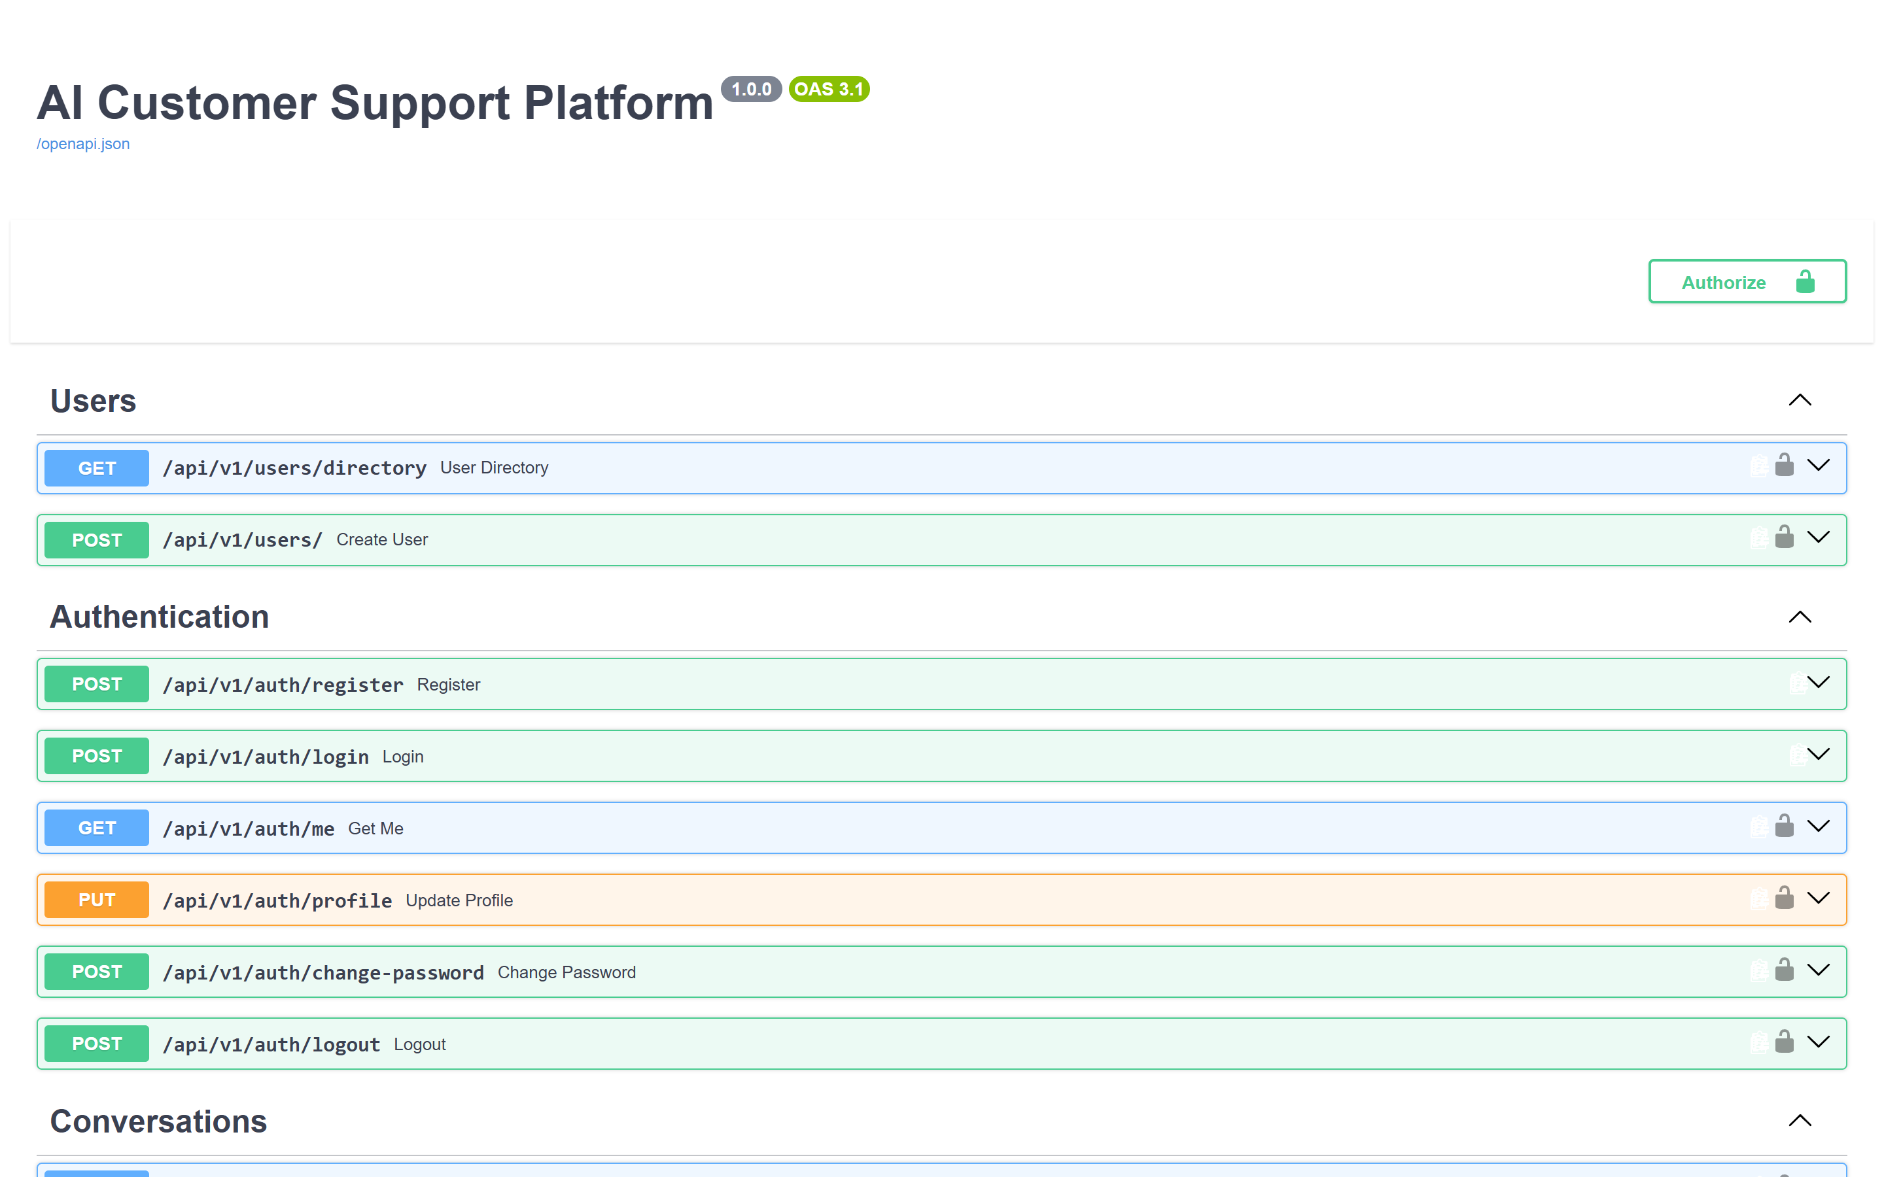
Figure 13: Backend — interactive OpenAPI documentation served at /docs.

6.6 Authentication and Authorization
Sign-in is implemented as an OAuth2 password flow. The submitted password is verified against the stored Argon2 hash and, on success, a JSON Web Token is issued carrying the user identifier as its subject and an expiry governed by configuration, by default sixty minutes. The token is signed with HS256 using a configurable secret.
A dependency resolves the caller on every protected route by decoding the token, loading the user and confirming that the account is active. Authorisation is then applied according to role and, for customer-scoped resources, according to ownership. Endpoints reserved for staff reject customers, and endpoints reserved for administrators reject agents.
Registration is public but creates only customer accounts; the role cannot be supplied by the caller. Elevated accounts are created exclusively through the administrative endpoint, which itself requires an administrator caller.

6.7 Database
Persistence is provided through SQLAlchemy using typed declarative models. The development configuration uses SQLite and creates the schema at start-up; the containerised configuration uses PostgreSQL and applies Alembic migrations. Embedding vectors are stored as portable JSON rather than in an engine-specific vector type, which keeps a single model definition valid on both engines. The schema is documented in Chapter 8.

6.8 API Endpoints
Table 14 lists the complete REST surface of the service as generated from the running application, grouped by router. All paths are relative to /api/v1.

6.8.1 Authentication
Method | Path | Access
POST | /auth/register | Public
POST | /auth/login | Public
GET | /auth/me | Authenticated
PUT | /auth/profile | Authenticated
POST | /auth/change-password | Authenticated
POST | /auth/logout | Authenticated

6.8.2 Users
Method | Path | Access
GET | /users/directory | Staff
POST | /users/ | Administrator

6.8.3 Conversations
Method | Path | Access
POST | /conversations/ | Customer
GET | /conversations/ask-ai | Customer
POST | /conversations/ask-ai/new | Customer
GET | /conversations/ticket/{ticket_id} | Owner or staff
GET | /conversations/my | Customer
GET | /conversations/ | Staff
GET | /conversations/{conversation_id} | Owner or staff
PATCH | /conversations/{conversation_id}/takeover | Staff
PATCH, POST | /conversations/{conversation_id}/handback | Staff
POST | /conversations/{conversation_id}/request-agent | Customer
POST | /conversations/live-agent/session | Customer

6.8.4 Messages
Method | Path | Access
POST | /conversations/{conversation_id}/messages | Owner or staff
GET | /conversations/{conversation_id}/messages | Owner or staff

6.8.5 Tickets
Method | Path | Access
POST | /tickets/ | Customer
GET | /tickets/my | Customer
GET | /tickets/ | Staff
GET | /tickets/{ticket_id} | Owner or staff
GET | /tickets/{ticket_id}/messages | Owner or staff
POST | /tickets/{ticket_id}/messages | Owner or staff
POST | /tickets/{ticket_id}/internal-notes | Staff
POST | /tickets/{ticket_id}/takeover | Staff
POST | /tickets/{ticket_id}/handback | Staff
PATCH | /tickets/{ticket_id} | Staff

6.8.6 Agents
Method | Path | Access
GET | /agents/me | Agent
GET | /agents/tickets | Agent
GET | /agents/tickets/unassigned | Agent
GET | /agents/tickets/filter | Agent
GET | /agents/tickets/search | Agent
POST | /agents/tickets/{ticket_id}/claim | Agent
PATCH | /agents/tickets/{ticket_id}/assign | Agent
GET | /agents/dashboard/stats | Agent
GET | /agents/conversations | Agent
GET | /agents/workload | Agent

6.8.7 Administration
Method | Path | Access
GET | /admin/users | Administrator
GET | /admin/users/{user_id} | Administrator
PATCH | /admin/users/{user_id}/status | Administrator
PATCH | /admin/users/{user_id}/role | Administrator
GET | /admin/agents | Administrator
GET | /admin/agents/{agent_id} | Administrator
GET | /admin/tickets | Administrator
GET | /admin/dashboard/stats | Administrator
GET | /admin/ai/analytics | Administrator

6.8.8 Knowledge Base
Method | Path | Access
GET | /knowledge/documents | Staff
GET | /knowledge/documents/{document_id} | Staff
POST | /knowledge/documents | Staff
POST | /knowledge/faqs | Staff
PATCH | /knowledge/documents/{document_id} | Staff
DELETE | /knowledge/documents/{document_id} | Staff
POST | /knowledge/reindex | Staff

6.8.9 Real-Time Endpoints
Protocol | Path | Description
WebSocket | /ws/conversations/{conversation_id} | Joins the conversation room. The token is supplied as a query parameter and validated on handshake; a customer may join only their own conversation.
WebSocket | /ws/tickets/{ticket_id} | Joins the ticket room under the same authentication and ownership rules.

6.9 Business Logic

6.9.1 Retrieval-Augmented Generation
The knowledge service performs retrieval. Documents are cleaned and divided into chunks of one thousand characters with an overlap of two hundred characters, so that a passage spanning a boundary is not lost. Each chunk is embedded with the local sentence-embedding model into a 384-dimensional vector and stored as JSON.
At query time the question is embedded and compared against the corpus by cosine similarity. Because both the query vector and the stored vectors are normalised, similarity reduces to a matrix-vector product, and the highest-scoring chunks are selected using a partial selection rather than a full sort. The four highest-scoring chunks are retained, and any chunk scoring below the configured minimum of 0.5 is discarded, so that an off-topic question yields no context rather than weak and misleading context.
index = _load_index(db) # cached, normalised chunk matrix
q_vec = _embed_query(query)
q_vec /= np.linalg.norm(q_vec) + 1e-9
scores = index['matrix'] @ q_vec # cosine similarity for the whole corpus
k = min(top_k, scores.shape[0])
top = np.argpartition(scores, -k)[-k:] # partial selection
order = top[np.argsort(scores[top])[::-1]] # order the k results

6.9.2 Index Caching
Retrieval originally decoded every stored embedding from JSON on each query. Measurement attributed approximately 250 milliseconds of a 300-millisecond search to that decoding, a cost that grows linearly with the corpus. The normalised matrix is therefore assembled once and cached in memory, keyed on an inexpensive signature of the corpus comprising the number of embedded chunks, the highest chunk identifier, the number of active documents and the latest document modification time. Any change to the corpus alters the signature and the index is rebuilt automatically, which removes the possibility of a stale cache surviving an edit. Measured retrieval latency fell to approximately 80 milliseconds.

6.9.3 Answer Generation and Intent Classification
The generation service composes a system prompt containing operating rules, the permitted intent vocabulary and, when retrieval produced context, the retrieved passages. The model is instructed to return a strict JSON object containing the customer-facing answer, exactly one intent from the permitted set, and a confidence value. The permitted intents are order_support, refund_request, order_tracking, order_cancellation, payment_issue, account_issue, technical_support, general_support and complaint.
The response is parsed defensively: a fenced or partially malformed payload is recovered where possible, an unrecognised intent is normalised to general support, and the confidence is clamped to the unit interval. Escalation is proposed when confidence falls below the configured threshold of 0.70 or when the classified intent is a complaint, on the reasoning that a dissatisfied customer should always be able to reach a person.

6.9.4 Graceful Degradation
Free-tier language model providers impose request quotas, and a support platform cannot fail when a quota is exhausted. Provider exceptions and unparseable responses are therefore caught and answered by a local extractive answerer, which composes a reply from the passages already retrieved. The customer receives a grounded answer drawn from the knowledge base rather than an error, and the event is logged.

6.9.5 Separation of the Assistant and Live Support Surfaces
A conversation with no linked ticket is the customer's assistant thread; a conversation with a ticket is a live support thread. This distinction is enforced rather than merely conventional. Live support never adopts an existing assistant conversation, an agent takeover is refused on an assistant conversation, and the message endpoint answers an assistant conversation with the assistant regardless of any stale flag on the record. Consequently the customer's assistant history cannot be absorbed into a support session.

6.9.6 Ownership of a Live Conversation
Within a live support conversation the assistant is the first responder. Ownership transfers to a human only through an explicit takeover operation, which sets the conversation status to human support and suspends the assistant. A hand-back operation restores the assistant. An agent reply alone does not transfer ownership, so a single acknowledgement does not leave the customer without a responder while the agent is occupied elsewhere.

6.10 Validation
Request bodies are declared as Pydantic models, so structural validation, type coercion and constraint enforcement occur before a handler executes; violations produce a 422 response describing the offending field. Field validators enforce domain rules, including normalisation and shape checking of email addresses and a password policy requiring a minimum of eight characters with upper case, lower case and numeric content. Message content is bounded between one and five thousand characters, and whitespace-only content is rejected.

6.11 Error Handling
- Expected domain failures raise HTTP exceptions carrying an accurate status code and a specific message, which the clients surface to the user.
- A central exception handler catches unhandled exceptions, records them with a stack trace in the server log, and returns a generic message, so that internal detail is never disclosed to a client.
- Retrieval failure is contained: if the knowledge service raises, the request proceeds without context rather than failing.
- Provider failure is contained by the local fallback answerer described in Section 6.9.4.
- Database integrity violations, such as a duplicate email address, are converted into meaningful client errors after rolling back the transaction.

6.12 Security
Control | Implementation
Password storage | Argon2 hashing through pwdlib; the hash is excluded from every response payload.
Authentication | JSON Web Tokens signed with HS256, expiring after a configurable interval of sixty minutes by default.
Authorisation | Role checks for staff and administrator endpoints, and ownership checks on all customer-scoped resources.
Privilege escalation | Public registration creates customer accounts only; the role cannot be chosen by the caller.
Rate limiting | Sliding window per client address: 15 requests per minute on authentication endpoints, 30 per minute on assistant messaging; exceeding either yields 429 with Retry-After.
Response headers | X-Content-Type-Options, X-Frame-Options, X-XSS-Protection and Referrer-Policy.
Cross-origin policy | An explicit origin list supplemented by a pattern permitting local development hosts.
Real-time access control | The WebSocket handshake validates the token and refuses a customer access to a conversation or ticket they do not own.
Internal notes | Agent notes are flagged internal, are excluded from customer-facing responses and are not broadcast to customer connections.
Secret management | Credentials are read from environment configuration; the environment file is excluded from version control.
Error disclosure | A central handler prevents stack traces from reaching clients.

6.13 Deployment
Two deployment paths are provided. For development, batch and PowerShell scripts at the repository root start the backend, the web console and the mobile web build together, and companion scripts terminate them. The backend is served by Uvicorn on port 8000, the console by the Next.js development server on port 3000, and the mobile web build on port 8080.
For containerised deployment a Docker Compose configuration defines a PostgreSQL service, the backend service and the web console service, with health checks and the API base address supplied to the console at build time. The backend image is based on a slim Python 3.12 image, includes the system library required by the embedding runtime and bakes the embedding model into the image so that no model download occurs at start-up. The container entry point applies Alembic migrations, seeds demonstration data and then starts the server.
[TO BE COMPLETED BY BACKEND TEAM MEMBER — production hosting target, domain and certificate configuration, secret management in the deployment environment, backup policy, and the results of a full container stack build.]

Chapter 7 — Web Application Implementation
Component owner: Hammad Mehmood, who was additionally responsible for system integration across the three components.

7.1 Web Application Overview
The web application is the staff console. It is used by support agents to triage and resolve tickets and by administrators to manage users, curate the knowledge base and review analytics. It is not used by customers; the customer channel is the mobile application. The console consumes the same REST API and the same WebSocket channels as the mobile application, which guarantees that both surfaces observe one state.

7.2 Technology Stack
Concern | Technology
Framework | Next.js 16.3.4 using the App Router
User interface library | React 19.2.8
Language | TypeScript 5
Styling | Tailwind CSS 4 with design tokens declared in a theme layer
Server state | TanStack Query 5.102.8
Icons | lucide-react 1.39.0
Charts | Recharts 3.10.1
Real-time | Native WebSocket wrapped in a custom React hook
Build output | Standalone output mode for containerised deployment

7.3 Architecture
The console is a client-rendered application within the Next.js App Router. Authenticated routes are collected in a route group that shares a single layout providing the navigation shell, so that navigation state and the query cache persist across route changes. Three modules form the data layer: a typed API client that wraps fetch and attaches the bearer token and normalises errors; a query module exposing one hook per resource built on TanStack Query; and a WebSocket hook that subscribes to a room and invalidates affected queries when an event arrives.
The decision to have the socket trigger invalidation rather than mutate the cache directly is deliberate. Because the console refetches from the authoritative source instead of appending a pushed payload, a message cannot be rendered twice and the displayed state cannot drift from the database.

7.4 Project Structure
Path | Responsibility
app/layout.tsx | Root layout, font loading and global providers.
app/page.tsx | Entry route redirecting according to session state.
app/login/page.tsx | Staff sign-in.
app/(app)/layout.tsx | Authenticated shell providing navigation and the session guard.
app/(app)/dashboard/ | Operations dashboard.
app/(app)/tickets/ | Ticket queue and ticket detail, with a loading state.
app/(app)/conversations/ | Conversation list and detail, with a loading state.
app/(app)/customers/ | Customer directory and detail, with a loading state.
app/(app)/knowledge/ | Knowledge base management.
app/(app)/admin/ | Analytics, agent management and user administration.
components/ | Shell, page header, user interface primitives, count bars, toast notifications, theme toggle and providers.
lib/api.ts | Typed fetch wrapper, base address resolution, bearer token attachment and error normalisation.
lib/queries.ts | One query or mutation hook per resource.
lib/auth.tsx | Session context, token persistence and route guarding.
lib/useWebSocket.ts | Room subscription and query invalidation.
lib/types.ts | Shared TypeScript interfaces mirroring the API payloads.
lib/theme.tsx, lib/nav.ts, lib/format.ts | Theme control, navigation definition and formatting helpers.
app/globals.css | Design tokens, colour scale and light and dark themes.

7.5 Pages
Table 16 lists the implemented routes. Screenshots follow.
# | Route | Purpose | Access
1 | /login | Staff authentication | Public
2 | /dashboard | Operations overview | Staff
3 | /tickets | Ticket queue | Staff
4 | /tickets/[id] | Ticket detail, reply and internal notes | Staff
5 | /conversations | Conversation list | Staff
6 | /conversations/[id] | Conversation detail, takeover and hand-back | Staff
7 | /customers | Customer directory | Staff
8 | /customers/[id] | Customer detail | Staff
9 | /knowledge | Knowledge base management | Staff
10 | /admin/analytics | Assistant analytics | Administrator
11 | /admin/agents | Agent management and workload | Administrator
12 | /admin/users | User administration | Administrator

7.5.1 Sign-In Page
Authenticates a staff member and stores the returned token, after which the session guard admits the user to the console. Invalid credentials produce a specific message returned by the backend.
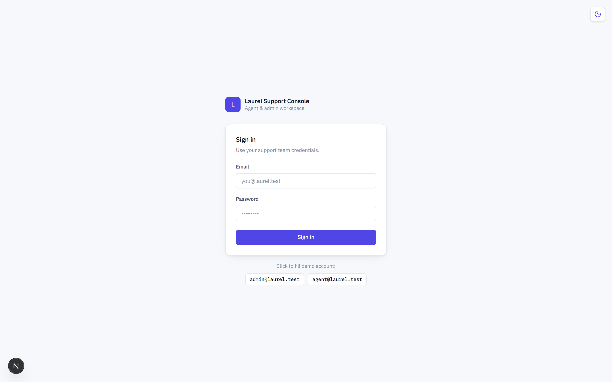
Figure 14: Web — staff sign-in page.

7.5.2 Operations Dashboard
Summarises the current operational picture: ticket counts by status, conversation activity and assistant performance indicators, with entry points into the queues.
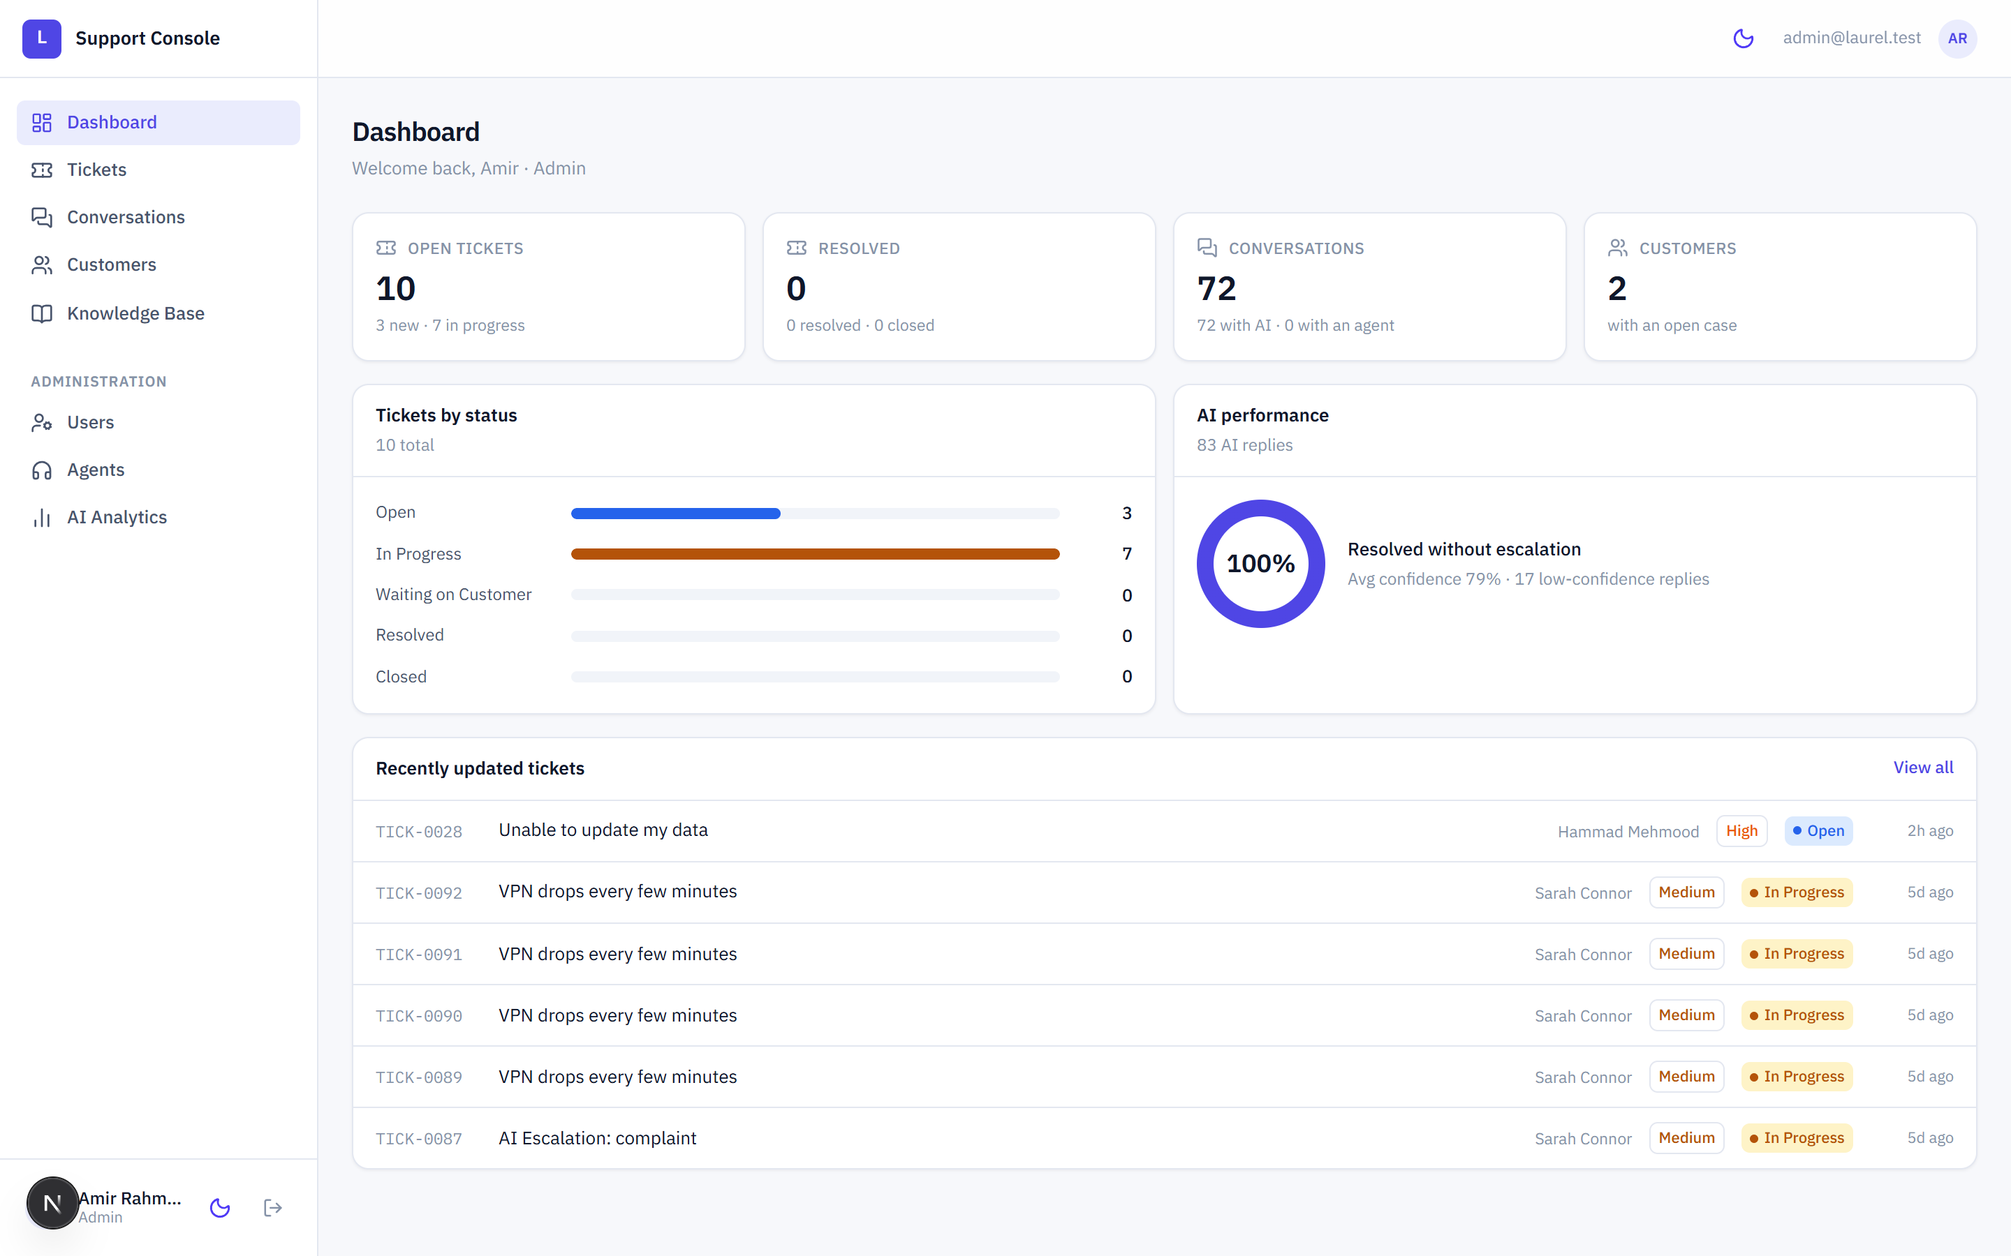
Figure 15: Web — operations dashboard.

7.5.3 Ticket Queue
Lists every ticket with reference number, subject, customer, priority, status and assignment. Each row is fully clickable: the reference link is stretched across the row so that the entire row is a single navigation target while remaining a genuine hyperlink, which preserves keyboard access and the browser's own affordances.
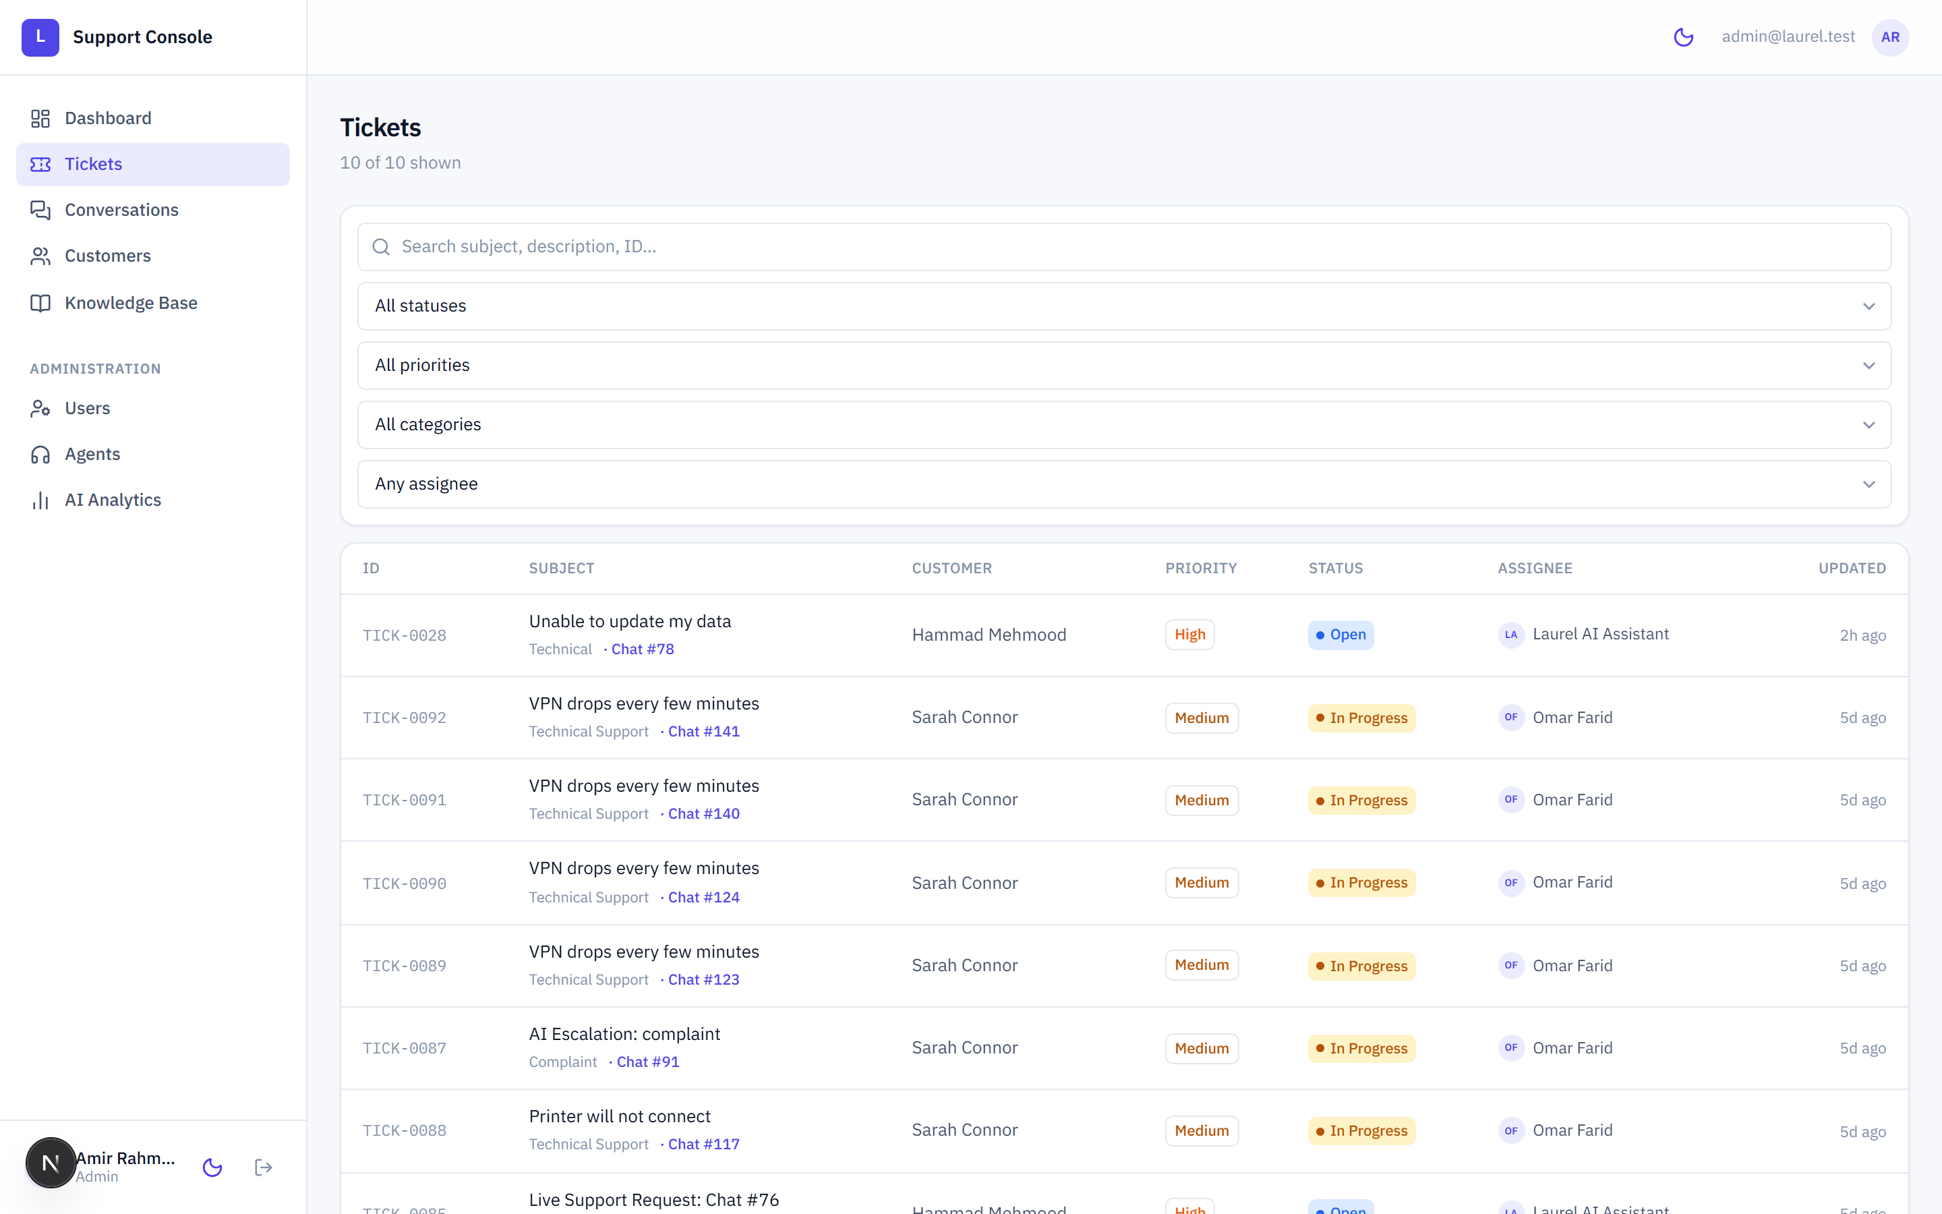
Figure 16: Web — ticket queue.

7.5.4 Ticket Detail
Presents the ticket header with status, priority, category and assignment controls, the full correspondence thread, a reply composer and a separate internal note composer. Internal notes are visually distinguished and are never delivered to the customer. Status, priority and assignment changes are submitted as mutations that invalidate the affected queries.
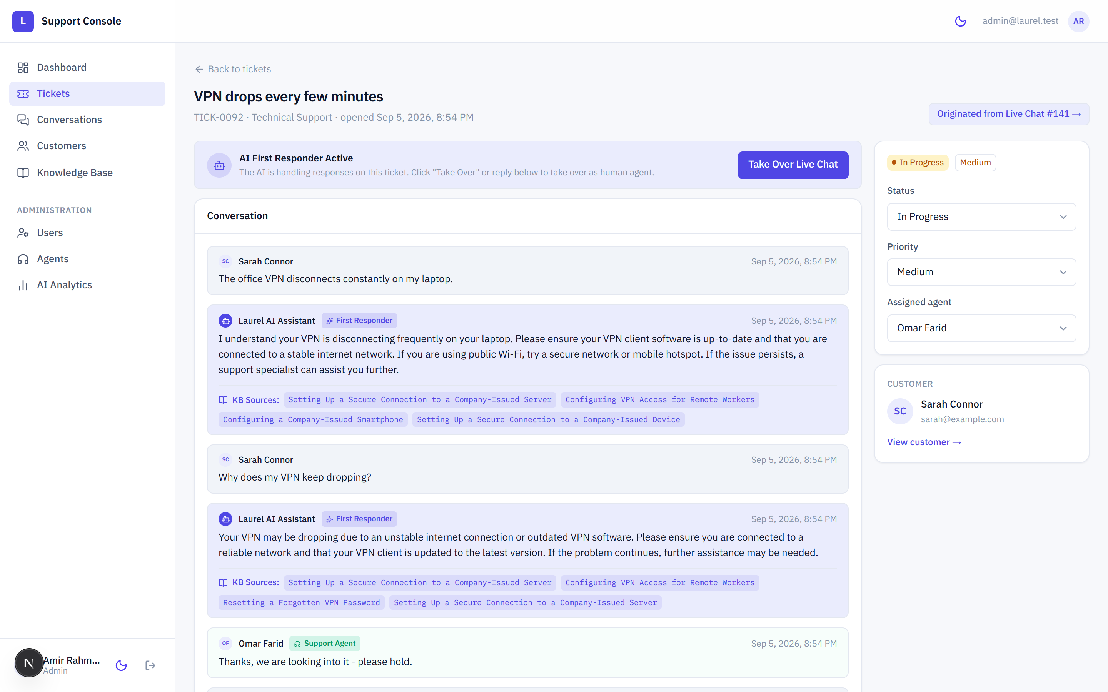
Figure 17: Web — ticket detail and reply thread.

7.5.5 Conversation List
Lists conversations with their customer, current status and whether the assistant or a human currently owns the thread.
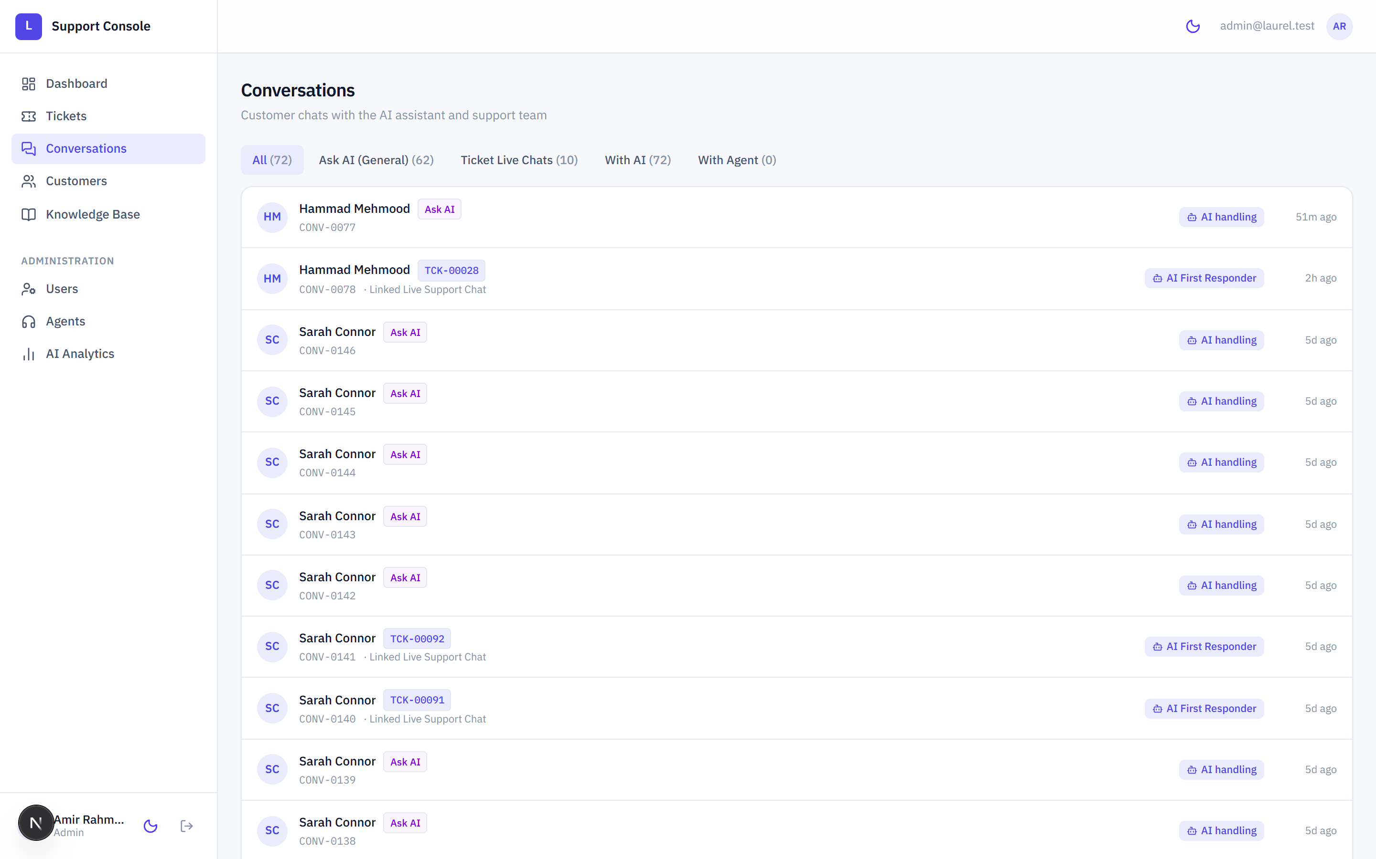
Figure 18: Web — conversation list.

7.5.6 Conversation Detail
Displays the full exchange. Each assistant message carries its intent, confidence and the knowledge-base articles cited, presented as source chips, so that a reviewing agent can see the basis of an automated answer. Takeover and hand-back controls transfer ownership between the assistant and the agent.
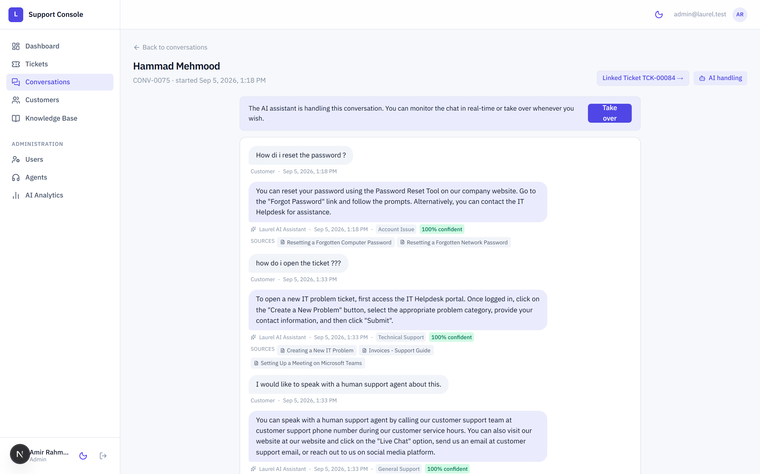
Figure 19: Web — conversation detail with assistant citations.

7.5.7 Customer Directory
Lists customers with their contact details and activity, and links to a detail view collecting an individual customer's tickets and conversations.
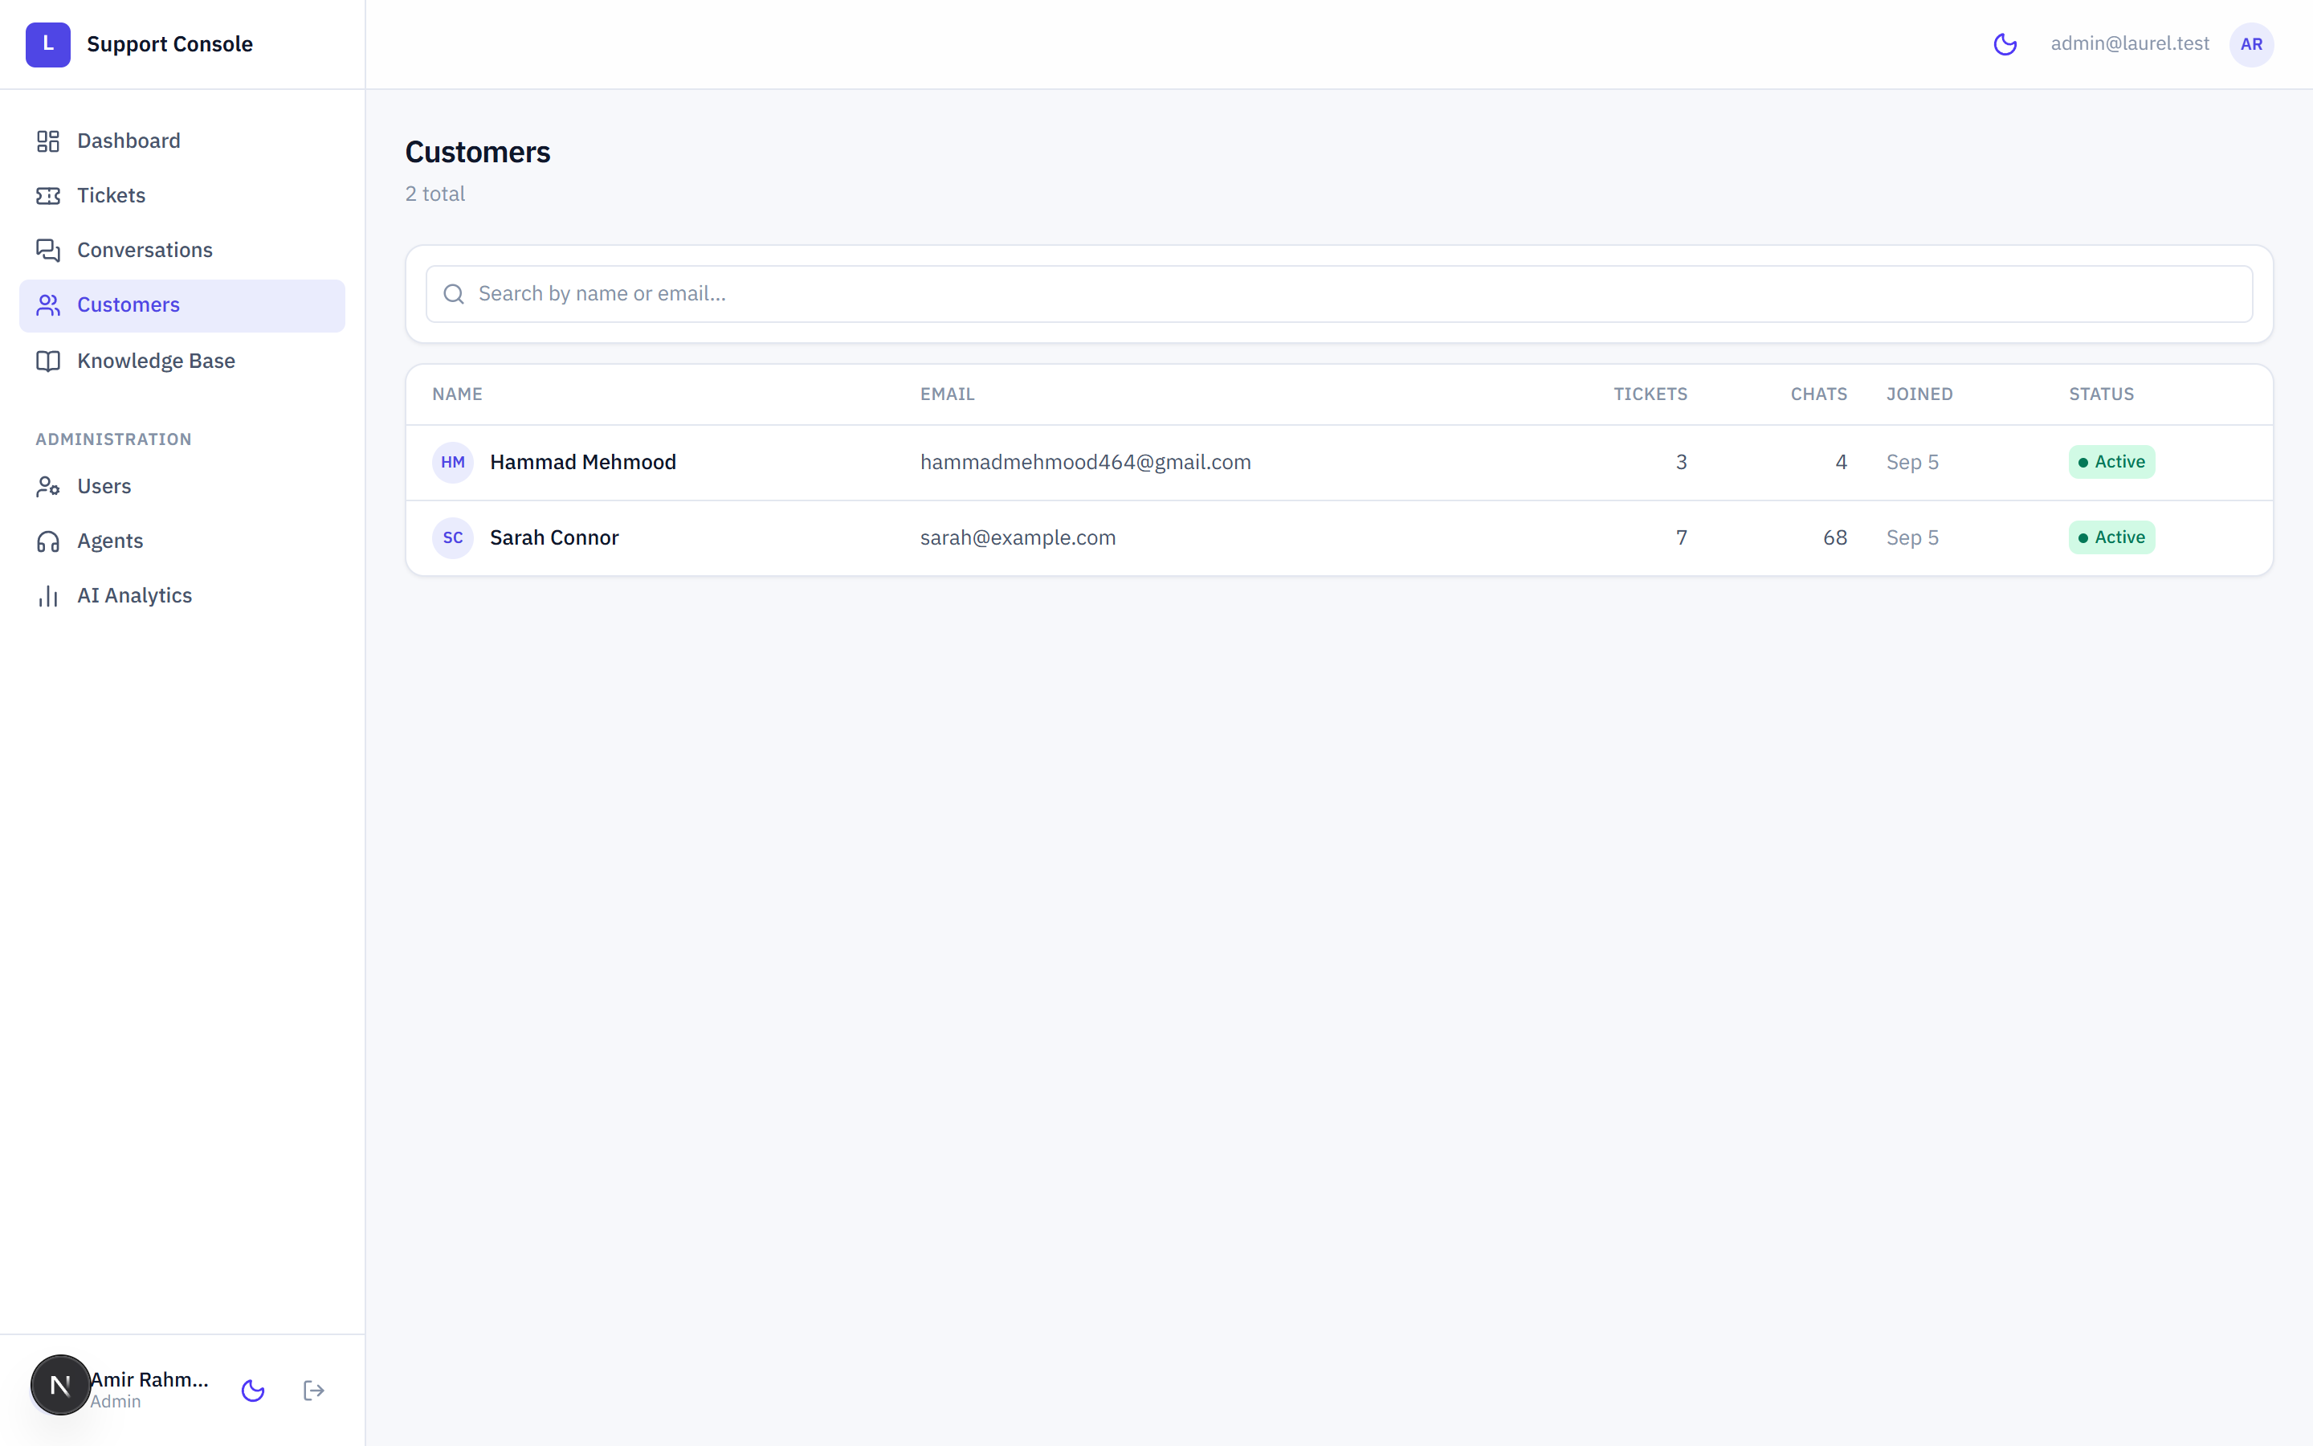
Figure 20: Web — customer directory.

7.5.8 Knowledge Base Management
Lists knowledge documents with their indexing state and provides upload, amendment, archival and reindexing operations. Reindexing regenerates embeddings and invalidates the retrieval cache.
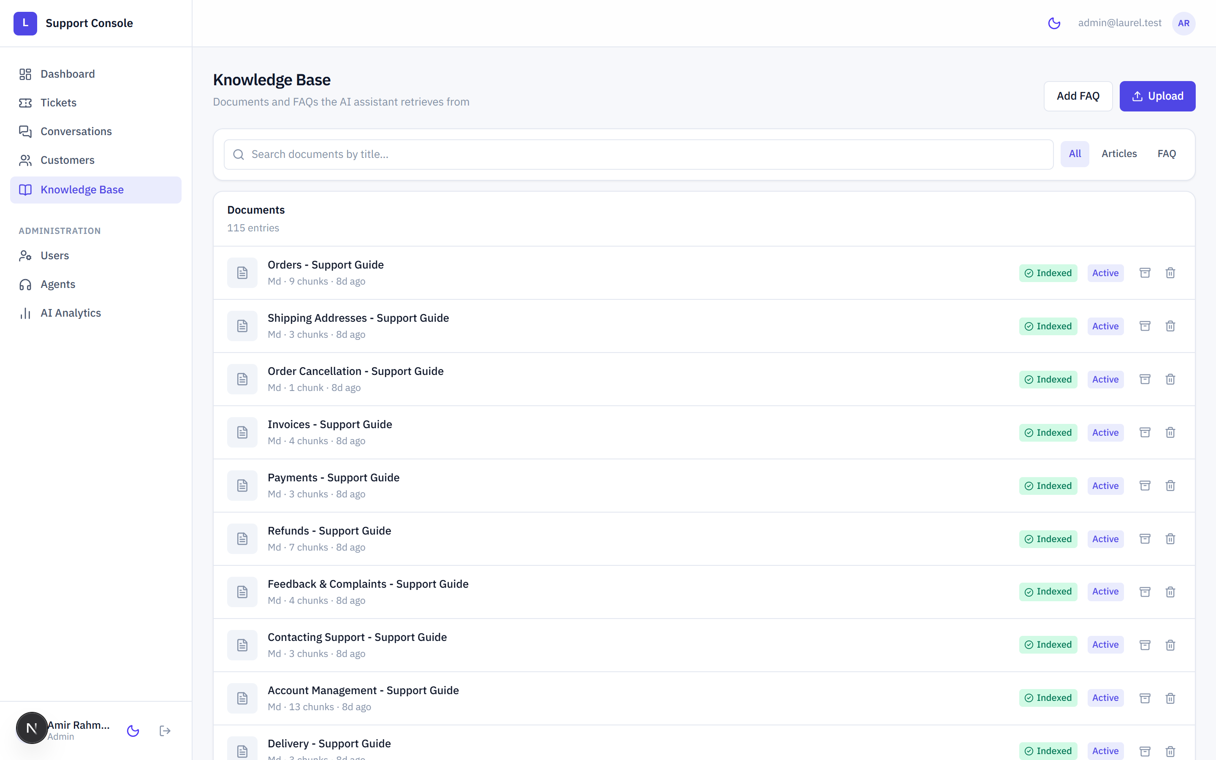
Figure 21: Web — knowledge base management.

7.5.9 Assistant Analytics
Presents aggregate assistant behaviour, including the distribution of classified intents and confidence characteristics, drawn from the administrative analytics endpoint.
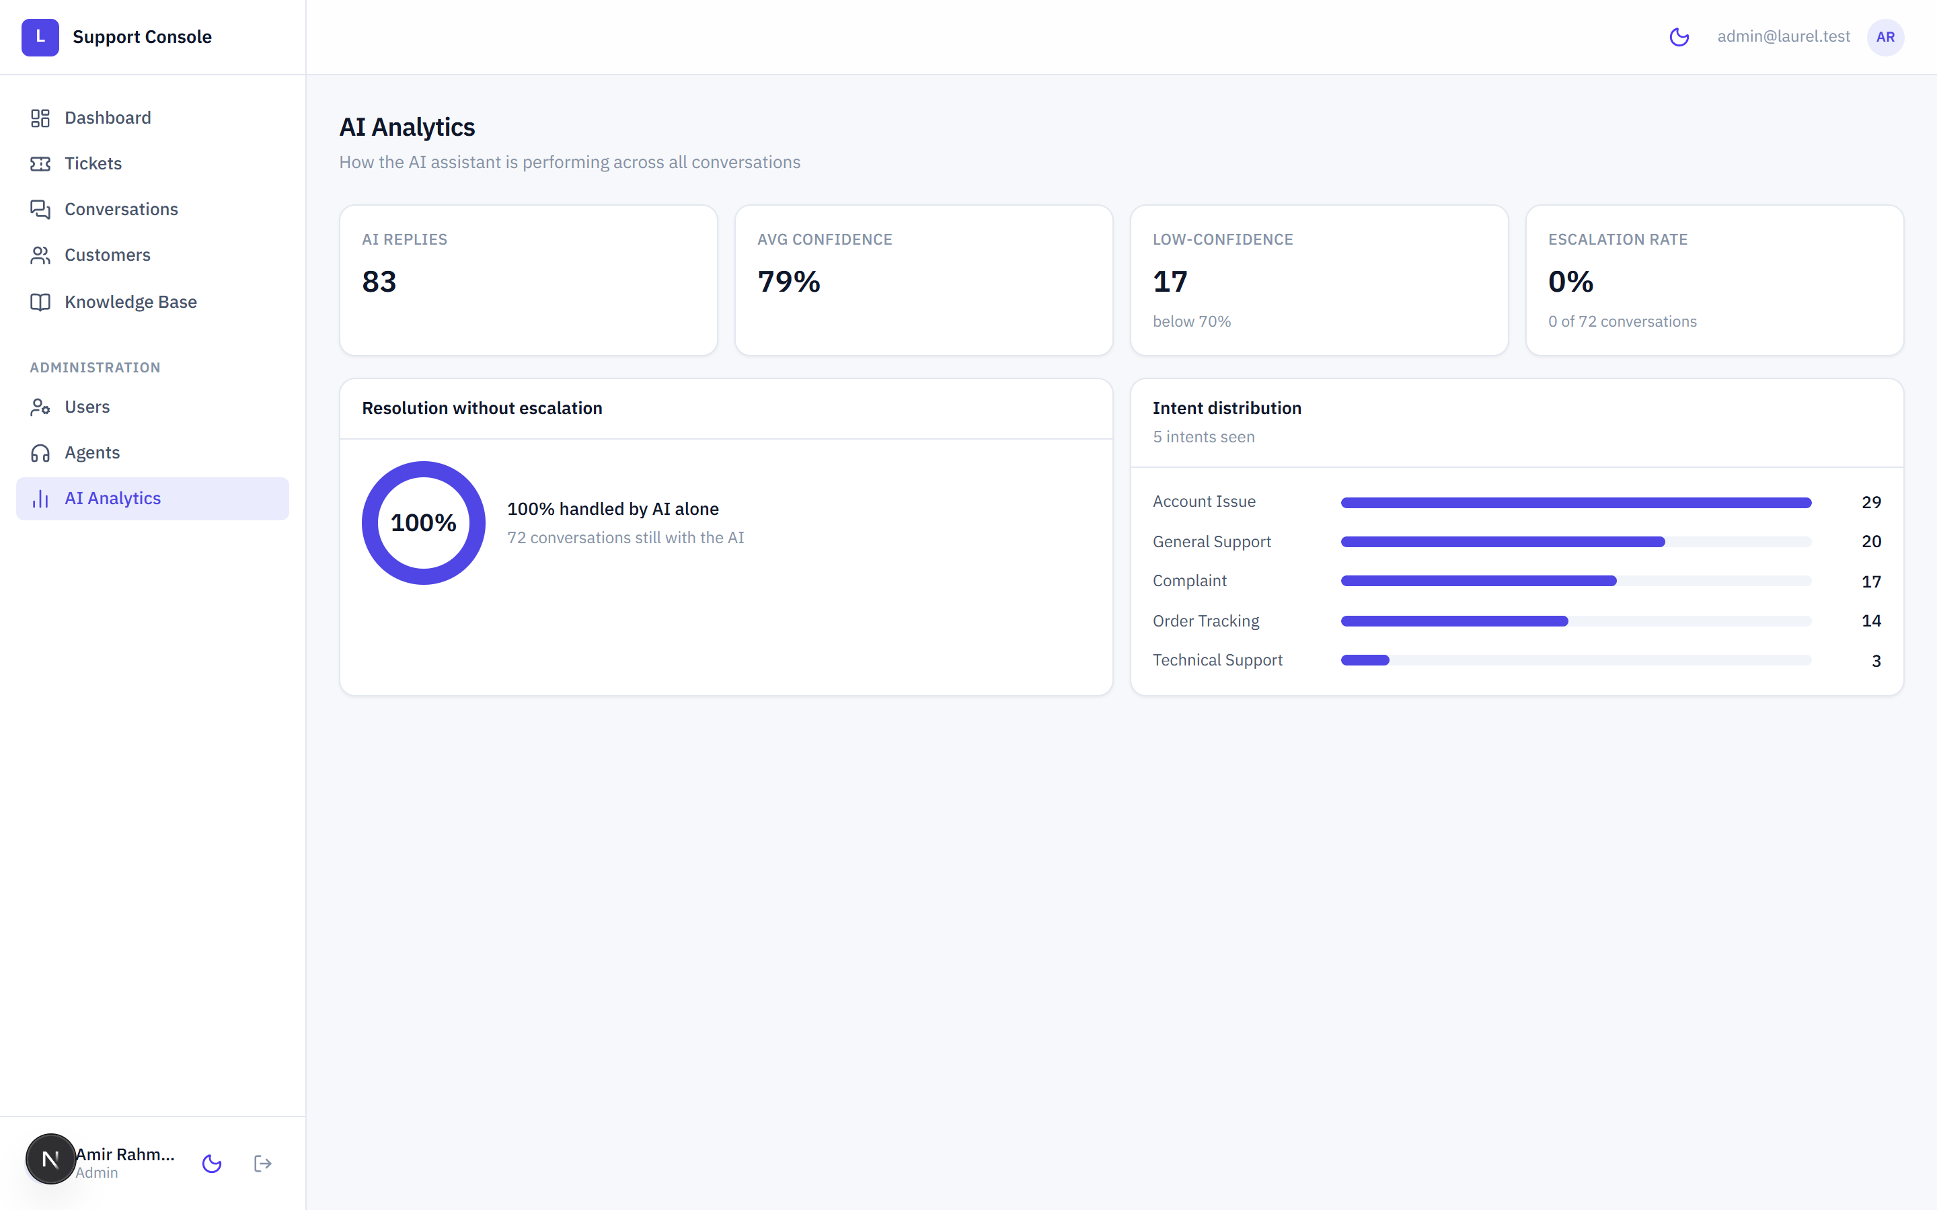
Figure 22: Web — assistant analytics.

7.5.10 Agent Management
Lists agents with their assigned workload, supporting distribution of tickets across the team.
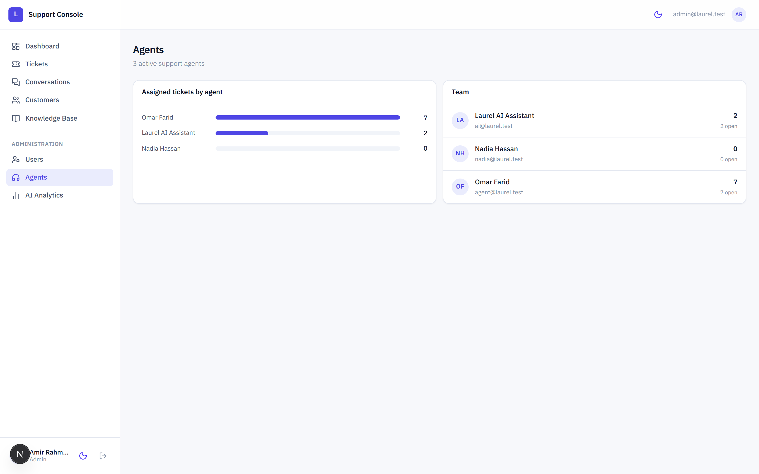
Figure 23: Web — agent management.

7.5.11 User Administration
Lists all accounts and allows an administrator to change a role or to activate and deactivate an account.
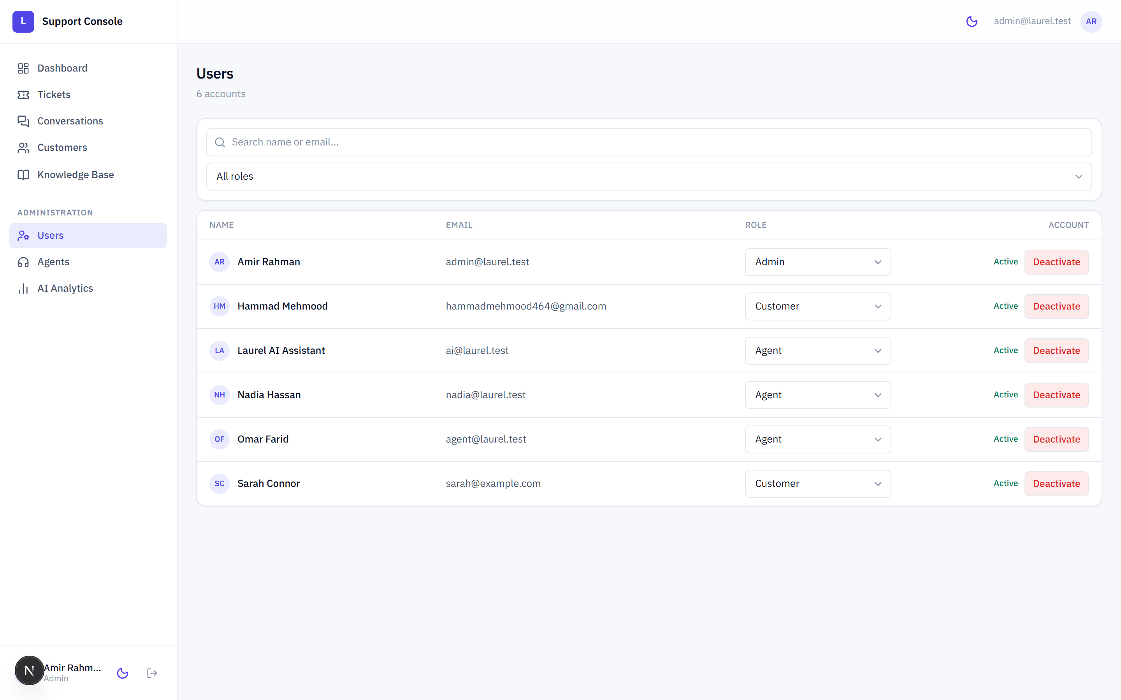
Figure 24: Web — user administration.

7.6 Components
- Shell. Navigation frame containing the primary navigation, the signed-in identity and the theme control.
- Page header. Consistent title, description and action area across pages.
- User interface primitives. Buttons, inputs, selects, badges, cards, empty states, error states and skeleton loaders used throughout.
- Count bars. Compact proportional visualisation used on the dashboard.
- Toast. Transient confirmation and error notifications raised by mutations.
- Theme toggle. Switches between light and dark presentation.
- Providers. Composes the query client, session context and theme context.

7.7 Authentication
The console authenticates against the same endpoint as the mobile application and retains the returned token in browser storage under a namespaced key. A session context exposes the current user and the authentication actions, and the authenticated layout acts as a guard, redirecting an unauthenticated visitor to the sign-in page. The API client attaches the token to every request, and an unauthorised response clears the session.

7.8 Backend and API Integration
All server interaction passes through a single typed client, so that the base address, authorisation header and error handling are defined once. The base address is read from an environment variable at build time, which allows the containerised build to target a different host without code modification.
export const API_BASE =
process.env.NEXT_PUBLIC_API_BASE ?? "http://localhost:8000/api/v1";
Every resource is exposed as a hook. Queries define their cache key and fetching function; mutations invalidate the affected keys on success so that dependent views refresh without manual coordination.

7.9 State Management
The console is dominated by server state, so no general-purpose client state container was introduced. TanStack Query provides caching, request deduplication, background refetching and mutation invalidation. The small amount of genuine client state — the active theme and the session — is held in React context. Component-local state is used for form fields and transient interface concerns.

7.10 Forms and Validation
Forms are controlled React components. Client-side validation prevents obviously invalid submissions, such as an empty reply or a missing required field, while the authoritative validation remains on the server. Server rejections are surfaced through the toast mechanism using the message returned by the API, so that the reason for a failure is specific.

7.11 Responsive Design
Layout is built with Tailwind's responsive utilities. The console is optimised for desktop use, which reflects how support staff work, and adapts to narrower viewports by collapsing multi-column arrangements. Wide content such as data tables scrolls within its own container so that the page itself never scrolls horizontally. Both light and dark themes are defined through the same token set, so a colour is never defined only for one theme.

7.12 Error Handling
- The API client normalises failures into typed errors carrying the message supplied by the backend.
- Query failures render a dedicated error state rather than an empty page.
- Loading states are represented by skeleton components that mirror the shape of the eventual content, which avoids layout shift.
- Mutation failures raise a toast and leave the form populated so that work is not lost.
- An unauthorised response clears the session and returns the user to sign-in.

7.13 Security
- No credential other than the bearer token is retained in the browser.
- The authenticated layout guards every staff route; direct navigation to a protected route without a session redirects to sign-in.
- Client-side guarding is treated as a usability measure only; authorisation is enforced by the backend on every request, so a manipulated client cannot gain access.
- Administrative operations are additionally restricted by role on the server.
- The WebSocket connection carries the same token and is subject to the same ownership rules.

7.14 Deployment
The console is configured for standalone output, which produces a self-contained server bundle suitable for a container image. The Docker Compose configuration builds the console with the API base address supplied as a build argument and runs it alongside the backend and the database. In development the console is served by the Next.js development server on port 3000.
[TO BE ADDED — production hosting target and domain configuration for the console.]

Chapter 8 — Database Design

8.1 Database Overview
The platform uses a single relational database accessed exclusively by the backend. Development uses SQLite for zero-configuration reproducibility, and the containerised deployment uses PostgreSQL. One set of SQLAlchemy models serves both engines, and embedding vectors are stored as portable JSON rather than an engine-specific vector type so that no model definition diverges between the two.
The schema contains seven application tables holding sixty columns. The figures quoted in this chapter were produced by introspecting the live development database rather than by reading the model definitions, so they describe the schema as actually created.

8.2 Entities
Table | Columns | Purpose
users | 10 | Every account in the system: customers, agents and administrators, with role, activation state and profile fields.
conversations | 7 | Chat threads. A null ticket reference identifies the customer's pure-assistant thread; a non-null reference identifies a live support thread.
messages | 9 | Individual turns within a conversation, including the assistant's intent classification, confidence and the knowledge-base citations behind an answer.
tickets | 11 | Support tickets with status, priority, category, customer and agent assignment.
ticket_messages | 8 | The ticket correspondence thread, including internal agent notes distinguished by a flag.
knowledge_documents | 8 | Source articles available to the retrieval pipeline, with an indexing status.
knowledge_chunks | 6 | Chunked article text with its 384-dimensional embedding vector.

The knowledge base in the delivered development database comprises 115 documents divided into 417 chunks.

8.3 Selected Attributes
The following tables record the columns of the three tables that carry the distinctive logic of the platform. A complete column-level export of all seven tables accompanies this report as described in Appendix C.

8.3.1 conversations
Column | Type | Null | Notes
id | INTEGER | No | Primary key.
customer_id | INTEGER | No | Foreign key to users.id.
status | VARCHAR(50) | No | Either 'active' or 'human_support'; the latter is set only by an explicit takeover.
ai_active | BOOLEAN | No | True while the assistant answers; set false only by an explicit takeover.
ticket_id | INTEGER | Yes | Null identifies the pure-assistant thread; otherwise links the live support ticket.
created_at | DATETIME | No | Creation timestamp.
updated_at | DATETIME | No | Last modification timestamp.

8.3.2 messages
Column | Type | Null | Notes
id | INTEGER | No | Primary key.
conversation_id | INTEGER | No | Foreign key to conversations.id.
sender_type | VARCHAR | No | One of customer, ai, agent or admin.
sender_name | VARCHAR | Yes | Display name captured at write time.
content | TEXT | No | Message body.
intent | VARCHAR | Yes | Assistant intent classification for the turn.
confidence | FLOAT | Yes | Assistant confidence in the unit interval.
sources | JSON | Yes | Knowledge-base citations supporting the answer.
created_at | DATETIME | No | Creation timestamp.

8.3.3 knowledge_chunks
Column | Type | Null | Notes
id | INTEGER | No | Primary key.
document_id | INTEGER | No | Foreign key to knowledge_documents.id.
chunk_index | INTEGER | No | Ordinal position of the chunk in its document.
content | TEXT | No | Chunk text of up to one thousand characters.
embedding | JSON | Yes | 384-dimensional vector; null until indexed.
created_at | DATETIME | No | Creation timestamp.

8.4 Relationships
From | To | Cardinality | Enforced
conversations.customer_id | users.id | Many to one | Yes
messages.conversation_id | conversations.id | Many to one | Yes
tickets.customer_id | users.id | Many to one | Yes
tickets.assigned_agent_id | users.id | Many to one | Yes
ticket_messages.ticket_id | tickets.id | Many to one | Yes
ticket_messages.sender_id | users.id | Many to one | Yes
knowledge_chunks.document_id | knowledge_documents.id | Many to one | Yes
conversations.ticket_id | tickets.id | One to one | No
tickets.conversation_id | conversations.id | One to one | No

Seven relationships are enforced by database foreign key constraints. The final two are maintained by the application: both columns are plain integer columns without a foreign key constraint, so referential integrity for the conversation-to-ticket link depends on application logic rather than on the database. This is recorded as a limitation in Chapter 12.

8.5 Entity Relationship Diagram
The entity relationship structure is presented as Figure 4 in Section 3.6.
[INSERT FORMAL ER DIAGRAM HERE — the schema export described in Appendix C can be loaded into a modelling tool to produce a rendered diagram.]

8.6 Indexing
Beyond primary and foreign key indexes, seven composite indexes were added to match the filter-and-order shapes actually issued by the list endpoints, so that the ordering is satisfied by the index rather than by a sort.
Index | Purpose
tickets(customer_id, updated_at) | A customer's tickets, most recent first.
tickets(status, updated_at) | Staff queue filtered by status.
messages(conversation_id, created_at) | Conversation replay in order.
ticket_messages(ticket_id, created_at) | Ticket thread in order.
conversations(customer_id, updated_at) | A customer's conversations.
conversations(updated_at) | Staff conversation list, most recent first.
knowledge_documents(status) | Active documents for retrieval.

8.7 Data Validation
- Column-level constraints declare nullability and length limits, and the email address column carries a unique index.
- Role, ticket status and ticket priority are enumerated types, restricting the permitted value set.
- Application-level validation through Pydantic rejects malformed payloads before they reach the data layer.
- Timestamps are populated by the model layer on insert and update rather than being supplied by clients.

8.8 Data Security
- Passwords are stored only as Argon2 hashes and the hash column is never serialised into a response.
- Access to rows is mediated entirely by the backend; no client holds a database credential.
- Customer-scoped queries are filtered by the authenticated caller's identity, so a customer cannot read another customer's tickets, conversations or messages.
- Internal agent notes are separated by a flag and excluded from customer-facing queries and broadcasts.

Chapter 9 — Testing

9.1 Testing Strategy
Testing concentrated on the backend, because the backend is where every business rule is enforced and is the component shared by both clients. The automated suite executes against a dedicated test database using the FastAPI test client, so tests exercise the real routing, validation, authentication and authorisation stack rather than calling functions directly. The generation provider is switched to the deterministic mock during testing, which makes assertions repeatable and removes any dependency on an external service or API quota.
Client behaviour was verified by a combination of static analysis, unit tests of the mobile business logic components, and manual end-to-end exercise of both clients against a running backend, with browser automation used to drive the interfaces and capture evidence.

9.2 Unit Testing
Unit tests cover pure logic in isolation, principally intent classification and response parsing on the backend, and the state components and model mapping on the mobile application. Table 19 records the automated backend suite as executed.
Test Module | Focus | Test Functions
test_intent_classification.py | Intent classification across the permitted vocabulary and defensive parsing of model responses | 13
test_rag_retrieval.py | Retrieval quality, ranking and the minimum-score threshold | 5
test_api_rag_flow.py | End-to-end assistant flow through the API, including assistant-surface purity | 5
test_auth_endpoints.py | Registration, sign-in, token handling and profile operations | 4
test_security_rbac_idor.py | Role-based access control and prevention of insecure direct object reference | 1
test_ticket_lifecycle.py | Ticket creation, correspondence and status transition | 1
test_live_agent_sync.py | Live support routing, assistant first response and explicit takeover | 2
test_websocket.py | Handshake authentication, room joining and broadcast delivery | 5
test_rate_limiting_and_uploads.py | Rate limit enforcement and knowledge document upload | 4

Executing the complete suite yields 62 collected tests, of which 61 pass and 1 is skipped. The skipped test is conditional on a second demonstration customer being present in the seeded data and is skipped by design when that account is absent.
$ python -m pytest
....s......................................................... [100%]
SKIPPED [1] tests/test_api_rag_flow.py: second demo customer not seeded
61 passed, 1 skipped in 28.64s
Mobile unit tests reside in the application's test directory and cover the authentication component, the ticket component and the ticket model.
[TO BE ADDED — recorded execution output of the Flutter test suite.]

9.3 Integration Testing
Integration tests exercise multiple layers together through the HTTP surface. They confirm that a ticket created by a customer appears in the staff queue, that an agent reply is mirrored into the linked conversation, that an internal note does not reach the customer, that a live support conversation is distinct from the assistant conversation, and that the assistant continues to answer in a support thread until an explicit takeover occurs.

9.4 System Testing
System testing exercised the complete stack with all three services running concurrently: the backend on port 8000, the staff console on port 3000 and the mobile web build on port 8080. Table 20 records the system test cases.
Test ID | Module | Test Case | Input | Expected Result | Actual Result | Status
ST-01 | Mobile — Auth | Sign in with valid customer credentials | Registered email and password | Session established; home dashboard shown | As expected | Pass
ST-02 | Mobile — Auth | Sign in with an incorrect password | Valid email, wrong password | Specific rejection message; no session | As expected | Pass
ST-03 | Mobile — Auth | Restore session after application restart | Existing stored token | Session restored from the server; home shown | As expected | Pass
ST-04 | Mobile — Assistant | Ask a documented support question | "How do I reset my password?" | Grounded answer with intent, confidence and citation | Answer returned with intent Account Issue, 90% confidence and a cited article | Pass
ST-05 | Mobile — Assistant | Replay history after reopening the assistant | Existing conversation | Previous turns and their metadata are restored | As expected | Pass
ST-06 | Mobile — Assistant | Send a message and confirm single rendering | One message | Message appears exactly once despite the socket echo | As expected | Pass
ST-07 | Mobile — Tickets | Create a support ticket | Subject, description, category, priority | Ticket created with an initial message and listed for the customer | As expected | Pass
ST-08 | Mobile — Tickets | Reply within a ticket thread | Reply text | Reply persisted and visible to staff | As expected | Pass
ST-09 | Backend — Security | Access another customer's conversation | Foreign conversation identifier | Request refused with 403 | As expected | Pass
ST-10 | Backend — Security | Exceed the authentication rate limit | More than 15 sign-in attempts in one minute | 429 returned with a Retry-After header | As expected | Pass
ST-11 | Backend — Assistant | Assistant surface resists agent takeover | Takeover request on an assistant conversation | Request refused with 400; assistant continues to answer | As expected | Pass
ST-12 | Backend — Assistant | Assistant answers despite a stale inactive flag | ai_active set false directly in the database | Assistant still answers on the assistant surface | As expected | Pass
ST-13 | Backend — Live support | Assistant remains first responder | Agent replies on the ticket without taking over | Assistant continues to answer the customer | As expected | Pass
ST-14 | Backend — Live support | Explicit takeover transfers ownership | Agent invokes takeover | Assistant withdraws; customer messages routed to the human | As expected | Pass
ST-15 | Backend — Live support | Hand-back restores the assistant | Agent invokes hand-back | Assistant resumes answering | As expected | Pass
ST-16 | Real-time | Message broadcast to a connected client | Message posted over REST while a socket is open | new_message event delivered to the room | As expected | Pass
ST-17 | Real-time | Internal note withheld from the customer | Agent posts an internal note | No event delivered to the customer connection | As expected | Pass
ST-18 | Web — Auth | Staff sign-in | Administrator credentials | Console opened at the dashboard | As expected | Pass
ST-19 | Web — Tickets | Open a ticket from the queue | Row selection | Ticket detail with the full thread | As expected | Pass
ST-20 | Web — Conversations | View assistant citations | Open a conversation containing assistant answers | Intent, confidence and source chips displayed | As expected | Pass
ST-21 | Integration | Ticket raised on mobile appears in the staff queue | Ticket created on the mobile application | Ticket present in the console queue | As expected | Pass
ST-22 | Integration | Agent reply reaches the customer | Agent replies in the console | Reply visible in the mobile ticket thread | As expected | Pass
ST-23 | Reliability | Provider quota exhausted | Language model provider returns 429 | Local extractive answer returned; no request failure | As expected | Pass

9.5 User Interface Testing
Interface behaviour was verified by driving both clients in a browser with an automation tool and capturing the rendered result. Because the mobile application renders to a canvas in its web build, its interface was driven by coordinate interaction and verified by inspecting the captured images rather than by querying a document object model. The screenshots reproduced in Chapter 5, Chapter 7 and Chapter 10 were obtained in this way against the live system.
Static analysis of the mobile codebase was run as part of the verification cycle and reports no issues.

9.6 API Testing
The API was exercised both by the automated suite through the test client and manually through the interactive documentation served at /docs, which permits an authenticated operator to invoke any endpoint and inspect the response. Additional scripted verification was used to confirm real-time delivery, by opening a WebSocket connection, issuing a REST request and asserting on the frames received.

9.7 User Acceptance Testing
[TO BE ADDED — record of user acceptance testing with representative users, including participant profile, tasks assigned, observations and the acceptance decision.]

Chapter 10 — Results and Screenshots
This chapter records the delivered system as executed. All screenshots were captured from the running platform with the backend on port 8000, the staff console on port 3000 and the mobile application on port 8080.

10.1 Mobile Application Results
The mobile application delivers the complete customer journey. Authentication, the assistant conversation with grounded and cited answers, live support with assistant first response, ticket creation and threaded correspondence, alerts and profile management are all implemented and operational. Figures 5 to 12 in Chapter 5 present these screens.
The most significant result is shown in Figure 10: a customer question is answered from the knowledge base and the answer is accompanied by its classified intent, a confidence percentage and the article on which it was based. This is the visible outcome of the retrieval-augmented pipeline and the property that distinguishes the assistant from an ungrounded chatbot.

10.2 Backend Results
The backend exposes 55 REST endpoints and 2 WebSocket endpoints, documented automatically and served interactively as shown in Figure 13. The knowledge base holds 115 documents divided into 417 embedded chunks. Retrieval latency after the index-caching optimisation is approximately 80 milliseconds, reduced from approximately 300 milliseconds. The automated suite reports 61 passing tests with 1 skipped.

10.3 Web Application Results
The staff console implements twelve routes covering the operations dashboard, ticket queue and detail, conversation list and detail, customer directory and detail, knowledge base management, analytics, agent management and user administration, in both light and dark themes. Figures 14 to 24 in Chapter 7 present these pages.

10.4 Integration Results
Integration across the three components was verified end to end against the running stack. The following behaviours were confirmed:
- A ticket created on the mobile application is immediately present in the staff queue, and an agent reply in the console becomes visible in the mobile ticket thread.
- An internal note recorded by an agent is not delivered to the customer through either the REST surface or the WebSocket channel.
- A message posted over REST is delivered to every client connected to the corresponding room, confirmed by opening a socket and asserting on the frames received.
- The customer's assistant conversation survives the opening of a live support session; the two threads remain distinct and history is not absorbed.
- The assistant continues to answer in a live support thread until an agent explicitly takes it over, and resumes when the conversation is handed back.
- Messages are rendered exactly once on the mobile application despite arriving both in the HTTP response and over the socket.
Cross-surface verification of the assistant, escalation and real-time behaviour was carried out as part of the integration responsibility described in Section 1.9.

Chapter 11 — Challenges and Solutions
This chapter records the substantive engineering problems encountered during development and the manner in which each was resolved. Each is presented as problem, cause, solution and result.

11.1 Retrieval Latency Growing with the Knowledge Base
Problem: Assistant responses carried a consistent delay attributable to retrieval, and the delay increased as the knowledge base grew.
Cause: Every query loaded all stored embeddings from the database and decoded them from JSON. Measurement attributed approximately 250 milliseconds of a 300-millisecond search to decoding alone, a cost linear in corpus size.
Solution: The normalised embedding matrix is assembled once and cached in memory, keyed on an inexpensive signature of the corpus. Any change to the corpus alters the signature and triggers an automatic rebuild, so no manual invalidation is required. Top-k selection was changed from a full sort to a partial selection.
Result: Retrieval latency fell to approximately 80 milliseconds and no longer scales with the number of stored chunks. Cache invalidation was verified by archiving and restoring a document and observing the chunk count change and return.

11.2 Schema Divergence Between Development and Deployment
Problem: The containerised deployment would have failed on first use, although development on SQLite worked correctly.
Cause: The embedding column was declared not-null in the migration but nullable in the model. Ingestion inserts chunks before embedding them. The development database is created from the models, where the column is nullable, so the defect was invisible; any database created by migration would reject the first document. It was further established that the migration chain had never been executed, so no environment had exercised it.
Solution: The defect was reproduced with a failing insert, the migration was corrected to make the column nullable, and the full chain was executed from an empty database.
Result: The migration chain applies cleanly and produces a schema consistent with the models, removing a failure that would otherwise have appeared only at deployment.

11.3 Real-Time Updates Never Reaching Clients
Problem: The real-time layer existed on all three components but no client ever received an event.
Cause: The endpoints that publish events are synchronous functions, which the web framework executes in a worker thread. The publishing helper obtained the running event loop, an operation that raises in a worker thread, and the resulting exception was caught by a handler that discarded it silently. Every broadcast in the system was therefore lost.
Solution: The publication mechanism was changed to schedule the broadcast through the framework's background task facility, which returns the coroutine to the main event loop.
Result: Broadcasts are delivered. The result was confirmed by connecting a client, issuing a REST request and observing the frames received. Two further defects became visible once events flowed: the customer's own message was never published, so a staff member observing a conversation saw only assistant replies; and event payloads omitted the identifiers of the conversation and ticket. Both were corrected.

11.4 Duplicate Rendering of Messages
Problem: After real-time delivery began working, each message sent from the mobile application appeared twice.
Cause: The application displayed the message optimistically and then appended the copy echoed by the server. A guard intended to prevent this compared timestamps within a five-second window, but the server records time in Coordinated Universal Time without a zone designator, which the client parsed as local time. On a device offset from Coordinated Universal Time the window could never match, and the identifier comparison failed because the optimistic copy had no server-assigned identifier.
Solution: Zone-less timestamps are now interpreted as Coordinated Universal Time and converted for display. Reconciliation is performed on the server-assigned identifier, with a fallback that replaces the pending optimistic entry in place. Ownership of the message collection was moved to the repository so that a single collection is reconciled.
Result: Each message renders exactly once, verified by driving the application against the live backend. The timestamp correction additionally removed a visible display error in which server-originated messages showed times several hours adrift.

11.5 Loss of the Assistant Conversation on Escalation
Problem: Opening a live support session caused the customer's assistant conversation history to disappear, and assistant messages appeared inside a support ticket thread.
Cause: The live-support routine selected the customer's most recently updated conversation of any kind, which was ordinarily the assistant thread, and attached a ticket to it. Because the assistant thread is identified by the absence of a ticket, it could no longer be found, and a new empty thread was created in its place.
Solution: The distinction between the two surfaces was made explicit and enforced. Live support considers only conversations that already carry a ticket and otherwise creates its own; a takeover is refused on an assistant conversation; and the message endpoint answers an assistant conversation with the assistant irrespective of any stale flag.
Result: The assistant conversation is preserved when a live session is opened, and the two surfaces remain independent. The behaviour was confirmed by scripted verification of the complete sequence.

11.6 A Single Agent Reply Silencing the Assistant Permanently
Problem: In a support conversation, once an agent had replied even once, the assistant stopped responding permanently and the customer received only an acknowledgement that the message had been delivered.
Cause: An agent reply was treated as an implicit takeover and set the conversation to human ownership. A brief acknowledgement such as a request to wait therefore left the customer without any responder until the agent returned.
Solution: Ownership is now transferred only by the explicit takeover operation. An agent reply no longer changes ownership, and the status broadcast that accompanied it was corrected to report the true state rather than a fixed value. Existing records carrying the previous meaning of the status were reset so that the new default applied to them.
Result: The assistant remains the first responder until an agent deliberately assumes control, and resumes on hand-back. The full sequence of fresh ticket, agent reply, takeover and hand-back was verified against the running system.

11.7 Fabricated Content in the Mobile Interface
Problem: The mobile ticket detail presented an agent reply and a progress timeline for every ticket, including tickets on which no agent had acted.
Cause: The screen generated placeholder correspondence and timeline entries locally instead of reading them from the server. In addition, the reply composer appended to a local list only, so a customer's reply never reached the server and an agent's reply never reached the customer.
Solution: The thread and the timeline were connected to the ticket message endpoints, and the timeline was restricted to facts the ticket actually records. Comparable placeholder content was removed from the alerts screen, the home dashboard and the ticket creation confirmation.
Result: The interface now reflects the true state of each ticket, and correspondence travels in both directions. Verification confirmed that an agent reply reaches the customer while an internal note remains hidden.

11.8 Language Model Quota Exhaustion
Problem: Assistant answers degraded to verbatim extracts of knowledge-base text rather than composed prose.
Cause: The provider's free tier permits a limited number of requests per day per model, and the allocation had been consumed. The system was operating entirely on its local fallback answerer.
Solution: The fallback behaviour was retained, since answering from retrieved content is preferable to failing. The configured model was changed to one with a separate quota allocation, and the extractive fallback was improved so that a passage beginning mid-sentence is trimmed to a sentence boundary.
Result: Composed answers resumed, and the degraded path now produces readable prose. The episode confirmed the value of the fallback design: the platform remained usable throughout the outage.

11.9 Session State Persisting Across Accounts
Problem: The server log recorded repeated refused connection attempts to a conversation belonging to a different account.
Cause: Conversation state held by the chat repository was never cleared on sign-out, so the next account to sign in on the same device inherited the previous account's conversation identifier and repeatedly attempted a connection it could not be granted. The reconnection routine retried indefinitely because it did not distinguish a permanent refusal from a transient disconnection.
Solution: Sign-out now clears conversation state, and the reconnection routine stops on close codes indicating a permanent condition and applies a ceiling to consecutive attempts.
Result: The refused connections ceased and account separation on a shared device is correct.

11.10 Absent Query Indexes
Problem: List endpoints filtered and ordered on the same column pairs without supporting indexes.
Cause: The schema declared only primary and foreign key indexes; the composite shapes actually issued by the list queries were unsupported, requiring a sort on every request.
Solution: Seven composite indexes were added matching the real query shapes, and their use was confirmed by inspecting the query execution plan.
Result: List queries are satisfied by index order, and the ordering no longer requires a separate sort step.

Chapter 12 — Limitations
The following limitations of the delivered implementation are recorded candidly. Each is a known and deliberate boundary of the current work rather than an undiscovered defect.
- Unenforced referential integrity on one link. The conversation-to-ticket association is maintained by application logic; the two columns involved carry no foreign key constraint, so the database does not prevent a reference to a non-existent row.
- Enumerated values stored as names. The object-relational mapper persists the name of an enumeration member rather than its value, so a column contains ADMIN or IN_PROGRESS where the application interface presents admin or in_progress. The interface behaves correctly because access is mediated by the enumeration, but direct queries and reporting tools observe the upper-case form. Correcting this requires a data migration.
- No pagination. List endpoints return complete result sets. This is acceptable at the volumes handled during development but will not scale; the knowledge document listing already returns over one hundred rows in a single response.
- Language model quota dependence. The configured provider's free tier limits daily requests per model. When the allocation is exhausted the system continues to operate through its local extractive answerer, but the quality of composed prose is reduced.
- Customer view of agent identity. Ticket payloads carry only the identifier of the assigned agent, and the staff directory is restricted to staff, so the customer application presents a generic support identity rather than an agent's name.
- No push notifications. Notification services were excluded from scope. A customer is informed of activity while the application is open, through the real-time channel and the alerts screen, but not while it is closed.
- Access tokens without refresh. The backend issues access tokens only. A refresh token field is present in the client storage layer but no refresh flow is implemented, so a session ends when the token expires.
- Single-process real-time state. The WebSocket connection manager holds room membership in the memory of one process. A multi-process or multi-instance deployment would require a shared broker to broadcast across instances.
- Container stack not executed. The Docker Compose configuration and images are defined and the migration chain has been validated, but a full container build was not executed on the development machine because Docker was not installed on it.
- English only. The knowledge base, the embedding model and the assistant operate in English; no multilingual capability is provided.
- Concurrent responders. Because ownership transfers only on explicit takeover, an agent who replies without taking the conversation over may find the assistant answering alongside them. This is the intended behaviour, chosen so that a customer is never left unattended, but it is a trade-off rather than a costless property.

Chapter 13 — Future Enhancements
The enhancements below are proposals for subsequent work. None of them is present in the delivered system.

13.1 Already Implemented (for reference)
- Retrieval-augmented answering with intent classification, confidence scoring and source citation.
- Separation of the pure-assistant surface from live support, with explicit takeover and hand-back.
- Full ticket lifecycle with threaded correspondence and internal notes.
- Real-time delivery of messages and status changes over WebSocket.
- Role-based access control, rate limiting and security headers.
- Knowledge base ingestion, chunking, local embedding and cached similarity search.
- An automated backend regression suite and a containerised deployment definition.

13.2 Proposed Future Work
- Pagination and cursor-based listing. Introduce bounded page sizes on all list endpoints, with corresponding infinite scrolling in both clients.
- Approximate nearest-neighbour search. Replace exhaustive cosine comparison with an indexed vector search, for example the pgvector extension, once the corpus outgrows in-memory comparison.
- Push notifications. Integrate a notification service so that customers are informed of agent replies while the application is closed.
- Refresh token flow. Issue refresh tokens alongside access tokens so that sessions can be extended without re-authentication.
- Distributed real-time state. Move room membership to a shared broker so the service can be scaled beyond a single process.
- Foreign key constraints on the conversation-to-ticket link. Add the missing constraints by migration so referential integrity is enforced by the database.
- Enumeration storage correction. Persist enumeration values rather than names, with a data migration for existing rows.
- Agent display names for customers. Embed the assigned agent's display name in ticket payloads so the customer application can identify the person handling the case.
- Multilingual support. Adopt a multilingual embedding model and translate the knowledge base to serve customers in additional languages.
- Answer quality feedback. Capture explicit customer feedback on assistant answers and use it to prioritise knowledge base improvement.
- Automated knowledge gap detection. Aggregate questions that retrieved no passage above the similarity threshold to identify documentation that should be written.
- Customer-visible agent presence. Indicate when an agent is actively viewing or composing within a conversation.
- Extended client test automation. Add end-to-end interface test suites for both clients to complement the backend regression suite.

Chapter 14 — Conclusion
This project set out to address a concrete operational problem in customer support: the consumption of scarce human agent capacity by repetitive questions whose answers are already documented, with the consequent effect on waiting times for every customer.
The delivered solution is an AI-Powered Customer Support Platform composed of three integrated components: a Flutter mobile application serving as the customer channel, a Next.js console serving support agents and administrators, and a FastAPI backend exposing 55 REST endpoints and 2 WebSocket endpoints over a shared relational database of seven tables. The components communicate exclusively through the backend, which is the sole authority for business rules and the only component with database access.
The distinguishing characteristic of the system is that its assistant is grounded rather than generative in isolation. Customer questions are embedded locally with a 384-dimensional sentence-embedding model and matched by cosine similarity against a knowledge base of 115 documents divided into 417 chunks. Retrieved passages constrain the language model, and every answer is returned with its classified intent, a confidence score and citations of the articles relied upon, so that a customer can judge how much weight to place on it and a reviewing agent can audit it.
Equal attention was given to the boundary between automation and human control. The assistant conversation is architecturally protected and cannot be converted into a support session or silenced by an agent. Within live support the assistant acts as first responder and yields only when an agent explicitly takes the conversation over, an action that is reversible. This design ensures both that a customer is never left without a responder and that a human retains ultimate authority.
The engineering outcome is supported by evidence rather than assertion. An automated suite of 62 tests exercises authentication, access control, the ticket lifecycle, retrieval quality, intent classification and real-time delivery, of which 61 pass and 1 is skipped by design. Retrieval latency was reduced from approximately 300 milliseconds to approximately 80 milliseconds by a measured optimisation. Defects that would have surfaced only in deployment, including a schema divergence that would have failed the container stack on first use and a real-time layer whose every broadcast was silently discarded, were identified and corrected before submission.
The project also demonstrates effective division of responsibility within a team. The backend, the mobile application and the web console were developed by separate members against a shared, automatically generated API contract, with integration verified end to end across all three surfaces.
Its significance is twofold. Practically, it presents a deployable pattern for reducing first-line support workload without removing human judgement from the process. Academically, it integrates information retrieval, applied natural language processing, real-time distributed communication, relational data modelling, cross-platform mobile development, modern web engineering and secure API design within one coherent system, and applies professional practices including automated regression testing, migration management, measured optimisation and defensive degradation under third-party failure.
The limitations recorded in Chapter 12 and the enhancements proposed in Chapter 13 define a clear path for continued development, but the system as delivered meets the objectives established in Section 1.4 and functions as an integrated whole.

References
- Anthropic. Anthropic API Documentation. Available at: https://docs.anthropic.com [Accessed 2026].
- Bai, J. et al. ONNX: Open Neural Network Exchange. Available at: https://onnx.ai [Accessed 2026].
- Beijing Academy of Artificial Intelligence. BGE: BAAI General Embedding — bge-small-en-v1.5. Available at: https://huggingface.co/BAAI/bge-small-en-v1.5 [Accessed 2026].
- Docker Inc. Docker Compose Documentation. Available at: https://docs.docker.com/compose [Accessed 2026].
- Google. Gemini API Documentation. Available at: https://ai.google.dev/docs [Accessed 2026].
- Google. Flutter Documentation. Available at: https://docs.flutter.dev [Accessed 2026].
- Google. Dart Language Documentation. Available at: https://dart.dev/guides [Accessed 2026].
- Harris, C. R. et al. (2020). Array programming with NumPy. Nature, 585, pp. 357-362.
- Internet Engineering Task Force (2015). RFC 7519: JSON Web Token (JWT).
- Internet Engineering Task Force (2011). RFC 6455: The WebSocket Protocol.
- Internet Engineering Task Force (2012). RFC 6749: The OAuth 2.0 Authorization Framework.
- Internet Engineering Task Force (2021). RFC 9106: Argon2 Memory-Hard Function for Password Hashing and Proof-of-Work Applications.
- Lewis, P. et al. (2020). Retrieval-Augmented Generation for Knowledge-Intensive NLP Tasks. Advances in Neural Information Processing Systems, 33.
- Meta Platforms. React Documentation. Available at: https://react.dev [Accessed 2026].
- Microsoft. TypeScript Documentation. Available at: https://www.typescriptlang.org/docs [Accessed 2026].
- OpenAPI Initiative. OpenAPI Specification. Available at: https://spec.openapis.org [Accessed 2026].
- Open Worldwide Application Security Project. OWASP Top Ten. Available at: https://owasp.org/www-project-top-ten [Accessed 2026].
- Pydantic. Pydantic Documentation. Available at: https://docs.pydantic.dev [Accessed 2026].
- Qdrant. FastEmbed Documentation. Available at: https://qdrant.github.io/fastembed [Accessed 2026].
- Ramírez, S. FastAPI Documentation. Available at: https://fastapi.tiangolo.com [Accessed 2026].
- Reimers, N. and Gurevych, I. (2019). Sentence-BERT: Sentence Embeddings using Siamese BERT-Networks. Proceedings of EMNLP-IJCNLP 2019.
- SQLAlchemy. SQLAlchemy 2.0 Documentation. Available at: https://docs.sqlalchemy.org [Accessed 2026].
- SQLAlchemy. Alembic Documentation. Available at: https://alembic.sqlalchemy.org [Accessed 2026].
- Tailwind Labs. Tailwind CSS Documentation. Available at: https://tailwindcss.com/docs [Accessed 2026].
- TanStack. TanStack Query Documentation. Available at: https://tanstack.com/query [Accessed 2026].
- Vercel. Next.js Documentation. Available at: https://nextjs.org/docs [Accessed 2026].
- Vaswani, A. et al. (2017). Attention Is All You Need. Advances in Neural Information Processing Systems, 30.

Appendix A — Mobile Application Screenshots
The screenshots reproduced below were captured from the running mobile application executing against the live backend. Additional screens are presented in Chapter 5.

Figure A.1: Home dashboard.

Figure A.2: Ticket list.

Figure A.3: Assistant answer with intent, confidence and citation.

Figure A.4: Live agent conversation.

Figure A.5: Profile and account.
[TO BE ADDED — screenshots of the Create Ticket screen, the Notifications screen and the Knowledge screen.]

Appendix B — API Documentation
The complete and authoritative interface specification is generated by the backend and served at /docs while the service is running, as reproduced in Figure 13. The machine-readable specification is available at /openapi.json. A tabulated summary of all 55 REST endpoints and 2 WebSocket endpoints is presented in Section 6.8.
Representative request and response payloads are shown below.
B.1 Sign-in request and response
POST /api/v1/auth/login
Content-Type: application/x-www-form-urlencoded
username=customer@example.com&password=********
200 OK
{
"access_token": "<jwt>",
"token_type": "bearer",
"user": { "id": 4, "name": "...", "email": "...",
"role": "customer", "is_active": true }
}
B.2 Assistant message request and response
POST /api/v1/conversations/{conversation_id}/messages
Authorization: Bearer <jwt>
Content-Type: application/json
{ "content": "How do I reset my password?" }
200 OK
{
"customer_message": { "id": 342, "sender_type": "customer", ... },
"ai_message": {
"id": 343, "sender_type": "ai",
"content": "To reset your password, ...",
"intent": "account_issue", "confidence": 0.9,
"sources": [ { "document_id": 12,
"title": "Resetting a Forgotten Computer Password",
"score": 0.8406, "snippet": "..." } ]
},
"sources": [ ... ],
"escalated": false
}
B.3 Real-time event payload
WebSocket /api/v1/ws/conversations/{conversation_id}?token=<jwt>
{
"event": "new_message",
"conversation_id": 116,
"ticket_id": null,
"message": { "id": 343, "sender_type": "ai",
"content": "...", "intent": "account_issue",
"confidence": 0.9, "sources": [ ... ],
"created_at": "2026-09-05T08:17:38" }
}

Appendix C — Database Schema
A machine-readable export of the schema accompanies the project in the docs/schema directory. It was produced by introspecting the live database rather than by reading the model definitions, and therefore records the schema as actually created.
File | Contents
schema_tables.csv | One row per table, with column count, row count, primary key, index count and description.
schema_columns.csv | One row per column across all seven tables: data type, nullability, key participation, referenced table and column, index membership, uniqueness and default value.
schema_relationships.csv | One row per relationship, with cardinality and whether the database enforces it.
database_tables.xlsx | One worksheet per table, for loading into a modelling or reporting tool. Password hashes and embedding vectors are excluded.

The schema summary is presented in Chapter 8. Two scripts in backend/scripts regenerate these exports from the current database.

Appendix D — Important Code Snippets
D.1 Similarity search over the cached embedding index
def search(db, query, top_k=None):
index = _load_index(db) # cached normalised matrix
matrix = index['matrix']
if matrix is None:
return []
q_vec = np.asarray(_embed_query(query), dtype=np.float32)
q_vec /= np.linalg.norm(q_vec) + 1e-9
scores = matrix @ q_vec # cosine similarity, whole corpus
k = min(top_k, scores.shape[0])
top = np.argpartition(scores, -k)[-k:]
order = top[np.argsort(scores[top])[::-1]]
return [{**index['meta'][int(i)],
'score': round(float(scores[i]), 4)} for i in order]
D.2 Escalation decision
return {
'response': response.strip(),
'intent': intent,
'confidence': confidence,
# Hand off when the model is unsure, or whenever it is a complaint -
# an unhappy customer should always be able to reach a human.
'should_escalate': confidence < CONFIDENCE_THRESHOLD
or intent == 'complaint',
}
D.3 Protecting the assistant surface
def _live_conversation_for(db, customer_id):
"""The customer's live-support conversation, created if absent.
Only conversations that already carry a ticket are candidates, so the
Ask AI thread can never be hijacked into live support.
"""
conversation = (
db.query(Conversation)
.filter(Conversation.customer_id == customer_id,
Conversation.ticket_id.isnot(None))
.order_by(Conversation.updated_at.desc())
.first()
)
if conversation is None:
conversation = Conversation(customer_id=customer_id,
status='active', ai_active=True)
db.add(conversation)
db.flush()
return conversation
D.4 Publishing a real-time event from a synchronous endpoint
# These endpoints are sync (`def`), so FastAPI runs them in a worker
# thread where there is no running event loop - asyncio.get_running_loop()
# raises there and the broadcast is lost. BackgroundTasks hands the
# coroutine back to the main loop, and runs it after the response is sent.
background_tasks.add_task(
ws_manager.broadcast_conversation_and_ticket,
conversation_id,
ticket_id,
payload,
)
D.5 Platform-aware API base address (mobile)
static const String _override = String.fromEnvironment('API_BASE_URL');
static String get baseUrl {
if (_override.isNotEmpty) return _override;
if (kIsWeb) return 'http://127.0.0.1:8000/api/v1';
if (defaultTargetPlatform == TargetPlatform.android) {
return 'http://10.0.2.2:8000/api/v1';
}
return 'http://127.0.0.1:8000/api/v1';
}

Appendix E — Additional Diagrams
The diagrams referenced below appear in the body of the report:
- Figure 1 — Overall system architecture (Section 3.1).
- Figure 2 — Retrieval-augmented generation request flow (Section 3.3).
- Figure 3 — Mobile application navigation structure (Section 3.5).
- Figure 4 — Entity relationship diagram (Section 3.6).
- Backend request pipeline (Section 6.2).
[TO BE ADDED — formally rendered versions of the architecture and entity relationship diagrams, produced with a diagramming tool for final submission.]

Appendix F — Running the System
The following configuration was used for development and for the capture of the evidence presented in this report.
Service | Port | Address | Command
Backend API | 8000 | http://localhost:8000 | python -m uvicorn app.main:app --port 8000
Interactive API documentation | 8000 | http://localhost:8000/docs | —
Staff web console | 3000 | http://localhost:3000 | npm run dev
Mobile application (web build) | 8080 | http://localhost:8080 | flutter run -d web-server --web-port=8080

Scripts at the repository root start and stop the complete stack: run_all.bat or run_all.ps1 to start, and stop_all.bat or stop_all.ps1 to terminate.
Demonstration accounts created by the seeding routine:
Role | Email | Purpose
Administrator | admin@laurel.test | Full console access including user administration and analytics.
Agent | agent@laurel.test | Ticket triage, replies and conversation takeover.
Agent | nadia@laurel.test | Second agent, used for workload distribution.
Customer | sarah@example.com | Mobile application demonstration account.
Customer | james@example.com | Second customer account.
Customer | maria@example.com | Third customer account.

Demonstration passwords are defined in the seeding routine at backend/app/seed.py. They are development credentials only and must be changed before any deployment beyond a local machine.

