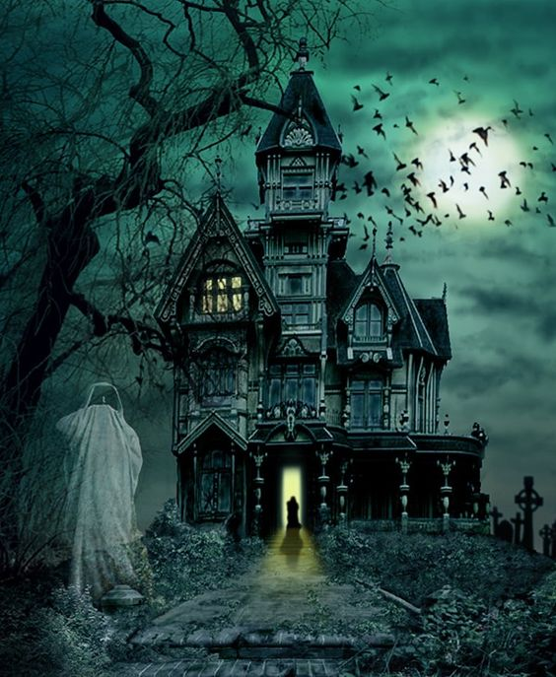

The House

Contents

Game Summary 1

Product Summary 8

# Game Summary

## High Concept

The house has been lived in. The mistake has been made.

## Premise and Story Synopsis

You begin the game by choosing your character. Playing as one half of a pair of twins, you may choose between Alex and Anne Russell.

Your character has received a puzzling letter from an estranged sibling. In it, you have been asked to spend the upcoming holiday weekend at the new house you were not even aware they had bought. On the surface, not that puzzling, but as you flip the letter over, you find an ominous message of ‘Help Me’ written in a splash of garish red.

Upon arriving at the house, you find your way barred by a massive iron gate. When you go to unlock it, you find yourself opposed by a vicious snake. You must try and find some sort of weapon to get the snake away from the gate so that you can unlock it. Finding a small shovel, you enter an attack and defense mini game, trying to dodge the snake’s fangs and dislodge it from the gate. (If the snake is successful in biting you three times, you will die from its venom and the game will be over.) Upon defeating the snake, it disappears in a gust of smoke.

Your character is now free to open the gate and continue towards their sibling’s house. On their walk, they notice a path to a garden maze and another unmarked path that leads off into ominous darkness and fog. Whilst attempting to choose which of the three paths to take, a bright light shines in the distance along the straight path towards the house, the source in the shape of an open door.

Determining that this is the path to the house itself, your character follows the light and comes upon the house, a towering Victorian monstrosity complete with a barren, decomposing tree in the front yard. Before you can reach the porch steps, however, the open front door that was your light in the darkness suddenly snaps closed accompanied by a flash of lightning that reveals the flash of a figure hanging from the decrepit tree. Over the crack of the electricity, you can hear the faintest, chilling laughter.

When the flash is gone, however, so is all the evidence of anything amiss with the property, and you brush it off as weariness from your travels. Mounting the porch steps, you ring the doorbell, hearing it echo through the house behind the old wood before you. No answer comes.

You try the bell once more, but this time find that only silence follows it. Grumbling, you knock on the heavy wood, and the door opens with a groan. Concerned, you call out to your sibling, and receive no answer.

Slowly, you enter the house to find that your sibling is still in the process of moving in. A few carboard boxes are piled in the dark entrance hall, and you spot a single piece of paper atop one of them. Putting down your suitcase, you retrieve the paper, finding a to-do list in your sibling’s handwriting.

~~Clean Bedroom and Unpack Bedroom  
Clean Kitchen~~ and Unpack KitchenClean Dining Room  
Clean Living Room and Unpack Living Room

As you finish reading the list, you hear faint music coming from down the hall, and look up to find that there is a light near the end of it. Assuming that your sibling is there, you begin to move towards the room.

Upon entering, you find the clean kitchen, still with boxes piled on available surfaces. A small, abandoned radio is on the far counter, the source of the soft music you hear. Your sibling, however, is still nowhere to be found. Next to the radio, you spot another piece of paper, and move towards it. Before you can pick it up, however, a mouse races across the counter, startling you, and stands upon the paper, it’s demeanor as threatening as a mouse can get.

Your character must search for something to distract the mouse, or risk being bitten if they simply try to take the paper from it. You go to the refrigerator and find some cheese. Attempting to tempt the mouse with it, you enter another attack and defense mini game, eventually managing to lure it off the paper so that you can safely pick it up. (If the mouse is successful in biting you five times, you will contract rabies and die and the game will be over. This includes bites from the mini game and attempting to steal the paper without the cheese.))

Upon this paper is written another to-do list, only this one has little to do with the normal tasks of moving into a house.

~~Find What’s Banging in the Cellar  
Find the Center of the Hedge Maze~~  
Open the Fountain

Your character puzzles on the last of these tasks, and reasons that their sibling must be at the center of the hedge maze with the mentioned fountain. Musing that this must be why they aren’t there to greet you, you decide to enter the maze yourself and attempt to find them there.

You exit the kitchen, intent on leaving the house and going back to the converging paths outside. As soon as you exit the room and start back towards the front door, another flash of lightning crackles, lighting up the hallway and exposing a terrifying figure between you and the door. It rushes at you just as the lightning dies, only to disappear just before it reaches you.

Frightened, your character races out of the house, determined to find your sibling and demand explanations about the strange house they now own. Upon exiting, however, you find that the moon has now been covered by clouds and it is too dark to see. You decide that you must brave the house again in order to find a flashlight. Cursing your sibling for late-night excursions and creepy houses, you re-enter the house and begin your search.

Inside the house, you find the hall light switch and flip it on, the sudden golden light comforting you only slightly. You then begin your search in the nearest room, the living room. Upon entering you again search for a light switch. As you flip it on, you catch the smallest glimpse of a disappearing figure in the corner and hear a soft laugh, but it is gone before the lights are fully glowing.

This room has not been touched by your sibling yet, and still looks overly dusty and abandoned, with cloth-covered furniture and stacks of boxes. Determining that there would not be flashlight stashed anywhere but the boxes, you search them, finding one labeled ‘Desk Supplies’. Upon opening it, an invisible figure laughs next to you, startling you and making you tip the box over, spilling the contents onto the floor.

Here, your character is faced with another mini-game. In this puzzle, you must attempt to fit all of the spilled objects back into the box without anything left over. Upon completion, you find the flashlight and can return the box to its pile. Having acquired the light, your character leaves the house once more, turning it on and beginning to make your way to the hedge maze.

Once your character reaches the entrance to the maze, they take in a very old ‘Beware Dog’ sign. Musing that your sibling doesn’t have a dog, as they are allergic, you ignore the words and step into the maze. As soon as you cross into the hedges, an ominous howl echoes through the night as the maze’s guardian catches your scent.

There are several different mazes that your character might have stepped into at this point, each one randomly selected from a set of options. Your goal is to reach the center of the maze before the ghostly dog (who has spawned at an opposite entrance) finds you. Throughout the maze, it is possible to find a stick and use it to distract the dog if it finds you by tossing it over the hedge and commanding it to fetch (you are given a reaction time counter), but as soon as the dog finds the stick, he will return to hunting you. (If the dog finds you and you do not have the stick, or fail to throw it in time, it will attack you and the game will be over.)

Upon reaching the center of the maze, you find a large fountain. Before you can step closer, you hear another howl and see the ghostly dog across from you. With a whine, it disappears into smoke as if it never was, leaving you alone with the fountain – with your sibling nowhere to be found.

With nothing else to do, you examine the sculpture, finding that it must be broken as no water is erupting from it. Remembering that your sibling wished to open the thing, you examine it closer. You find a piece of fabric lodged within the stone. You determine that your sibling literally meant to open the fountain, and decide that you must, too.

Upon even further examination of the stone, your character finds a plaque embedded into it, featuring a short phrase.

“I have loved them  
too fondly to be   
fearful of the night.”

Around the words are six stars cut from shining marble, but the last one seems to be missing, evidenced by an empty seventh indentation in the pattern. Your character must find the missing stone star. You search the surrounding grass, but are unable to find the star. Burgeoning on frustration, you are interrupted by the caw of a bird.

Looking around, you find a raven sitting on the top of the fountain, glaring at you, and notice that it holds the missing star piece in it’s talons. You must find something with which to distract the raven, hoping that if you do so, it will drop the star. Looking around, you spot a loose stone at the base of the fountain. Using the small shovel still in your inventory, you can pry it loose to reveal a clump of earthworms.

After declaring your disgust, your character scoops up the worms and attempts to use them to distract the bird from the star. You enter another attack and defense mini game, eventually managing to distract it so much that it drops the star. (If the raven is successful in pecking you three times, it will become enraged and go for the eyes. If it does so, you will die, and the game will be over. If you attempt to steal the star twice times without the earthworms, the raven will fly away, and you will never be able to get the star, meaning that the game will end.)

Once you have the star, you place it into the indentation ins the monolith. Here, you are faced with another mini-game. The stars turn themselves over to reveal that they are all different colors. The plaque turns itself over as well to reveal a riddle.

“You see me in the air  
But I am not a kite.  
I am what’s created  
When water refracts light.”

First, your character must choose the correct answer from the selections that will appear on the screen.

Prism  
Rainbow  
Crystal  
Spectrum

The correct answer is Rainbow. If you choose something other than the correct answer, you will be prompted to choose again but your character mentioning that they don’t believe that your choice was right. If you choose wrong twice, your character will have access to an extra comment once the correct answer is chosen. (“Right. Rainbow. Obviously.”)

Once the correct answer, has been selected, your character will comment that it looks like the stars must be pressed in the correct order of the colors of the rainbow. Your character will not receive any help with this initially, but a counter within the game will start. If your character takes too long choosing the colors, or the wrong order is pressed more than four times, a small rainbow will appear on the plaque to guide you. The correct order is: Violet – Indigo – Blue – Green – Yellow – Orange – Red.

Once the rainbow code has been entered, the fountain will open, and your character will find the entrance to a secret passageway within. As soon as the passage is open, you hear the faint sound of laughter, and your flashlight flickers out. Cursing, your character attempts to turn it back on, and as soon as they do, you find the terrifying figure standing next to you once more. The flashlight is dropped, and as you scramble for it, the figure disappears and another howl sounds from within the maze.

Deciding that the secret passageway now seems far less dangerous than first thought, your character scrambles into it and shuts the door behind them with a heavy thud. After this, a tiny sound can be heard from the other side of the door, and your character believes that it must be one of the stars falling out again.

With no other choice now, your character begins to make their way through the secret passage. It is dark and gloomy and full of cobwebs and grime. It is pitch black, but you can see filth-covered candelabra embedded into the walls around you, and wish that you had brought some matches to light them with.

Before you have gone too far, you hear faint crying in the distance. You stop, fearful that the shadowy creature might appear. When it does not, you call out to the voice, hoping that it is your sibling.

The crying stops, and you hear a faint response, calling your character’s name. You proceed towards the voice, finding two old, closed doors around the next corner. You call out to your sibling again, and they answer that they are trapped behind a door and can’t get out, stating that something was chasing them through the passage.

Before they can finish speaking, however, you hear a low and ominous growl. A choice lies before you. Behind one door is your sibling and behind the other is another ghostly dog that will attack you if you let it loose.

You ask your sibling which door they went into, and they say that they aren’t sure. Your character will have to deduce which door based on how close it is to the hallway they have just come from. (The right door.) If you choose correctly, your sibling will be freed, and if you choose the wrong door, you will die, and the game will be over.

Once your sibling has been freed, you get the chance to speak with them and ask what is going on. They explain to you that they bought this house sight-unseen, and had heard rumors that there were strange things that went on there, but that they didn’t believe them – why would they? They explain that the strange things had begun to happen from the moment they moved in. The figure in the tree, the laughter, even the lightning – pointing out that it’s never raining when the lightning strikes, and that it always comes before the figure appears.

As they finish pointing this out, a flash of lightning can be heard above you, and you both turn to find the figure at the end of the hall behind you, coming from the fountain entrance. Laughter can be heard, this time louder. Your sibling suggests that you run, and you both turn and flee the figure, heading deeper into the secret passage and away from the figure.

The secret passage is another maze, and you must lead your sibling to the exit door before the shadowy figure can catch you. (It moves much slower than you, but take too many wrong turns and she will eventually catch you, thus ending the game.)

Once you reach the door at the end of the labyrinth, you are confronted with another door puzzle. This puzzle challenges you to unlock the door yourself by moving the metal blocks out of the way of the latch. This is a random selection of blocks, and you are on a timer. If you begin taking too long, you will be warned by your sibling that the figure is getting closer. Take too long, and the figure will catch you, causing the game to end.

Once you make it through the door, you and your sibling will climb a ladder to safety, landing you both back in their living room by crawling out of the fireplace.

For class purposes, the game will end here.

The figure will follow you into the living room, where it will thank you for freeing it and disappear into smoke.

From here, the game will be extended to include the actual solving of the mystery of the ghost, but since this is a class project and should have a far quicker ending, we will end it here.

# Product Summary

## Genre

House of Shadows: A single player 1st-person point-and-click mystery adventure horror game with small points of action.

## Features

### Characters & Props

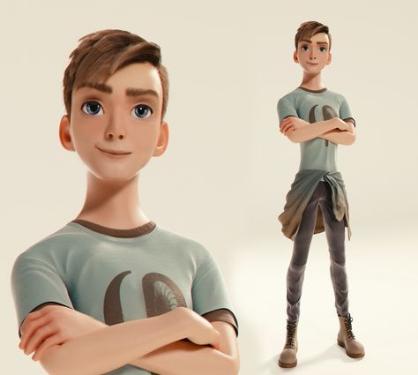 Alex Russell – Male Possible Player Character

 Anne Russell – Female Possible Player Character

### Game Mechanics

This is a single-player, first-person, point and click game. The character will move through the scenes by clicking on the direction they wish to move in. The player will have an inventory of useful items that they can collect throughout the game. There will be small puzzles or timed mini-games throughout. All movement and puzzle decisions will be based upon the click of the player’s mouse.

### Levels, Puzzles, Challenges, and Quests

Main Game –

Areas

Player Character’s House 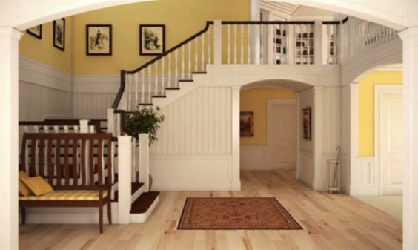

Front Gate 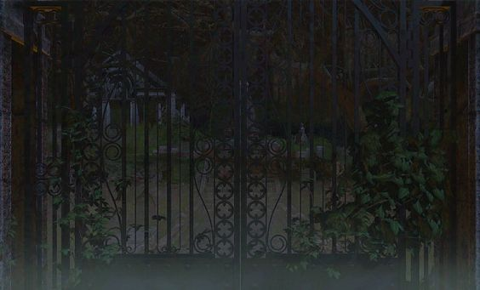

Crossroads

Path to Darkness 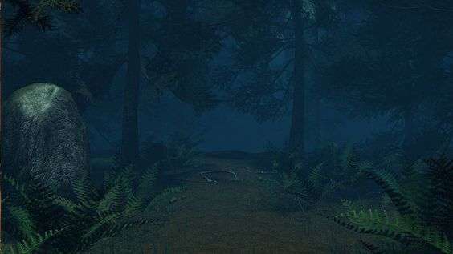

Front Yard 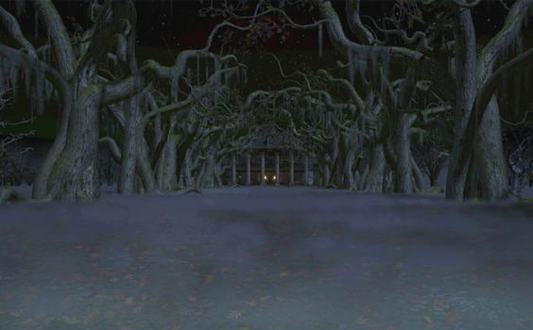

Front Porch (From Path) 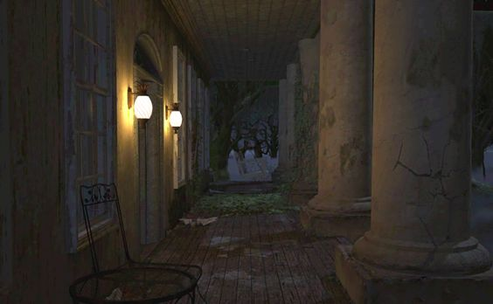

Entrance Hall (From Door) 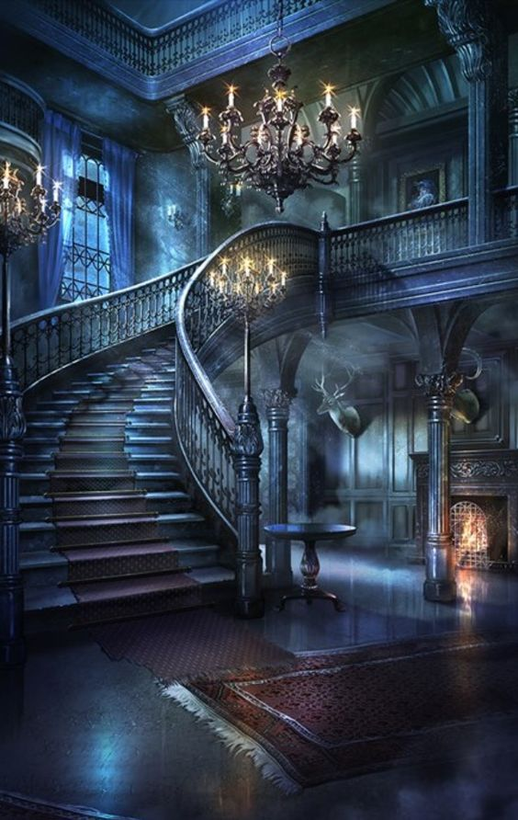

Kitchen 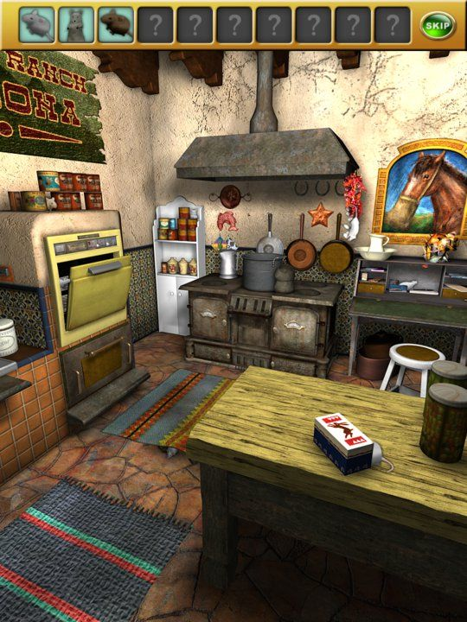

Entrance Hall (From Kitchen)

Front Porch (From House)

Hedge Maze Entrance 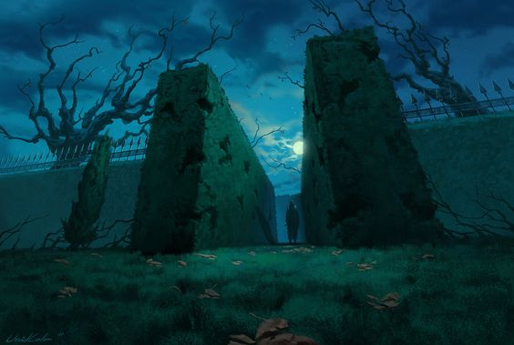

Hedge Maze 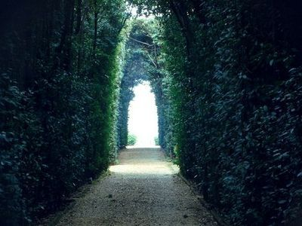

Maze Center

Fountain 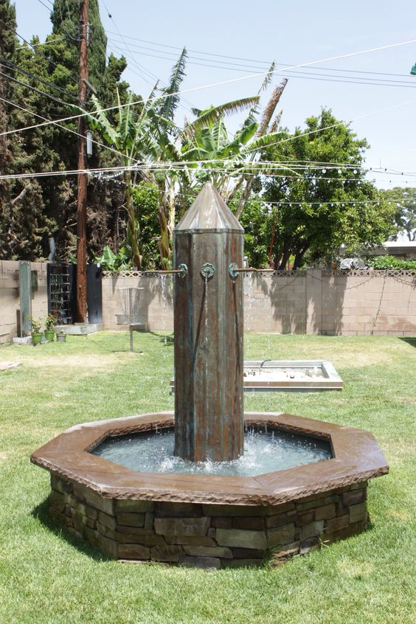

Secret Passage Entrance

Secret Passage Hallway 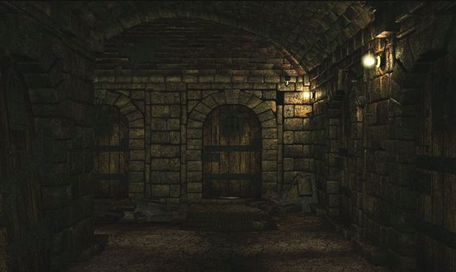

Mini Game 1: Attack and Dodge – The concept of this game is to battle or lure the creature trying to attack you. The creature will have random area that it will try to attack, and the player will be prompted to quickly dodge these attacks. If they dodge in time, the dodge will be successful, and no harm will come to the player, if they do not dodge in time, the attack will land, and the player is one attack closer to losing the game. The player also has a tool to attack or distract the creature, and will also have a timed prompt to do so.

1. Snake
2. Mouse
3. Raven

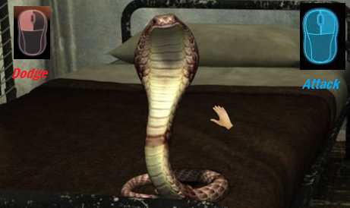

Mini Game 2: Folder Order Puzzle – The goal of this puzzle is to put the labeled folders back in their proper order, or else we will be in very big trouble with our sibling. The folders are in four different alphabets – English, Greek, Runic, and Russian. Each language in a color-coded folder. The player will be prompted to color-code the folders, and to alphabetize them correctly. As this is a very difficult puzzle, there is a timer within the game to generate a Skip Game option for those players who wish to skip the game.

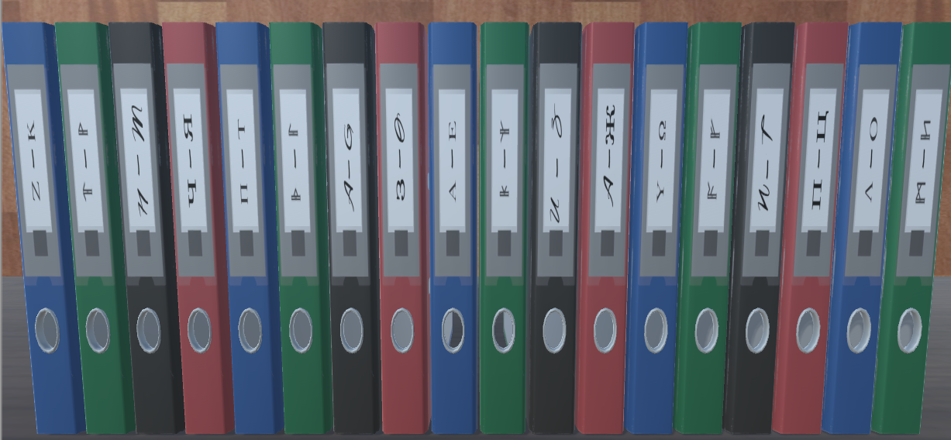

Mini Game 3: Maze Navigation While Avoiding Enemy – The goal of this game is twofold. The player must navigate the maze, trying to avoid dead-end areas. The more dead-ends they hit, the more likely they are to be caught by the AI following them. They must also try and avoid said AI.

1. Ghost Dog in the Hedge Maze - In this version of this mini-game, the player can happen upon pickups in the form of sticks that will allow them to distract the ghost dog by playing fetch with it. If they have a stick in their inventory, the player will be given a timed prompt to throw it. If they throw the stick in time, the ghost dog will run away to get the stick. Once it reaches the stick, it will stop and begin to hunt the player again. If the player does not have a stick in their inventory, or fails the timed prompt, the ghost dog will attack and they player will die.  
   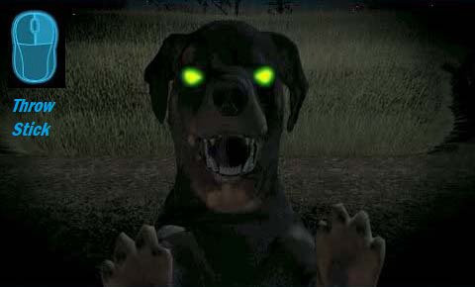
2. Shadowy Figure in the Secret Tunnel – There is no distraction for the shadowy figure. The only advantage the player has here is that the figure is very, very slow.

Mini Game 4: Monolith Puzzle – Once the player has acquired the last star piece from the raven mini-game and placed it in it’s proper indentation, they will reach this puzzle. The object here is to first solve the riddle on the monolith’s plaque, and then to press the stars in their proper order.

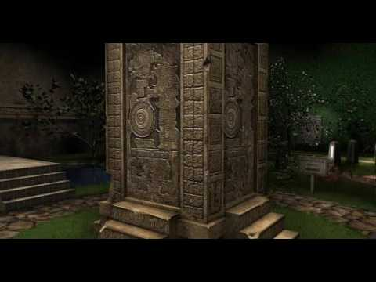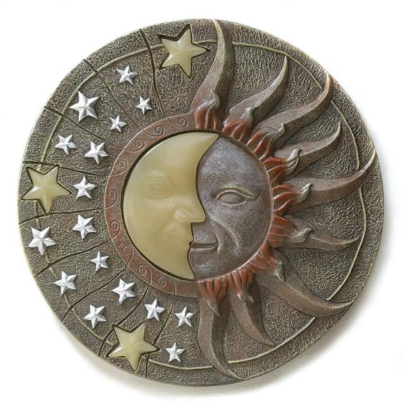

Mini Game 5: Labyrinth Exit Block Puzzle – The goal of this puzzle is to move the excess blocks out of the way of the needed tile. Each block will move the entire length of the empty space once prompted, so the player must be strategic to get to the piece that they need. There should be many of these puzzles for the randomizer to choose from, but the player will only get one per game. This puzzle is timed, and if the player takes too long in solving it, the shadowy figure will catch them and the game will end.

