How To Play

House of Shadows:

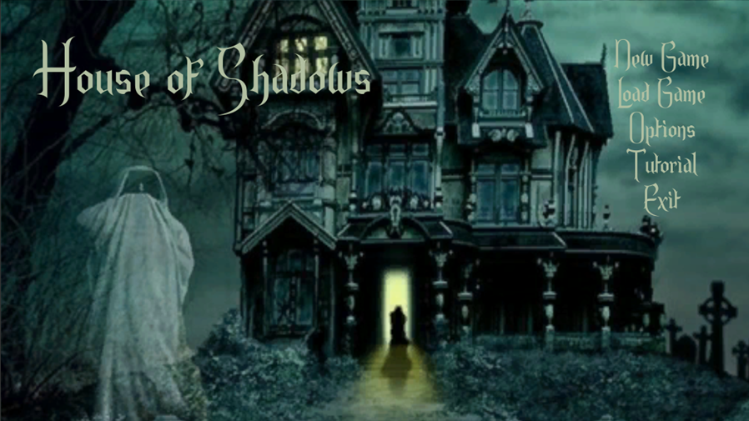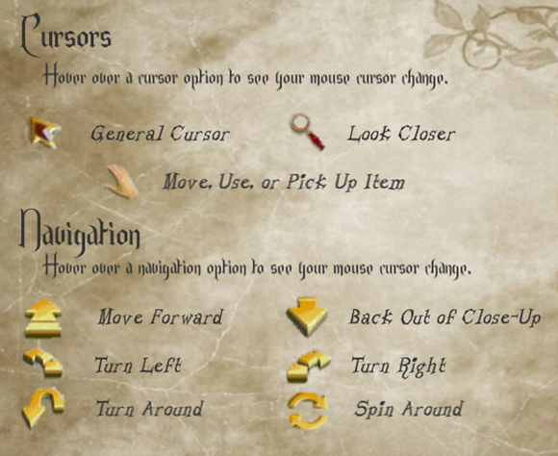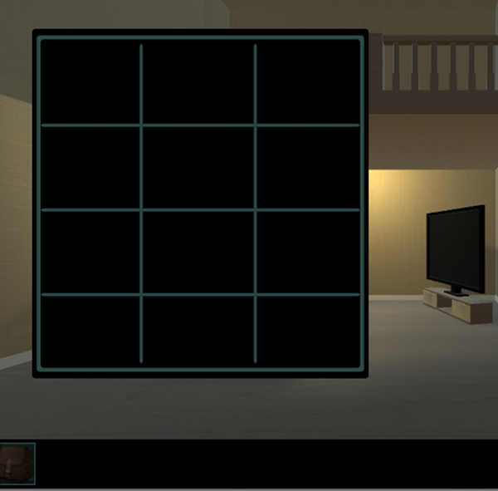House of Shadows is a point and click adventure mystery game. Your player moves throughout the game and interacts with the various segments of the environment depending on the mouse cursor type that is shown on screen (Examples below). You may also perform different actions with the mouse to complete subtasks or puzzles as they become available. Players can also interact with the game using the menu systems. There are also portions of the game in which the player may be granted the ability to move or aim in real time using the W,A,S,D keys to move and the Q and E keys to adjust their camera rotation.

The player can view the items that they’ve collected throughout the course of the game by opening the inventory panel. Many interactable events require an item before they can be activated.