**Pascal’s Triangle and Binomial Coefficients**

Lauren Alexandra

Colorado State University Global

MTH 350: Discrete Mathematics

Dr. Wael Abushammala

December 20, 2020

**Introduction**

Blaise Pascal illuminated uses of the number pattern known as Pascal’s triangle in his 1665 treatise *Traité du Triangle arithmétique* (Whiteside, 1961). The pattern maintains an array of nested patterns and connections with binomial coefficients at the center. Pascal’s triangle is built on binomial coefficients which represent quantities that multiply variables within an algebraic expression that describes the sum or difference of two terms (Levin, 2020).

**Binomial Coefficients**

The symbol $\left({n \atop k}\right)$ or *n* choose *k* indicates a binomial coefficient which also constitutes the formula for a cell within Pascal’s triangle (Levin, 2020). Pascal’s triangle can be assembled with a recurrence relation, such that solving for a cell’s *n* and *k* can be found using the cell’s predecessors. The recurrence relation for $\left({n \atop k}\right)$ is defined as $\left({n \atop k}\right)$ = $\left({n-1 \atop k-1}\right)$ + $\left({n-1 \atop k}\right)$ (Levin, 2020). Given cells C(3, 1) and C(3, 2), we can find the binomial coefficient directly below them. C(n, k) can also be represented as C(n, k) = C(n, n-k) for all *n* and *k*. If we choose *k* elements of a set with cardinality *n*, we are extracting a set of our selections from the original set. By selecting *k* elements, we select *n* – *k* elements for the modified set. Thus we know that if we identify cell C(3, 1) we can expect its pair cell to exist, C(3, 2) (see Figure 1). Furthermore, a cell’s *n* and *k* not only highlight its pair but also its bit strings and binary paths from the 0th cell.

For example, if we start at the first cell in the triangle and navigate down to the left (code 0), then down to the left again (code 0), and lastly down to the right (code 1), we will reach a cell with a bit string of 001 (see Figure 2). This string has a length of 3

**Figure 1**

*Pascal’s Triangle: Binomial Coefficients*

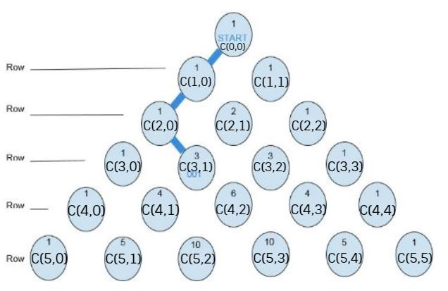

**Figure 2**

*Bit String Paths*

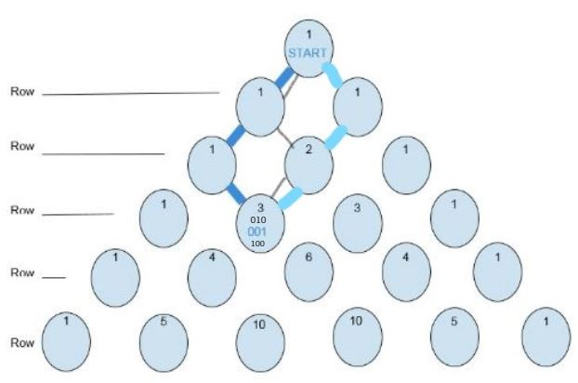

binary values and a weight of 1, with a single 1 present. Two additional paths will reach the cell resulting in bit strings 010 and 100. These strings possess the same length and weight as the initial path result. Subsequently, this cell can be denoted as C(3, 1) where 3 chose 1, the chosen bit of value 1.

**Combinations**

Pascal’s triangle can be easily constructed with combinations. Adding a cell to the triangle according to C(n, k) requires navigating to the nth row and kth cell in the row. The closed formula for choosing k elements of n elements is $\left({n \atop k}\right)$ = $\frac{n!}{\left(n-k\right)!k!}$ (Levin, 2020). To find a cell such as C(7, 2) we can calculate $\left({7 \atop 2}\right)$ = $\frac{7!}{\left(7-2\right)!2!}$, returning 21. The triangle allows us to figure out everything from the different combinations of heads and tails for some given coin tosses to the potential ways to group products from a store’s inventory to calculating the number of combinations from a gargantuan set of elements (Pickover, 2001).

**Conclusion**

Mathematicians have studied Pascal’s triangle for centuries and unearthed a variety of intriguing patterns and properties within the pattern. At its core, the triangle is comprised of binomial coefficients. Ultimately, we can utilize these coefficients to identify combinations with both sets and binary strings.

**References**

Levin, O. (2020). *Discrete Mathematics: An Open Introduction*.

<http://discrete.openmathbooks.org/dmoi3/frontmatter.html>.

Pickover, C. A. (2001). *Wonders of Numbers: Adventures in Mathematics, Mind, and*

*Meaning*. Oxford University Press.

Whiteside, D.T. (1961). Patterns of mathematical thought in the later seventeenth

century. *Arch. Rational Mech*, *1*, 179-388. https://doi.org/10.1007/BF00327940