Main Features:

* Add slides (formation / transition)
* Plot dancer
* Drag and drop
* Side panel / template (Maggie)
* Paste picture for music panel
* Swipe back and forth between slides

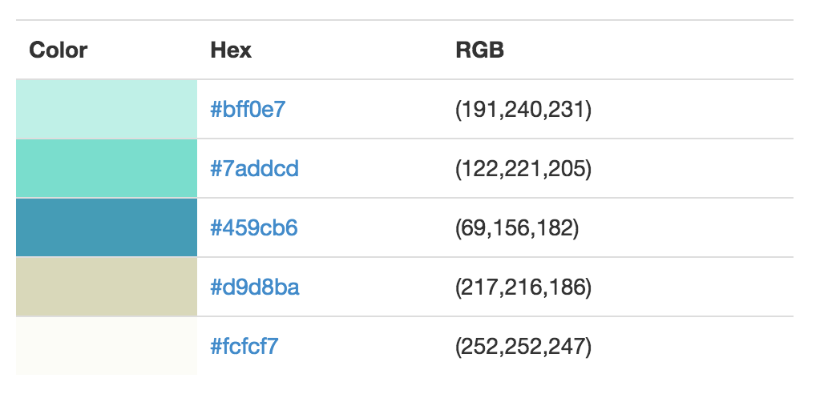

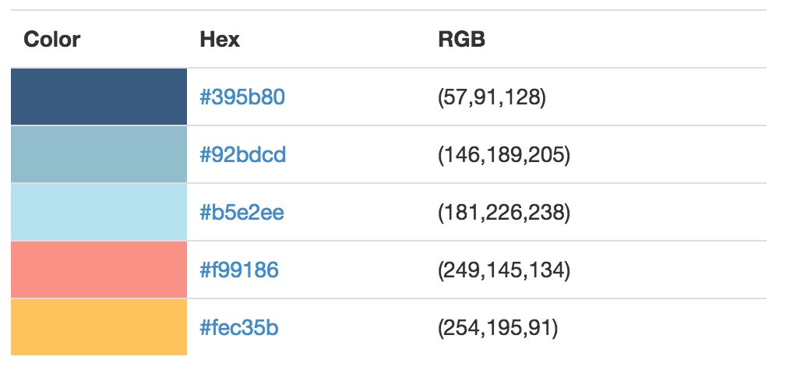

Stage dimensions:

25ft X 40ft

People:

JD 5ft

FF 5.8ft

GM 6ft

AY 5.3ft

EK 4.4ft

http://wavesurfer-js.org/examples/