Data Management Example – Processing a Healthcare Survey

Task. In (Out of Class) Activity 1.2 - Getting started with git and GitHub, we use data from a healthcare survey to practice git repositories and data management in polars. Your job is to redo this work in PySpark.
Note. The materials from the previous activity are attached and it is your task to translate instructions from polars to pyspark.

Dr. Bergen, Director of the Statistical Consulting Center at WSU, needs you to prepare the attached data for analysis. Note that health_survey.csv contains the responses to a series of health-related questions that we want to recode on a numeric scale and then aggregate. Dr. Bergen had a follow-up meeting with his client, and it turns out that some of the columns need a reverse coding, see the Needs Reverse Coding? column in ReverseCodingItems.csv. Please perform the following steps to prepare the required csv file.

Old Label | New Coded Value | Reverse Coding
“Strongly Disagree” | 1 | 5
“Somewhat Disagree” | 2 | 4
“Neither Agree nor Disagree” | 3 | 3
“Somewhat Agree” | 4 | 2
“Strongly Agree” | 5 | 1

- Look at the questions that need reverse coding and explain why it makes sense to reverse the coding on these items.

The types of questions where reverse coding is needed are ones where people are expected to disagree. This is key because if their answer “scores” are not adjusted, they will be false indicators of how someone feels.

- Create a data repository for this project. Make sure that notebook is in the root of the repository and the data files are stored in a data folder.

- You will need to redo the file construction, but now need to take the reverse coding into account.
  - Stack the columns.
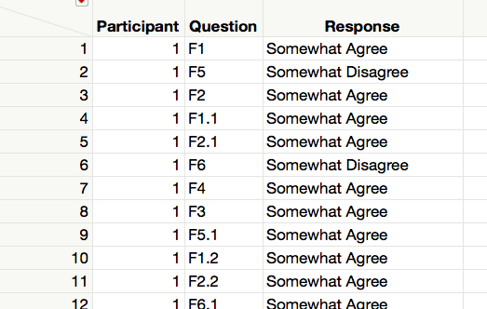

  - Make a new column called Needs Reverse by Recoding the Question Identifier to “Yes” or “No” per the Needs Reverse Coding? column in ReverseCodingItems.csv.
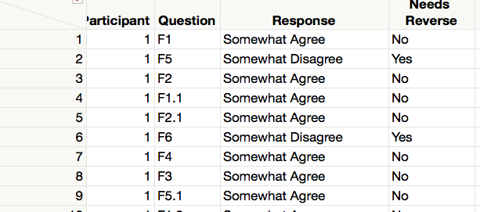

  - Make a new column called Temp Coded Value by Recoding the Questions Responses to the New Coded Values.
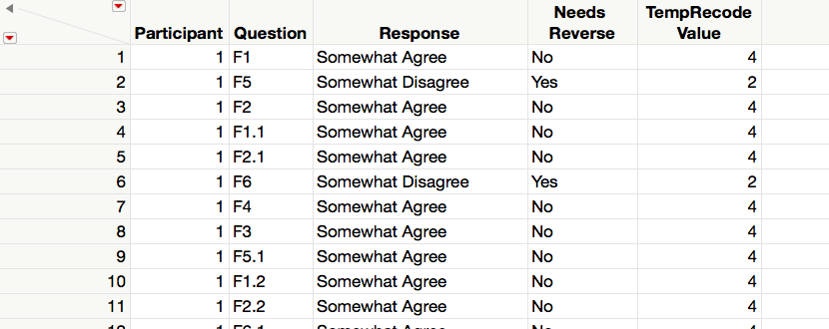

  - Make a new column called Temp Coded Value by Recoding the Questions Responses to the Reversed Coded Values.
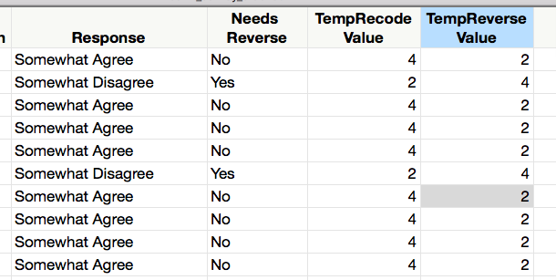
  - Make a new column called Recoded Value that holds the correct value for each question. You will want to use an case-when statement and use Needs Reverse to decide which temporary value to use.
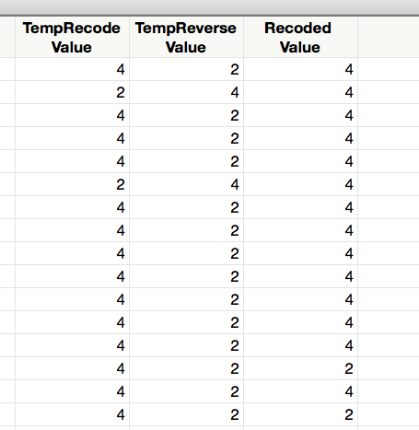

  - Make a new column by Recoding the Question Types to F1, F2, …, F6.
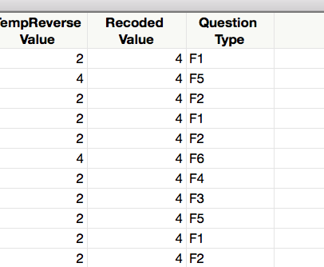

  - Aggregate and Split.
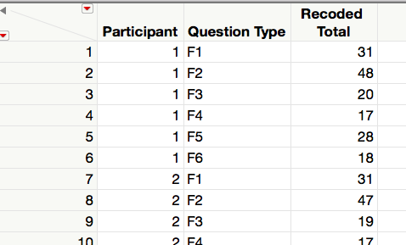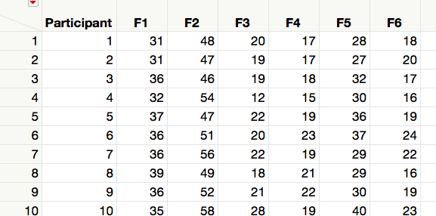

- Write the resulting table to a CSV file named health_survey_summary.csv in the data folder.

Deliverables. Submit this document with your answer to question 1, a link to your data repository, and a csv file with your final table.

