WorkForce (NPUPS) — Platform Handover Manual
Digital workflow for worker enrolment, fortnightly timesheets, payroll processing and HR reporting. Developed by Laurence Peter · Built with AI support
Purpose of this document. This is the definitive handover reference for the team taking ownership of the WorkForce platform. It explains *what the system does*, *how work flows through it*, *how every role uses it*, *what the colours and dashboards mean*, and *how the tamper-evident audit trail proves that nothing was altered behind the scenes*. Read it end-to-end once; then use the Table of Contents as a lookup.

Table of Contents
1. The one-paragraph pitch
2. System architecture at a glance
3. Signing in & the demo accounts
4. The nine roles
5. The end-to-end flow (bottom → top)
6. The timesheet lifecycle & its nine stages
7. Payroll automation — "not a penny more or less"
8. Statutory deductions & net pay
9. Backpay (retroactive rate changes)
10. Rosters & attendance defaults
11. The Director dashboards & colour coding
12. The Audit Trail explained
13. Worker registry & document verification
14. Excel export
15. Bottlenecks & how to prevent them
16. Security & network requirements
17. Running & deploying the platform
18. Troubleshooting
19. Colour reference (one-page)
20. Glossary

1. The one-paragraph pitch
WorkForce replaces a paper-based municipal payroll process — where fortnightly timesheets travelled by hand through four departments, were re-keyed at every desk, and were reconciled against bank details on a separate sheet — with a single digital pipeline. A worker enters one thing: their attendance. Everything else — wage, cost-of-living allowance (COLA), allowance, gross, National Insurance, Health Surcharge and net pay — is computed by the system and only ever *verified* by a human, never re-typed. Each timesheet climbs a fixed nine-stage approval ladder with full visibility for management, and every change is written to a tamper-evident, hash-chained audit trail that can be proven un-altered in an external review or in court. The result: time-to-first- payment drops from weeks to days, and every worker is paid their actual salary — not a penny more, not a penny less.

2. System architecture at a glance
WorkForce is a Flutter web front-end talking to a Node.js + Express API, which is the *only* process that touches PostgreSQL. The browser never connects to the database directly.
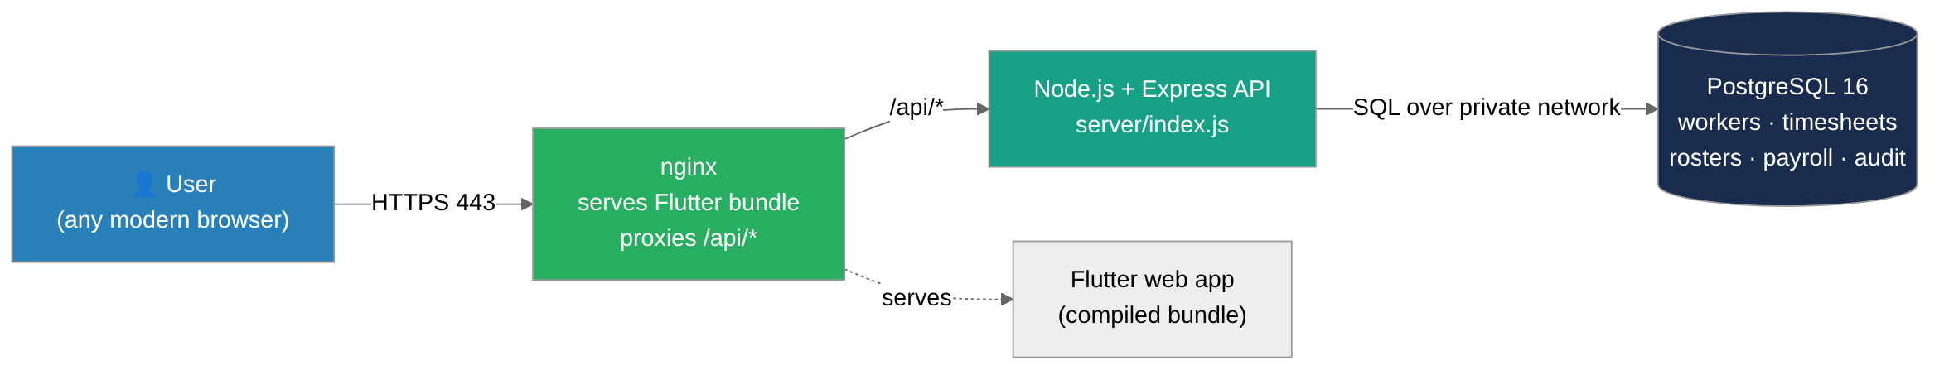
Layer | Technology | Notes
Front-end | Flutter 3.x / Dart 3.2+ | Compiled to a static web bundle; no backend URL baked in
API | Node.js 18 + Express 4 | Same-origin /api/*; the only tier that reaches the DB
Database | PostgreSQL 16 | Schemas in db/ — RBAC, domain, edit-locks
Infra | Docker + nginx + GitHub Actions | Web image is built in CI and pulled by the host

Key design guarantee. Because the browser calls /api/* on the *same origin* it was served from, the deployed bundle needs no per-environment rebuild and there is no cross-origin preflight. After login, Bootstrap.loadAll() fans out to /api/workers, /api/timesheets, /api/audit-logs, /api/rosters, /api/backpay-records and populates the on-screen data stores. All data originates in PostgreSQL — nothing is hard-coded in the front-end except the proof-of-concept demo logins.

3. Signing in & the demo accounts
Open the platform URL in Chrome, Firefox or Edge (1280×720 or higher). Enter your email and password and click Login. You land on the dashboard for your role. If you see a red "Backend unreachable" banner, the API container is down or misconfigured — see Troubleshooting.
Demo / proof-of-concept credentials (staging only — never enable in production):
Role | Email | Password
System Admin | admin@workforce.app | admin123
Regional Coordinator | coordinator@workforce.app | test123
HR | hr@workforce.app | test123
Worker | worker@workforce.app | test123
Sub-Accounts | accounts@workforce.app | test123
Director / Permanent Secretary | ps@workforce.app | test123
Main Accounts | mainaccounts@workforce.app | test123
Executive Dept | executive@workforce.app | test123
DMCR | dmcr@workforce.app | test123

4. The nine roles
Each user has exactly one role, assigned by the System Administrator. The role decides which screens and actions are available. Read the table bottom-to-top — that is the order a fortnight actually moves.
# | Role | What they do | Primary screens
1 | Worker | Submit their own fortnightly timesheet (attendance only) | Timesheet · Workers
2 | Regional Coordinator | Enter group/paper timesheets; review & approve worker submissions | Dashboard · Review · Timesheet · Workers
3 | HR Department | Confirm active employment, leave & programme compliance | Dashboard · HR Review · Workers
4 | Sub-Accounts Clerk | The recheck — verify rates, days, totals & bank details | Dashboard · Accounts · Export
5 | Main Accounts Clerk | Authorise approved payments; manage cheque processing | Dashboard · Accounts · Export
6 | DMCR | Worker-data compilation & coordination across corporations | Dashboard · Workers
7 | Director / Permanent Secretary | Whole-pipeline oversight & bottleneck detection | Pipeline · Drill Down · Bottlenecks · Workers · Export
8 | Executive Department | Programme-level oversight across the corporation | Dashboard · Workers · Export
9 | System Administrator | Full access; user management; troubleshooting | All screens

Note on names. Internally the "Director" oversight role is the Permanent Secretary (`ps`) account — that is the login that opens the Pipeline / Drill Down / Bottlenecks dashboards described in §11.

5. The end-to-end flow (bottom → top)
A timesheet is *born at the bottom* (a worker's attendance) and *finishes at the top* (money in the bank). It only ever moves up one stage at a time on approval, or down one stage on rejection.
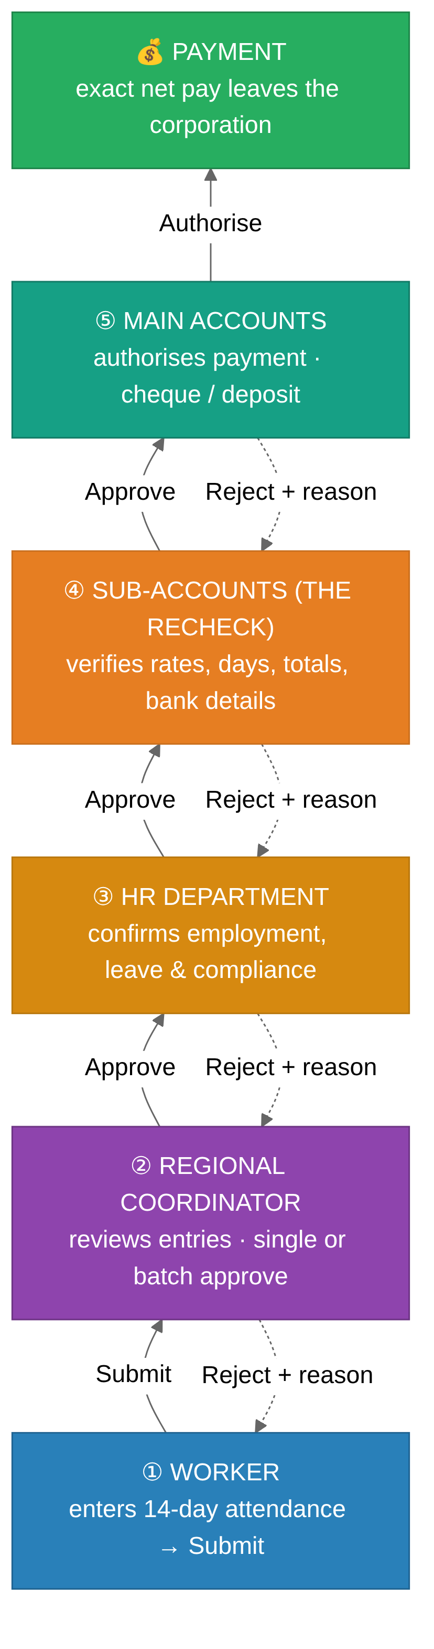
The two human jobs. Notice that humans do only the two things that must not be automated: record the attendance (bottom) and verify the result (the recheck). Every arithmetic step in between is the system's job, performed identically every fortnight.
Rejection is never silent. A reject at any stage sends the timesheet back *one* stage and requires a written reason. The originator is notified, and the reason is visible in the approval history and in the audit trail.

6. The timesheet lifecycle & its nine stages
Under the hood, a timesheet is a small state machine. These nine stages, their owners and their colours are defined in code (lib/models/timesheet_model.dart) and are the single source of truth for the colours you see across the app.
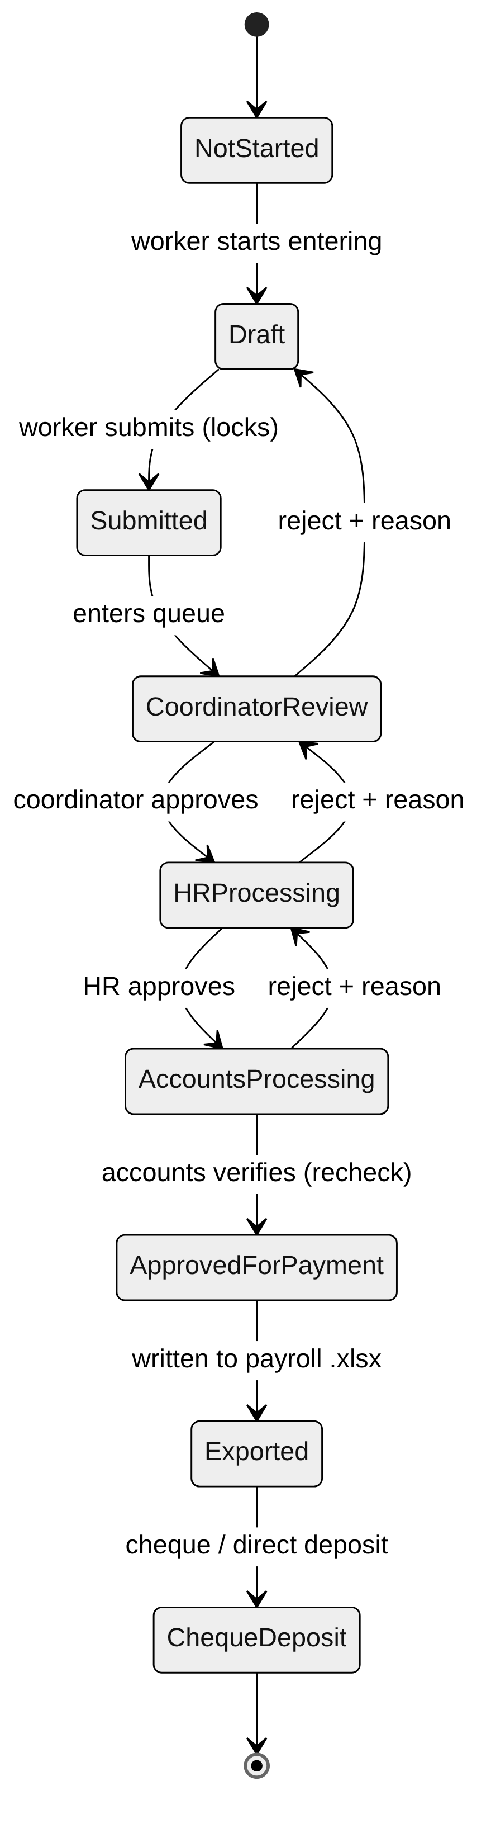
# | Stage | Owner | Colour | Hex | Meaning
1 | Not Started | Worker | ⬜ Grey | #9CA3AF | Timesheet exists, no attendance yet
2 | Draft | Worker | ◼️ Slate | #6B7280 | Being entered; totals preview live; editable
3 | Submitted | Regional Coordinator | 🟦 Blue | #2980B9 | Locked by worker; awaiting review
4 | Coordinator Review | Regional Coordinator | 🟪 Purple | #8E44AD | Coordinator checking entries
5 | HR Processing | HR Department | 🟧 Amber | #D68910 | Employment/leave/compliance check
6 | Accounts Processing | Sub-Accounts | 🟧 Orange | #E67E22 | The recheck — verify figures & bank
7 | Approved for Payment | Main Accounts | 🟩 Green | #27AE60 | Figures confirmed & authorised
8 | Exported | Accounts | 🟦 Teal | #16A085 | Written to payroll .xlsx
9 | Cheque / Direct Deposit | Accounts | 🟦 Navy | #1A2C4E | Money issued — terminal state

Editable window. A timesheet can only be edited while it is Not Started or Draft. Once Submitted, it is read-only unless an approver rejects it back down.

7. Payroll automation — "not a penny more or less"
This is the heart of the platform. The worker types attendance; the system derives everything else. All figures below come straight from lib/models/timesheet_model.dart and are computed deterministically — the same inputs *always* produce the same cent.
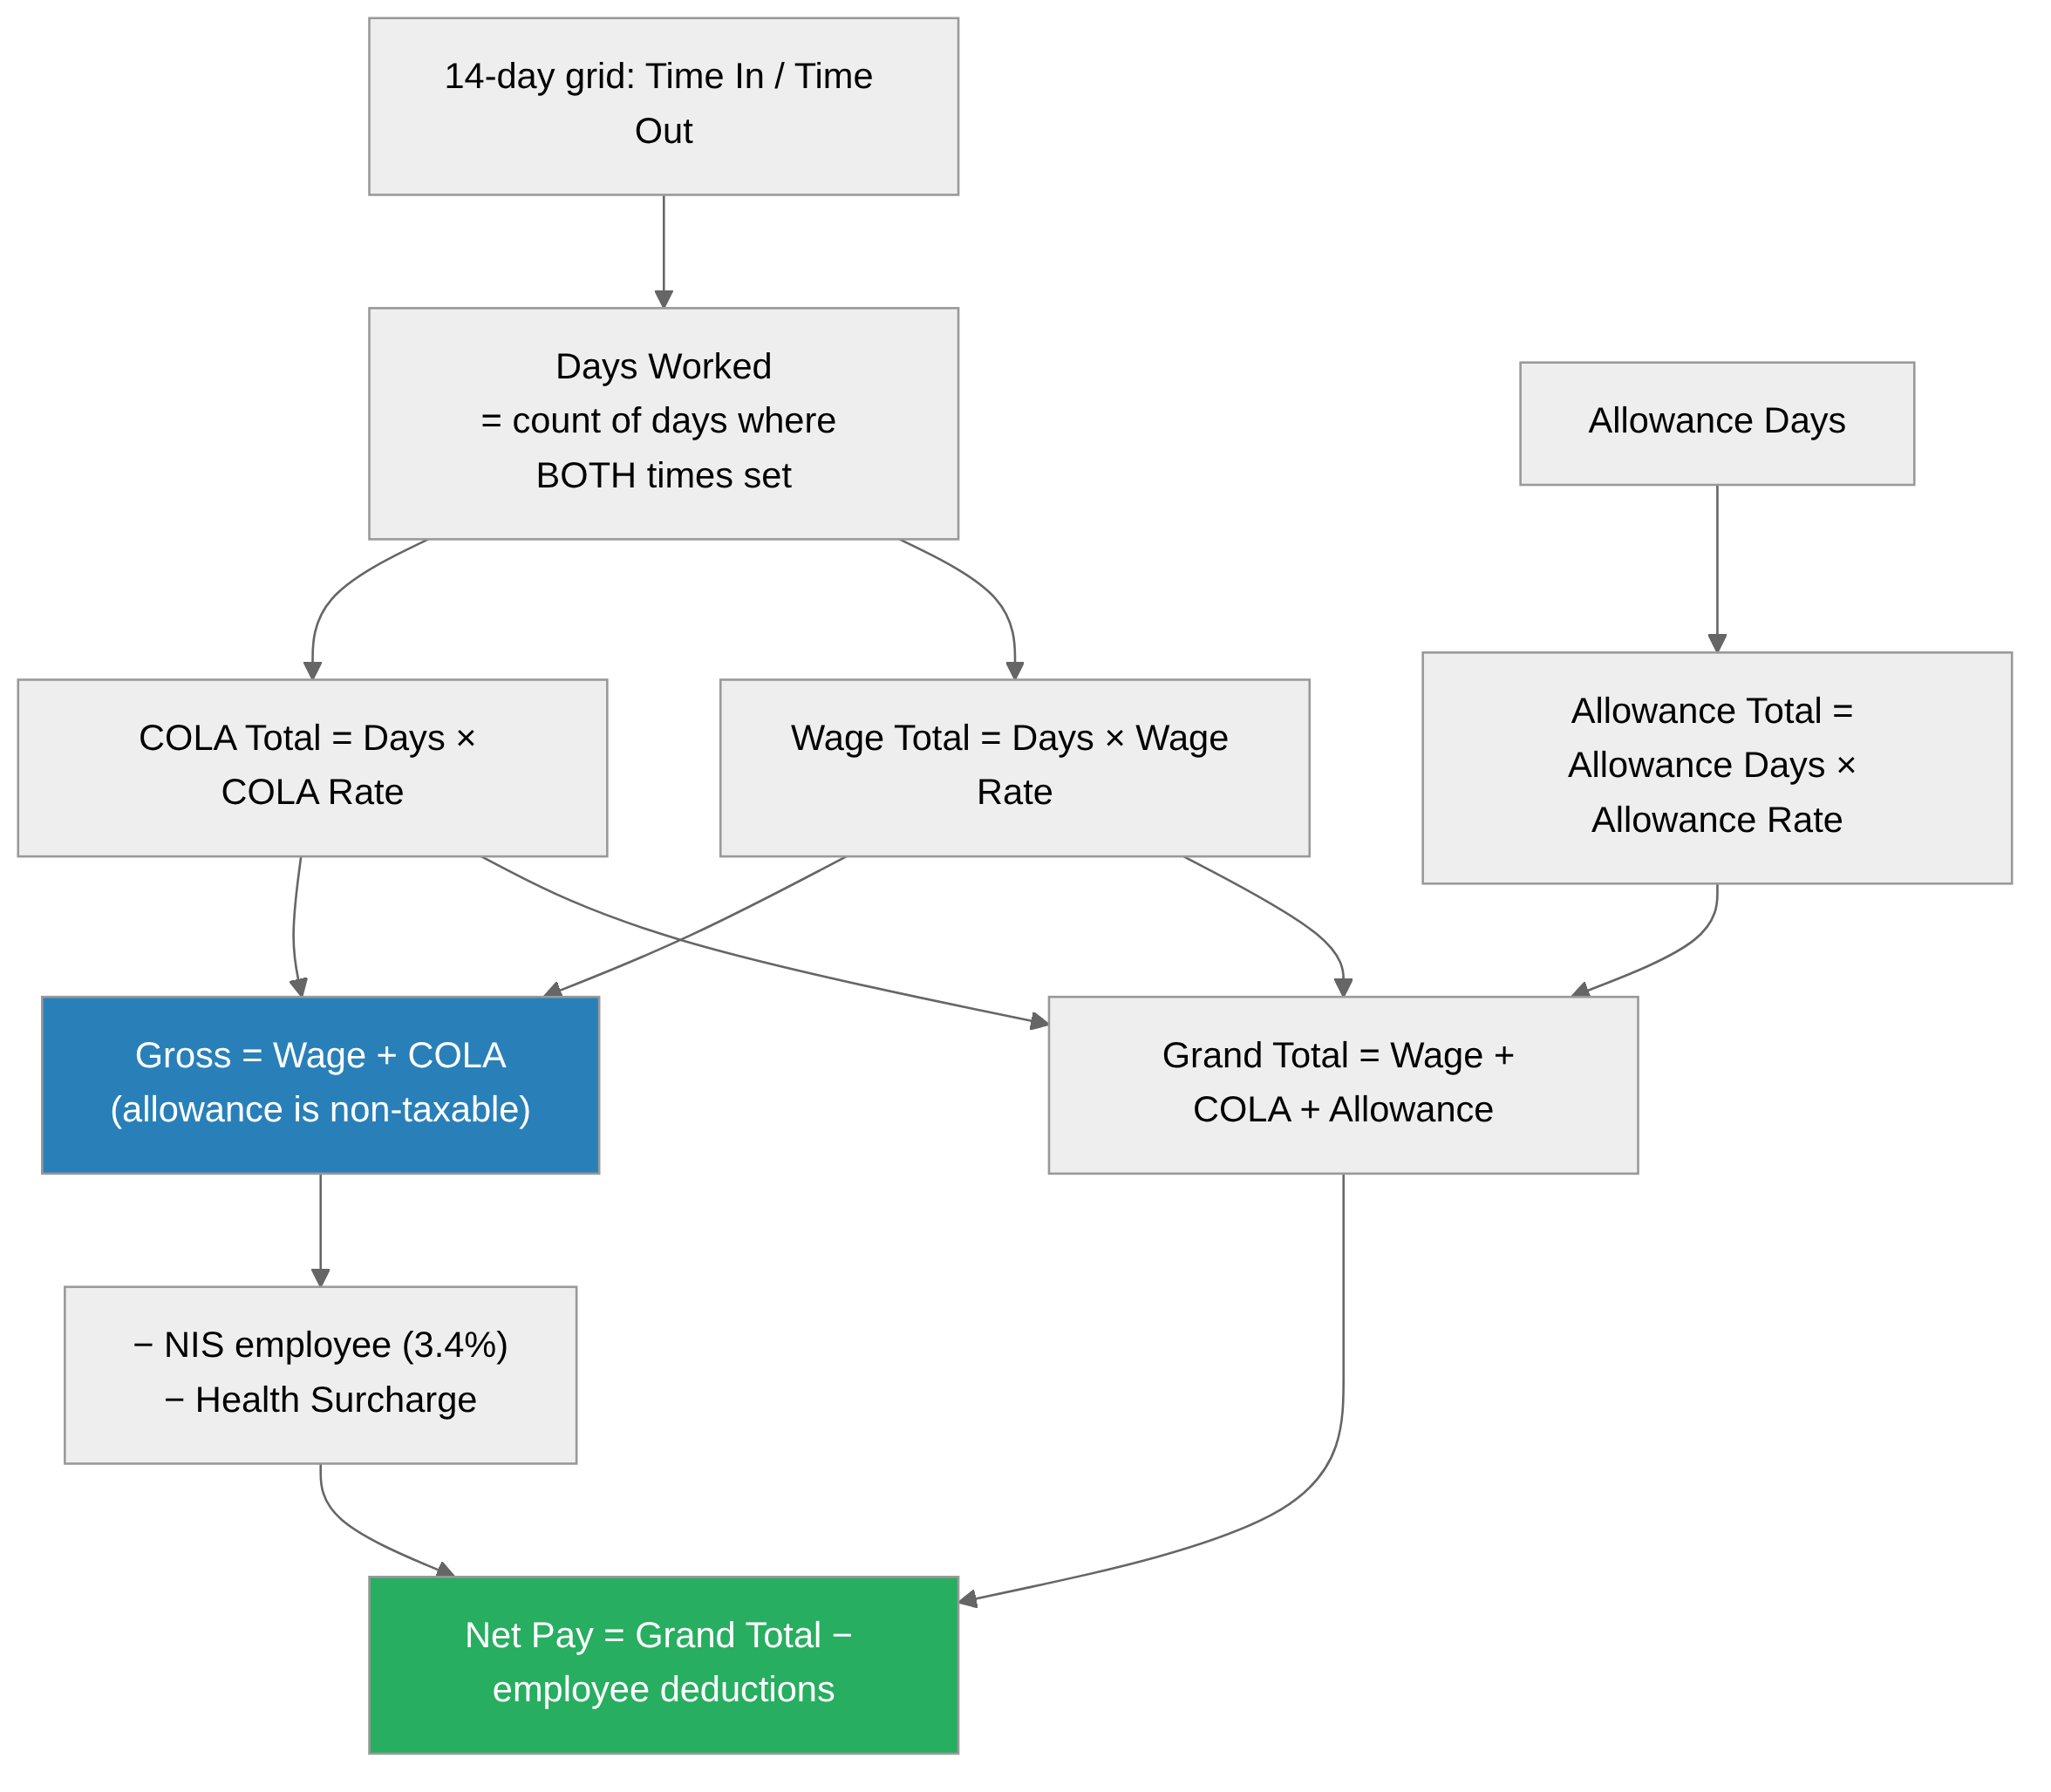
The formulas (exact):
Quantity | Formula
Days Worked | count of days where both Time In and Time Out are set
Wage Total | Days Worked × Wage Rate
COLA Total | Days Worked × COLA Rate
Allowance Total | Allowance Days × Allowance Rate
Grand Total | Wage Total + COLA Total + Allowance Total
Gross Salary | Wage Total + COLA Total (allowance is non-taxable)
Net Pay | Grand Total − (NIS employee + Health Surcharge)

Worked example (Wage $168/day, COLA $30/day, Allowance $25/day):
 | Value
Days worked | 10
Wage total | 10 × $168.00 = $1,680.00
COLA total | 10 × $30.00 = $300.00
Allowance total | 5 × $25.00 = $125.00
Grand total | $2,105.00
Gross (wage + COLA) | $1,980.00
NIS employee (3.4%) | −$67.32
Health Surcharge ($8.25/wk × 2) | −$16.50
Net pay | $2,021.18

The interactive presentation in presentation/platform-walkthrough.html lets you drag these inputs and watch the statement recompute live — useful for demonstrating exactness to stakeholders.

8. Statutory deductions & net pay
Deductions are modelled in lib/models/payroll_deductions_model.dart. Rates default to Trinidad & Tobago figures and are versioned by year (DeductionRateTable), so historical fortnights stay auditable even after a rate change.
Deduction | Rate (2026 default) | Basis
NIS — employee share | 3.4% of gross | Deducted from the worker
NIS — employer share | 6.5% of gross | Paid by the employer, never deducted from the worker
Health Surcharge (high band) | $8.25/week → ×2 = $16.50/fortnight | When gross > $469.99
Health Surcharge (low band) | $4.80/week → ×2 = $9.60/fortnight | When gross ≤ $469.99

- Gross for deduction purposes is Wage + COLA only — the allowance is
non-taxable and does not attract NIS or Health Surcharge.
- Total employer cost = gross + employer NIS. Total NIS remitted =
employee + employer share.
- All money values are rounded to the cent (round(v × 100) / 100).

9. Backpay (retroactive rate changes)
When a wage or COLA rate is raised retroactively (e.g. an annual collective-agreement increase effective from an earlier date), the system generates a backpay record capturing the exact per-fortnight shortfall — no manual recalculation. Modelled in lib/models/backpay_model.dart.
For each affected fortnight:
wage delta = (new daily rate − old daily rate) × days worked
COLA delta = (new COLA rate − old COLA rate) × days worked
line total = wage delta + COLA delta
The record totals every line and moves through its own small workflow: Calculated → Approved → Disbursed (or Cancelled). Each backpay record carries the id of the originating audit entry (the wage-rate change), so the trail is closed end-to-end.

10. Rosters & attendance defaults
The fortnight roster (lib/models/roster_model.dart) makes data-entry *subtraction, not entry*:
- Workers are present Monday–Friday by default; data-entry staff simply
un-tick absent days and can record an absence reason.
- Weekend work is off by default and only shown if an admin enables it.
- There is a maximum days-per-fortnight cap (default 10), overridable
per-worker by an admin for exceptional cases. This cap means no one can be recorded — or paid — beyond the maximum.

11. The Director dashboards & colour coding
The Director / Permanent Secretary login opens a three-tab oversight console (lib/screens/ps_dashboard_screen.dart). This section explains exactly what each tab shows and what every colour means.

11.1 Pipeline tab
A horizontal flow of all nine stages, each rendered in its own stage colour (the swatches in §6), with a live count of timesheets sitting at that stage. Tapping a stage filters the drill-down. Above it sit four KPI cards:
KPI card | Colour | Meaning
Total | 🟦 Accent blue #2980B9 | Neutral count of all timesheets in view
Payroll | 🟩 Green #27AE60 | Combined payroll value (money = green)
Stalled | 🟥 Red #C0392B when > 0, else 🟩 Green | Items needing attention
Complete | 🟩 Green #27AE60 | Timesheets that reached Cheque/Deposit

Colour grammar of the whole app: green = healthy / money / done, red = attention / stalled / rejected, amber = warning / in-review / threshold, blue = neutral information / counts, and each pipeline stage keeps its own identity colour so a timesheet is recognisable at a glance wherever it appears.

11.2 Drill Down tab
A filterable list of individual timesheets. Filters: Corporation, Stage, Date Range, Worker, and an Overdue/Stalled toggle. Each timesheet card is tinted with its stage's colour (at low opacity), so you can scan a long list and see the distribution of stages by colour alone. A stalled item additionally shows its "Xh stalled" age in red.

11.3 Bottlenecks tab
Automatically surfaces every timesheet that has been stuck at the same stage longer than the threshold. The threshold is 48 hours by default and is selectable from {24, 48, 72, 96} hours at the top of the tab (⏱️ timer icon in amber). For each stalled item you see the worker, the stage it is stuck at, how long it has been stalled (in red), and the responsible role. When nothing is stalled, the tab shows a positive "no bottlenecks" state.
How "stalled" is measured. Each timesheet records updatedAt — the moment it last changed stage. timeAtCurrentStage = now − updatedAt. If that exceeds the threshold, the item is flagged. Terminal states (Not Started, Cheque/ Deposit) are excluded from stall counting.

12. The Audit Trail explained
The Audit Trail is the platform's tamper-evidence system. It is reachable via the Workers → Audit Trail area and is restricted to the System Admin, Director/PS, HR and DMCR roles. This section answers, in plain language: *what it is*, *what the hash numbers are*, and *what "chain broken" means* — the three things every handover reader asks.

12.1 What it is
Every meaningful action in the system — a login, a worker created, a document approved, a stage advanced, a wage rate changed, a payment recorded — is written as an immutable audit entry. Each entry records who did it (user, role, session), when (to the millisecond), what (action + entity), a before → after diff of every field that changed, and any supporting attachments (e.g. the signed paysheet). Entries are append-only: the database revokes UPDATE and DELETE, so history cannot be quietly edited.

12.2 What the hash numbers are for
Each entry carries a 64-character SHA-256 hash — a digital fingerprint of the entry's contents *plus the fingerprint of the entry before it*. This is called hash chaining. In formula form (matching AuditService._computeHash):
hash(entry) = SHA-256(
previousHash ← the hash of the entry immediately before
|| id ← e.g. AUDIT-000007
|| millisecondsSinceEpoch ← the timestamp
|| userId || action || entityType || entityId
|| fieldChanges ← "field|old|new;field|old|new"
|| attachments ← "id|contentHash|sizeBytes"
)
Because each entry's hash feeds into the next one's hash, the entries form a chain. The very first entry links to an empty *genesis* value (previousHash = ""). An attachment content hash binds the actual file bytes into the chain, so swapping a file for a different one also breaks the chain.
In short: the hash numbers are not IDs or sequence numbers — they are cryptographic fingerprints whose only job is to make silent tampering mathematically detectable.

12.3 What "chain intact" and "chain broken" mean
At the top of the Audit Trail screen is a badge and a summary line. Pressing "Re-verify chain" (↻) recomputes every hash from the stored contents and compares it to what is on file, while also checking that each entry's previousHash really equals the previous entry's hash.
- 🛡️ Chain Intact — N entries verified. Every entry's recomputed hash matches
its stored hash and every link matches. Nothing has been altered.
- ⚠️ Chain Broken at entry #N (AUDIT-00000N). The verifier hit the first
entry whose contents no longer match its fingerprint, *or* whose link to the previous entry is wrong. This is exactly what you want to see if someone edited, inserted, deleted or reordered a record directly in the database: the tamper is pinpointed to the first affected entry, and everything after it is thrown into doubt.

⚠️ Fixed in this handover: the false "Chain Broken at entry #1"
Previously the badge reported "Chain broken at entry #1 (AUDIT-000001)" on a perfectly clean database. That was a false alarm, not real tampering — and it has been corrected. Two root causes were fixed:
1. The seeded history carried placeholder fingerprints. The demo audit
rows in db/domain_schema.sql were stored with a stand-in hash (sha256(id || '|seed')) instead of a *real* chain hash, so the app's verifier — which recomputes the genuine fingerprint — rejected the very first row. The seed now computes real chain hashes with the exact same formula the app uses, so a freshly loaded database verifies as Chain Intact while any *genuine* later tampering still breaks it.
2. Timestamp precision mismatch on reload. The fingerprint used microsecond
time, but the API transports timestamps at millisecond precision — so even legitimately added entries could fail re-verification after a page reload. The fingerprint now uses millisecond time on both sides (AuditService._computeHash and the SQL seed), so the chain survives a round-trip through the database.
This was verified against a live PostgreSQL 16 instance: all 13 seeded entries now report Chain Intact, the first entry's hash matches an independent reference implementation to the character, and deliberately editing a seeded value correctly re-breaks the chain at that entry.

12.4 Reading an audit entry
Tap any entry to expand it. You will see: Entry ID, exact timestamp, User ID, Session ID, Entity ID, any note, the entry's Chain Hash (selectable, for copying into an external verifier), the field changes shown as red *old* → green *new* chips, and any attachments with their type, size and SHA-256 prefix. Action icons are colour-coded — green for creates/approvals, red for deletes/rejections, amber for rate and roster changes, blue for updates/uploads.
You can filter by action type, entity type, date range and free-text search, and export the whole chain as JSON for offline/printed compliance review.

13. Worker registry & document verification
The Workers tab (available to all roles) lists every registered worker with a photo/initials avatar, name, position, corporation, and a document verification progress bar. Each worker requires five compliance documents: NIS Registration Card, Birth Certificate, Bank Letter, ID Card, Police Certificate. The badge is:
Badge | Colour | Meaning
Verified | 🟩 Green | All 5 documents uploaded
Partial | 🟧 Orange | Some documents uploaded
Missing | 🟥 Red | No documents on file

Tap a worker to open Personal Information, Bank Information and Document Verification, and to initiate uploads. Search matches any part of a name, NIS number or ID number; filters cover document status and corporation.

14. Excel export
Accounts (and Admin/Director) can generate the payroll .xlsx for a group: select Corporation → Group Number (1–12) → Fortnight Start Date (the system snaps to the correct Monday), review the pre-populated worker list, and click Generate Export. The file matches the official timesheet template — title header, per-day Time In/Out columns, calculated Wage/COLA/Allowance/Total columns, and signature lines for Supervisor, Coordinator and Corporation — with borders and alignment ready for printing.

15. Bottlenecks & how to prevent them
A pipeline is only as fast as its slowest desk. The system already *detects* stalls (§11.3); here is how to *prevent* them.
Where it stalls | Symptom | Built-in prevention
Coordinator Review | Queue piles up card-by-card | Batch approve — select the whole queue and approve in one action
HR Processing | Sheet sits without a decision | Reject-with-reason bounces it back immediately rather than stalling silently
Accounts Processing | Bank-detail mismatch on the recheck | Bank fields are read-only from the verified registry, so the recheck rarely fails here
Submitted (paper workers) | Workers without digital access | Group entry — a coordinator digitises up to 12 workers from one paper form
Any stage | Nobody knows where the file is | 48h bottleneck detection names every overdue sheet *and its owner* on the Director's tab
Draft | Over-max attendance recorded | Roster cap (10 days) blocks anyone being recorded — or paid — beyond the maximum

Recommended operating rhythm: Coordinators clear their review queue at least once per working day; HR and Accounts check their queues each morning; the Director reviews the Bottlenecks tab twice a week and reassigns anything past 48 hours. The same stalled-item signal that feeds the Director can, as the programme scales, drive automated reminders and reassignment.

16. Security & network requirements
This platform handles personal data — NIS numbers, ID numbers, bank account details and payroll figures — so transport security is mandatory.
Port | Protocol | Purpose | Required
443 | HTTPS/TLS | Encrypted web traffic (primary access) | Yes — mandatory
80 | HTTP | Redirect to 443 only | Redirect only

- All traffic must be encrypted with TLS 1.2 or higher. Port 80 should only
issue an automatic redirect to HTTPS — it must never serve application content in plaintext.
- Obtain a certificate from a trusted public CA (e.g. Let's Encrypt, DigiCert)
and configure nginx on the 443 server block, with an 80→443 redirect.
- Personally identifiable data is masked in the UI (bank, NIS, ID) via
security_utils, and the API is the only tier that reaches the database.

17. Running & deploying the platform
One-command demo (bundles its own seeded Postgres):
docker compose up --build
# web → http://localhost:8081 (Flutter via nginx, proxies /api/*)
# api → http://localhost:8080 (GET /api/health for liveness)
# db → localhost:5432 (Postgres 16, db/*.sql auto-loaded on first boot)
Load the schemas manually (managed Postgres, in this order):
psql "$DATABASE_URL" -f db/rbac_schema.sql # roles & permissions
psql "$DATABASE_URL" -f db/domain_schema.sql # workers, timesheets, payroll, audit (+ seed)
psql "$DATABASE_URL" -f db/edit_locks_schema.sql # optimistic concurrency locks
Sanity-check the seed: workers = 19, timesheets = 17, timesheet_daily_entries = 238, rosters = 6, app_audit_logs = 13.
Production (Coolify). The web image is built in GitHub Actions (flutter build web --release peaks at ~1.6 GB RAM and would overwhelm a small deploy host) and published to ghcr.io/<owner>/npups:latest; Coolify just pulls it. Deploy with docker-compose.prod.yml (web + api only), set DATABASE_URL in Coolify env vars, point the public domain at the web service, and load the schemas into the managed Postgres once before the first deploy. See README.md for the full Coolify checklist.

18. Troubleshooting
Symptom | Likely cause | Fix
Red "Backend unreachable" banner | API container down, or API_UPSTREAM points at the wrong host | docker compose logs api; confirm http://localhost:8080/api/health responds
"Chain Broken" on a clean DB | (Historically) placeholder seed hashes / timestamp precision | Fixed — reload db/domain_schema.sql; the seed now writes real chain hashes (§12.3)
"Chain Broken" on a live DB | Genuine tampering, or a manual SQL edit to app_audit_logs/field changes/attachments | Investigate the named entry (#N) — the audit trail deliberately flags exactly this
Users created "at work" not visible "at home" | Two machines pointing at different databases | Point both at the same managed Postgres (data lives in the DB, not the browser)
Dashboard empty after login | Bootstrap.loadAll() fetch failed | Check the API health endpoint and browser console/network tab
Timesheet won't edit | It has been Submitted | Only Not Started / Draft are editable; an approver must reject it back

19. Colour reference (one-page)
Semantic colours (whole app):
Colour | Hex | Used for
🟩 Success green | #27AE60 | Healthy, money, complete, approvals
🟥 Error red | #C0392B | Stalled, rejected, deletions, attention
🟧 Warning amber | #D68910 | Warnings, in-review, thresholds, rate changes
🟦 Info / accent blue | #2980B9 | Neutral counts & information
🔵 Primary navy | #1A2C4E | App chrome, headers, terminal "paid" stage

Pipeline stage colours: Grey #9CA3AF · Slate #6B7280 · Blue #2980B9 · Purple #8E44AD · Amber #D68910 · Orange #E67E22 · Green #27AE60 · Teal #16A085 · Navy #1A2C4E (in flow order, stages 1→9).
Audit action icon colours: green = create/approve/activate/stage-advance · red = delete/deactivate/reject/reverse · amber = wage-rate/backpay/roster changes · blue = update/upload/import/export.

20. Glossary
Term | Meaning
COLA | Cost-of-Living Allowance, paid per day worked; part of gross
NIS | National Insurance Scheme contribution (employee 3.4%, employer 6.5%)
Health Surcharge | Weekly statutory levy (×2 per fortnight), banded by gross
Gross | Wage + COLA (the basis for deductions; allowance excluded)
Net pay | Grand Total − employee deductions — the amount actually paid
Grand Total | Wage + COLA + Allowance (before deductions)
Fortnight | The two-week pay period; 14 attendance days
Stage | One of the nine positions in the approval pipeline
Stalled / Bottleneck | A timesheet stuck at one stage beyond the threshold (default 48h)
Backpay | Retroactive shortfall owed after a rate increase
Hash chain | The linked SHA-256 fingerprints that make the audit trail tamper-evident
Chain intact / broken | Whether every audit fingerprint still matches its contents and its link
RBAC | Role-Based Access Control — one role per user, gating every screen

*Document version 1.0 — 2026 · WorkForce (NPUPS) · Developed by Laurence Peter.* *For the interactive walkthrough of this flow, open presentation/platform-walkthrough.html.*

