Lauren Courtney

March, 2020

EN 605.715.81 Embedded Systems

**Project 8 – Download IMU from Arduino to RPi to Host**

**Requirements**

1. Connect the IMU sensor to the Arduino and collect Yaw, Pitch, and Roll data

a. Use FreeRTOS to do this

2. Send IMU data from the Arduino to the Raspberry Pi

a. Send this data using Serial over USB

3. Send the IMU data from the Raspberry Pi to your host.

a. Send this data over WiFi

4. Mount the Arduino and Raspberry Pi on the Quadcopter and capture Roll+Pitch+Yaw data while flying

a. Display the IMU data on your host as the quadcopter flies

**Design**

**Hardware**

1 Quadcopter (built per the instructions in project 4)

1 Adafruit BNO055 Absolute Orientation Sensor

1 Arduino – Mega 2560

1 serial to USB cable

1 Raspberry Pi in its case with Raspbian installed (set up per the instructions in project 6)

1 portable charger

1 USB to USB-C cable

4 Jumper cables

1 breadboard

1 Laptop

Wire the BNO055 to the Arduino based on [these instructions](https://cdn-learn.adafruit.com/downloads/pdf/adafruit-bno055-absolute-orientation-sensor.pdf). I have a Mega 2560, so I connected Vin to 3.3V power, GND to GND, SCL to digital pin 21, and SDA to digital pin 20. This is shown below:

These photos show the Arduino and BNO055 attached to the drone, I did not have a case so it is rather precarious. The Arduino is connected to the Raspberry Pi via the USB cable, and the Pi is still powered by the portable battery.

**Software**

1. Set up the Raspberry Pi based on the instructions in module 6
2. VNC into the RPi and download the Arduino IDE based on [these instructions](https://www.youtube.com/watch?v=ySyBNdndB58) (you can skip this step if you want to configure the Arduino on your laptop, but I think this is easier)
   1. Open a terminal and run ‘uname -m’, my output is armv7l, so I am running 32-bit arm, if it says aarch64, then you are running 64-bit arm
   2. Open a web browser and go to <https://www.arduino.cc/en/Main/Software>
   3. Download the appropriate Linux ARM Arduino IDE
   4. Click on the download to “Show in Folder” then right click to “Extract Here”
   5. Once extracted, note the destination folder and in a terminal “cd” into that folder
   6. Run “sudo ./install.sh”
   7. Now you can open the Arduino IDE and use it as you would on your laptop
   8. Make sure to choose the correct board and port for you Arduino
3. Get set up to use FreeRTOS based on [these instructions](https://create.arduino.cc/projecthub/feilipu/using-freertos-multi-tasking-in-arduino-ebc3cc)
   1. Install the library in the Arduino IDE: Tools -> Manage Libraries -> Search for FreeRTOS, and install the latest version of the one by Richard Barry
   2. Under Sketch -> Include Libraries -> make sure FreeRTOS is included in your sketch
   3. Now you can write sketches in the FreeRTOS syntax to handle tasks
   4. Note that if your sketch has the header #include <Arduino_FreeRTOS.h> but no FreeRTOS syntax the sketch will not work as intended and the output will be bizarre.
4. Install the libraries needed for the BNO055
   1. Tools -> Manage Libraries -> search for Adafruit_Sensor
      1. Install the Adafruit Unified Sensor library (install all to install its dependencies)
      2. Install the Adafruit BNO055 library
5. Upload the “IMU” sketch to the Arduino
   1. You should now see Yaw, Pitch, and Roll data printing on the Serial Monitor on the Arduino software running on the Pi, so it’s transmitting IMU data via serial successfully

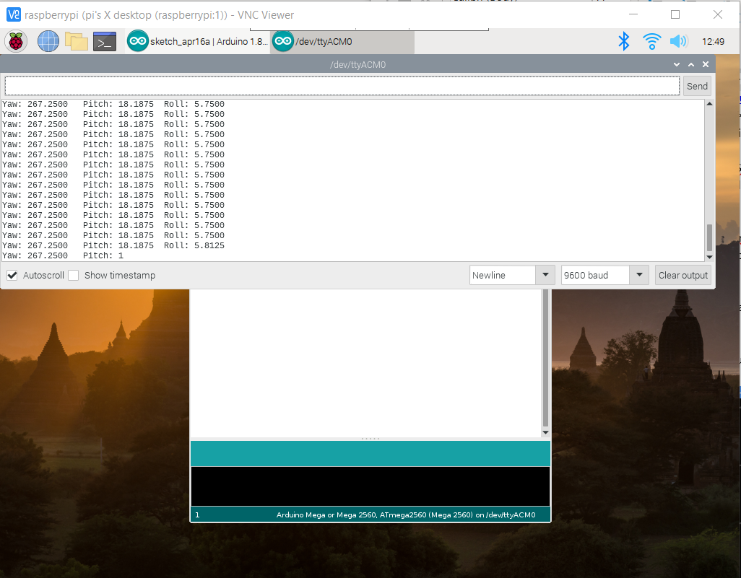

1. Run the sendimu.py script on the RPi
   1. This will act as a [TCP server](https://wiki.python.org/moin/TcpCommunication) to send data over TCP to the laptop
2. Run the getimu.py script on the laptop
   1. This will act as a [TCP client](https://wiki.python.org/moin/TcpCommunication) and receive IMU data from the RPi
   2. The IMU data will now stream via WiFi on the laptop and look like this:

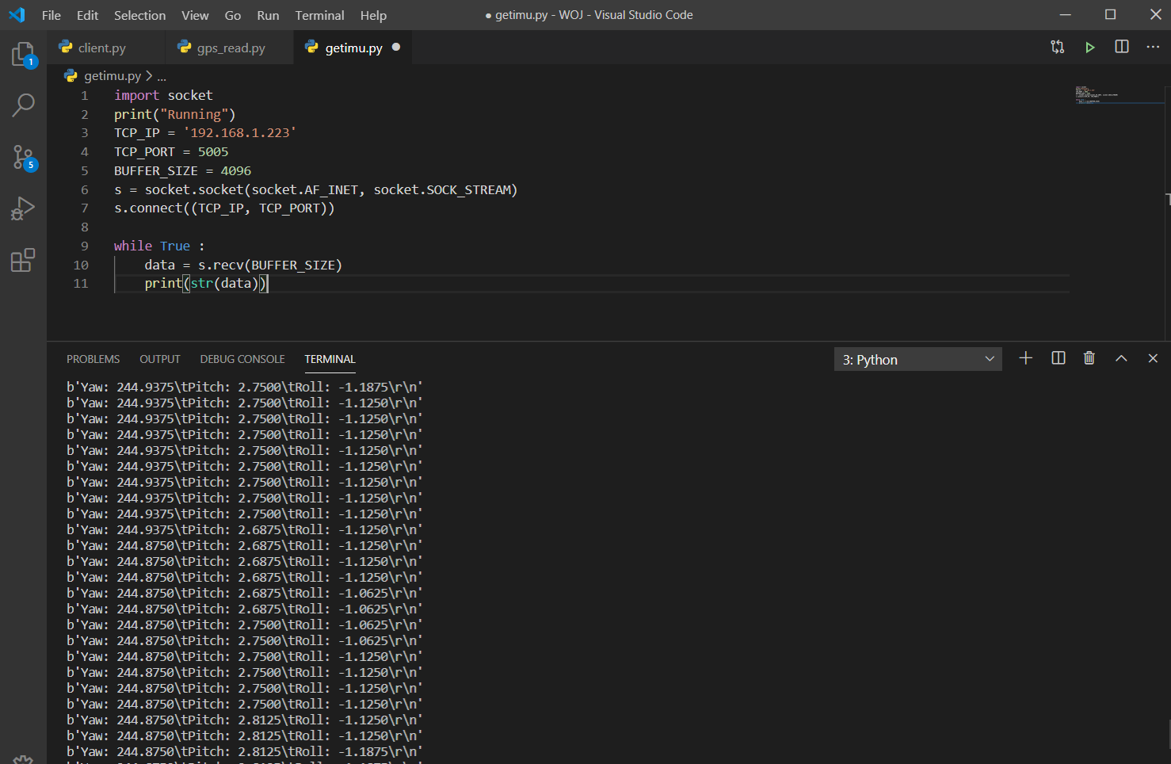

**Demo**

Demo can be found on YouTube at <https://youtu.be/FLw8Dr2p8QI>

**References**

Source 1: <https://www.youtube.com/watch?v=ySyBNdndB58>

Source 2: <https://create.arduino.cc/projecthub/feilipu/using-freertos-multi-tasking-in-arduino-ebc3cc>

Source 3: <https://cdn-learn.adafruit.com/downloads/pdf/adafruit-bno055-absolute-orientation-sensor.pdf>

Source 4: <https://www.raspberrypi.org/forums/viewtopic.php?t=185407>

Source 5: <https://raspberrypi.stackexchange.com/questions/70476/tcp-communication-raspberry-pi-and-pc-via-ethernet>

Source 6: <https://wiki.python.org/moin/TcpCommunication>

Source 7: Classmates! Thank you!