Lauren Courtney

April, 2020

EN 605.715.81 Embedded Systems

**Project 9 – Download IMU from Arduino to RPi to Host with Bluetooth**

**Requirements**

1. Connect the IMU sensor to the Arduino and collect Yaw, Pitch, and Roll data

a. Use FreeRTOS to do this

2. Send IMU data from the Arduino to the Raspberry Pi

a. Send this data using Serial over USB

3. Send the IMU data from the Raspberry Pi to your host.

a. Send this data over Bluetooth

4. Mount the Arduino and Raspberry Pi on the Quadcopter and capture Roll+Pitch+Yaw data while flying

a. Display the IMU data on your host as the quadcopter flies

**Design**

**Hardware**

1 Quadcopter (built per the instructions in project 4)

1 Adafruit BNO055 Absolute Orientation Sensor

1 Arduino – Mega 2560

1 serial to USB cable

1 Raspberry Pi in its case with Raspbian installed (set up per the instructions in project 6)

1 portable charger

1 USB to USB-C cable

4 Jumper cables

1 breadboard

1 Laptop

Wire the BNO055 to the Arduino based on [these instructions](https://cdn-learn.adafruit.com/downloads/pdf/adafruit-bno055-absolute-orientation-sensor.pdf). I have a Mega 2560, so I connected Vin to 3.3V power, GND to GND, SCL to digital pin 21, and SDA to digital pin 20. This is shown below:

These photos show the Arduino and BNO055 attached to the drone, I did not have a case so it is rather precarious. The Arduino is connected to the Raspberry Pi via the USB cable, and the Pi is still powered by the portable battery.

**Software**

1. Set up the Raspberry Pi based on the instructions in module 6
2. Set up the Arduino to transmit IMU data to the Pi based on the instructions in module 8
   1. You should see Yaw, Pitch, and Roll data printing on the Serial Monitor on the Arduino software running on the Pi, so it’s transmitting IMU data via serial successfully

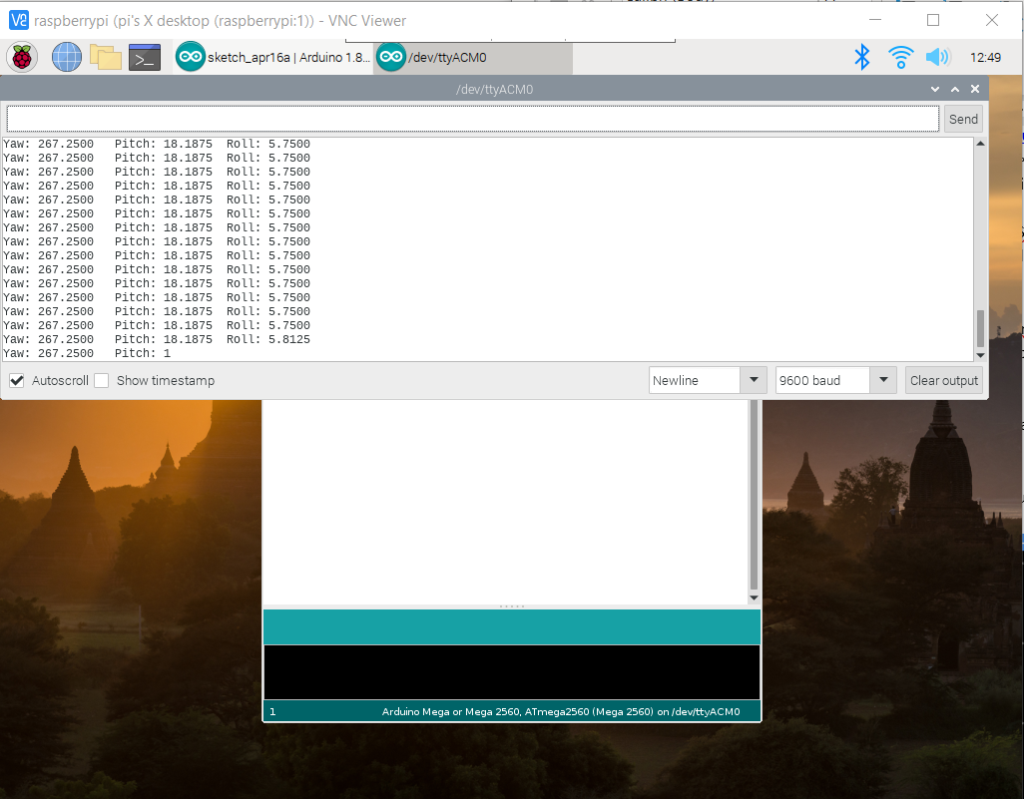

1. Configure the RPi for Bluetooth
   1. Create the file /home/pi/btserial.sh and write the contents as designated below:
      1. This is based on Alec’s implementation which is based on [this source](https://hacks.mozilla.org/2017/02/headless-raspberry-pi-configuration-over-bluetooth/)

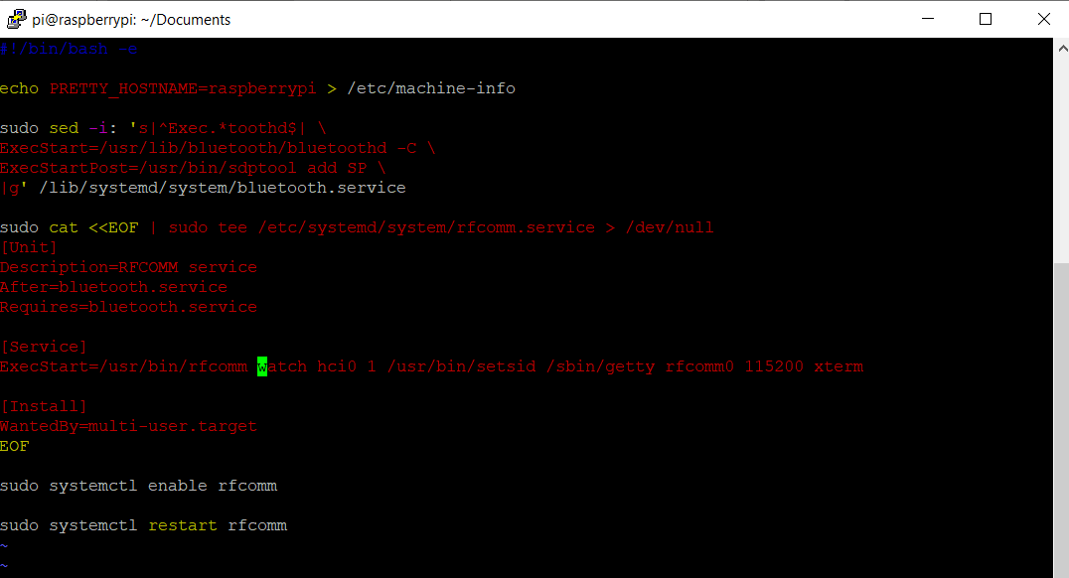

* 1. Make the file executable by running ‘sudo chmod 755 /home/pi/btserial.sh’
  2. Run this on startup by adding the line ‘sudo /home/pi/btserial.sh &’ to /etc/rc.local
  3. Reboot the raspberry pi with ‘sudo reboot’

1. Configure Windows 10 for Raspberry Pi Bluetooth
   1. Go to Start -> Settings -> Devices -> scroll down to Related Settings -> Devices and Printers -> find your laptop -> right click and open Bluetooth Settings
   2. Go to COM ports -> Add -> select Outgoing -> Browse -> select the Raspberry Pi -> click OK twice, now you should see the Raspberry Pi and its associated COM port

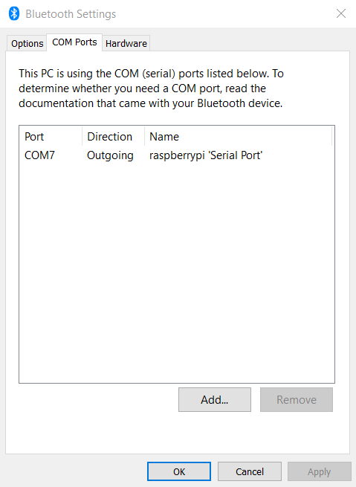

1. Now open PuTTY on your laptop, and you should be able to connect to the RPi via Bluetooth over that COM port with a baud rate of 115200

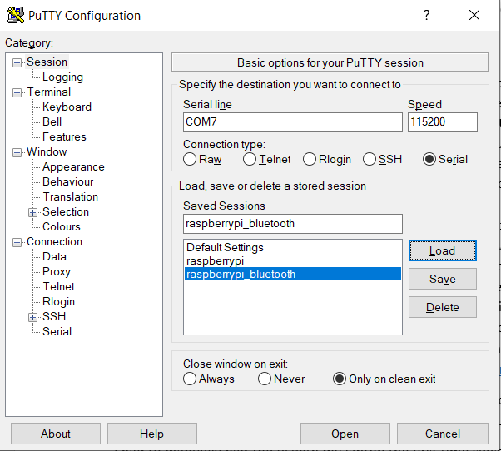

1. Now that you’re in the Pi, run display_imu.py to stream the IMU data from your host

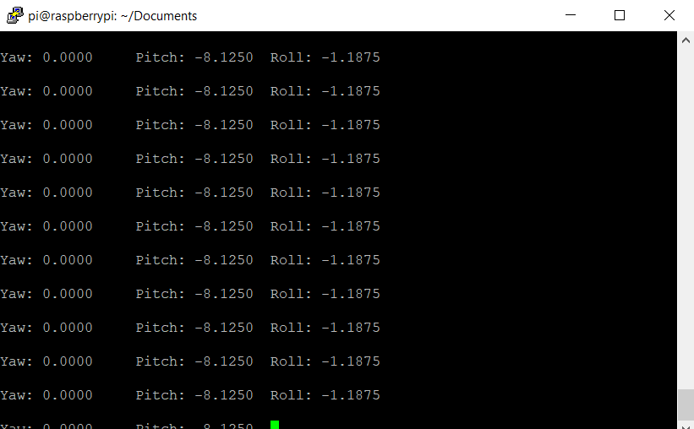

**Demo**

Demo can be found on YouTube at <https://youtu.be/n2angv-xlqI>

**References**

Source 1: <https://hacks.mozilla.org/2017/02/headless-raspberry-pi-configuration-over-bluetooth/>

Source 2: <https://www.instructables.com/id/Raspberry-Pi-Bluetooth-to-PuTTY-on-Windows-10/>

Source 3: Classmates, thank you!