Lauren Courtney

March, 2020

EN 605.715.81 Embedded Systems

**Project 4 – Build and Fly Drone – Final Solution**

**Requirements**

1. Build the drone based on the instructions listed in the module 5 documents

2. Use either the MiniPix or the KK flight controller and calibrate them correctly

3. Get the drone to fly

4. Register the drone with the FAA

**Design**

**Hardware (all provided in box except for adapter for MiniPix)**

1 frame with 4 ESCs

1 Frame Center

2 Frame Legs – Red

2 Frame Legs – White

4 Landing legs

2 LIPO Batteries

1 AC/DC Adapter to charge the batteries

1 BC Balance Charger

4 A2212/13T 1000KV motors

4 motor screws

4 motor caps

4 motor screw bases

16 motor nuts

2 Clockwise Propellers (1045)

2 Counter-clockwise Propellors (1045R)

4 Propellor gaskets to tighten propellors

20 2.5x.45x6mm hex cap screws

16 3x.5x8mm hex cap screws

1 T8F8 Transmitter

4 AA batteries to power transmitter

1 R8EF Receiver

1 MiniPix flight controller

1 MiniPix power module

1 MiniPix buzzer/safety button module

1 XT60 to T-Plug Adapter to power MiniPix (I had to order this from Amazon, it wasn’t in my kit)

1 Hex wrench for screws

Fasteners such as velcro, zip ties, and double sided tape to secure batteries and flight controller

1 Laptop

1 USB cable

Assemble the drone as described in the [video](https://blackboard.jhu.edu/bbcswebdav/pid-7439620-dt-content-rid-86103522_2/courses/EN.605.715.81.SP20/EN.605.715.81.SP20_ImportedContent_20191216013848/EN.605.715.81.FA19_ImportedContent_20190801014537/Qwinout%20450mm%20Frame%20DIY%20Drone%2002192-X.mp4) attached in the course module.

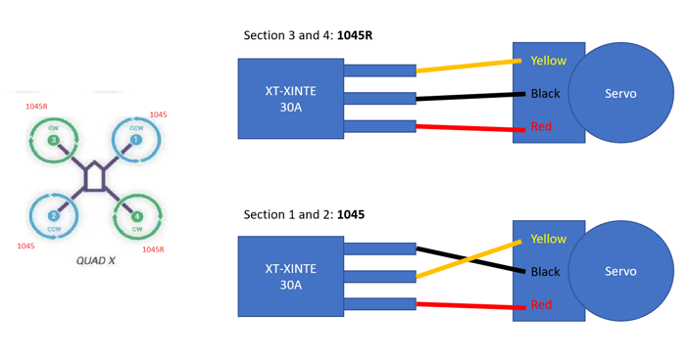Make sure your motors are plugged in to the flight controller based on the below diagram. The numbers correspond to the slot in the MiniPix that each ESC should be connected to.

Set up the MiniPix based on the instruction in the [manual](http://radiolink.com.cn/doce/UploadFile/ProductFile/MiniPixManual.pdf).

Below are photos of the assembled drone:

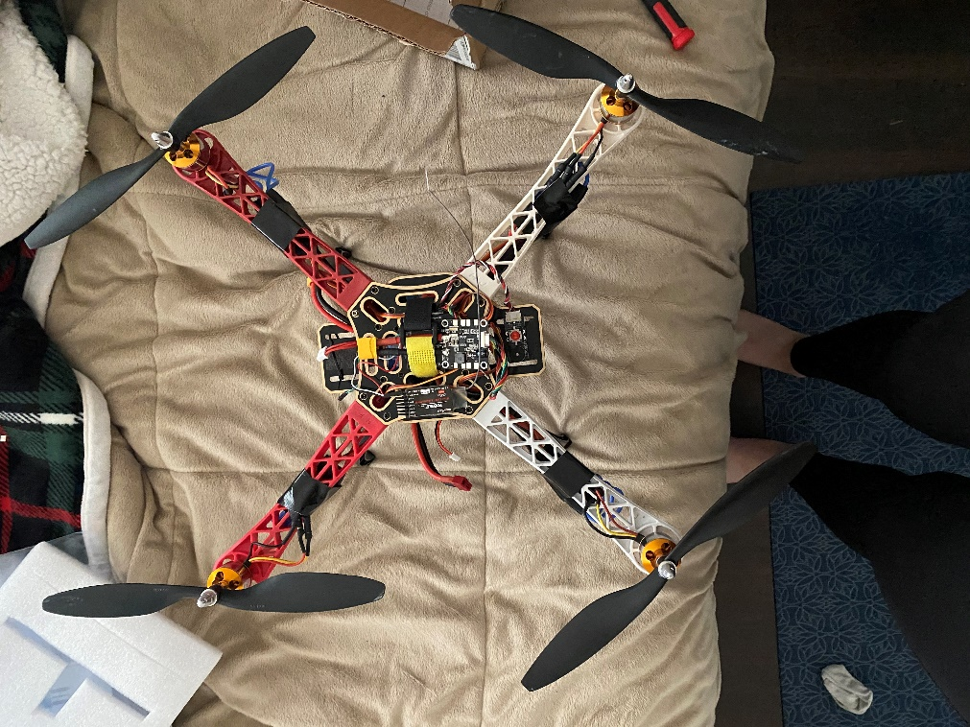

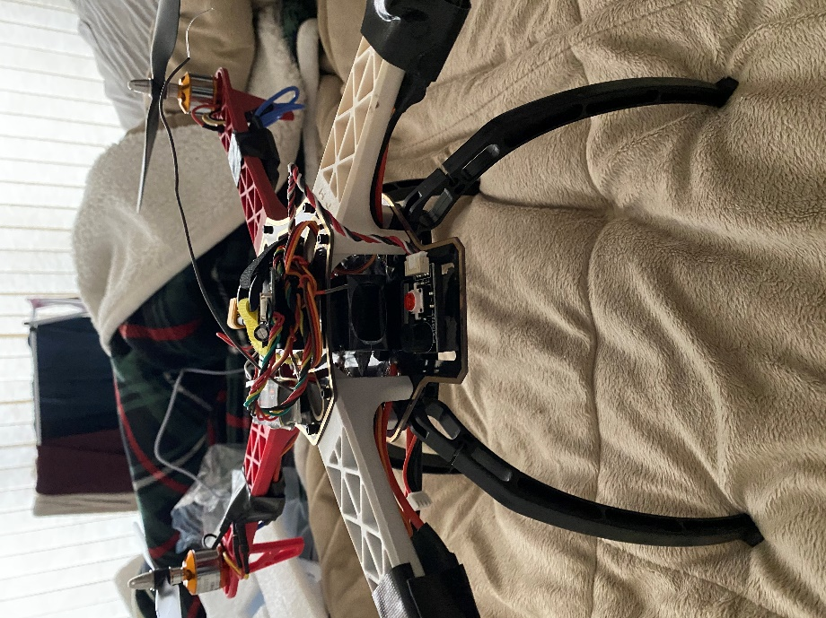 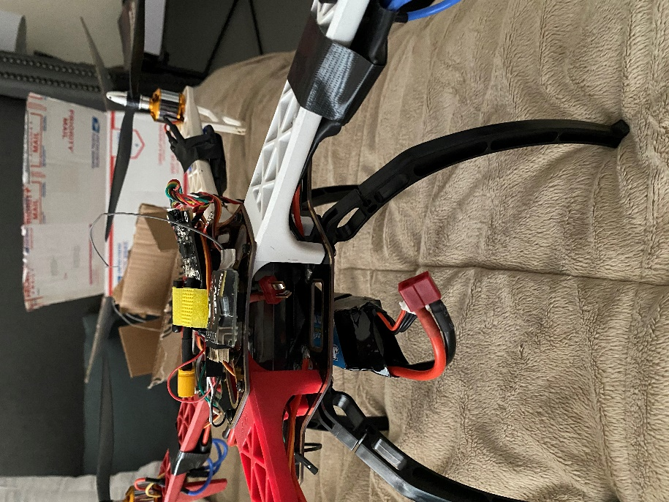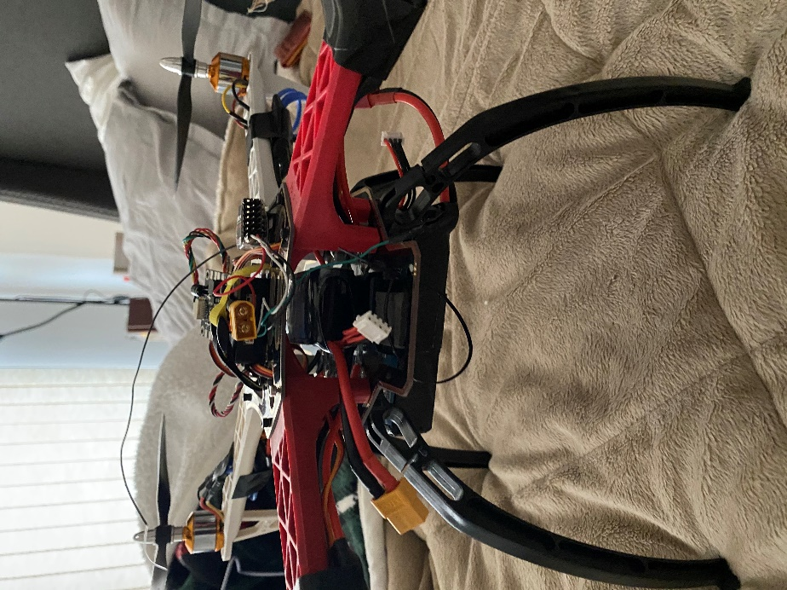 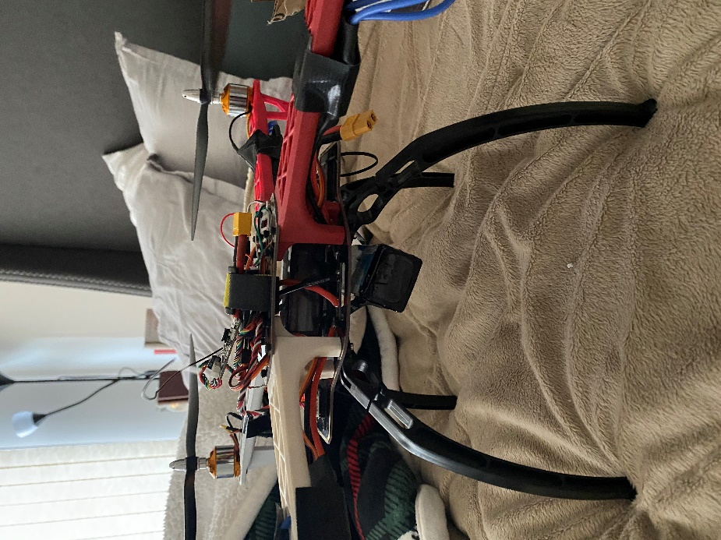

**Software**

* Download the MiniPix [drivers](https://dotnet.microsoft.com/download/dotnet-framework/net462) and the [Mission Planner software](http://radiolink.com.cn/doce/minipix-mission-planner.html) for RadioLink as provided.

I. Initialization

1. Connect the MiniPix to your computer via the USB cable

2. Go to the Initial Setup tab and choose “Wizard”

3. Choose the frame for a diagonal quadcopter and install the firmware

4. Make sure to set the flight modes to Stabilize

II. Configuration

1. Calibrate the accelerometer via the Wizard by placing the drone on each of its sides as [demonstrated.](https://ardupilot.org/copter/docs/common-accelerometer-calibration.html)

2. Calibrate the compass by spinning the drone along each of its axes as demonstrated [here.](https://www.youtube.com/watch?v=DmsueBS0J3E)

3. Set the R8F8 receiver to SBUS by pressing the button on its side twice in a row rapidly. The light should turn purple.

4. Turn on the transmitter to connect to the receiver, then calibrate the transmitter levels using the Wizard by toggling each switch as far as it goes.

5. Run the motor test in the Optional Hardware section of the Initial Setup tab

a. Check that the motors are spinning in the directions as listed

b. If one of the motors is not spinning the right way, switch two of the wires connecting it to the ESC to change its direction.

c. Ensure that the correct propellers go with the correct motors, per the diagram.



III. Fly

1. Disconnect the MiniPix from the computer and connect the battery to its power module
2. Connect the plug on the frame to the other battery to power the motors
3. Turn on the transmitter
4. Press the red safety button until it is solid
   1. The MiniPix button should now be blue, if it is not, plug the MiniPix back into the computer, connect it to the Mission Planner software, and check the reason for arming failure.
      1. If you get the error “Check Mag Field” it may be that the receiver is too close to a computer or that you need to recalibrate your compass
5. Arm the drone by holding the throttle (the left joystick) down and to the right
   1. If it works, you will hear a long beep from the motors
   2. If it does not work, you will hear two low beeps in a row, this means there was an error arming, plug in the MiniPix to see the error message.
6. You should now be able to fly the drone by increasing the throttle
   1. When I originally was unable to fly the drone after successful completion of all these steps, I found that one motor had significantly less thrust than the others. A new motor fixed these problems!

**FAA Registration**

Register your drone online as a recreational user at [Source 4](https://www.faa.gov/uas/recreational_fliers/). The cost of registration is $5. My drone’s registration ID is FA37N9EXWA and my registration is valid for 3 years.

**Demo**

I was able to get my drone to fly successfully, here is its first flight: <https://youtu.be/VQK5fOGVDEs>

A video of the motor test and my ESC configuration: <https://youtu.be/-NPDOWOKrjk>

And just for fun, a compilation of many failed flight attempts: <https://youtu.be/vQWz92ycPds>

😊

**References**

Source 1: <https://dotnet.microsoft.com/download/dotnet-framework/net462>

Source 2: <http://radiolink.com.cn/doce/minipix-mission-planner.html>

Source 3: <http://radiolink.com.cn/doce/UploadFile/ProductFile/MiniPixManual.pdf>

Source 4: <https://www.faa.gov/uas/recreational_fliers/>

Source 5: <https://www.youtube.com/watch?v=DmsueBS0J3E>

Source 6: <https://www.youtube.com/watch?v=X4746_KLVEI>

Source 7: <https://ardupilot.org/copter/docs/initial-setup.html>

Source 8: <https://blackboard.jhu.edu/bbcswebdav/pid-7439620-dt-content-rid-86103522_2/courses/EN.605.715.81.SP20/EN.605.715.81.SP20_ImportedContent_20191216013848/EN.605.715.81.FA19_ImportedContent_20190801014537/Qwinout%20450mm%20Frame%20DIY%20Drone%2002192-X.mp4>

Source 9: Classmates and the many troubleshooting suggestions in the Google thread. Thank you!