Lauren Courtney

March, 2020

EN 605.715.81 Embedded Systems

**Project 5 – ESP8266 Weather Station**

**Requirements**

1. Follow the directions in “[esp8266weatherstationsgettingstartedguide-20180911.pdf](https://blackboard.jhu.edu/bbcswebdav/pid-7439642-dt-content-rid-86103536_2/courses/EN.605.715.81.SP20/EN.605.715.81.SP20_ImportedContent_20191216013848/EN.605.715.81.FA19_ImportedContent_20190801014537/esp8266weatherstationgettingstartedguide-20180911.pdf)” to set up a weather station using the ESP8266

2. Use the ESP8266 to get weather data from Open Weather and display it on the OLED display

3. Use the DHT11 to get temperature and humidity readings and push them to Thingspeak using the ESP8266

a. Display a moving graph of the temperature and humidity readings in Thingspeak

b. Display the temperature and humidity data on the OLED display

**Design**

**Hardware**

1 Thing Pulse ESP8266 Weather Station Kit

Contents:

* ESP8266
* Serial to USB cable
* DHT11 temperature and humidity sensor
* Visual display module
* Jumper cables

1 Laptop

Connect the OLED display to the ESP8266 as shown:

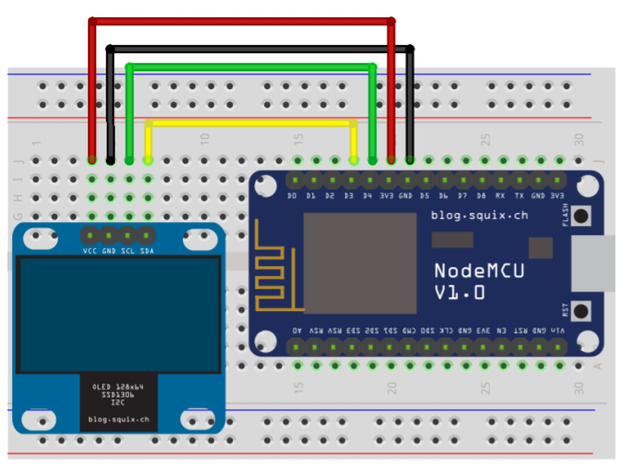

Connect the DHT11 to the ESP8266 as shown:

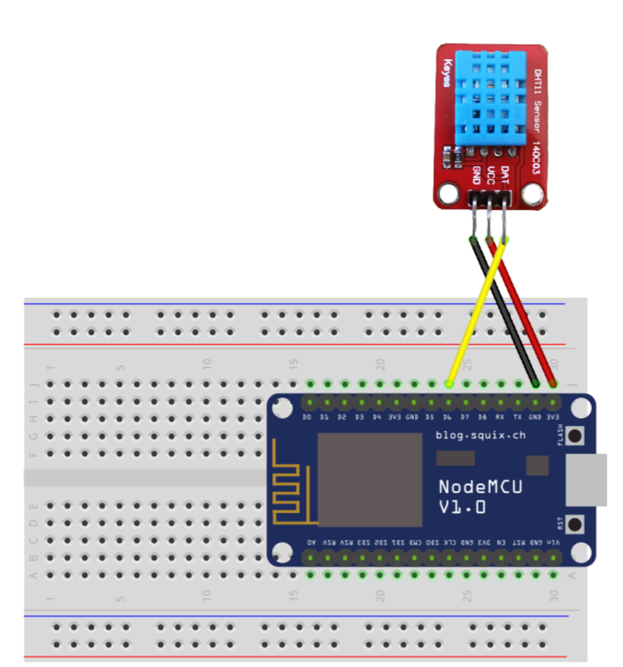

Note I did not use a breadboard in my implementation and instead wired everything in directly, but a breadboard is certainly an option for a more secure weather station.

**Software**

* Download the CP2012 [drivers](https://www.silabs.com/products/development-tools/software/usb-to-uart-bridge-vcp-drivers)
* Set up the Arduino Board Managers to understand the ESP8266
  + In your Arduino IDE, File -> Preferences -> Additional Board Manager URLs and add the URL: http://arduino.esp8266.com/stable/package_esp8266com_index.json
  + Tools -> Board -> Boards Manager -> search for ESP8266 board and click Install
    - Make sure you have the latest version of the tool chain installed
* Make sure you choose the correct board: with the starter kit you have NodeMCU
  + Choose that with Tools -> Board -> NodeMCU 1.0 (ESP-12E Module)
* Install the necessary libraries
  + Sketch -> Include Library -> Manage Libraries
    - Search for “esp8266 oled” and install “ESP8266 and ESP32 OLED driver for SSD1306 display”; for the OLED display
    - Search for “dht espx” and install “DHT sensor library for ESPx”; for the DHT11
    - Search for “[WiFi Manager](https://github.com/tzapu/WiFiManager/blob/master/README.md)” and install the one by “tzapu”; for WiFi security
    - Search for “esp8266 weather station” and install “ESP8266 Weather Station”
    - When you install the Weather Station, you may be prompted to also install the Json Parser, but if not: search for “json streaming parser” and install “Json Streaming Parser by Daniel Eichhorn”; for reading and understanding data from weather service

I. Check that ESP8266 runs as expected by pushing the WIFI scan sketch

1. Connect the ESP8266 to your computer using the Serial cable
2. Go to File -> Examples -> ESP2866 Wifi -> Wifi Scan
3. Compile and push this to your device
4. Open the serial monitor. You should see that the ESP8266 is now running a wifi scan of available networks.

II. Use the Weather Station Demo to get started

1. Go to File -> Examples -> ESP8266 Weather Station -> WeatherStationDemo
2. Get the OpenWeatherMap API Key
   1. Go to [OpenWeatherMap](https://openweathermap.org/appid), sign up, then get your key [here](https://home.openweathermap.org/api_keys)
3. Adjust the parameters for your setup:
   1. Use the WiFi Manager to connect securely to your WiFi network
   2. Ensure the display settings correspond to your display pins (D3 and D4)
   3. Change the time client settings to your UTC-relative time zone
   4. Add in your API key
   5. Choose your location on [OpenWeatherMap](https://openweathermap.org/find?q), and set the location ID accordingly (based on the digit at the end of the URL for your location’s map).
4. You should now be able to display a weather station for your area

III. Adjust the Weather Station to display local data

1. Use [Thingspeak](https://thingspeak.com/users/sign_up) to display your local data
   1. Sign up for an account
   2. Go to My Channels -> New Channel and fill in the Name, Description, Field 1 as Temperature and Field 2 as Humidity
   3. Find the API keys for your channel, write and read.
   4. Note the Channel ID
2. Push temperature and humidity data to Thingspeak every 15 seconds
   1. pushThingspeak – based on this [reference](https://github.com/squix78/esp8266-dht-thingspeak-logger/blob/master/esp8266-dht-thingspeak-logger.ino)
3. Pull down most recent Thingspeak data during every display update
   1. Use the [ThingspeakClient](https://github.com/ThingPulse/esp8266-weather-station/blob/master/src/ThingspeakClient.cpp) provided
4. Create a new frame to display temperature and humidity data

**Demo**

Demo can be found on YouTube at https://youtu.be/_03Wa_DgG7g

**References**

Source 1: <https://blackboard.jhu.edu/bbcswebdav/pid-7439642-dt-content-rid-86103536_2/courses/EN.605.715.81.SP20/EN.605.715.81.SP20_ImportedContent_20191216013848/EN.605.715.81.FA19_ImportedContent_20190801014537/esp8266weatherstationgettingstartedguide-20180911.pdf>

Source 2: <https://www.silabs.com/products/development-tools/software/usb-to-uart-bridge-vcp-drivers>

Source 3: http://arduino.esp8266.com/stable/package_esp8266com_index.json

Source 4: <https://github.com/tzapu/WiFiManager/blob/master/README.md>

Source 5: <https://openweathermap.org/appid>

Source 6: <https://home.openweathermap.org/api_keys>

Source 7: <https://openweathermap.org/find?q>

Source 8: <https://thingspeak.com/users/sign_up>

Source 9: <https://github.com/squix78/esp8266-dht-thingspeak-logger/blob/master/esp8266-dht-thingspeak-logger.ino>

Source 10: <https://github.com/ThingPulse/esp8266-weather-station/blob/master/src/ThingspeakClient.cpp>