Lauren Courtney

Data Visualization

April 2020

**Final Paper**

**Abstract**

This paper explores terrorist activity globally over the last 50 years [1], exploring trends and patterns. Location, attack type, terrorist groups, and fatality rates are used to draw conclusions about terrorist activity. A Tableau dashboard is created to explore the data in depth, along with a visualization in Python to further enhance analysis. The results demonstrate clear shifts in the locations of terrorism throughout the decades, favoring of certain attack types by certain groups, and a penchant for the most fatal attack types by the most active groups. Global events are mapped to spikes and drops in terrorist activity, leading to the assessment that instability in a region can be directly mapped to increases in terrorist activity, though it is unclear which is the causal factor in this relationship.

**Introduction**

The Global Terrorism database “was designed to document every known terrorist event across time” [2]. It summarizes key information from all terrorist attacks from 1970 to 2017 across the globe. This paper analyzes that data in order to answer the question: How has terrorism changed over time? The goal of the paper is to identify the changes in terrorist activity and map those to world events that may have been contributing factors. Specifically, the paper will explore how the locations in which terrorism occurs and the types of terrorist attacks have changed in the last 50 years.

**Background**

The Global Terrorism Dataset was compiled by the University of Maryland using information on terrorist attacks from a variety of sources including newspapers and official government reports [2]. The definition of terrorism used to qualify events for this data set is: “the threatened or actual use of illegal force, directed against civilian targets, by non-state actors, in order to attain a political, economic, religious or social goal, through fear, coercion, or intimidation” [3]. A known weakness in the dataset includes potential media bias in documenting events, but otherwise it is the most comprehensive database of terrorist activity openly available. It has over 181,000 rows each indicating a separate terrorist event, and it has 151 features with information for each event. This paper focuses on only a few of these many features, namely location, attack type, number of people killed/wounded, and terrorist group, but there is potential to dig far deeper into the data’s many facets.

Many researchers have used this dataset to make conclusions about the global terrorism landscape. The team that compiled the data released a summary of its trends in 2008 [3]. At the time, the number of attacks in 2008 had reached the previous peak from 1992. The paper highlighted that terrorism was at its lowest levels in the years leading up to 9/11, yet sharply spiked since then. After 2008, attacks continued to climb, so this paper strives to update conclusions made over a decade ago with new data.

Other research uses this data to narrow in on specific regions, such as a paper on the efficacy of counter-terrorism interventions in Australia and neighboring nations [4]. Specifically, the findings show that interventions that are successful in one region can have opposite effects in another. That research provides an insightful example of enhancing terrorism data with policy and political data. Additionally, a team at the University of South Carolina explored the complexities of visualizing the intensely multi-variate terrorism data sets [5]. Both of these works heavily influenced the analysis in this paper.

**Approach**

A dashboard was created in Tableau to allow for deep exploration of the data, and a visualization was made in Python to augment the results displayed in the dashboard. Three main features were explored: location, attack type, and terrorist groups.

In exploring location, the visualization seeks to answer how the countries in which terrorist attacks occur have changed over time. Countries were assigned for each attack given the historical name at the time of the attack [2]. Thus, a few values needed to be normalized. For instance, Yugoslavia was mapped to modern day Serbia, and USSR to Russia. The first visualization was created as part of the Tableau dashboard. It shows countries of the world colored with intensity based on the attack type. A filter allows users to narrow in based on attack year. Figure 1 gives an example of this visualization filtered from 1990 to 2000. Moving the time filter allows users to watch as the global terrorism landscape changes.

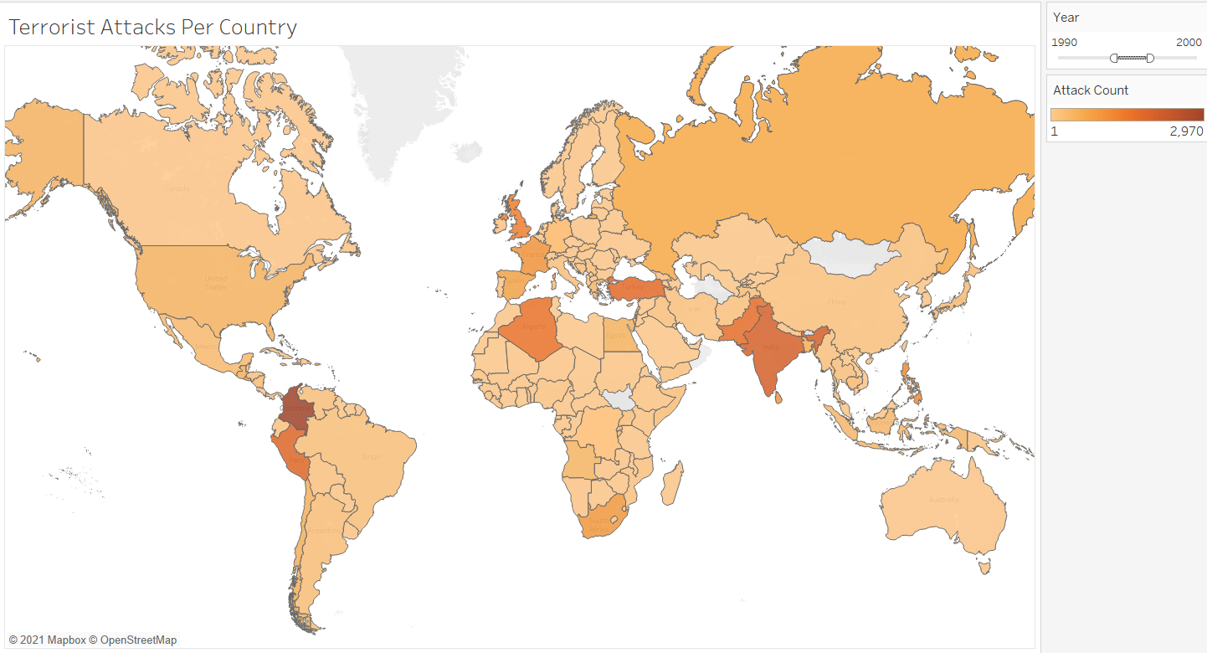*Figure 1: Terrorist attack count per country from 1990 to 2000.*

Figure 1 is not able to give a holistic sense of how terrorist attacks have moved throughout regions of the world without significant user interaction. To quickly gain a full view of the terrorist landscape, a single visualization was created in Python based on attack region. Figure 2 groups the number of attacks into 12 regions of the world. It displays those over time in a multi-line graph.

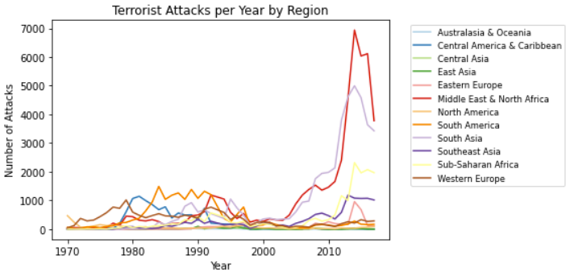*Figure 2: Terrorist attacks per year based on geographical region*

The second variable explored was attack type – how had terrorist attacks themselves changed over time? The dataset categorizes all attacks into one of 9 categories. There is some overlap within these categories, and sometimes attacks involve more than one; therefore, each event was assigned up to three attack types [2]. For the purposes of this analysis, only the primary attack type was used for each attack. One visualization on this topic created in Tableau is a multi-line graph seen in Figure 3 showing attacks per year, with each line colored based on attack type.

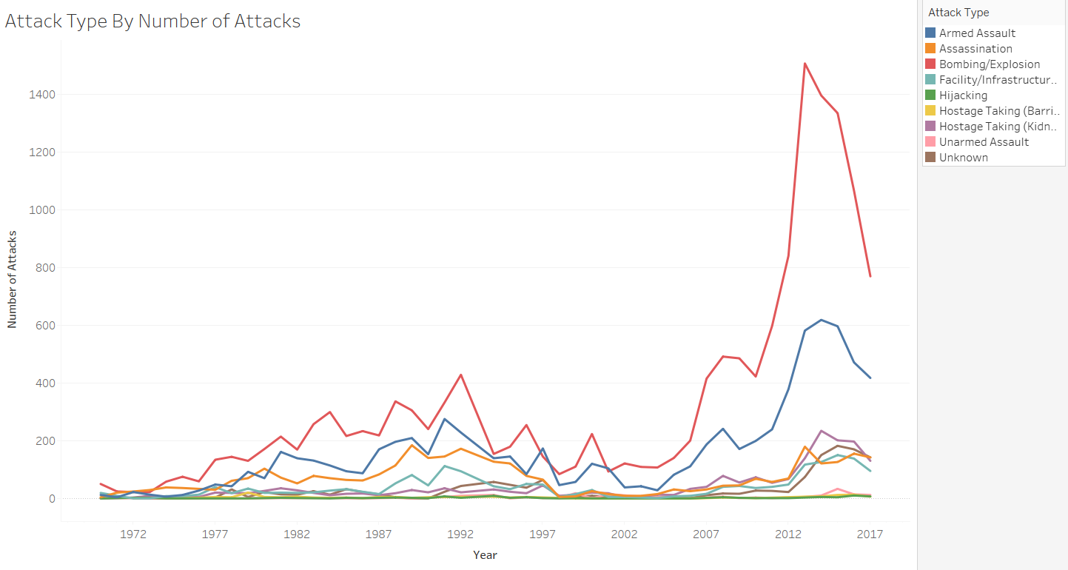*Figure 3: Total attacks per year colored by attack type.*

While Figure 3 shows which attack types are most common, a logical next question is which attack types are most deadly? A stacked bar chart was used to visualize this question. This visualization can be seen in the bottom left of the dashboard in Figure 4. Because this also summarizes attack types, the visualization in Figure 3 was not incorporated into the dashboard in favor of this one.

The final variable explored was the group attributed to each terrorist attack. This was slightly more complex as over 3,000 groups were named, and over 80,000 attacks had an unknown group. The 15 groups who were attributed to the most attacks were chosen for this visualization, and a bar chart created in Tableau is shown in the bottom right of the dashboard. Abbreviations are used for terrorist group names in order to display a cleaner axis.

The combination of these three variables in the dashboard in Figure 4 allows for more complex questions to be answered, such as which time periods were deadliest and why, or to identify where certain groups were most prevalent and the attack types they employed. All three visualizations act as filters, so users can narrow in on particular countries, eras, attack types, or groups. The discoveries derived from pivoting the dashboard in such ways are explored in the Results section below. This dashboard is published to Tableau Public [8].

*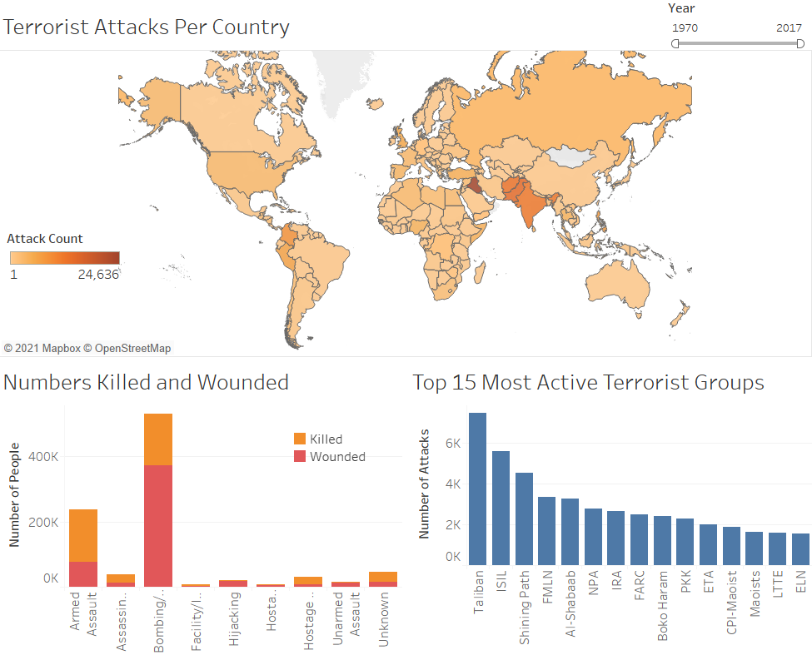Figure 4: Tableau dashboard exploring Global Terrorism dataset*

**Results**

To analyze how terrorism has changed over time we turn first to our location visualizations to answer how the countries in which terrorist attacks have taken place changed over time. Figure 1 above showed terrorist attacks in the 1990s. They were concentrated in Latin America and South-Central Asia. Compare this to Figure 5 below, which shows attacks in the 2000s. Iraq, which had only 135 terrorist attacks in the 90s, had 6,368 in the 2000s. This rise in terrorism over the early 2000s correlates directly to United States’ war on terror following the attacks of 9/11.

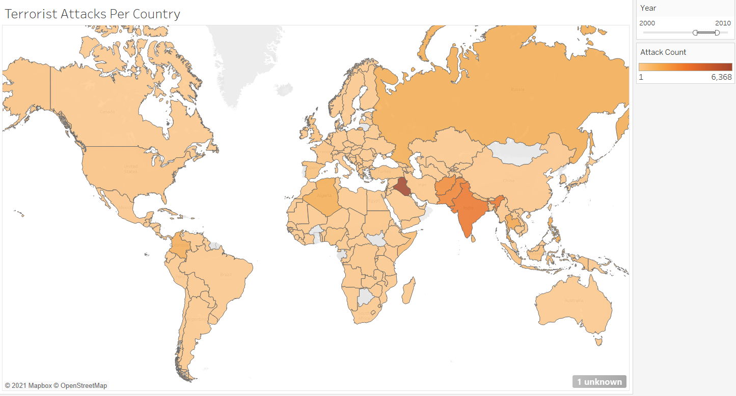

*Figure 5: Terrorist attacks per country from 2000 to 2010.*

The relationship between political unrest or war in a country is directly correlated to the number of terrorist attacks in the region. Figure 2 shows that the all-time spike in terrorist attacks occurred in 2013 primarily in the Middle East. The BBC attributes this spike to the war and destabilization in Syria at the time [6]. The overall amount of terrorist activity does begin to fall around 2016 which can be attributed to the deterioration of ISIL [7]. This data is not sufficient to indicate whether political unrest is caused by terrorism or whether terrorism leads to unrest, but it is clear that the two are correlated.

Terrorism in the Middle East and South-Central Asia truly dominates the 21st century, though this was not the case in previous decades; specifically, the mid-80s to 90s when South America had the globe’s highest terrorism rates. Once terrorism declined in this region, it has stayed relatively low. It will be interesting to follow the trend line in the Middle East to determine if the same may hold true there.

Analysis of the attack type sheds further light. An unexpected result is that the attack types appear to be correlated to one another. Spikes in terrorist activity do not involve just spikes in one particular attack type, but increases in many types of attacks. This demonstrates that terrorists employ a variety of tactics rather than just one method.

The relationships between terrorist group, attack type, and location are quite interesting. Between 1970 and 1985, armed assaults and bombings were equally prevalent, with Latin American groups generally favoring armed assaults, and the majority of bombings conducted by European groups. Over the next 15 years bombings begin to overtake armed assaults, led primarily by South Central Asian groups. Starting in 2000 with the rise of groups such as the Taliban and ISIL, bombing becomes the clear attack type of choice for terrorist groups, particularly in the Middle East. Simultaneously, groups in other parts of the world become increasingly less active, though overall terrorism levels still experience a significant increase.

Unfortunately, the deadliest attack types, bombing and armed assaults, are also the most prevalent, though this does give insight into the intentions of terrorists. While perhaps a forgone conclusion, the dataset clearly demonstrates that the intention of most terrorists is to kill and harm, wreaking the most devastation possible. In understanding the motivations and goals of terrorists, hopefully insight can be gained that will lead to effective techniques to stop them.

**Conclusion**

A plethora of interesting information is present in these datasets that is yet to be explored. This paper did not touch on even a fraction of the groups committing the attacks, nor did it investigate the types of victims. Future work would be focused on expanding the variables which are considered and exploring different ways to visualize many variables while maintaining clarity. Additionally, narrowing in on one specific region or group would allow for more fine-grained analysis. A natural next step for this kind of trend analysis is to think about not only what causes terrorism rates to spike, but also what causes them to drop, and to try to more conclusively identify which comes first: unrest or terrorism. Latin American efforts to quell terrorism in the 90s would provide an interesting example of a strategy that appears to have worked, but it is known that counter-terrorism strategies in one region are not always effective in another [4].

In conclusion, changes in terrorism over time include shifting to different regions, now squarely focused in the Middle East, and a transition to bombings as the primary attack type. Major increases or decreases in terrorism levels can be mapped to political or structural events such as war or policy changes. The causality in these mappings is undetermined, but the relationship is undeniable. Additionally, much can be understood about the motivations of terrorist groups by examining a dataset such as this one. Namely, terrorists strive to cause as much devastation as possible. Perhaps more optimistically, no group has remained highly active over the entire 50-year period examined, giving hope that the groups of today will not be concerns in the future. Pessimistically, the data also shows that new groups have continued to pop up, so there is still much work to be done to decrease global terrorism levels as a whole. Data-driven analysis provides invaluable insights, and it is key to developing strong counter-terrorism strategies.

**References**

[1] “Global Terrorism Database.” *Kaggle*, www.kaggle.com/START-UMD/gtd.

[2] Dugan, L., Fogg, H. V., La Free, G., & Scott, J. (2006). *Building a global terrorism database* National Criminal Justice Reference Service. Retrieved from http://proxy.library.jhu.edu/login?url=https://www.proquest.com/books/building-global- terrorism-database/docview/58768381/se-2?accountid=11752

[3] LaFree G. (2012) Generating Terrorism Event Databases: Results from the Global Terrorism Database, 1970 to 2008. In: Lum C., Kennedy L. (eds) Evidence-Based Counterterrorism Policy. Springer Series on Evidence-Based Crime Policy, vol 3. Springer, New York, NY. https://doi.org/10.1007/978-1-4614-0953-3_3

[4] White, G., Mazerolle, L., Porter, M. D., & Chalk, P. (2014). *Modelling the effectiveness of counter- terrorism interventions* Australian Institute of Criminology. Retrieved from http://proxy.library.jhu.edu/login?url=https://www.proquest.com/books/modelling- effectiveness-counter-terrorism/docview/1735644982/se-2?accountid=11752

[5] Guo D, Liao K, Morgan M. Visualizing Patterns in a Global Terrorism Incident Database. *Environment and Planning B: Planning and Design*. 2007;34(5):767-784. doi:10.1068/b3305

[6] Cheung, Helier. “Global Terror Attack Deaths Rose Sharply in 2013, Says Report.” *BBC News*, BBC, 18 Nov. 2014, www.bbc.com/news/world-30086435.

[7] “Report: Terrorism on Decline in Middle East and North Africa.” *Wilson Center*, www.wilsoncenter.org/article/report-terrorism-decline-middle-east-and-north-africa.

[8]https://public.tableau.com/profile/lauren6941#!/vizhome/GlobalTerrorismDashboard_16187201999550/Dashboard-Final