Lauren Courtney

April, 2021

Data Visualization

**Project 5 – Scientific Visualization Using ParaView**

**Introduction**

Two datasets, “Skull.nrrd” and “lobster.raw” were used to explore visualization in ParaView. The first comes from a repository of 3D data meant to provide blueprints for 3D printing of medical conditions. There were many CT scan datasets available to choose from that could be easily rendered in ParaView. The second dataset comes from a repository of CT scans of various objects. CT scans offer very detailed information that can be easily explored within ParaView, so both datasets provided an interesting starting point.

**Skull.nrrd**

This dataset is a CT scan of a human head without contrast [1]. It was uploaded to the medical imaging website on 12/14/2020, so it can be assumed to be relatively recent data. There is not further information about the patient, such as gender, so this information remains unknown. The file type is .nrrd which is N-dimensional raster data, commonly used in the scientific visualization field. The size according to the ParaView information tab is 512x512x291.

The first visualization involves volume rendering. Initially, all that was visible in volume rendering was a large box around the skull, so tinkering was done with the color map in order to remove the outer layer of the box and only show the skull. Essentially the color levels were modified so only the very most dense items would be shown. In this rendering, the areas of most density are shown in red and least density in blue. The brain is not visible in this rendering, it only shows the skull and teeth. This visualization is good if you are only trying to see the bones of the head, one could imagine it might be used to look for fractures or other skull abnormalities.

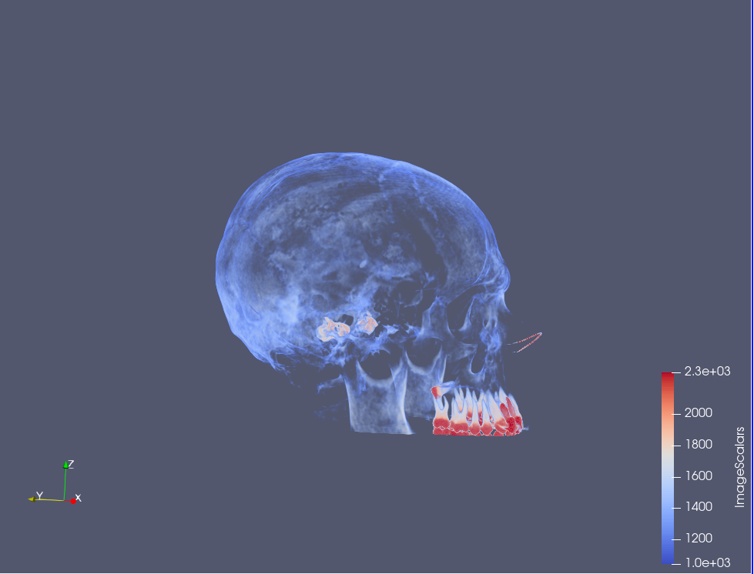

The next visualization shows a different view of volume rendering, this displays slices of the head. You can move this slice along the central axis to see slices at all different points throughout the head. The color map was changed from Diverging to Step in order to see the contours in the brain itself, which are not visible in other views. While the dataset is not granular enough to give a an ultra-clear image of the brain, we would be able to see any masses or abnormalities in the brain with this visualization. We can also change the central axis to take the cross section from a different part of the brain. The first view below is a cross section along the X-axis, as if you were cutting the head in half from the nose, and the second view shows cross-sections along the Z-axis, so looking down on the head from above.

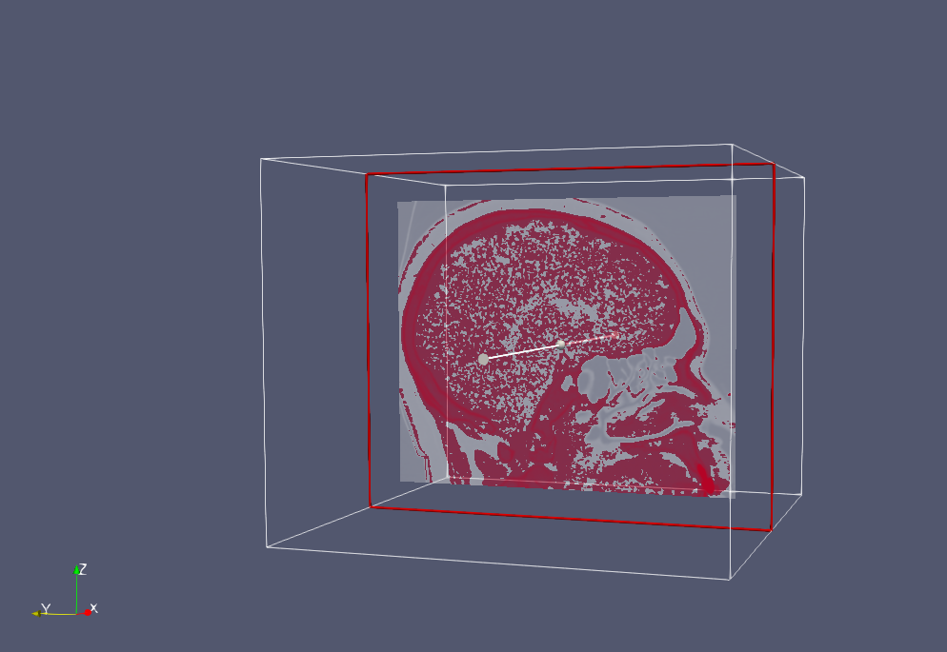

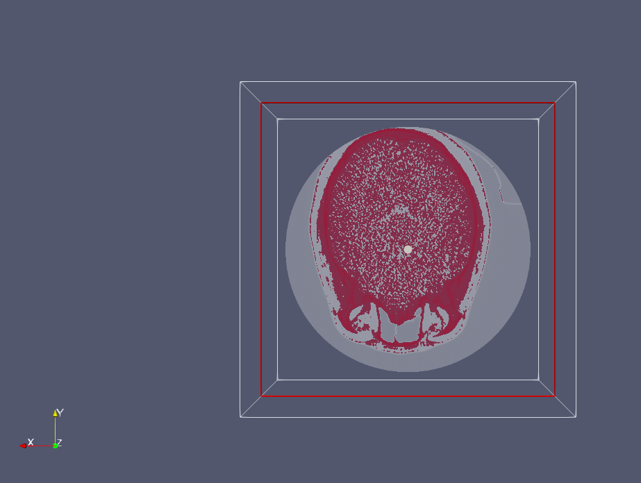

The third visualization of the skull data shows the isosurface view, in which you can see both the skull and the brain. Isosurfaces connect all data points that have the same scalar value, so they are useful to give an idea of depth [2]. I had to modify the color map to show this view by enabling opacity mapping for surface and toggling the color scale a bit until the brain came into clear focus as compared to the skull. I wanted to add a filter that would slice through this view as well in order to show the inside of the brain; however, Paraview crashes anytime I try to add additional filters. This visualization is good to show the relationships between the organs and the bones, and you can imagine that it is important in medicine to get a holistic view of the organs and skull.

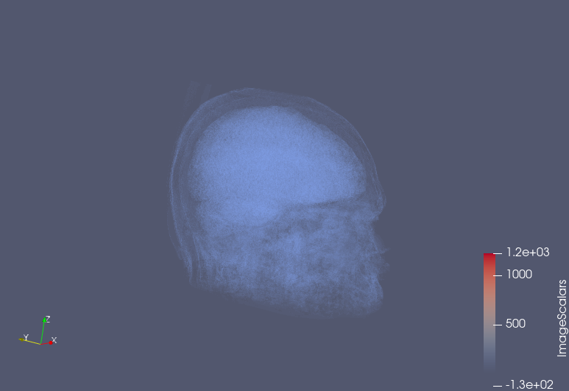

**Lobster.raw**

This dataset is a CT scan of a lobster encased within a block of resin [3]. The file extension was simply “.raw”, so in order to properly read in this file, I needed to use metadata describing the file itself. The data’s header indicates the data is uint8, meaning it should be read in as unsigned char, and it also specified that it was little endian. It’s dimensions are specified as well, 301x324x56. To read in this data, I used ParaView’s ImageReader which then allows you to specify these data properties, along with the dimensions in the Data Extent field. Once loaded in, it is very clear to see that resin and the lobster. The block of resin appears to be oval shaped, and we can assume from the fact that it was encased that the lobster was dead at the time of scanning. No further information is known about the data set.

The first visualization is a volume rendering of the lobster. With the default volume rendering, the encasing resin is seen in blue, and the lobster itself is clearly visible inside. However, by changing the lower bound on the opacity mapping, I was able to completely eliminate the resin from view, leaving only the lobster. The exoskeleton of the lobster is more transparent, while the lobster’s internal tissues appear more solid. This view is useful to simultaneously see the full shape of the lobster while also being able to view its internals.

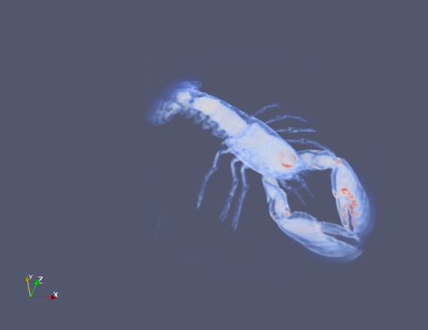

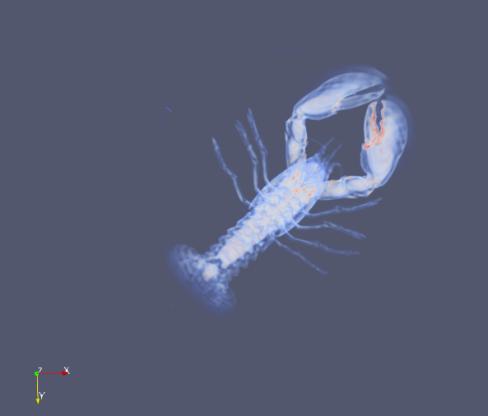

The second visualization shows slices of the lobster along the Z-axis. You can move this slice up and down, but I find it most interesting as close to the middle of the lobster as you can get, which allows you to see as much of the inside of the lobster’s body and claws as possible. This view is enabled with the volume rendering of the lobster and choosing Blend of Slice. Then the range of the visualization mapping is again adjusted to make sure that none of the resin falls within the range, therefor the resin is not shown (though it is there quite faintly in dark blue if you look closely).

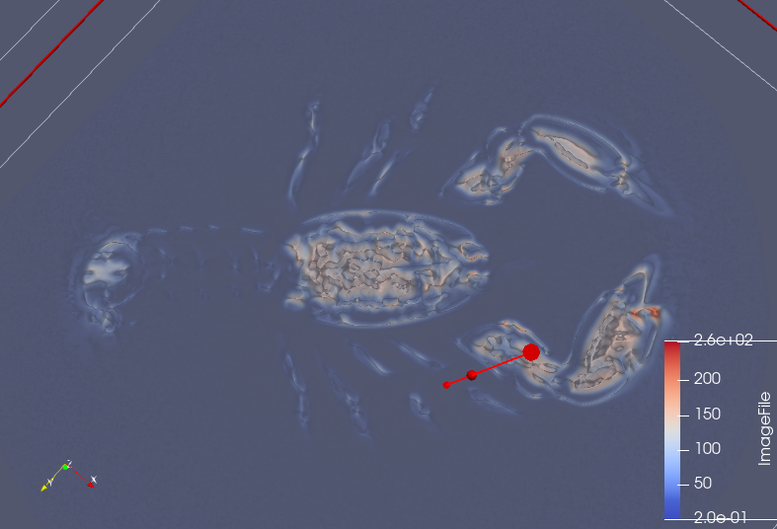

The final visualization shows an isosurface rendering of the lobster. The isosurface value chosen is 80, as this is the level at which most of the lobster is visible. The color mapping was modified to make the lobster red rather than blue, this was purely an aesthetic choice so it looks more like a lobster. The mapping was also modified to make the lobster look more filled in rather than transparent. While some of the lobster’s internals can be seen, this view is mostly focused on displaying the exoskeleton of the lobster, which is plainly seen.

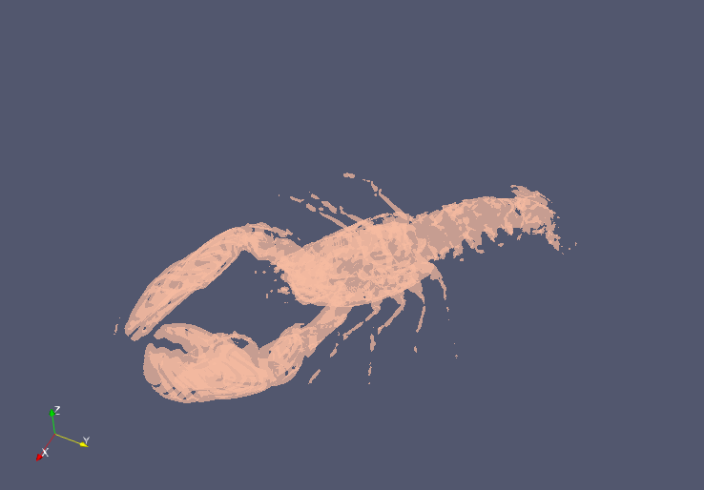

**References**

[1] <https://www.embodi3d.com/files/file/44675-ct-scan/>

[2] <https://cvw.cac.cornell.edu/Paraview/isosurfaces>

[3] <http://klacansky.com/open-scivis-datasets/>