**Microwave Lab3**

*Calibration Meas*

|  |  |
| --- | --- |
| **Uncalibrated gain measurements** | **Calibrated gain measurements** |
| Gain | Gain |
| Phase | Phase |

We can observe that the calibration process enabled the S parameter S11 to decrease in magnitude which results in a decrease of the loss or of the noise that come with the signal. S22 goes to 0 dB after calibration process.

Regarding the phase, we can clearly see a tendency for the calibrated port S12 and S21 to be defined (somehow constant) whereas the uncalibrated ports keeps variating very abruptly.

*Coupler Measurements*

S21=-7.38dB S12=-7.09dB S21/12=transmission in-coupledport=-0.29dB

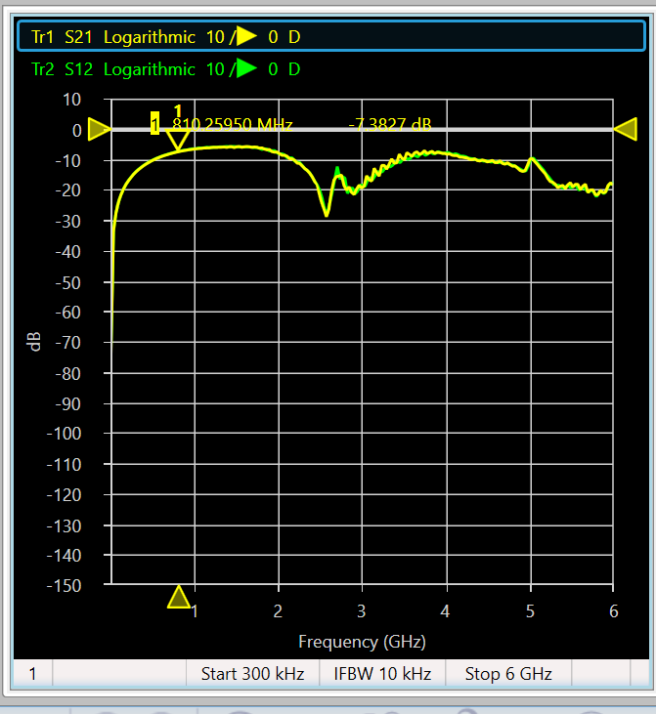 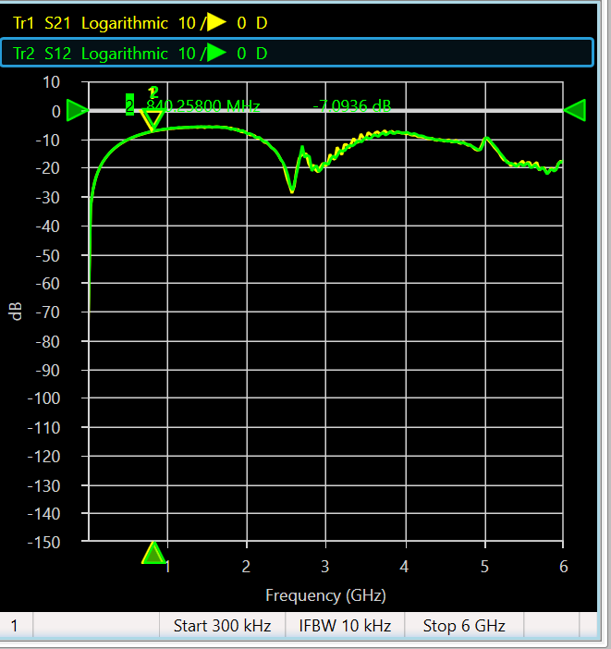

S12 gain = -38.161dB, S21 gain = -38.357dB, S21/S12 out-coupled = 0.196dB

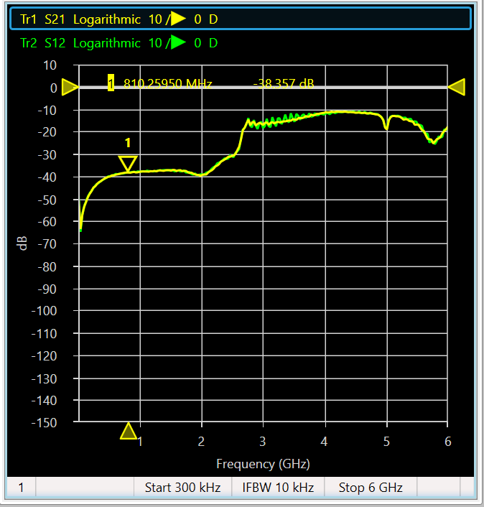 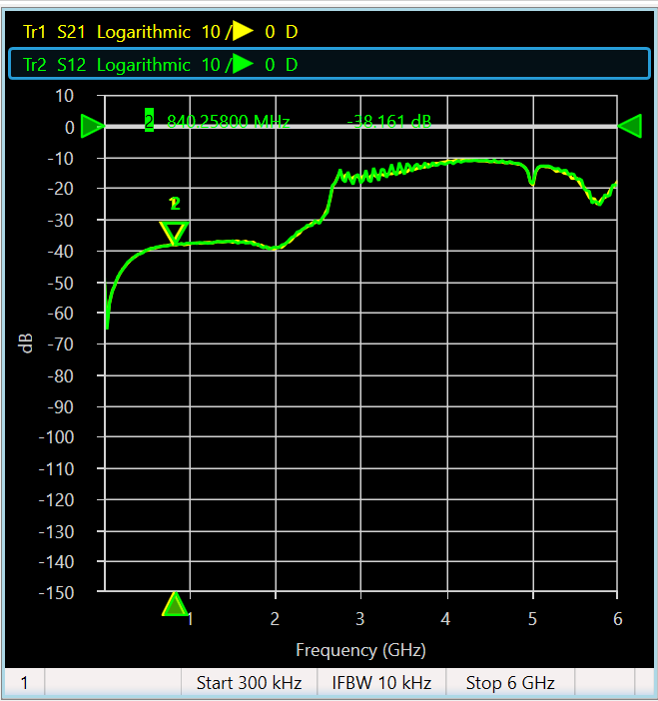

D=directivity=0.486dB

1GHz->2GHz, IL = -1.43+1.1= -0.33 dB -> input to output

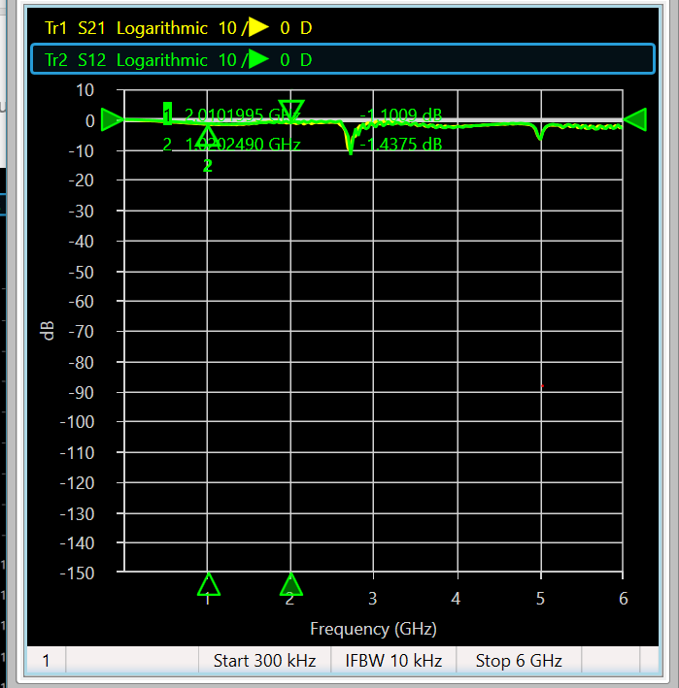

*Filter Measurements*

VBFZ-2130+:

Bandwidth = 2.91 – 1.17= 1.74 GHz

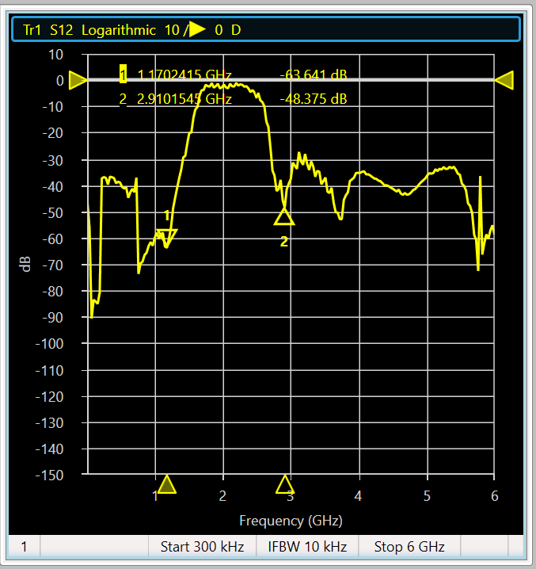

IL = S21/S12 = -10.8+3.62 = -7.18 dB

RL = S22/S11 = -2.56 + 8.78 = 6.22dB

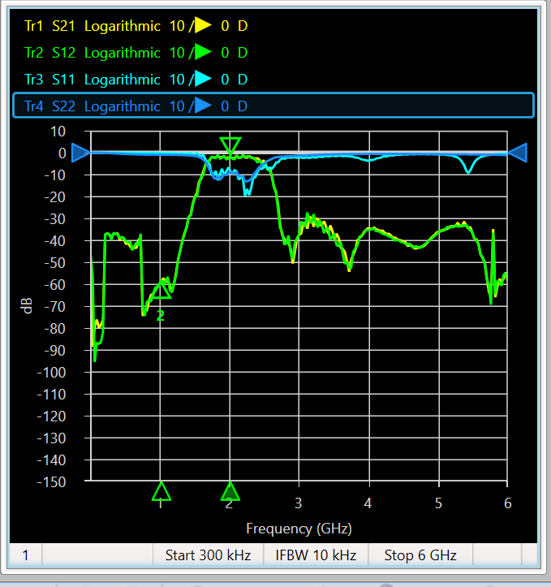

The observed frequency response are typical of a bandpass filter.

SLP-2400+:

Bandwidth = 2 GHz

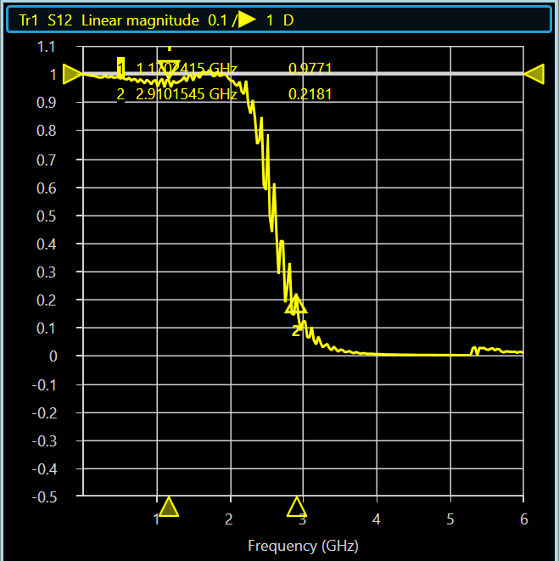

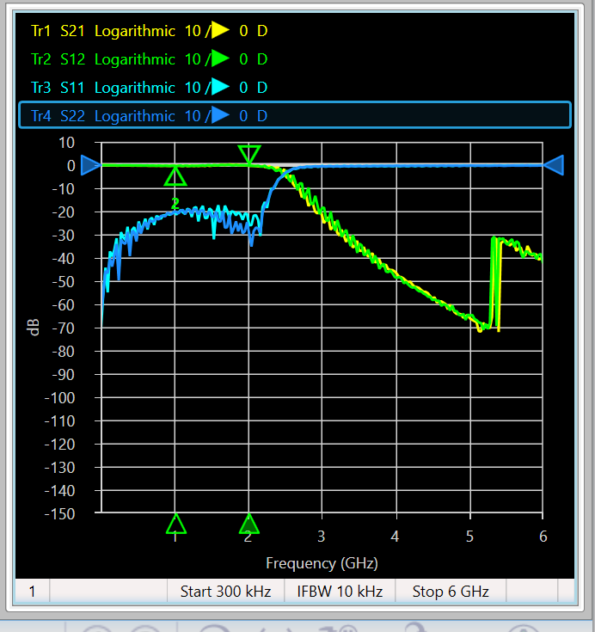

IL = S21/S12 = -0.05+ 0.600 = 0.550dB

RL = S22/S11 = -0.6 + 0.64 = 0.04 dB

Wesee that the filter has the typpical frequency response of a LPF(s21)