

Veteran Foreign Medical Program (VFMP) and Civilian Health and

Medical Program of the Department of Veterans Affairs (CHAMPVA) Forms

Performance Work Statement (PWS)

Customer Experience, DevOps, Agile Releases (CEDAR) Indefinite Delivery, Indefinite Quantity (IDIQ) contract vehicle

VA-23-00098546

8/14/2023

# 1.0 Background and Purpose

## 1.1. Mission of the requesting business office

In 2017, the VA Office of the Chief Technology Officer (OCTO) partnered with VA Central Office and all three VA Administrations to identify a vision statement for enhancing VAʼs digital presence for Veterans. That vision is known as the Digital Modernization Vision and is supported by a group of VA executives known as the Digital Modernization Council. This council is chaired by the CTO.

The VA Digital Modernization Vision defined in July 2017:

*VA will deliver self-service tools on par with top private sector companies and will have the best online experience in the Federal Government. Every digital service will be customized to the individual using it. Interacting with VA digital services will feel like navigating TurboTax, not filling out a form.*

The work described in this PWS directly supports the VA OCTO. Our office has three North Star goals:

1/ Increase the usage and throughput of VA services

2/ Decrease the time Veterans spend waiting for an outcome

3/ Increase the quality and reliability of VA services

In addition to these north stars, the team that runs VA.gov (OCTO-Digital Experience (OCTO-DE) Portfolio) has a vision and mission that describes our idea of the state of the world and role in making it happen.

**Our Vision:** Every Veteran is guaranteed access to self-service benefits and accurate data

**Our Mission:** Continuously deliver high-quality digital experiences for the benefit of all Veterans and their families

The OCTO-DE team has worked for several years to digitize VA forms. This work was prioritized by the form transaction volume, value to Veterans, and form complexity. There are hundreds of VA forms which currently have no digital version on VA.gov. Many of these forms exist only as downloadable PDFs. The 21st Century IDEA (Act) requires VA to create user-friendly and accessible digital versions of all forms.

## 1.2. Problem Agency (VA) is trying to solve

The current eligibility application and claims submission processes for Civilian Health and Medical

Program of the Department of Veterans Affairs (CHAMPVA), the Foreign Medical Program, and the Camp Lejeune Family Member Program are high-contact and rely on paper applications that are faxed or mailed to VA. The processes currently do not include any option for electronic application processing, instead relying heavily on fax and physical mail. Legacy products were built around expecting physical mail, requiring scanning and processing of barcodes and “bubble sheets”. With eligibility being managed in standalone systems, applications must be “swivel-chaired” from their scanned and reviewed visual form to the benefits record in the legacy system.

Figure 1: Current process flow

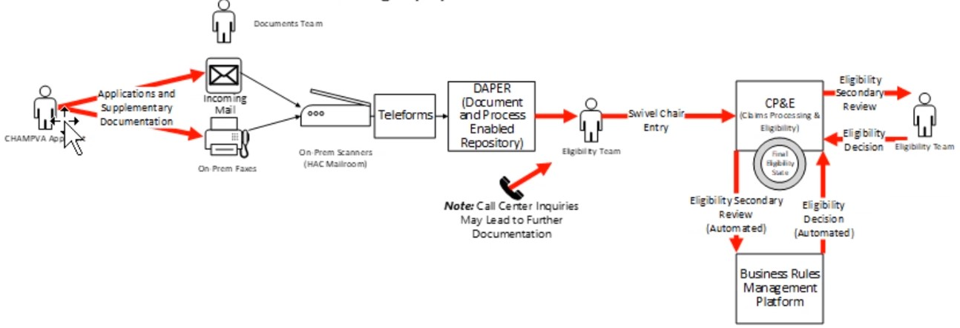

The 21st Century Integrated Digital Experience Act (21st Century IDEA) was signed into law in December 2018. The Act aims to improve the digital experience for Government customers and reinforces existing requirements for federal public websites. Specifically, the Act requires all executive branch agencies to:

* modernize their websites,
* digitize services and forms,
* accelerate use of e-signatures,
* improve customer experience, and
* standardize and transition to centralized shared services.*

*(Digital.gov, <https://digital.gov/resources/21st-century-integrated-digital-experience-act/>)

The OCTO-DE created digital experiences for the highest-volume and most critical Veteran forms including those for: Health Enrollment (10-10EZ), Disability Claim (526), and GI Bill Application (1990). The digital versions of these forms use the VA Design System, VA Content Style Guide, and are built on the VA.gov Platform infrastructure. Additionally, the VA.gov Platform provides a Forms Library for developers. The VA Forms Library is a comprehensive system that provides an easy to use and consistent way of creating complex forms for Veterans and their family members and caregivers.

OCTO-DE is completing its auditing of the forms problem space and creation of the forms roadmap.

The teams under this effort will work specifically on forms related to CHAMPVA, Camp Lejeune Family Member Program, and Foreign Medical Program which currently include the forms below, but the list may evolve as more research is performed and forms are prioritized (the first 5 forms listed below are the 5 prioritized initially for this effort, however, should there be capacity for additional forms, the remaining items will be digitized and are listed in priority order:

## 1. CHAMPVA Application Form – VA Form 1010D 2. CHAMPVA Beneficiary Claims Submission – VA Form 10-7959A 3. OHI Form – VA Form 10-7959C 4. FMP Registration Form – VA Form 10-7959-1 5. Foreign Medical Program Claim Cover Sheet – VA Form 10-7959f-2

1. Power of Attorney form – VA Form 10-0137
2. Release of Information (ROI) form – VA Form 10-5345
3. SB Claim Form for Miscellaneous Expense – VA Form 10-7959E
4. Decision Review Request Board Appeal (Notice of Disagreement) - VA Form 10182
5. Decision Review Request Higher-Level review - VA Form 20-0996
6. Decision Review Request Supplemental Claim VA Form 20-0995 12. Camp Lejeune Application Form – VA Form 10-10068
7. Camp Lejeune Treating Physician Report – VA Form 10-10068b
8. CLFMP information Update Form – VA Form 10-10068c
9. CLFMP Claim Form – VA Form 10-10068a

### 1.3. Existing relevant documentation

All applicable documents included in Section 3.0 of the CEDAR Base PWS apply to this Task Order (TO). Additionally, the following applies to this order:

* Find-a-Form Tool: <https://www.va.gov/find-forms/>-   
  VA Design System: <https://design.va.gov/>-   
  VA.gov Platform Forms Library:

[https://depo-platform-documentation.scrollhelp.site/developer-docs/va-forms-library-overvie w](https://depo-platform-documentation.scrollhelp.site/developer-docs/va-forms-library-overview)

* 21st Century IDEA:

<https://digital.gov/resources/21st-century-integrated-digital-experience-act/>

# 2.0 Scope

## 2.1. Overview of work

The team will focus on digitizing the above-named forms and building them on VA.gov. Forms will be made to use VA.govʼs existing design system, content style guide, and forms system, as named above.

The goal is to allow a user to complete the form and submit it online. Initially, the forms will be submitted to a backend, possibly Box.com, where there will be an automated file pickup to the Document and Process Enables Repository (DAPER) on Pega. It is expected that a more permanent backend solution will be built in FY24 or FY25, but the connection to that back-end will likely not be ready for this effort.

This team will coordinate with the VA Notify team to send notifications of successful or failed form submission for each form type.

## 2.2. Development methodology and functional areas

The Contractor shall provide VA with teams that shall deliver viable, digital solutions in support of VAʼs strategic mission and objectives, in accordance with the development methodologies described in the CEDAR Base PWS Section 4.9.

The Contractor(s) shall provide VA with so ware development services which may include Technical Functional Areas 1-13, as described in CEDAR Base PWS Section 5.0.

# 3.0 Objectives

## *3.1.* Product vision

VA provides a digital submission for Veterans and their family members to apply for CHAMPVA, Camp Lejeune Family Member Program, and Foreign Medical Program benefits through VA.gov.

## 3.2. Desired user outcomes

1. Veterans and family members can easily find the form they are looking for on VA.gov.
2. Veterans and family members can complete and digitally submit the forms they are looking for on VA.gov.
3. Veterans and family members can upload applicable documents related to their form submission to VA.gov and include the attachments in their submission.
4. Each form has an appropriate digital experience that is accessible, user-friendly, uses plain language in accordance with VA.govʼs content style guide.
5. Veterans and family members receive an email notification letting them know their form was successfully submitted or not.

## 3.3. Desired business outcomes

1. Congress has been asking for an experience similar to that provided to Veterans on VA.gov for family members and beneficiaries. The business is looking to respond to that demand.
2. Expedite the application process for these three programs by digitizing the forms.
3. Reduce the number of paper forms mailed and faxed.

**3.4. Potential MVP features and Epics**

1. Conduct a one or two-sprint discovery to understand technical complexity of the forms and create a roadmap for completion.
2. Using Design System, Content Style Guide, and Forms System, design, write, and build the above named forms on VA.gov
3. Integrate vets-api with BOX.com backend.
4. Conduct user research & testing to validate successful form submission.
5. Establish monitoring and analytics to track form submission.
6. Partner with VA Notify team to establish user notifications for successful or failed form submission.

Notional process flow:

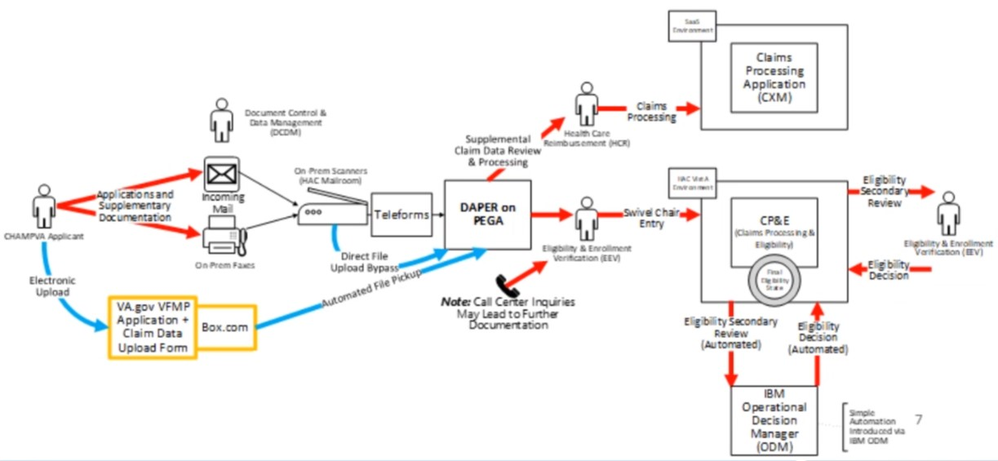

# 4.0 General Requirements

## 4.1. PoP and budget estimate

The overall PoP shall be for one 12-month period.

The Anticipated budget for the base period of this Task Order is $4,000,000. No materials or travel is anticipated for this effort.

**4.2. Contract type**

The effort shall be proposed on a Firm Fixed Price (FFP) basis.

**4.3. Key Personnel**

No Key Personnel are required for this effort.

## Additional Information

SCRUM teams will be considered acceptable when they can effectively work. This may include some resources that are staffed, but not cleared. This will be case by case and worked with the COR. For the initial team to be deemed ready to work, all members of the team will have a SAC Adjudication letter in order to obtain access to working tools such as GitHub and Slack that do not require VA network access. Access to Amazon Web Services requires an Electronic Questionnaires for Investigations Processing release date.

### 4.4. Kickoff Meeting

The Contractor shall hold a kickoff meeting within 10 days a er TO award. The Contractor shall present, for review and approval by the Government, at a minimum the details of the intended approach, work plan, and onboarding plan. The Contractor shall specify dates, locations (can be virtual), agenda (shall be provided to all attendees at least five (5) calendar days prior to the meeting), and meeting minutes (shall be provided to all attendees within three (3) calendar days a er the meeting). The Contractor shall invite the Contracting Officer, Contract Specialist, Contracting Officerʼs Representative (COR), and the VA Program Manager/Product Owner.

# 5.0 Quality Assurance Surveillance Plan (QASP)

## 5.1. Product specific objectives and key results

In accordance with 4.10 of Base PWS. Language about Contractor provided QASP metrics. The

Government is open to discussion with the vendor about appropriate QASP metrics for this task order.

## 5.2. CEDAR scorecard

The Contractor shall participate in the CEDAR scorecard process. This may include responding to questionnaires, collaboratively assessing work performance, providing feedback on independent Government assessments, and identifying relevant metrics to assess work performance. The specifics of the scorecard process are under development and will be iteratively implemented with feedback from CEDAR Contractors. The current anticipated timeline for CEDAR scorecard is bi-annually.

## 5.3. Recurring deliverables

**Delivery and Monitoring Report and Roster:** The Contractor shall provide a single monthly report, detailing and providing links to all stories, epics, and other work completed. This includes a plain language description of all work accepted by the Government Product Owner and COR at the end of each sprint. This report shall include, in plain language, additional details about the project status, sprint team velocity, sprint team goal completion, and highlight project risks. The report shall also highlight and provide links to key infrastructure and application monitoring data. The report shall also include details with links to documentation for any critical incidents or outage events that resulted in service outages or significant service degradations. The Contractor shall attach or provide links to postmortem documentation for all critical incidents or outage events. Should there not be any reported incidents during the reporting period, a link to the relevant monitoring tools is sufficient. The specific data points and format of this monthly report shall be determined by the Contractor in collaboration with the Government Product Owner and COR. Lastly, the Contractor shall submit a roster to the COR in accordance with Base PWS subparagraph 9.2.4, that includes the Status of Government Furnished Equipment (GFE) in accordance with Base PWS subparagraph 9.2.2. The Delivery and Monitoring Report and Roster shall be uploaded to a VA provided SharePoint.

## 5.4. Data and Open Source Requirements

The Government shall receive Unlimited Rights to data first produced in performance of this contract in accordance with (IAW) FAR 52.227-14, “Rights In Data-General” (MAY 2014). This includes all rights to source code and any and all documentation created in support thereof. License rights in any Commercial Computer So ware shall be governed by FAR 52.227-19, “Commercial Computer So ware License” (DEC 2007). Any data delivered shall be submitted and protected IAW VA handbook 6500.

VA intends that the so ware delivered under this task order will be publicly posted without restriction. To the extent that the Contractor seeks to incorporate into the so ware delivered under this task order any so ware that was not first produced in the performance of this task order, VA encourages the Contractor to incorporate either so ware that is in the public domain, or free and open source so ware that qualifies under the Open Source Definition promulgated by the Open Source Initiative. In any event, the Contractor must promptly disclose to VA in writing, and list in the documentation, any so ware incorporated in the delivered so ware that is subject to a license fee.

### 5.5. VA policy and security considerations

The Contractor(s) shall comply with all language specified in CEDAR Base PWS Addendums, including:

* Section 7.0 Security and Privacy
* Section 8.0 Contract Management
* Addendum A– Additional VA Requirements, Consolidated
* Addendum B – VA Information and Information System Security/Privacy Language

Specific TO requirements relating to Addendum B, Section B4.0 paragraphs 10 and 11 supersede the corresponding CEDAR Basic PWS paragraphs, and are as follows,

1. The vendor shall notify VA within 24 hours of the discovery or disclosure of successful exploits of the vulnerability which can compromise the security of the Systems (including the confidentiality or integrity of its data and operations, or the availability of the system). Such issues shall be remediated as quickly as is practical, based on the severity of the incident.
2. When the Security Fixes involve installing third party patches (such as Microso OS patches or Adobe Acrobat), the vendor will provide written notice to VA that the patch has been validated as not affecting the Systems within 10 working days. When the vendor is responsible for operations or maintenance of the Systems, they shall apply the Security Fixes based on the severity of the incident.

# 6.0 Other Administrative Items

## 6.1. Government furnished property

In accordance with Section 4.6.1 of the CEDAR Base PWS. Based on the Government assessment of remote access solutions and the requirements of this TO, the Government estimates that the following GFE will be required by this TO:

● 2 of standard laptops

## 6.2. Place of performance

Efforts under this TO shall be performed at Contractor facility(ies). The Contractor shall identify the Contractorʼs place of performance in their Task Execution Plan submission.

**6.3. Travel**

Travel is not anticipated under this effort.

## 6.4. Hours of work

The contractor shall set their own work hours. However, contractors may be required to attend meetings with Government personnel between standard east coast work hours (typically 8am – 5pm

ET).

## 6.5. Position Designation (PDAT)

In accordance with VA Handbook 0710, Personnel Security and Suitability Program, the

position sensitivity, and the level of background investigation commensurate with the required level of access for tasks within the PWS. All tasks are considered **Tier 2 / Moderate Risk** unless otherwise specified in the table below.

## Position Sensitivity and Background Investigation Requirements by Task

|  |  |  |  |  |  |  |  |  |  |
| --- | --- | --- | --- | --- | --- | --- | --- | --- | --- |
| **Task Number** | **Tier 1/ Low Risk** | | | **Tier 2 / Moderate Risk** | | | **Tier 4 / High Risk** | | |
| Across all tasks |  | ☐ |  |  | ☒ |  |  | ☐ |  |

The Tasks identified above, and the resulting Position Sensitivity and Background Investigation requirements identify, in effect, the Background Investigation requirements for Contractor individuals, based upon the tasks the particular Contractor individual will be working. The submitted Contractor Staff Roster must indicate the required Background Investigation Level for each Contractor individual based upon the tasks the Contractor individual will be working, in accordance with their submitted proposal.

### 6.6. Contract Management

All requirements of Sections 8.0 and 9.0 of the CEDAR Base PWS apply to this effort. This TO shall be addressed in the Contractorʼs Progress, Status and Management Report as set forth in the CEDAR Base PWS (Section 9.2.1).

### 6.7. Contracting Officerʼs Representative (COR) Information

Eunice Garcia

661-544-6706

Eunice.Garcia@va.gov

# 7.0 508 Compliance – Section 508 – Information and Communication Technology (ICT) Standards

On January 18, 2017, the Architectural and Transportation Barriers Compliance Board (Access Board) revised and updated, in a single rulemaking, standards for electronic and information technology developed, procured, maintained, or used by Federal agencies covered by Section 508 of the Rehabilitation Act of 1973, as well as our guidelines for telecommunications equipment and customer premises equipment covered by Section 255 of the Communications Act of 1934. The revisions and updates to the Section 508-based standards and Section 255-based guidelines are intended to ensure that information and communication technology (ICT) covered by the respective statutes is accessible to and usable by individuals with disabilities.

The following Section 508 Requirements supersede Addendum A, Section A3 from the CEDAR Basic PWS.

The Section 508 standards established by the Access Board are incorporated into, and made part of all VA orders, solicitations and purchase orders developed to procure ICT. These standards are found in their entirety at:

[https://www.access-board.gov/guidelines-and-standards/communications-and-it/about-the-ict-refres h/final-rule/text-of-the-standards-and-guidelines](https://www.access-board.gov/guidelines-and-standards/communications-and-it/about-the-ict-refresh/final-rule/text-of-the-standards-and-guidelines). A printed copy of the standards will be supplied upon request.

Federal agencies must comply with the updated Section 508 Standards beginning on January 18, 2018.

The Final Rule as published in the Federal Register is available from the Access Board:

[https://www.access-board.gov/guidelines-and-standards/communications-and-it/about-the-ict-refres h/final-rule](https://www.access-board.gov/guidelines-and-standards/communications-and-it/about-the-ict-refresh/final-rule).

The Contractor shall comply with “508 Chapter 2: Scoping Requirements” for all electronic ICT and content delivered under this contract. Specifically, as appropriate for the technology and its functionality, the Contractor shall comply with the technical standards marked here:

☒ E205 Electronic Content – (Accessibility Standard -WCAG 2.0 Level A and AA Guidelines)

☒ E204 Functional Performance Criteria

☐ E206 Hardware Requirements

☒ E207 Software Requirements

☒ E208 Support Services and Documentation Requirements

## 7.1. Compatibility with assistive technology

The standards do not require installation of specific accessibility-related so ware or attachment of an assistive technology device. Section 508 requires that ICT be compatible with such so ware and devices so that ICT can be accessible to and usable by individuals using assistive technology, including but not limited to screen readers, screen magnifiers, and speech recognition so ware.

## 7.2. Acceptance and acceptance testing

Deliverables resulting from this solicitation will be accepted based in part on satisfaction of the Section 508 Chapter 2: Scoping Requirements standards identified above.

The Government reserves the right to test for Section 508 Compliance before delivery. The Contractor shall be able to demonstrate Section 508 Compliance upon delivery.

## 7.3. Social Security Number (SSN) Reduction

The Contractor solution shall support the Social Security Number (SSN) Fraud Prevention Act (FPA) of 2017 which prohibits the inclusion of SSNs on any document sent by mail. The Contractor support shall also be performed in accordance with Section 240 of the Consolidated Appropriations Act (CAA) 2018, enacted March 23, 2018, which mandates VA to discontinue using SSNs to identify individuals in all VA information systems as the Primary Identifier. The Contractor shall ensure that any new IT solution discontinues the use of SSN as the Primary Identifier to replace the SSN with the Integrated Control Number (ICN) in all VA information systems for all individuals. The Contractor shall ensure that all Contractor delivered applications and systems integrate with the VA Master Person Index (MPI) for identity traits to include the use of the ICN as the Primary Identifier. The Contractor solution may only use a Social Security Number to identify an individual in an information system if and only if the use of such number is required to obtain information VA requires from an information system that is not under the jurisdiction of VA.