

YOGA RETREAT

Antigua, Guatemala

March 3rd – 9th, 2019

Come spend a week in the beautiful old capital of Guatemala, a traveler’s and yogi’s paradise.

All-inclusive (travel, food, lodging, yoga classes) week-long getaway: $4,000

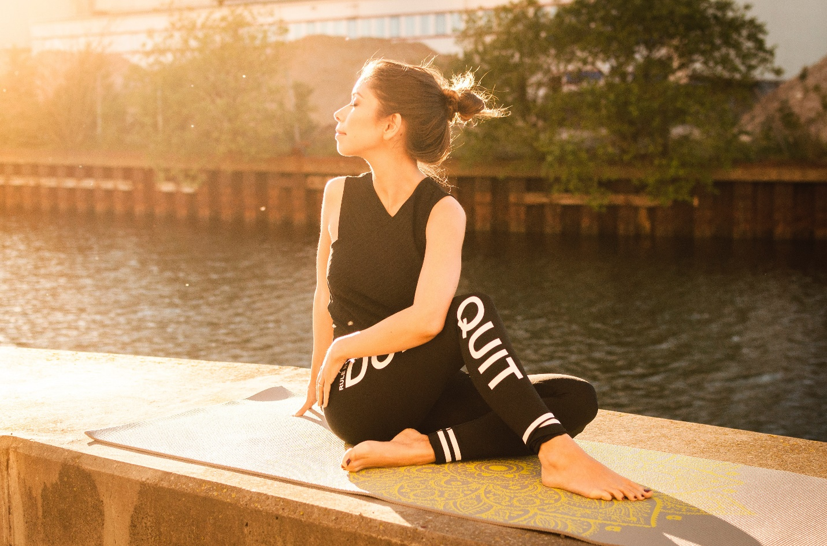

SUNRISE YOGA

Stocksdale Park - Liberty, Missouri

March 9th, 2019 - 6:30 AM

All you need for this monthly event is a yoga mat, a towel, and a smile!

For questions, contact The Yoga Group

theyogagroup@gmail.com



VINYASA FLOW

The Liberty Yoga Studio – Liberty, MO

March 6th, 2019

$15 to drop in OR use your monthly pass

Enjoy an hour-long session of vigorous vinyasa flow. All levels welcome.

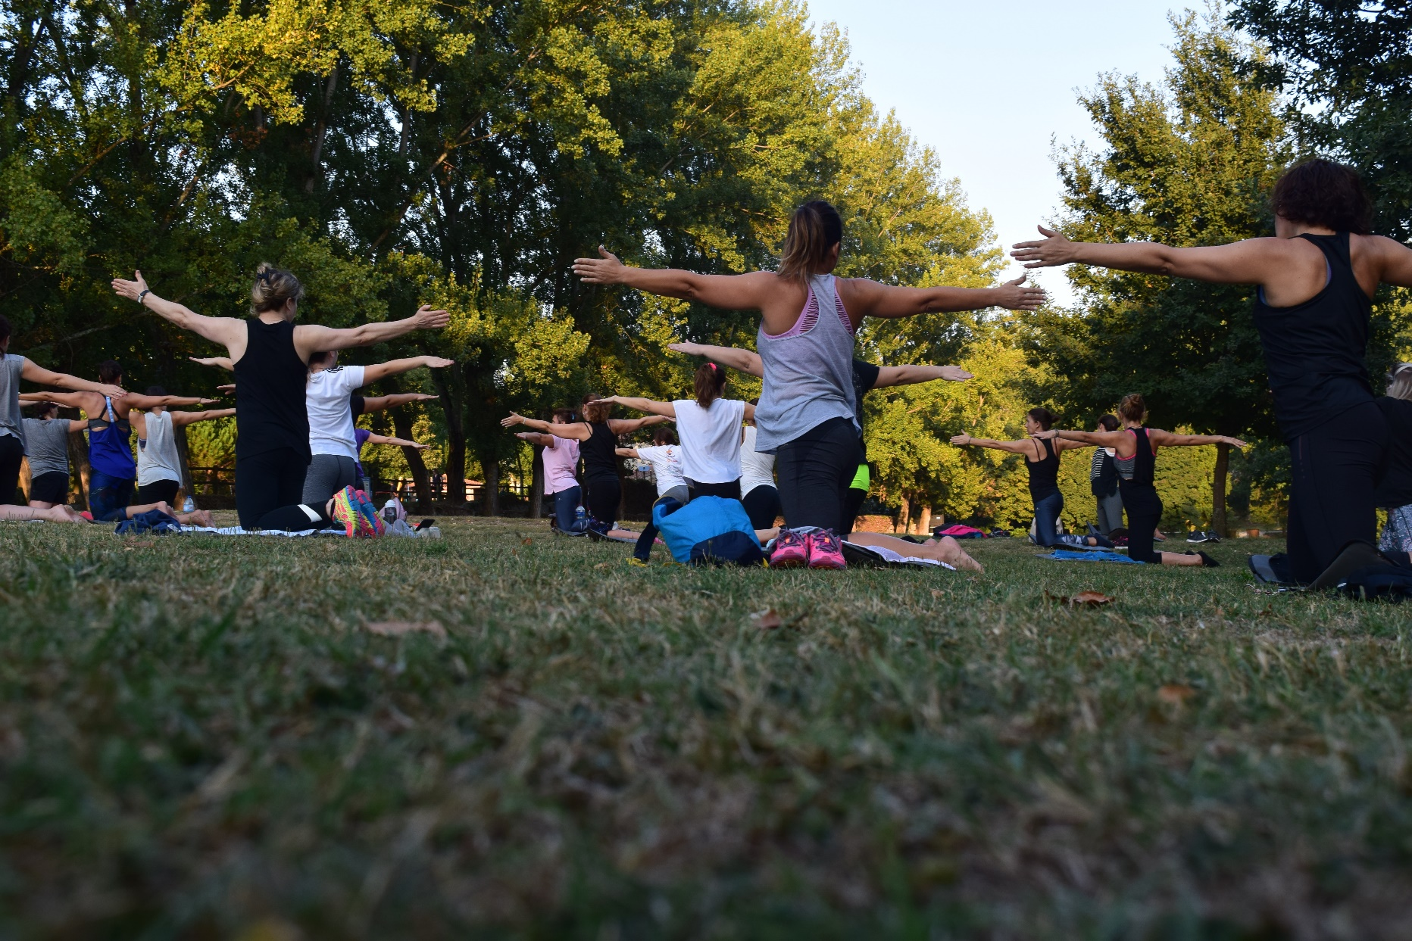

Tahlequah, Oklahoma – City Park

March 30th, 2019

Come bring your friends (and your dog) for an evening of relaxation and realignment.

FREE! Just bring your mat.

YOGA IN THE PARK

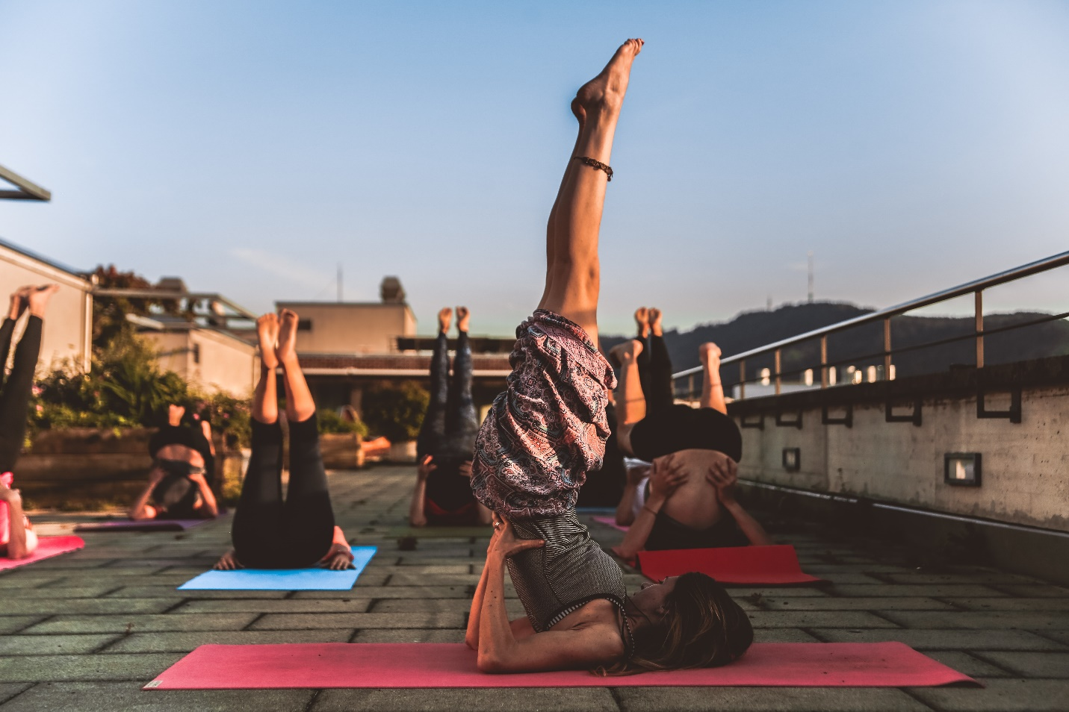

The Dowtown Terrace

Kansas City, MO

March 8th, 2019

Enjoy a night of wine and yoga for $20. Must be 21 or older. Bring your mat.

ROOFTOP YOGA