Simple document
Lauren Holley
html_document: toc: True toc_float: True
`word_document`
I’m an R Markdown document!

Section 0: libraries
library(tidyverse)
## ── Attaching core tidyverse packages ──────────────────────── tidyverse 2.0.0 ──
## ✔ dplyr 1.2.1 ✔ readr 2.2.0
## ✔ forcats 1.0.1 ✔ stringr 1.6.0
## ✔ ggplot2 4.0.3 ✔ tibble 3.3.1
## ✔ lubridate 1.9.5 ✔ tidyr 1.3.2
## ✔ purrr 1.2.2
## ── Conflicts ────────────────────────────────────────── tidyverse_conflicts() ──
## ✖ dplyr::filter() masks stats::filter()
## ✖ dplyr::lag() masks stats::lag()
## ℹ Use the conflicted package (<http://conflicted.r-lib.org/>) to force all conflicts to become errors

Section 1
Here’s a code chunk that samples from a normal distribution:
samp = rnorm(100)
length(samp)
## [1] 100

Section 2
I can take the mean of the sample, too! The mean is 0.0299725.

Section 3: a tibble
“option command i” to create more code chunk
plot_df =
tibble(
x = rnorm(1000, sd = 0.5),
y = 1 + 2 * x + rnorm(1000)
)

Section 4: plots
These are plots from our random sample
ggplot(plot_df, aes(x = x)) + geom_histogram()
## `stat_bin()` using `bins = 30`. Pick better value `binwidth`.
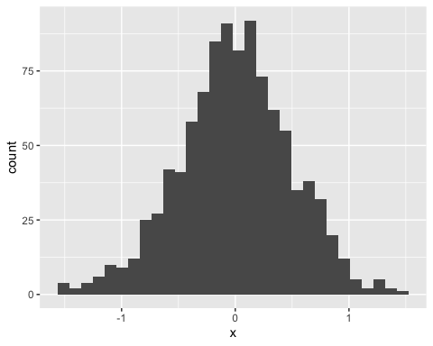
ggplot(plot_df, aes(x = x, y = y)) + geom_point()
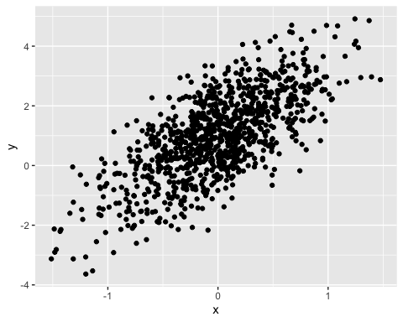

Section 5: Learning Assessment 2
Learning assessment: Write a named code chunk that creates a dataframe comprised of: a numeric variable containing a random sample of size 500 from a normal variable with mean 1; a logical vector indicating whether each sampled value is greater than zero; and a numeric vector containing the absolute value of each element. Then, produce a histogram of the absolute value variable just created. Add an inline summary giving the median value rounded to two decimal places. What happens if you set eval = FALSE to the code chunk? What about echo = FALSE?
This plot shows the distribution of the absolute value of $X∼N(1,1)$
set.seed(0)
la_df =
tibble(
num_var = rnorm(n = 500, mean = 1),
log_var = num_var > 0,
abs_var = abs(num_var)
)
ggplot(la_df, aes(x = abs_var)) + geom_histogram()
## `stat_bin()` using `bins = 30`. Pick better value `binwidth`.
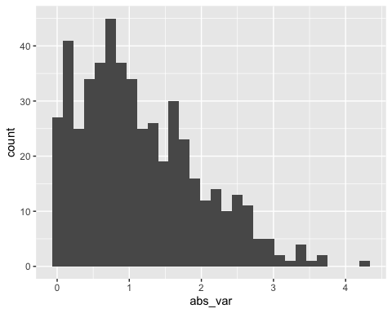
log_var is a logical vector returning true or false
The median is 0.94

# Section 6: Text formatting
italic or italic bold or bold code superscript² and subscript₂

Headings

1st Level Header

2nd Level Header

3rd Level Header

Lists
- Bulleted list item 1
- Item 2
  - Item 2a
  - Item 2b
- Numbered list item 1
- Item 2. The numbers are incremented automatically in the output.

Tables
First Header | Second Header
Content Cell | Content Cell
Content Cell | Content Cell

Section 7: Learning Assessment 3
After the previous code chunk, write a bullet list given the mean, median, and standard deviation of the original random sample.
- The median is: 0.94
- The mean is: 1
- The standard deviation is: 0.99

