Regression Analysis of the Impact of Remote Work Availability on Key Demographic Groups According to the American Time Use Survey Dataset

Lauren Mach // 011338659
Western Governor’s University
Master of Science in Data Analytics
D214: Graduate Capstone
January 23, 2025

Research Question
To what extent does remote work availability affect key populations’ participation in the workforce?
Null hypothesis: Remote work availability does not statistically significantly affect key populations’ participation in the workforce.
Alternate hypothesis: Remote work availability statistically significantly affects key populations’ participation in the workforce.
The aim of this study is identifying populations whose participation in the workforce is greater when remote work is available. This has significant implications for individual businesses as well as the larger economy, since changing labor participation means that “economies will increasingly need to diversify their sources of workers in order to maintain economic growth” (Earl et al., 2017).
The study is based on the American Time Use Survey dataset. Vosoughkhosravi et al. successfully performed a regression analysis on the same dataset to understand gender and income generating activities (2023). Bloom et al. looked at work from home data over a similar period to demonstrate a causal link between remote work availability connected to the COVID-19 pandemic and disability employment rates (2024). What other demographic groups are impacted by the availability of telework?
Based on Bloom et al.’s findings (2024), the hypothesis is that telework availability significantly impacts the extent to which other populations participate in the workforce.

Data Collection
The American Time Use Survey (ATUS) dataset is collected and maintained by the US Bureau of Labor Statistics (BLS) as part of the US Census (American Time Use Survey, 2024). The data was originally collected via phone interviews with participants representative of the US population. The data and dictionaries are publicly available through the BLS at https://www.bls.gov/tus/data/datafiles-0323.htm. ATUS details participants’ demographic information, daily activities, and responses to questions about their lives and households.
For this study, the 2003-2023 multiyear data files and dictionaries from the ATUS are used. 2019-2023 data (298,841 lines, each representing a participant) are extracted from the atuscps file. A major advantage of using a single established dataset is the consistency of the variables, both in what they are and in how they are recorded. However, this structure also limits what variables are available and what demographics can be included.
Even broken down into multiple files, the dataset is extremely large. Reloading it into Jupyter Notebook repeatedly would be both time and space consuming. Instead, only the desired columns are loaded into the dataset. After dropping rows from years before 2019, the remaining columns are exported into new csvs that can be reloaded quickly. “People” dataframes that retain identifying columns but drop most variables are also used throughout the study to select subsets of the population, such as participants from a specific year or participants from the target population. The people datasets are then left joined to the full dataset to add any other needed variables back in.

Data Extraction and Preparation
Notes and full visuals for each step are included in the following python/html files, which should be accessed in the following order:

Thesis-extract-data
- Atuscps data is imported into dataframes, cases from before 2019 dropped, and exported into four csvs:
  - categorical variables
  - continuous variables (will be converted to categorical)
  - telework variables (will be renamed for clarity because they refer to different time periods, separated for ease of cleaning)
  - work variables (most are for supplemental illustration after the regression is complete, but they are all extracted here so that the original atuscps file can be deleted from the drive for space/processing speed optimization)
- Continuous variables are visualized using histograms and different numbers of bins to find an appropriate breakdown for conversion to categorical, then merged into an allcat df with existing categorical variables
- People dataframe with minimal columns and all rows created
  - Full time student (PESCHENR=1), armed forces (PEAFNOW=1), and retired (PEDWWNTO=3 or PEMLR=5) participants dropped from the dataset because many in those populations are not considered employed or seeking employment in a conventional sense. This could skew correlation results, since not employed/no telework is a positive correlation and including these participants could mean the targeted population is one that is not seeking employment rather than one where telework unavailability is a barrier to employment.
  - From this point forward, “people dataset” or “all participants” refers to the participants in the dataset after that transformation.
  - EMPSTAT column added with a calculated value:
    - Full time (PEHRWANT=3) or part time by choice (PEHRWANT=2) is EMPSTAT=1 (fully employed)
    - Unemployed (PEMLR =3-4) or part time and want more work (PEHRWANT=1) = 2 (unemployed/underemployed)
  - EMPSTAT incorporates underemployment as well as unemployment because the regression will be run on the typical number of hours worked in a week and because someone who is limited to part-time in person may be able to work additional hours with the flexibility of partial or full telework.
  - TELEALL created to represent all telework fields, but individual telework fields also retained.
    - 2020-2023 are represented accurately by the TELEALL variable
    - 2019 is partially represented by TELEALL. If a participant had N/A (<0) values for TELECOVID and TELENOW but a true (1) or false (2) value for TELE2019, that value is included in TELEALL. If there are positive values in TELE2019 and another telework field, the more recent field is included.
    - Participants will not have overlapping TELECOVID and TELENOW responses because only one of those questions was included on a given survey
    - No participants from HRYEAR=2019 have data about telework because no questions were asked about telework until 2020. Instead, there is a retrospective question asked in 2020-2023 about whether the individual teleworked in 2019. For analysis of 2019 specifically, TELE2019 must be used. For the other years, either the category for that year (TELECOVID for 2020-Oct 2022, TELENOW for Nov 2022-2023) or the TELEALL column can be used.
  - Finally, CORR is added
    - CORR=1 if TELEALL == EMPSTAT and both have values >0.
      - This excludes all datapoints where HRYEAR = 2019. Because these lines have no telework data, it is not possible to assess their telework/employment correlation individually
      - All possible 2019 telework data is included via TELEALL
      - HRYEAR = 2019 rows can be included in the regression even though they are not part of the correlation analysis, because they have data from other columns that will be identified as most and least correlated to the CORR field
    - CORR=2 if TELEALL != EMPSTAT and both have values >0.
    - CORR=-1 if either TELEALL or EMPSTAT has a negative (NA) value

Thesis-MCA
- The people dataset is split into CORR=1 and CORR=2 dfs and 100,000 random rows selected from each for the resampled dataset
  - This process ensures that NA CORR values are excluded and that the selected columns are not skewed based on the CORR value makeup of the overall dataset
- The resampled dataset and allcat dataset are loaded and left joined to retain only the resampled lines and columns irrelevant to MCA, including the identifying columns, are dropped.
- The proposal stated that PCA would be used to assess which columns to use in the regression. This should have said MCA, because PCA requires continuous variables and almost all variables in ATUS are categorical. Many categories that appear to be continuous are encoded categorically, and the few that aren’t can be easily converted. Using PCA would restrict the column selection so much that it would be impossible to answer the research question.
- MCA is run using a variety of different configurations to find the optimal number of components.
- While PCA typically returns a small number of components relative to the number of columns, in MCA “the inertia (i.e., variance) of the solution space is artificially inflated and therefore the percentage of inertia explained by the first dimension is severely underestimated. In fact, it can be shown that all the factors with an eigenvalue less or equal to 1/K simply code these additional dimensions” (Abdi & Valentin, 2007).
  - The MCA dataset has 38 original columns, each with between 2 and 51 possible dimensions (values from survey answers) that are automatically one hot encoded. The MCA dataset therefore evaluates hundreds of columns when developing components.
  - The number of components with an eigenvalue over 1/K and the number of components required to explain >50% of the variance in the dataset are both around 50.
- Below is a table of the variables and dimensions that most significantly (>1 or <-1) impact these components:
Variable | Description | Values
GEDIV | Geo division (all of them) | 1,2,3,4,5,6,7,8,9
GESTFIPS | State (all) | All
GEMETSTA | Metro status (n/a) | 3
HEHOUSUT | Nontransient hotel, rooming house, mobile home (w/wo extra rooms), other housing unit | 2,4,5,6,7
HETENURE | Does not own home or pay cash rent | 3
HRHTYPE | Hh type: married armed forces, unmarried armed forces, civ fem hoh, single armed forces | 2,5,7,8
PEABSRSN | Work absence reason: vacation, injury/illness, childcare, fam/pers obligation, parental leave, weather, other | 4,5,6,7,8,10,14
PEAFEVER | Ever serve in armed forces (y) | -1,1
PECERT1 | Have cert or license | 1
PECERT3 | Need cert or license for work | 1,2
PECYC | Years of college: <1,3-4,4+ | 1,4,5
PEDIPGED | GED or equivalent | 2
PEDISDRS | Difficulty dressing/bathing | 1
PEDISEAR | Hearing disability | 1
PEDISEYE | Visual disability | 1
PEDISOUT | Difficulty doing errands alone | 1
PEDISPHY | Difficulty walking/using stairs | 1
PEDISREM | Cognitive disability | 1
PEERNCOV | unionized | 1
PEMARITL | Married spouse abs, widowed, divorced, separated | 2,3,4,5
PEMJOT | More than 1 job | 1
PRCITSHP | US cit from PR or outlying area, US cit born abroad to cit parent(s), foreign born non-cit | 2,3,5
PRDISFLG | Any disability | 1
PTDTRACE | Native,Asian,Hawaiian,white-Black,W-N,W-A,W-H,B-N,B-A,N-A,W-B-A,W-B-N,W-N-A,W-B-A | 3,4,5,6,7,8,9,10,11,13,16,17
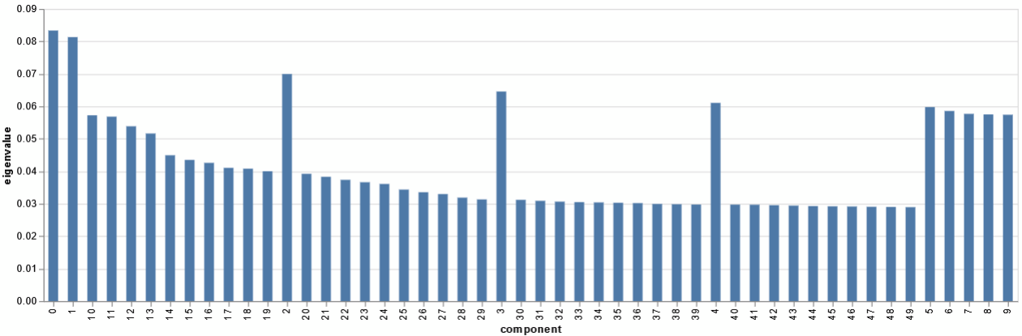
- The components are configured into lists and tables a few different ways, but no substantial changes are made to the datasets
- Some of the MCA results are consistent with prior research: every category of disability is included, consistent with Bloom’s 2024 study. Other results are less clear or less useful, such as the inclusion of every state and every geo division.
- Because and there is overlap between components (or different responses to a question in the same component),
- MCA is not as useful of a method as expected to choose which columns to select for the target populations for several reasons
  - Each component incorporates dozens of variables and 50 components are needed to explain most of the variance, resulting in a long list of contributing variables.
  - Different responses to the same question are encoded as separate columns, meaning the same variable can appear in multiple components at varying levels of significance
  - Conflicting responses to a question can also exist within the same component, such as two different states of residence

Thesis-corr-var
- An alternate method of selecting the target populations is a simple analysis of the rate of correlation using the CORR column.
- Using a different method to select the target populations does not adversely affect the research question or hypothesis, as they only require the target populations to be defined prior to the regression and do not mention a specific method or group.
- The beginning of this file includes the MCA data as a point of comparison. The correlation results can be validated against the MCA dataset; if they are completely different, more work will be necessary to develop a method of defining target populations.
- Much like in the MCA preprocessing, the people and allcat datasets are merged and unneeded columns dropped. The remaining variables are then one hot encoded for analysis.
  - The one hot encoded variables are grouped by CORR value and summed (True=1, False=0) to find the count of each CORR value for each variable dimension. The output is a dataframe with each variable dimension in a row and columns for the variable dimension name, count of CORR true, and count of CORR false
  - A percentage column is added calculating the percentage of CORR=1 values for each variable dimension
  - Dimensions that represent NA answers (negative numbers) are dropped from the dataframe
  - Dimensions with responses representing <0.1% of the dataset (n = 231) are dropped to avoid skewing results—several have 100% correlation but fewer than 10 observations.
- A few different visualizations and summary statistics are run to understand the distribution of variable dimensions based on CORR value.
  - 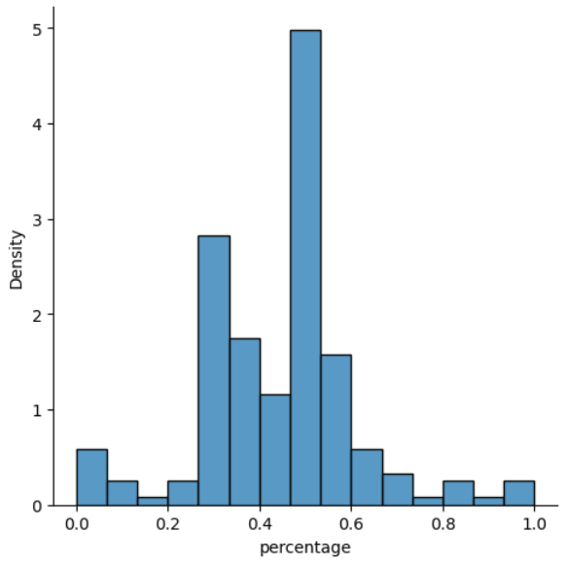
  - 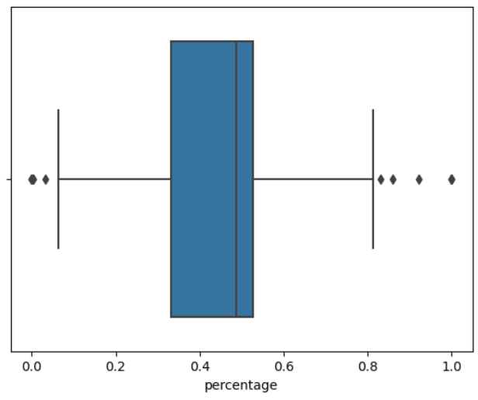
  - count 181.000000
mean 0.445664
std 0.171484
min 0.000000
25% 0.332726
50% 0.486413
75% 0.527152
max 1.000000
Name: percentage, dtype: float64
  - The dataframe is also exported to a csv that will be imported into Tableau to visually present the information in the final presentation; for example, showing the top and bottom categories graphically

Thesis-people
- A dataset including all people, relevant categories, and work variables (from cpswork) is combined in preparation for the linear regression.
- Participants with any response identified as being >1 standard deviation above the mean in correlation percentage are merged into a dataset called top16. A column ‘rank’ is added and the value for every line in this dataset is set to 16
  - 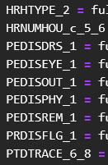
  - Like in the MCA results, many disabilities are at the top of the list
- Participants with any response identified as being in the top 25% of correlation percentage are merged with top16 into a dataset called top25. Any NA value for rank (in top 25% but not >1 std dev above mean) is replaced with 25
  - 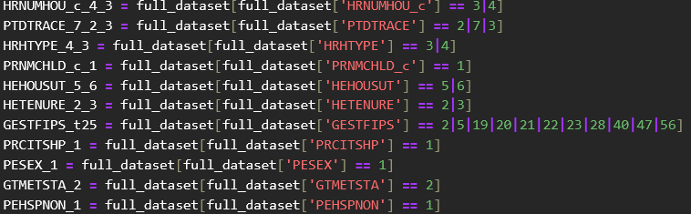
  - Many states and other variables that were significant contributors to the top 50 MCA components are in this list
- The top16 and top25 datasets are re-merged with the full dataset and any NA rank value is replaced with 100.
  - The rank values will allow separation of participants in target populations for the regression.
  - Including a column value for all participants instead of just using the filtered dataset for the regression is both more efficient (all three regressions can be run simultaneously, with the ranks as dimensions) and provides an easy way to visualize the target population vs. full population

Thesis-regression
- The full dataset (now including the rank column) is imported
- PEHRUSLT, the usual number of hours worked in a week (0-150), is the column that will be used for the regression.
  - This offers a more nuanced look at employment than PEMLR (7 dimensions covering employed/unemployed/not in workforce) or EMPSTAT (2 dimensions fully employed/underemployed including unemployed)
  - This variable captures whether someone is able to work more (such as full vs part time) with telework options
  - For participants with a temporary alteration in their work schedules (vacation, illness, busiest week of the year), PEHRUSLT offers a more accurate picture of their employment status than employed-present or employed-absent
  - PEHRUSLT includes hours worked at non-primary jobs
  - Rows with NA values (PEHRUSLT < 0) are dropped to avoid skewing results. Rows with a value of 0 are retained.
- A preliminary visualization of PEHRUSLT by year and rank
  - 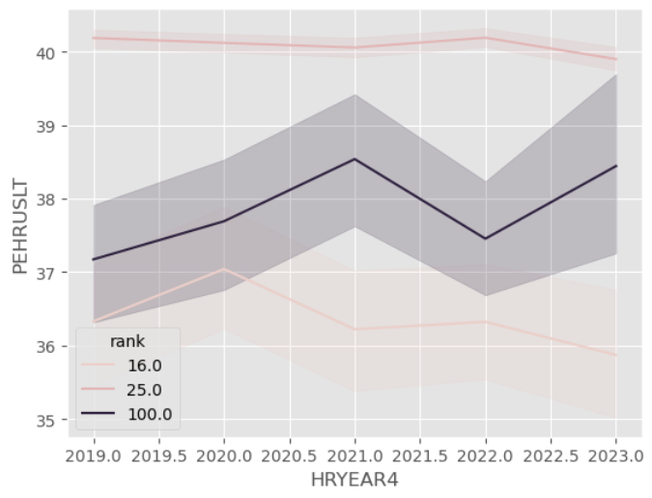
  - Note that for this visualization, 25.0 = participants with a response in the top 25% of correlated variable dimensions but no response >1 std deviation
- Parameters of the first regression (training)
  - Y = PEHRUSLT
  - X =
    - 0 const 120774 non-null float64
1 TELENOW_1 120774 non-null int64
2 TELENOW_2 120774 non-null int64
3 TELECOVID_1 120774 non-null int64
4 TELECOVID_2 120774 non-null int64
5 TELE2019_1 120774 non-null int64
6 TELE2019_2 120774 non-null int64
7 HRYEAR4 120774 non-null int64
8 rank_16.0 120774 non-null int64
9 rank_25.0 120774 non-null int64
10 rank_100.0 120774 non-null int64
  - test_size = 0.3 of full dataset via train_test_split
  - 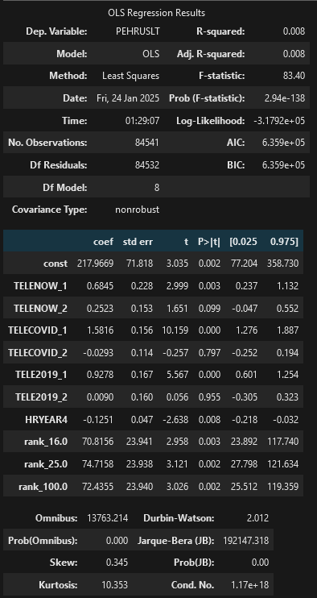
  - (results discussion in Analysis section below)
  - MAE: 5.513319
  - RMSE: 10.401
- The second and third regressions use the same parameters, with the exclusion of rank. They are pulled from the top16 and top25 (inclusive of top16) datasets. They are not split for training.
  - Top16 results (discussed in Analysis below)
    - 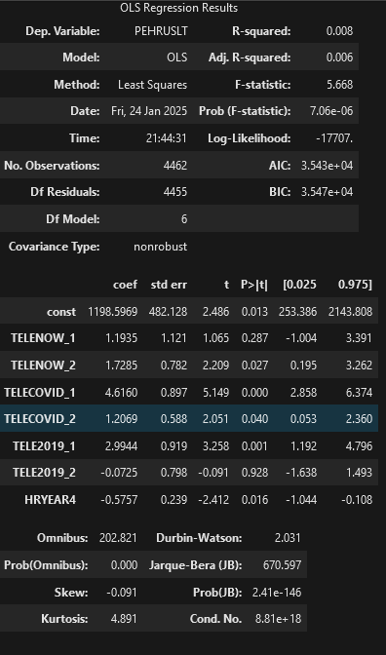
  - Top25 results (discussed in Analysis below)
    - 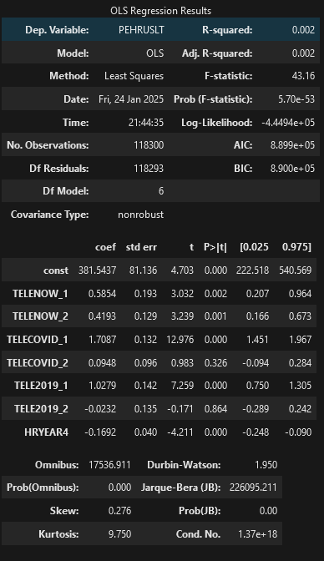

Analysis

Target population selection
Telework rates have increased over the last five years (US Bureau of Labor Statistics). However, due to the COVID-19 pandemic and the breadth of factors that go into employment rates and hours, the date alone cannot be accurately used as a stand in for telework availability. Furthermore, telework options are not equally available to everyone—level of education was cited as a significant factor in telework rates in a press release for the most recent American Time Use Survey (US Bureau of Labor Statistics, 2024).
Assessing the actual telework rates for different variable dimensions and the high-level correlation of a whole dimension’s telework rate to employment rate provides a way to extrapolate and predict telework availability and general employment rates. Since telework has shifted so rapidly alongside the pandemic, this study will provide three sets of predictions: one based on 2019 telework rates (retrospective), one based on COVID survey questions, and one based on the most recent telework data.
Ultimately, this exact study could be validly run using any population selection metric to get the results specific to that population. The use of simple dimensional telework/employment correlation rather than MCA or another method provides a starting point with an easy way to adjust how much of the population is included (rank/percentile of correlation across all variables) and provide multiple breakdowns (everyone vs. top 25% vs. top 16%).
Some variables were excluded from the rankings, including variables with <0.1% valid responses (CORR=1 + CORR=2 <= 231), variables indicating N/A responses, and variables that would conflict with the regression (HRYEAR4, variables that imply specific employment situations such as TELEWORK and PEMLR).
The populations used in the regression are:
Top 16%
Variable_dimension | % CORR=1 | Description
PEDISDRS_1 | 86.03% | disability: difficulty dressing or bathing
PEDISOUT_1 | 81.29% | disability: difficulty running errands or going out alone
PEDISPHY_1 | 76.69% | disability: serious difficulty walking or going up stairs
PTDTRACE_6 | 72.85% | white-Black
PTDTRACE_8 | 70.22% | white-Asian
PEDISREM_1 | 68.69% | disability: serious cognitive or memory difficulties
HRHTYPE_2 | 67.19% | husband/wife primary family in Armed Forces
PRDISFLG_1 | 64.84% | any disability
HRNUMHOU_c_6 | 64.73% | household size >9
PEDISEYE_1 | 64.24% | disability: serious difficulty with vision
HRNUMHOU_c_5 | 63.38% | household size 7-8

Top 25% (in addition to above)
Variable_dimension | % CORR=1 | Description
HRNUMHOU_c_4 | 61.49% | household size 5-6
PTDTRACE_7 | 61.31% | white-Native
HRHTYPE_4 | 59.41% | female civilian head of household
PRNMCHLD_c_1 | 58.83% | no children
HEHOUSUT_5 | 56.48% | mobile home or trailer with no permanent rooms
GESTFIPS_28 | 55.77% | MS
HEHOUSUT_6 | 54.73% | mobile home or trailer w/room(s) added
HETENURE_2 | 54.51% | rent home
PTDTRACE_2 | 54.38% | Black
PTDTRACE_3 | 54.13% | Native
GESTFIPS_56 | 54.10% | WY
GESTFIPS_2 | 54.00% | AK
HETENURE_3 | 53.99% | housing not owned and no cash rent paid
PRCITSHP_1 | 53.93% | US-born citizen
GESTFIPS_21 | 53.91% | KY
GESTFIPS_23 | 53.85% | ME
GESTFIPS_22 | 53.72% | LA
GESTFIPS_19 | 53.49% | IA
HRHTYPE_3 | 53.43% | civilian male head of household
GESTFIPS_5 | 53.29% | AR
PESEX_1 | 53.26% | male
GTMETSTA_2 | 53.20% | non-metro area
GESTFIPS_47 | 53.06% | TN
PEHSPNON_1 | 52.90% | Hispanic/Latino
GESTFIPS_40 | 52.83% | OK
GESTFIPS_20 | 52.78% | KS
HRNUMHOU_c_3 | 52.72% | household size 3-4

Training model
The model was trained on 30% of the full dataset (n. = 84,851) using the least squares method. The least squares method takes the input datapoints and outputs the closest fitting line to allow the researcher to make predictions beyond the existing dataset. Because there are multiple independent variables, this is a multiple linear regression. Because the variables are one hot encoded dimensions of a smaller set of variables, there is strong multicollinearity—that is, dimensions of a variable are strongly correlated because they are interrelated.
The r squared and adjusted r squared for this model are low and indicate that the provided variables explain only 8/10ths of a percent of the variance in hours worked is explained by telework status, year, and rank. This is not a concern for the research question of the study, because the model does not need to explain the majority of what affects number of hours worked. Rather, the aim is to determine whether telework status has any statistically significant effect on predicted hours worked
This means the p value is the most relevant metric for the research question. The p values for all three ranks (top 16%, top 25%, bottom 75% represented by 100) are <0.05, meaning they have a statistically significant effect on hours worked across the full dataset. All three positive (1) telework fields also have statistically significant effects across the entire population, as does the year. Being able to analyze the statistical significance of each of these variables simultaneously is an advantage of using OLS modeling.
Because this model uses one hot encoded categorical variables within X, the variables are most accurately compared to their alternative dimensions rather than directly to one another. Rank_25 increases the most for every additional hour worked, followed by rank_100 and rank_16. The year decreases slightly with every additional hour worked. Positive telework variables (1) increase between .7 and 1.6, while negative variables vary in value and direction, in addition to being not statistically significant.
The RMSE for this model is 10.401, so the typical error is 10.4 hours above or below the actual hours worked. This is a disadvantage of this method of analysis, as it is a non-negligible portion of a workweek that represents slightly less than 1 standard deviation of the variable (10.419). However, understanding employment participation within 10.4 hours is still a useful metric and offers more insight than PEMLR or EMPSTAT.
When the predictions from this model are compared to the training data, the mean error is only 5.51 hours.

Top16 model
This model is the same as the training model but fitted on a subset of the data (rank=16, n=4462) and with rank dropped from the x variables. For participants with a variable dimension >1 standard deviation above the mean in telework/employment status correlation, the provided x variables (telework, year) explain more of the variance in hours worked (0.8%) than the original x variables (telework, year, rank) did of hours worked in the training set (0.2%). This is still a small amount of variance but suggests that telework and year are more significant to predicting the target populations’ working hours than they are to predicting working hours for all populations.
The p values in the top 16 model are significant (p < 0.05) for HRYEAR4 (coef = –0.58), TELENOW_2 (coef = +1.73), TELE2019_1 (coef = +2.99), and both TELECOVID dimensions (coef 1 = +4.62, coef 2 = 1.21). Interestingly, teleworking recently (TELENOW_1) is not statistically significant when predicting working hours but not teleworking now (TELENOW_2) is.

Top25 model
This model is the same as the top 16 model, with the inclusion of rows from the full dataset where any response was in the top quartile of most correlated variables (n = 118,300). The r squared value is the same as the training model (r-squared = 0.002) despite not including the rank variables.
For this population, current telework rates are statistically significant (p < 0.05, coef 1 = +0.59, coef 2 = +0.42), as are positive older telework rates (coef COVID = +1.71, coef 2019 = +1.03) and the year (coef = -0.17).

Data Summary and Implications

Results
This analysis supports the alternate hypothesis that remote work availability statistically significantly affects key populations’ participation in the workforce. Two sets of key populations, listed above, had employment participation rates statistically significantly impacted by telework rates across the last five years. The key populations themselves also have a statistically significant relationship to the typical number of hours worked, demonstrating variance between the key populations and the wider dataset.
For participants with at least one response >1 standard deviation above the mean in telework : employment correlation, COVID telework rates are the strongest significant predictor of hours worked per week (+4.62 hours per week for those who teleworked vs +1.21 for those who did not), followed by 2019 telework rates (+2.99 hours per week for those who teleworked).
For participants with at least one response in the top quartile of telework : employment correlation, inclusive of the previous group, the same pattern emerges but less strongly; COVID telework rates have a +1.71 hour increase, followed by 2019 rates with a +1.03 increase.

Summary
Across the board, positive telework status is associated with increased workforce participation at a statistically significant level. This effect is stronger in the key populations, with the largest effect among those who are disabled, White-Black or White-Asian, have a household >7 people, and married couples where at least one person is currently in the Armed Forces.

Limitations
Some limitations of this study include:
- It is limited to people in the United States
- Telework data from before 2022 (and especially before 2019) is collected inconsistently and is incomplete
- It includes any amount of telework and does not differentiate between fully remote, hybrid, and in-person jobs with occasional telework components
- The dataset does not include telework data beyond current status; for example, whether someone has the option to telework but chose not to cannot be represented in the dataset
- Data on industry and type of work was not included
- Because this dataset excluded current members of the armed forces on active duty, this study does not give a complete picture of veterans and military-specific employment rates

Implications for businesses
The expansion of telework to its practical limit during the emergence of COVID-19 increased the participation of certain populations in the workforce, despite overall workforce participation plummeting. Expanding telework opportunities allows businesses to tap into a labor market that is otherwise limited or unable to access those positions.
The locations identified in the top 25% are not generally considered hubs of business: MS, KY, AK, WY, non-metro areas. Opening telework opportunities has the biggest impact on people who are completely outside of many companies’ hiring pools purely because of where they live.
A major theme in which populations are most affected by telework availability is disability. A wide range of disabilities are included in the dataset, and all but one (significant hearing impairment) are at the top of the correlated variables list. All disability variables were present as significant MCA contributors. Beyond providing an additional pool of talent, being inclusive of disabled individuals by expanding telework opportunities can increase retention, since anyone can become disabled at any time. A company that is prepared and open to flexible working arrangements is much better positioned to retain talent than one with limitations on how and where people work.
Finally, many identified populations are underrepresented in corporations. In addition to people with disabilities, Black, Native, white-Asian, white-Black, white-Native, Hispanic/Latino, female heads of household, military families, and large households (>7) are all represented in the top 25 dataset. Companies that are trying to be more representative of the populations they serve or incorporate perspectives that are different from the industry mainstream can find a different, more robust candidate pool with a telework position than they would with an in-person one.

Approaches for Future Study
Two factors that were not included in this study but are responsible for variation in telework opportunities are industry and job types. Repeating the study targeting those variables or using the identified populations from this study and looking into how those variables affect them could provide further insight into what companies this information is most applicable to.
Another analysis that is possible with the top 16 and top 25 datasets is an application of the predictions to a specific company or industry. How many more applicants might a hard-to-fill position have if it was remote? What demographics would shift within a department or leadership team if their telework options were expanded?

Sources

Abdi, H., & Valentin, D. (2007). Multiple Correspondence Analysis. https://personal.utdallas.edu/~herve/Abdi-MCA2007-pretty.pdf
American Time Use Survey User’s Guide. (2020). https://www.bls.gov/tus/atususersguide.pdf
‌American Time Use Survey—ATUS 2003‐2023 Multi‐Year Microdata Files. (2024, June 27). Bureau of Labor Statistics. https://www.bls.gov/tus/data/datafiles-0323.htm
Bloom, N., Dahl, G. B., & Rooth, D. O. (2024). Work from home and disability employment (No. w32943). National Bureau of Economic Research.
Earl, C., Taylor, P., Roberts, C., Huynh, P. and Davis, S. (2017), "The Workforce Demographic Shift and the Changing Nature of Work: Implications for Policy, Productivity, and Participation ", Age Diversity in the Workplace (Advanced Series in Management, Vol. 17), Emerald Publishing Limited, Leeds, pp. 3-34. https://doi.org/10.1108/S1877-636120170000017002
Kruse, D., Park, S.R., van der Meulen Rodgers, Y. et al. Disability and remote work during the pandemic with implications for cancer survivors. J Cancer Surviv 16, 183–199 (2022). https://doi.org/10.1007/s11764-021-01146-z
Rsundery. (2021, March 16). Interpreting the results of Linear Regression using OLS Summary. GeeksforGeeks. https://www.geeksforgeeks.org/interpreting-the-results-of-linear-regression-using-ols-summary/
U.S. Bureau of Labor Statistics. (2024, June 27). American Time Use Survey Summary - 2023 A01 results. U.S. Bureau of Labor Statistics. https://www.bls.gov/news.release/atus.nr0.htm
U.S. Bureau of Labor Statistics. (n.d.). Telework (CPS). U.S. Bureau of Labor Statistics. https://www.bls.gov/cps/telework.htm
von Hippel, E. (2006). Democratizing Innovation. In library.oapen.org. The MIT Press. https://library.oapen.org/handle/20.500.12657/26093
Vosoughkhosravi, S., Jafari, A., & Zhu, Y. (2023). Application of American time use survey (ATUS) in modelling energy-related occupant-building interactions: A comprehensive review. Energy and Buildings, 294, 113245.

