CSCI 3202 Introduction to Artificial Intelligence Name_________________________________

Instructor: Hoenigman

Midterm

Friday October 8 at 4 – 4:50pm.

You are allowed one page of notes for this exam. All other assistance from your cell phone, friends, or the internet is excluded.

Problems:

1. In Assignments 3 and 5, you implemented various search algorithms to help the horse navigate through the maze to retrieve the apple. The maze is a rectangular environment with dimensions M × N, as shown below. Squares could be open, contain walls, or contain mountains. Open and mountain squares are passable and squares with walls are not. Optimality is always in terms of time steps.

For this question, assume the horse can move in all directions. All actions have a cost of 1 regardless of where the horse moves.

|  |  |  |  |  |  |  |  |  |  |
| --- | --- | --- | --- | --- | --- | --- | --- | --- | --- |
|  |  |  |  |  |  |  |  |  | **** |
|  |  |  |  |  |  |  |  |  |  |
|  |  |  |  |  |  |  |  |  |  |
|  |  |  |  |  |  |  |  |  |  |
|  |  |  |  |  |  |  |  |  |  |
|  |  |  |  |  |  |  |  |  |  |
|  |  |  |  |  |  |  |  |  |  |
| Macintosh HD:Applications:Microsoft Office 2011:Office:Media:Clipart: Animals.localized:AA028240.png |  |  |  |  |  |  |  |  |  |

Describe the state space and state space size based on how you implemented the solution to this problem in your code. If you didn’t do the assignment, answer the question assuming that you had.

**State space description:**

**State space size:**

**Which of the following is an admissible heuristic? Circle all that apply.**

1. The width of the maze.
2. Manhattan distance from the current location to the apple.
3. The number of walls encountered on the Euclidean path between the current position and the goal.
4. Consider the following graph, where you start at state A and end at state G. The edge weights are the cost between the nodes. The numbers in the square boxes next to the nodes are the heuristic values from that node to the goal.

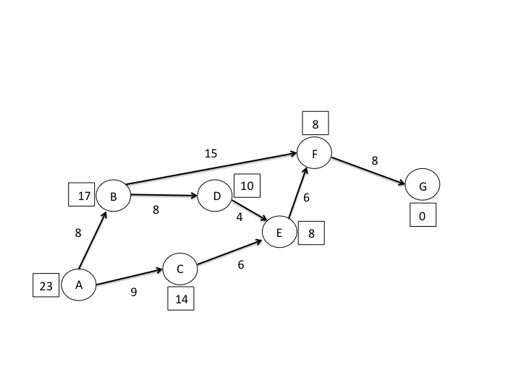

1. List the order that nodes will be expanded in Uniform Cost Search (Dijkstra’s algorithm).
2. List the order that nodes will be expanded in A* Search.
3. What is the purpose of AB pruning in the minimax search algorithm and why is it important?
4. In the following tree, how many fewer terminal nodes are evaluated when AB pruning is used than when the standard minimax is used? Explain your answer.

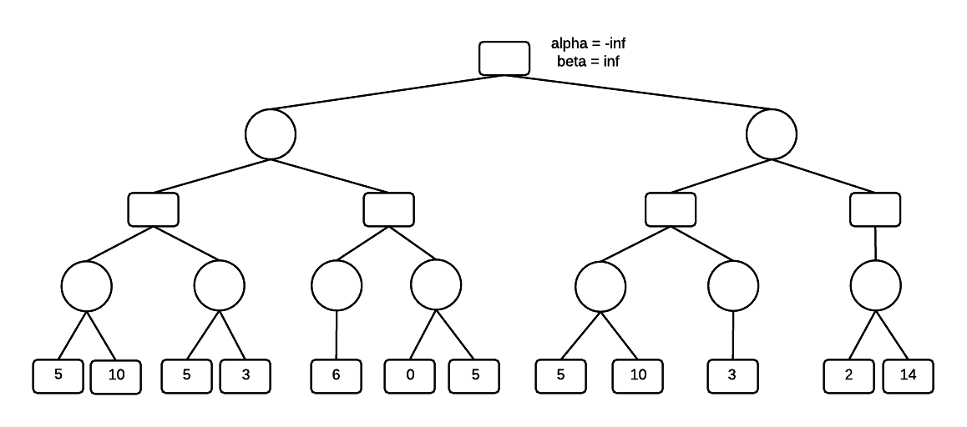

1. In an unweighted graph, the depth-first search algorithm is not guaranteed to find the optimal solution. However, that doesn’t mean that it never finds the optimal solution. On the other hand, breadth-first search on an unweighted graph always finds the optimal solution.

Show an example where DFS and BFS would both find the optimal solution, but DFS would evaluate fewer nodes in the graph than BFS to find the solution. A node is evaluated when its value is checked to determine if it is the goal node.

Your example should include a drawing of the graph and an explanation of how both algorithms would evaluate the graph.