GET THE LAB FILES

**Go to CipherLab wiki page:**

https://wiki.itap.purdue.edu/display/CERIASSA/CipherLab

or https://goo.gl/u39Lux

*-lab.py with commented blanks to fill in; *-solution.py full

INTEGER VALUES

**A = 0 and…**

|  |  |  |  |  |
| --- | --- | --- | --- | --- |
| **B = 1** | **C = 2** | **D = 3** | **E = 4** | **F = 5** |
| **G = 6** | **H = 7** | **I = 8** | **J = 9** | **K = 10** |
| **L = 11** | **M = 12** | **N = 13** | **O = 14** | **P = 15** |
| **Q = 16** | **R = 17** | **S = 18** | **T = 19** | **U = 20** |
| **V = 21** | **W = 22** | **X = 23** | **Y = 24** | **Z = 25** |

PYTHON PRIMER

Python can come with an editor: IDLE

Automatic tabbing/commenting, F5 to run program

Brackets? Semicolons? Actually just whitespace

tab: 4 spaces, Python interpreter uses whitespace to determine blocks

No type casting and no type coercion

If it ain’t compatible, it ain’t going to convert – find a wrapper/conversion method

Python works in lists (a list named L)

*.append()*, *.find()*, *.length()*, *L[i]* gets item *i*, definition as *a = (1,2,3,4,5)*

Special cases: strings (a string named S) 🡨 **we’ll be working here**

*+=*, *.find()*, *len(S)*, *str[S]* gets character *i*, definition as *a = ‘a’* or *a = ‘’*

IF statements: *if :*, *elif*, *else*

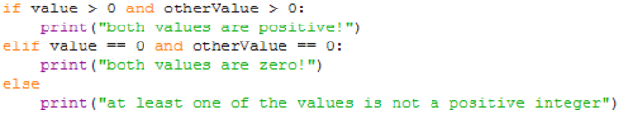

Other keywords*: in, and, or, not*

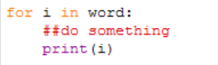FOR and WHILE statements also slightly different…

Print statements

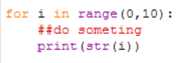To print an integer value *V* as part of a string, convert it using str(V) & add it

What’s missing? Ask!