**VOLUNTEER FEATURE - INDEX**

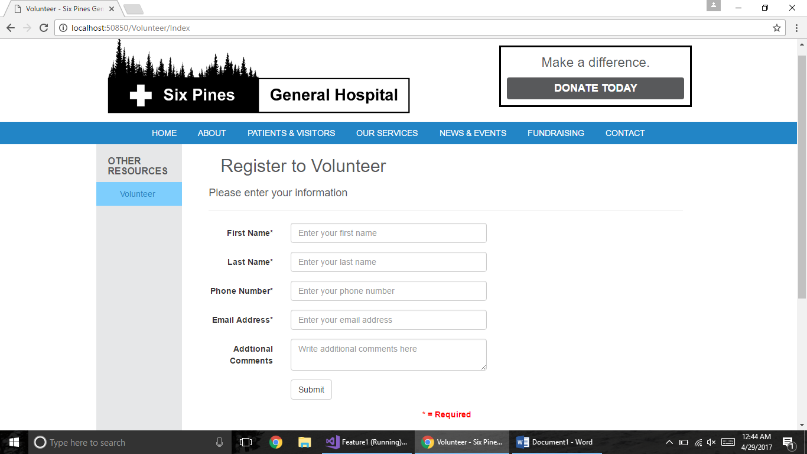

**VOLUNTEER FEATURE – ADMIN**

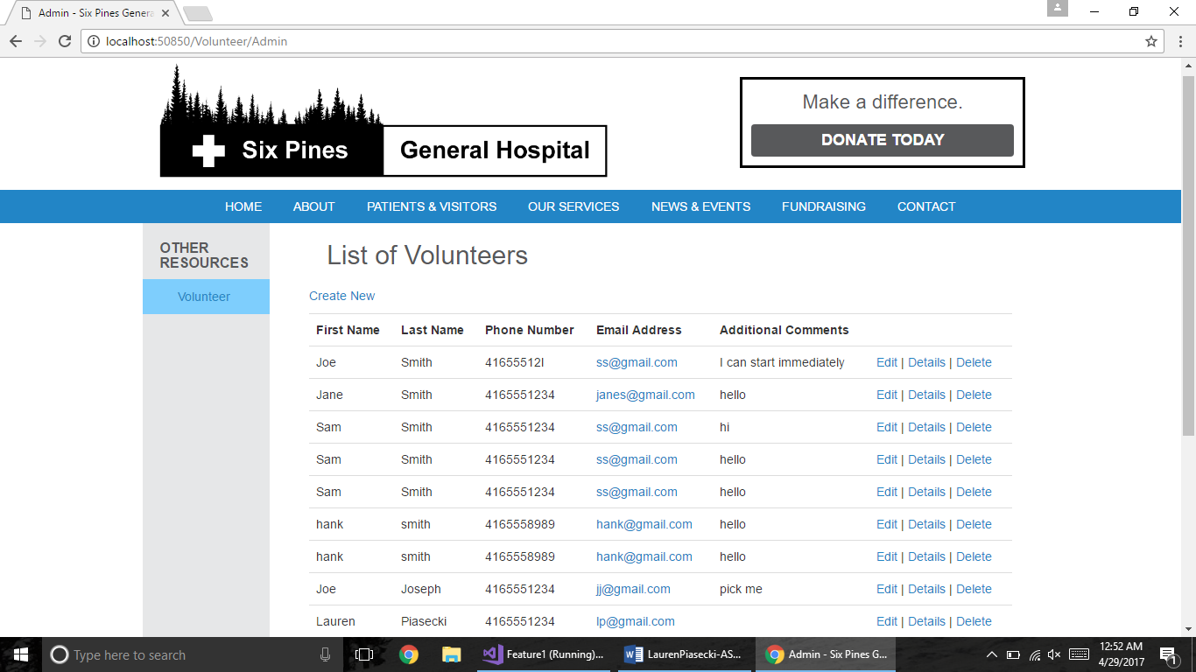

**BLOG FEATURE – INDEX**

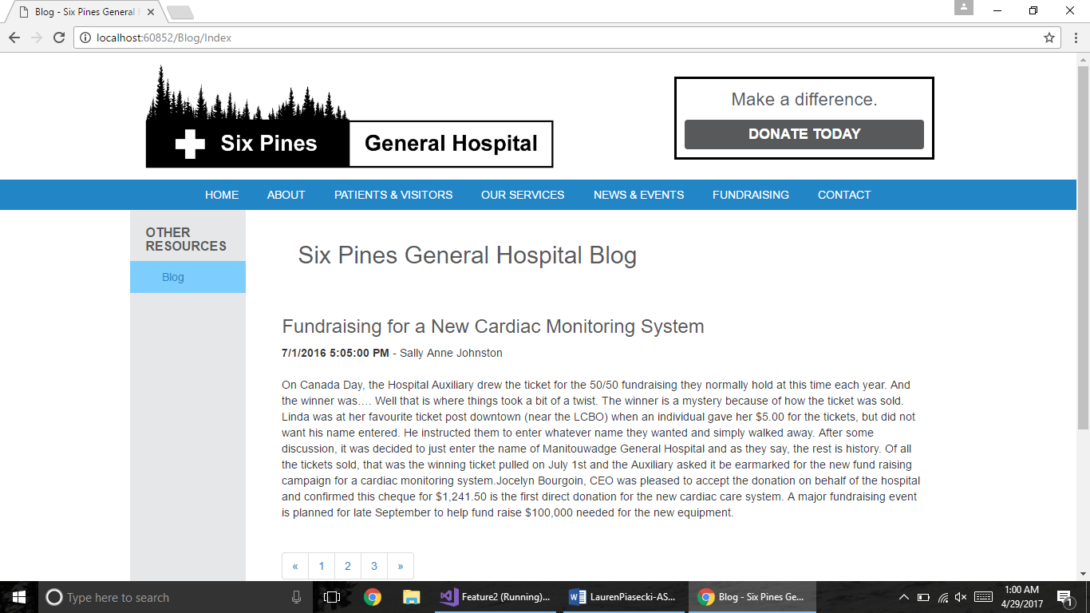

**BLOG FEATURE – ADMIN**

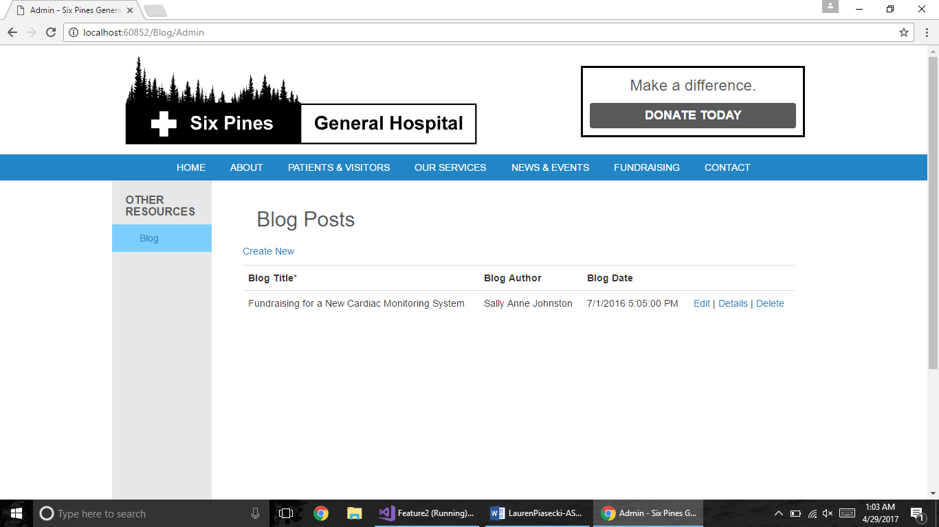

**EVENTS CALENDAR – INDEX**

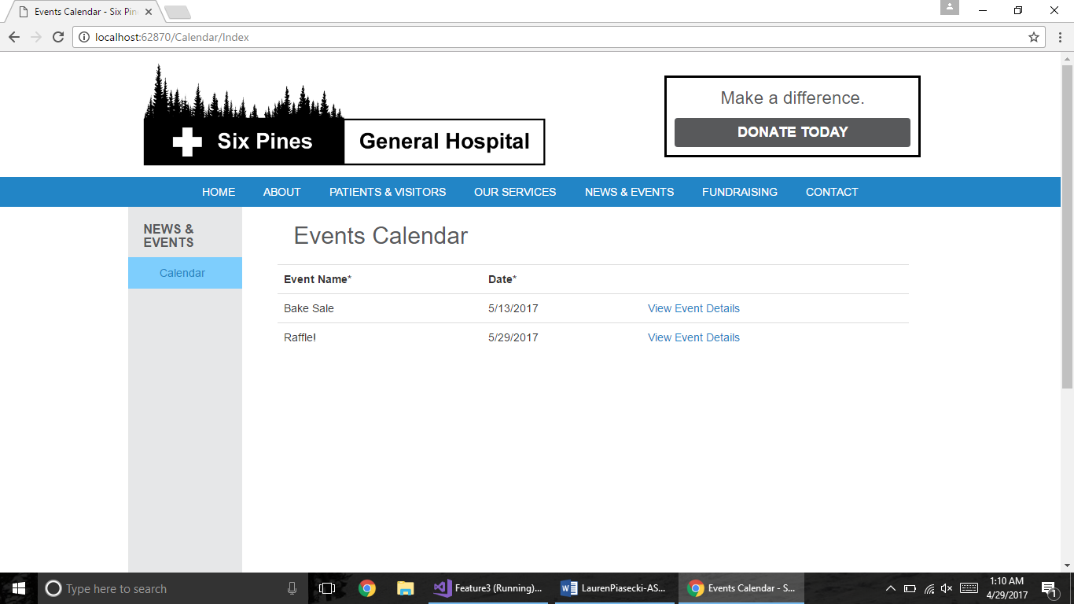

**EVENTS CALENDAR – ADMIN**

