Histograms of peak intensities
Noise (peaks less than 5E5)
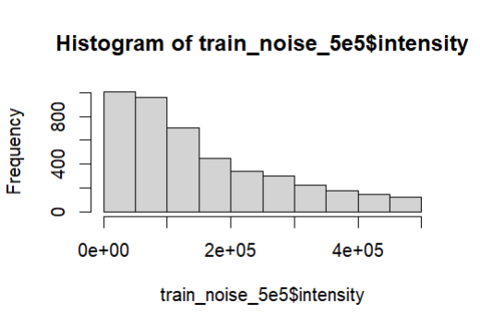
Signal (peaks less than 5E5)
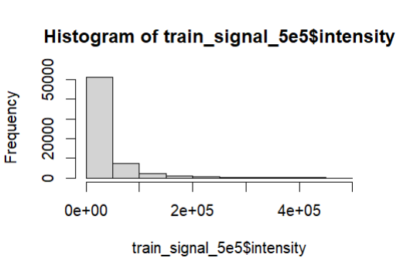

Noise (peaks less than 1E5)
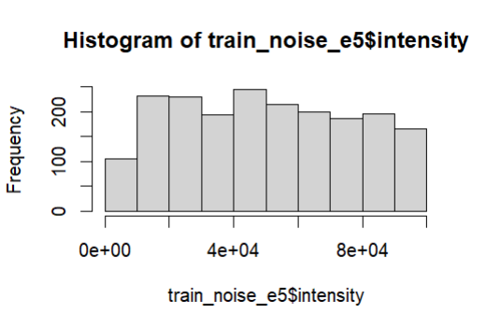
Signal (peaks less than 1E5)
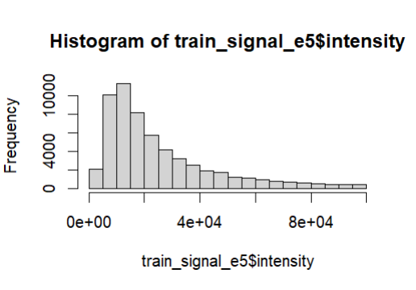

Signal to Noise ratio for number of peaks per spectrum
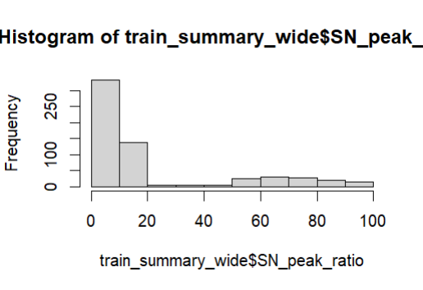

Correctly predicted labels
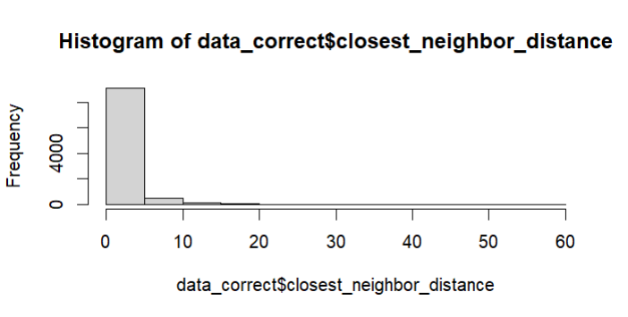
Incorrectly predicted labels
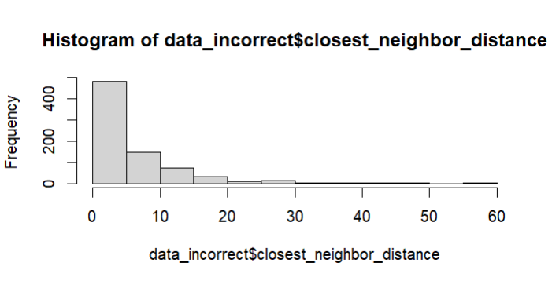

SKlearn model notes
- Code here: https://github.com/laurenroyer1/MBI_iSCMS_Hackathon2025.git
- Swapping to log pred as linear is poor fit for 0/1 binary output
    - sklearn.linear_model import LogisticRegression
- Initial test no manual weighting just using train set split:
Accuracy: | 0.92474
 | precision | recall | f1-score | support
0 | 0.54 | 0.07 | 0.12 | 1063
1 | 0.93 | 1 | 0.96 | 12902
accuracy |  |  | 0.92 | 13965
macro avg | 0.74 | 0.53 | 0.54 | 13965
weighted avg | 0.9 | 0.92 | 0.9 | 13965
- Test no manual weighting adding in validation set only benefit from (increasing training size)
Accuracy: | 0.927059
 | precision | recall | f1-score | support
0 | 0.63 | 0.09 | 0.16 | 806
1 | 0.93 | 1 | 0.96 | 9819
accuracy |  |  | 0.93 | 10625
macro avg | 0.78 | 0.54 | 0.56 | 10625
macro avg | 0.91 | 0.93 | 0.9 | 10625

- 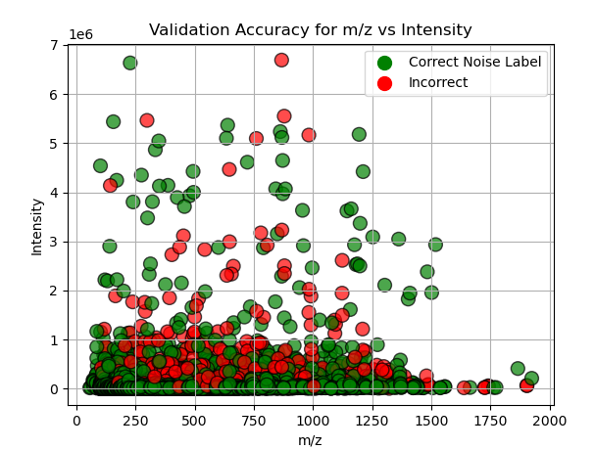
- 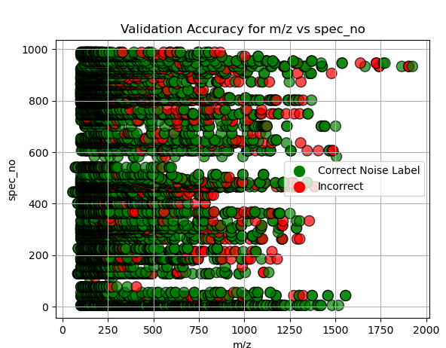
- 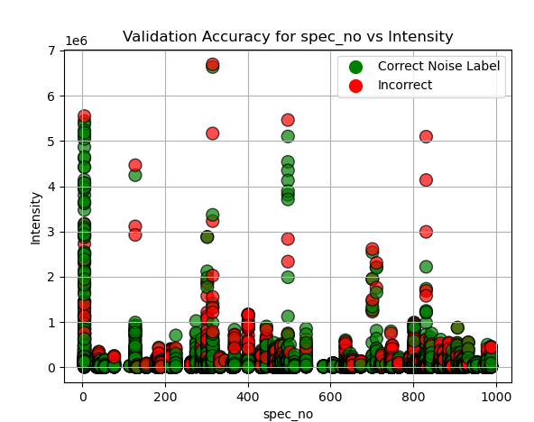
- 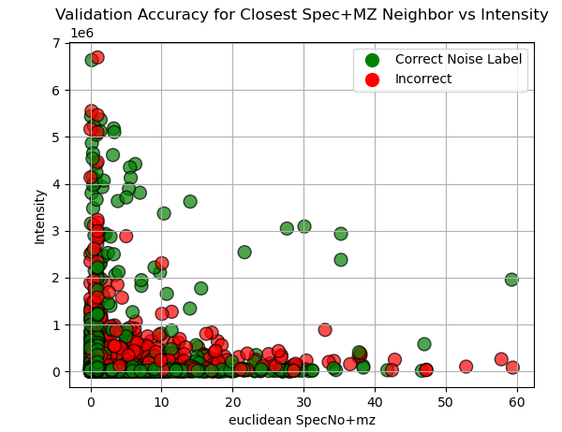
- From this added Euclidian distance of scannumxmz to nearest neighbor as column but this worsened the accuracy
Accuracy: | 0.9168
 | precision | recall | f1-score | support
0 | 0.44 | 0.35 | 0.39 | 806
1 | 0.95 | 0.96 | 0.96 | 9819
accuracy | 0.92 | 10625
macro avg | 0.69 | 0.66 | 0.67 | 10625
weighted avg | 0.91 | 0.92 | 0.91 | 10625
- So just doing

