GROUP : Lauren Ruffner and Hannah Davidson

5.1 Problem 1:

State Diagram:

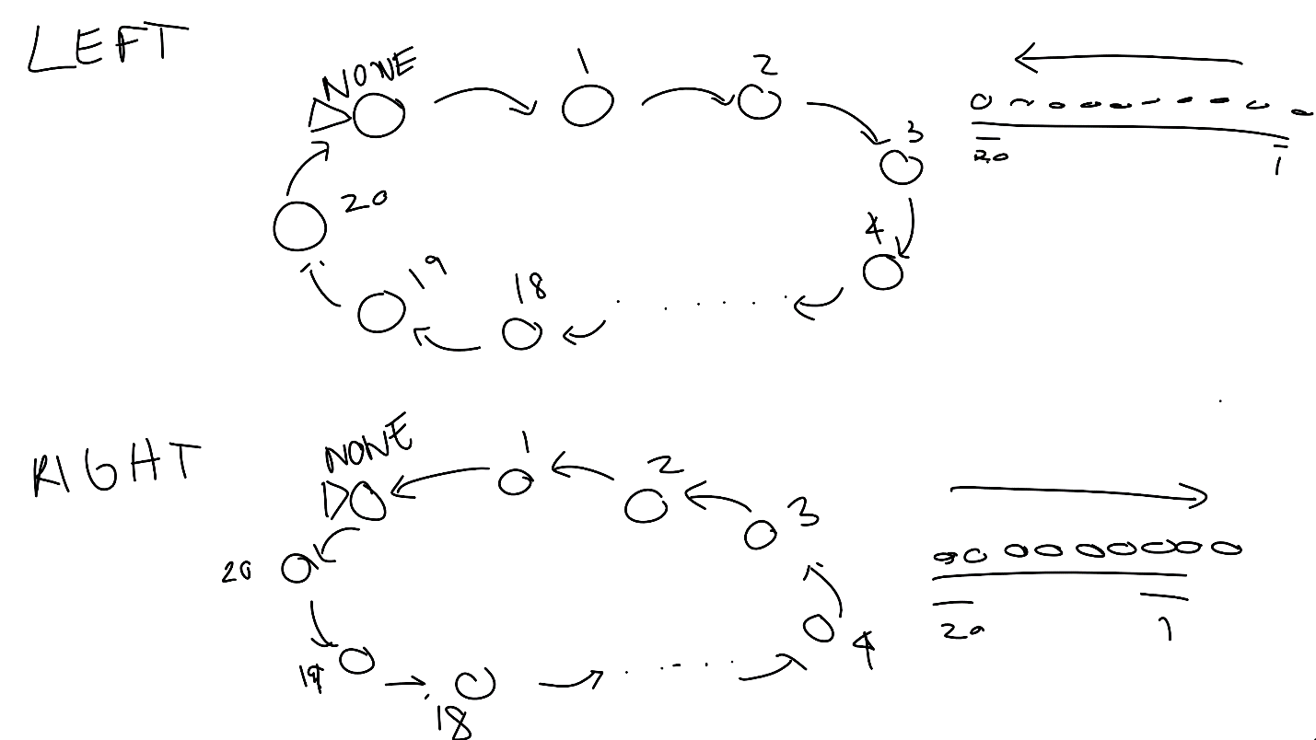

It will start at none and then count up from 1 to 20 and then back to NONE for LEFT and count down from 20 to 1 and then back to NONE for RIGHT

5.1 Problem 2:

Logisim:

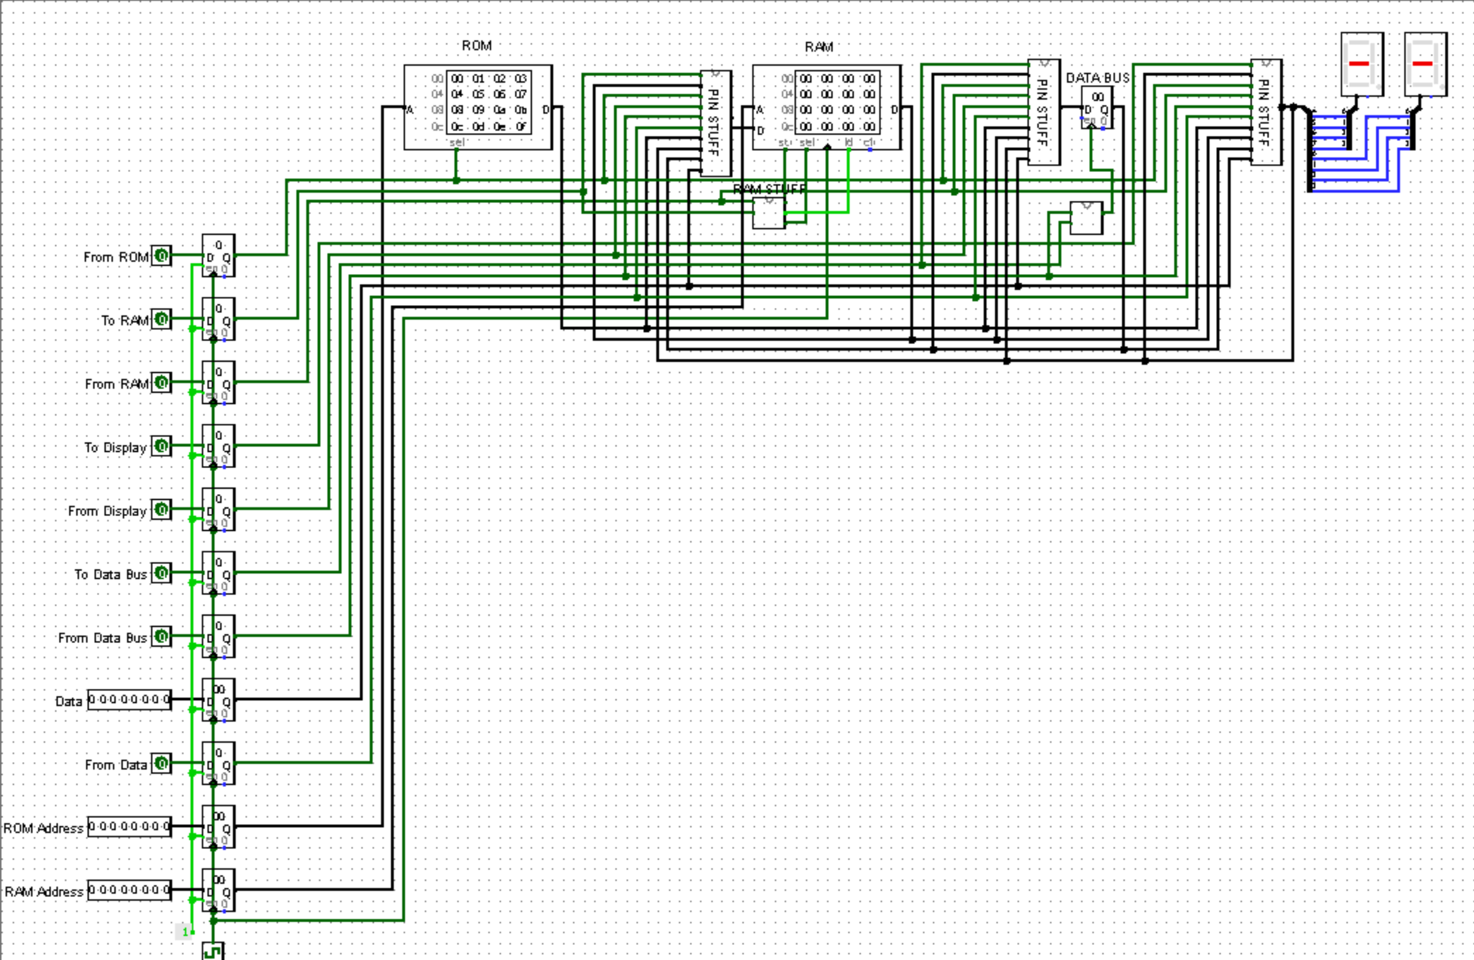

Provide brief text description, truth table and signal timing diagram to illustrate the operation of each sub-system or modules in your design.

My Logisim works by having the ROM already set up with data from 00000000 to 11111111. To write to RAM, Display, or the Data Bus you must first read the data from somewhere. To read from a certain address in ROM you must have “From ROM” as 1 and then it will read from the set address “ROM Address”. ROM is read only memory so you may not write to ROM. That data from ROM can be moved to the Data Bus, RAM, or display by selecting the TO for any of those three. The only caveat for that is that you must select an address for it to write to in RAM and that is set by “RAM Address”. The data bus stores the data to be moved either to RAM or display. You can also have an input DATA that can be stored on RAM, Data Bus and Display.

|  |  |  |  |  |  |  |  |  |  |  |  |  |
| --- | --- | --- | --- | --- | --- | --- | --- | --- | --- | --- | --- | --- |
|  | DISPLAY ON | DISPLAY ON | DISPLAY ON | DISPLAY ON | SAVE IN RAM | SAVE IN RAM | SAVE IN RAM | SAVE IN RAM | SAVE TO DATA BUS | SAVE TO DATA BUS | SAVE TO DATA BUS | SAVE TO DATA BUS |
| FROM ROM | 1 | X | X | X | 1 | X | X | X | 1 | X | X | X |
| TO RAM | X | X | X | X | 1 | 1 | 1 | 1 | X | X | X | X |
| FROM RAM | X | 1 | X | X | X | X | X | X | X | 1 | X | X |
| TO DISPLAY | 1 | 1 | 1 | 1 | X | X | X | X | X | X | X | X |
| FROM DISPLAY | X | X | X | X | X | 1 | X | X | X | X | 1 | X |
| TO DATA BUS | X | X | X | X | X | X | X | X | 1 | 1 | 1 | 1 |
| FROM DATA BUS | x | X | 1 | X | x | X | 1 | X | X | X | X | X |
| FROM DATA | X | X | X | 1 | X | X | X | 1 | X | X | X | 1 |
| CLOCK | 1 | 1 | 1 | 1 | 1 | 1 | 1 | 1 | 1 | 1 | 1 | 1 |

TIMING DIAGRAM:

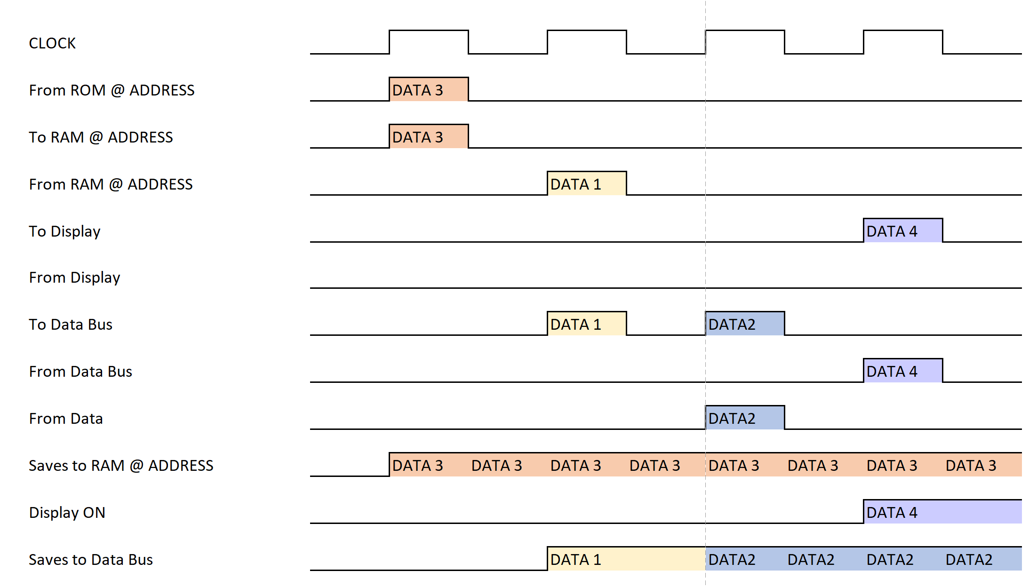

The data highlighted lets you know where that data came from and where it is saved

PSEUDO/ C CODE THINGS:

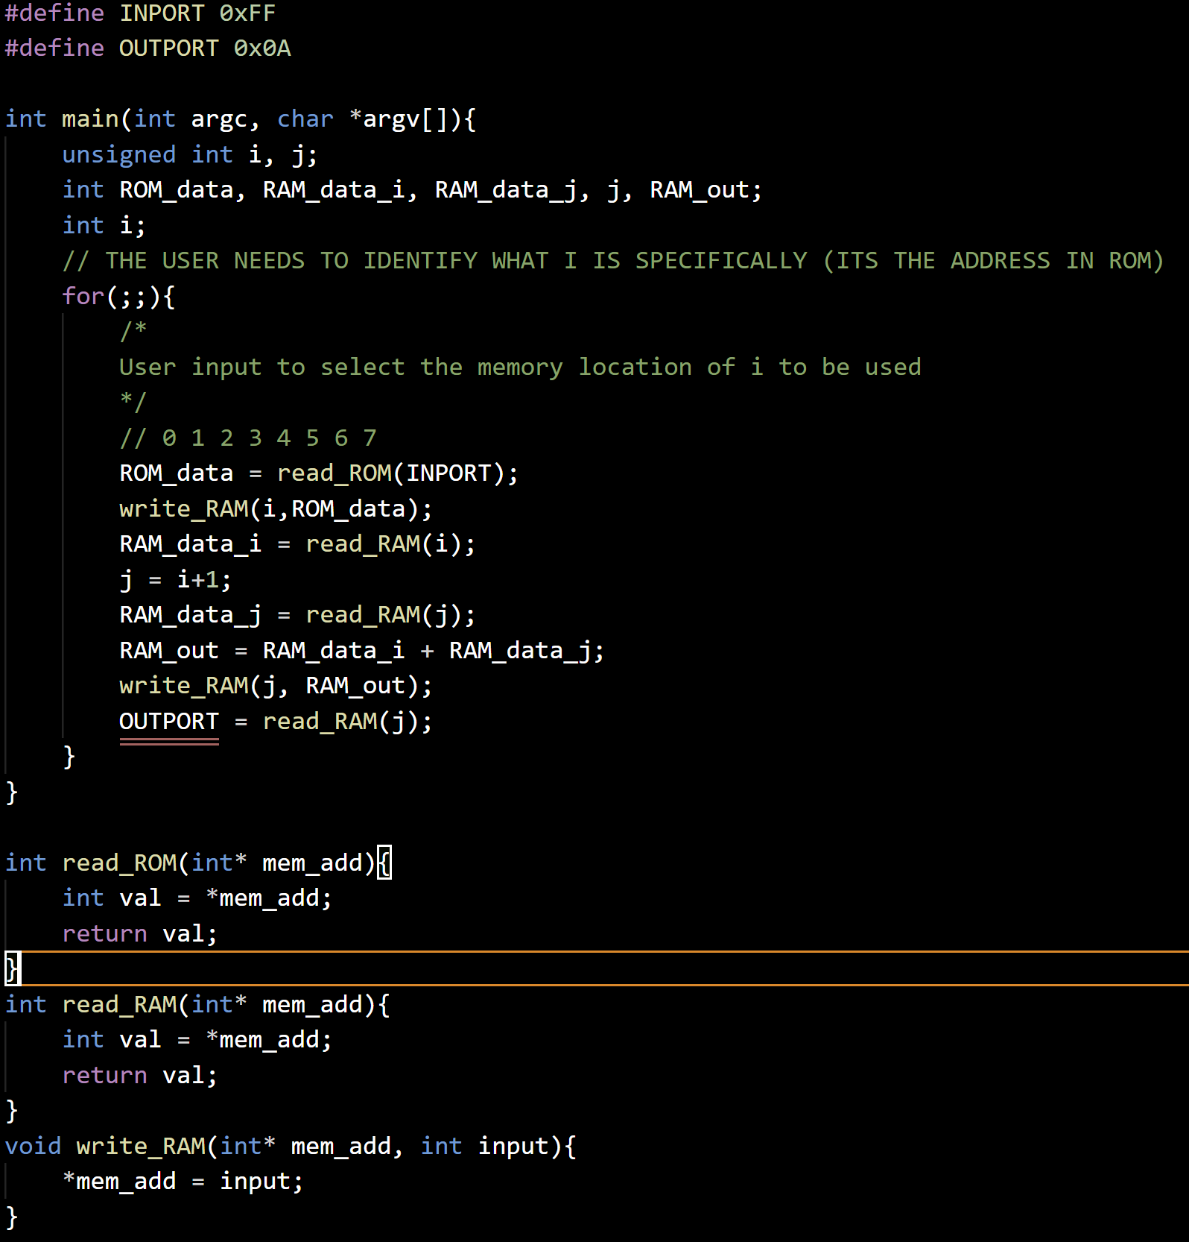

TIMING DIAGRAM

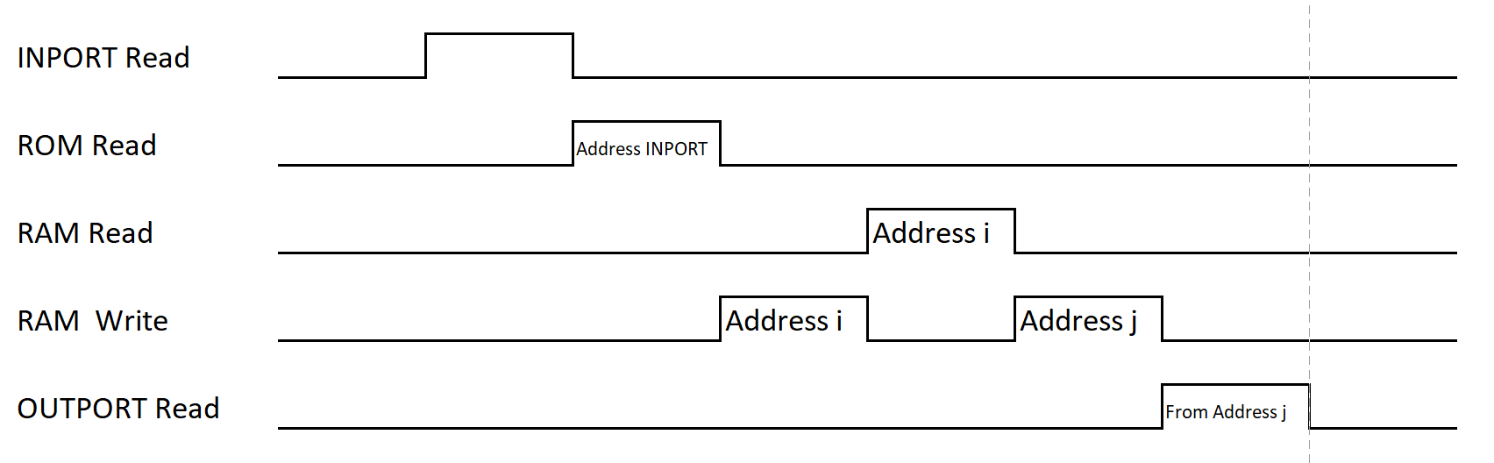

5.1 Problem 3:

ADDER:

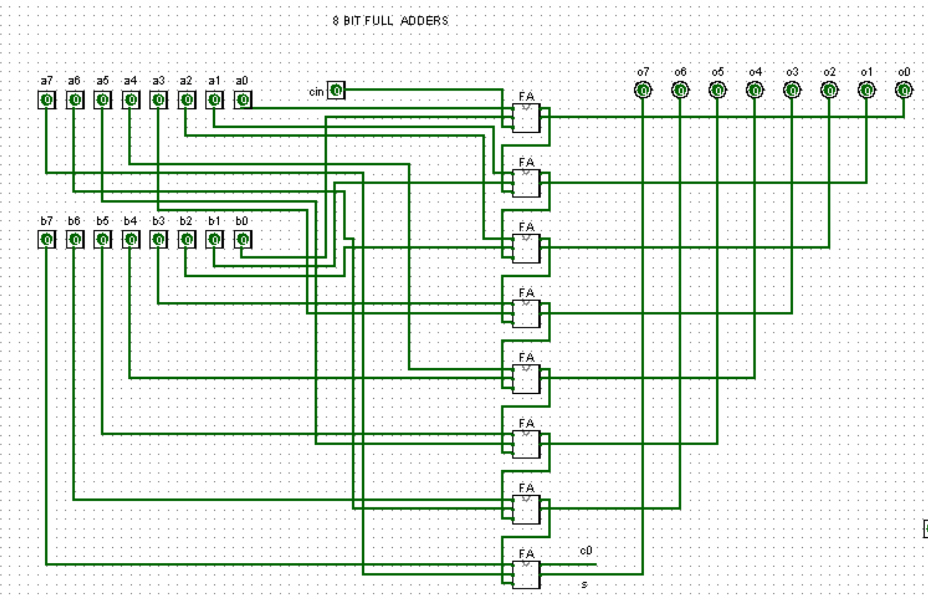

SUBTRACTOR:

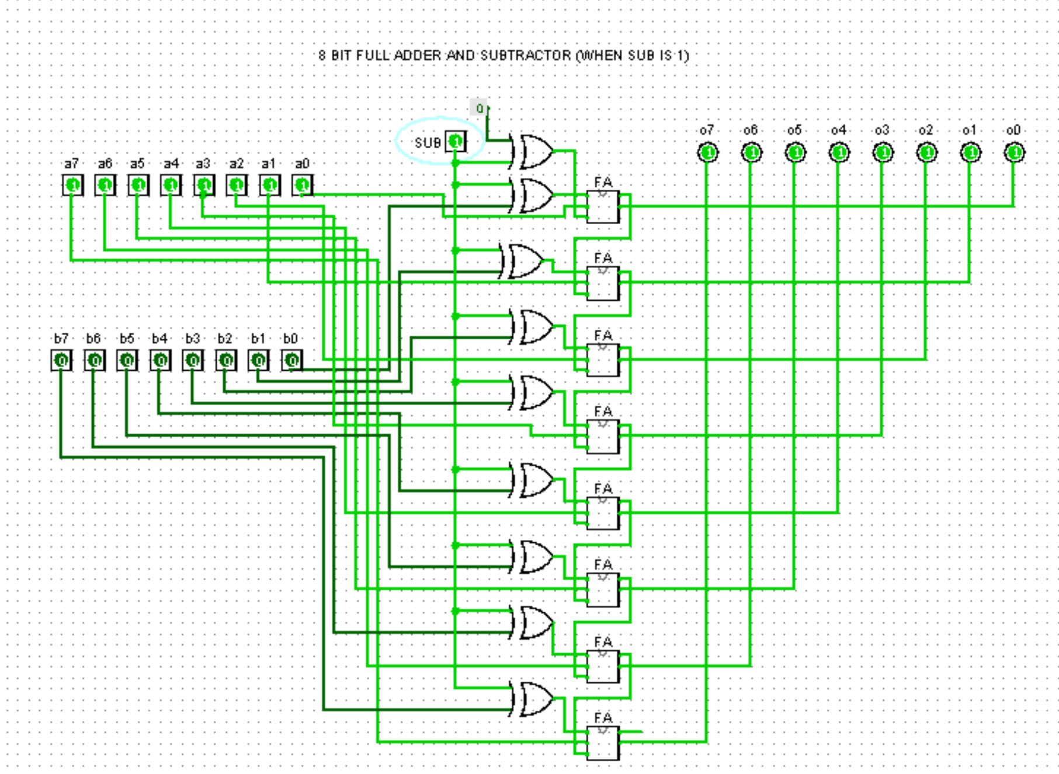

MAGNITUDE COMPARATOR:

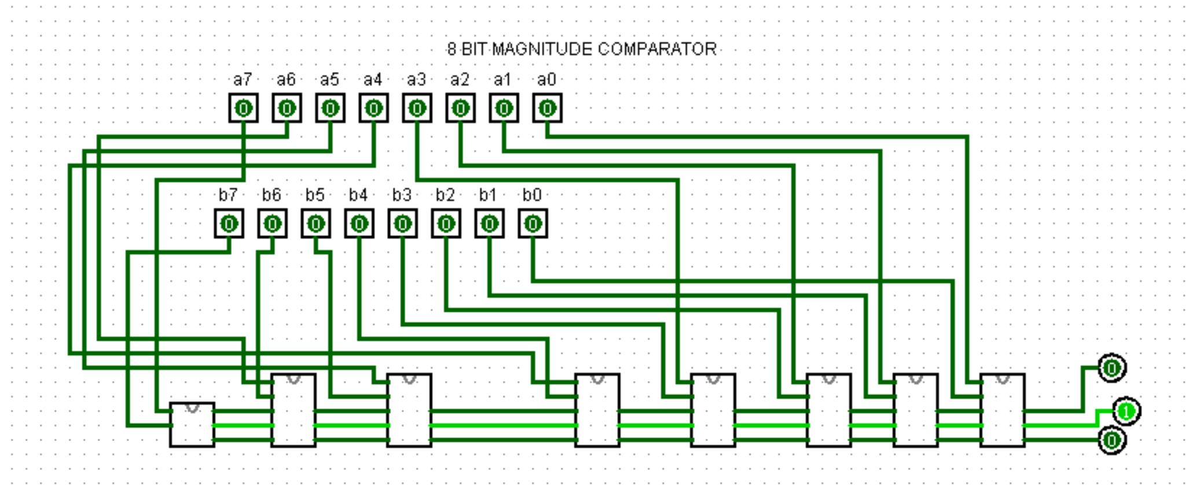

BARREL SHIFTER:

