** Lauren’s plants**

**Welcome to the plant party!**

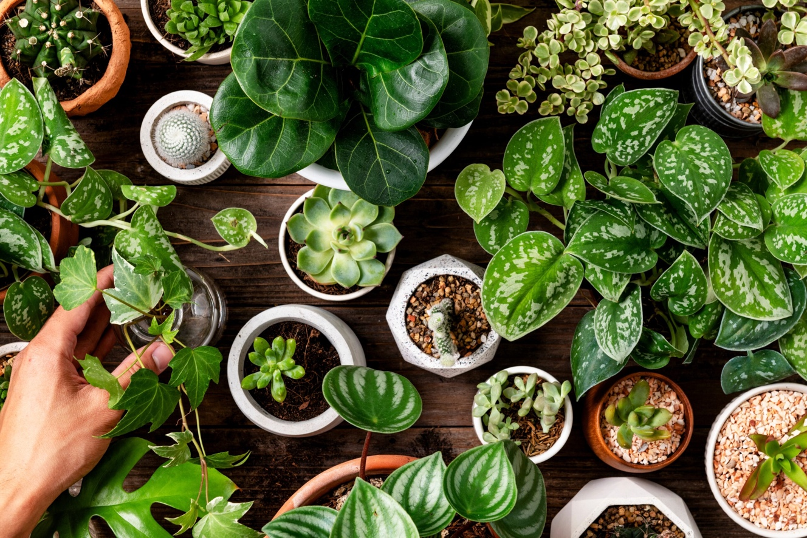

Bring your best friend, dog, family, or whoever you want to come learn about houseplants and receive our expert-level care advice! See the table below for a list of our services and pricing.

**Price List**

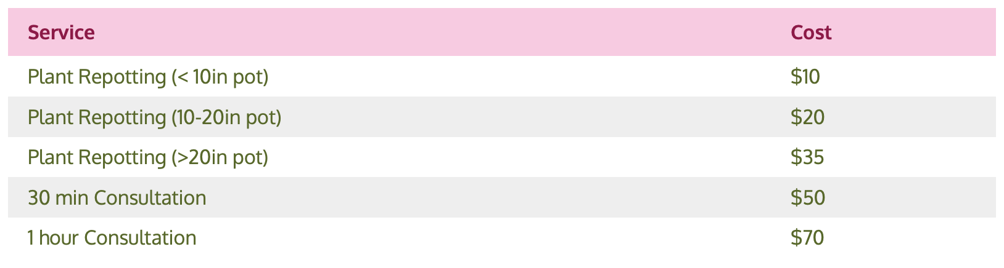

**See you soon!**