# Homebrew Computer RedBoard6809

By Favard Laurent, 2003/2013, Hobby project around 8 bits processor

Updated: 2013, May 24

Summary

Homebrew Computer RedBoard6809 1

Overview 3

History 3

Apple Mac Computer 3

Hardware 4

CPU Board #1 4

I/O Board #2 4

CPU Board schematic 5

I/O Board schematic 6

Memory map 7

Problem and troubleshooting 8

Wires and clock checking 8

First program test: 8

Second test program 9

Last tests programs 9

Software: EK6809Monitor 10

Boot sequence and initialization 11

Monitor header 12

RAM system variables 12

Monitor functions table 12

ROM Expansion at $8000 13

Automatic Execution 13

Applications Expansion 13

Annexe: Oscilloscope screenshots 15

E clock screenshot 15

/CSROM waveform showing regular processor access 15

4060 Q4 signal: Crystal 2.457600 MHz / 16= 153600 Hz 15

Annexe: Source examples 16

Skeleton of Application Expansion ROM 16

Skeleton of Automatic Expansion ROM 17

Skeleton of Diagnostic Expansion ROM 18

Annex: Monitor Screenshots 23

# Overview

The RedBoard 6809 homebrew computer is a small system Motorola 6809 8bits processor based. The system is made-up of two boards, the CPU board which hosts the processor, RAM, ROM, memory decoder and power supply regulation; the I/O board which hosts a 6821 PIA, a 6850 ACIA and clock generation for bauds speed.

RedBoard it’s because PCBs are in red color.

# History

These boards have been designed in 2003 years but then put aside, this project has been picked up in 2012. Because, I’m worked on a small 6809 Emulator as hobby under Mac OSX with Xcode, It was interesting to emulate these boards in the Emulator instead of any other more complicated 6809 based computer. When the Emulator started to works, I wrote a small Monitor in 6809 assembly for fun…Then, It became clear that the final step was to put this one in a real Eprom and run it on a real hardware. The loop was looped!

The CPU was working for the first time on February 1, 2013 and the full computer was alive on Februray 24, 2013.

# Apple Mac Computer

I used a USB/Serial RS-232 adapter PL20xx chip based. Under OSX Lion, you need the following driver: **PL2303_Serial-USB_on_OSX_Lion.pkg**

To have a terminal program, you can use the built-in Unix command “screen /dev/tty.PL2203 9600” or any other tools like Zterm.

Beside the 6809 emulator running under OSX, I adapted a 6809 assembler from C sources to compile under Xcode .

# Hardware

## CPU Board #1

The goal of this board is to host the full computer system without any I/O. This board is made-up of:

* Simple power supply regulator 7805 based
* Processor 68B09 with external crystal at 8MHz (For a bus frequency at 2MHz)
* Static RAM 62256, 32kB.
* EEPROM Atmel 28C64, 8kB.
* Memory decoder 74HCT138 (3 to 8)

## I/O Board #2

This board allows the CPU to access to a peripheral parallel and serial interface.

* PIA 68B21 for general purpose usage
* ACIA 68B50 for RS-232 communication with a Max232
* Clock generator 4060 with crystal 2.4576 Mhz based for ACIA speed rate

## CPU Board schematic

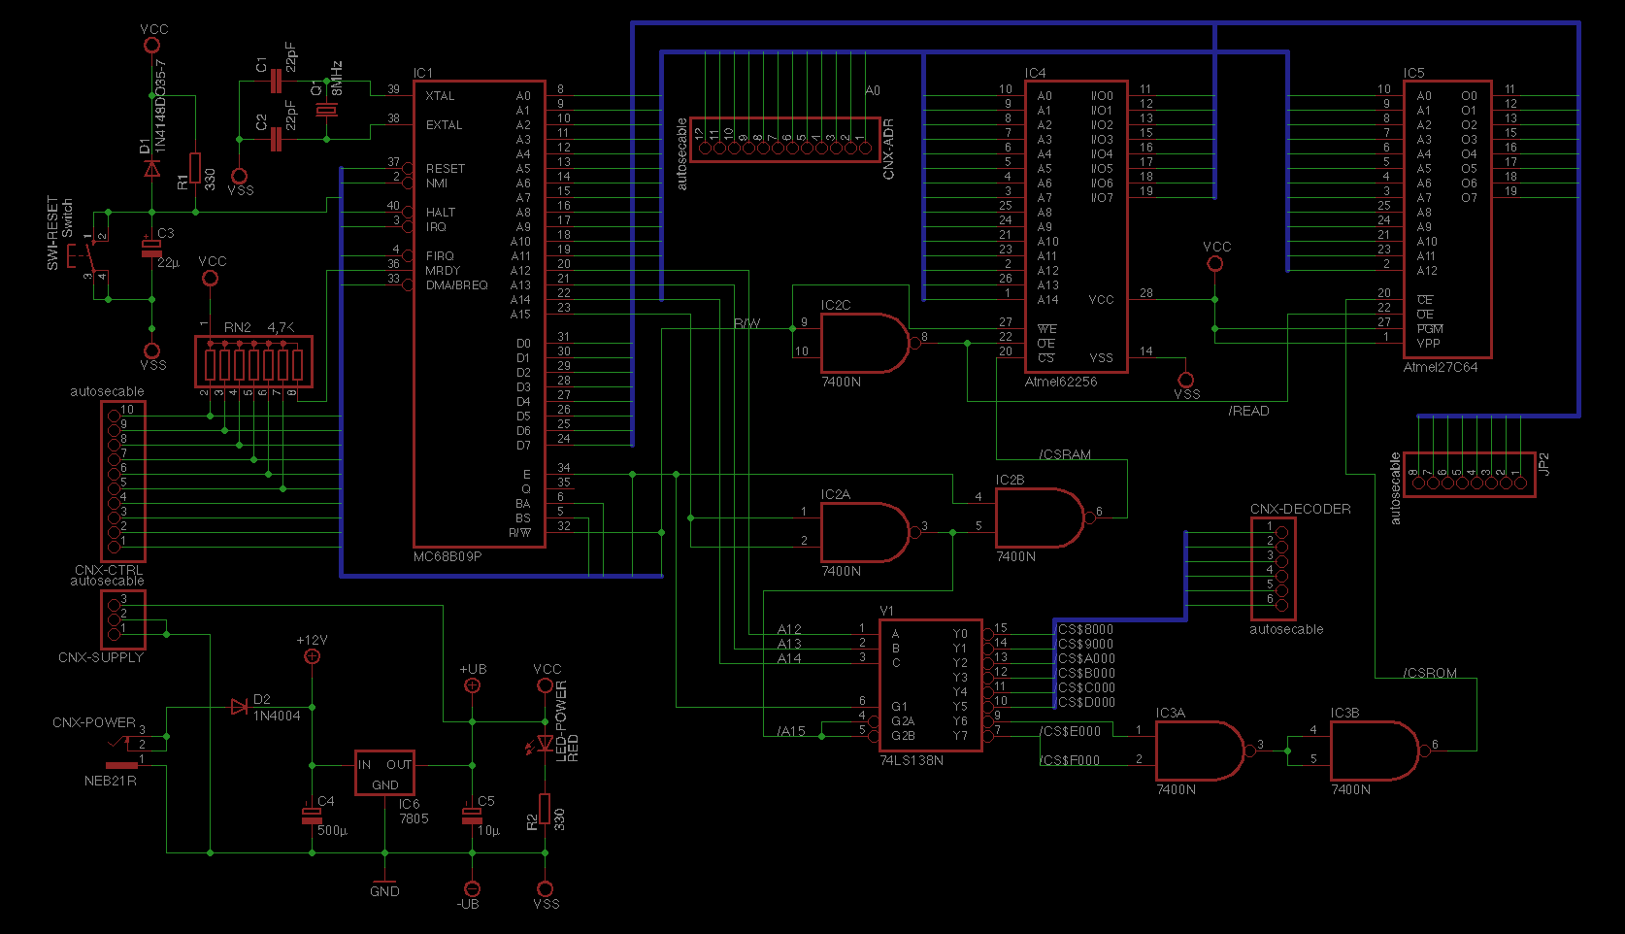

## I/O Board schematic

## Memory map

For the hardware point of view, the memory map is as follow:

$FFFF

EEPROM for Boot/Monitor 8kB

$E000

$DFFF

I/O 6821, 6850 (Board#2] 4kB

$D000

$CFFF

No hardware in this area 4kB

$C000

$BFFF

No hardware in this area 4kB

$B000

$AFFF

No hardware in this area 4kB

$A000

$9FFF

No hardware in this area 4kB

$9000

$8FFF

No hardware in this area* 4kB

$8000

$7FFF

Static RAM 32kB

$0000

*Monitor considers this area as the start of ROM expansion. Check the Monitor chapter to more information. However, for the hardware there is nothing specific.

## Problem and troubleshooting

### Wires and clock checking

Check that all wires are correctly done, not any unexpected wires between wrong signals. Then, with a scope, check the E signal clock on the processor (Or Q). The signal must be correct (See screenshot in Annexes)

E = crystal frequency / 4.

### First program test:

We are lucky, 6809 has a great and useful instruction: **Sync**.

I used a small program (EK6809Boot1.bin) which contains a **sync** instruction**.** When the processor executes a **sync** instruction it stops its activity and wait for an external synchronization, i.e., an interrupt! In this case **BA** signal = 1 and **BS** signal = 0. I suggest having two LEDs to visualize the **BA/BS** status.

So, to check that processor is able to read the ROM, find the correct Reset vector and fetch some instruction before to stop, I burned an EEPROM with the following code:

org $E000

BootCode: lds #$100

ldu #$100

loop: sync ; BA = 1 and BS = 0

bra loop

Vector: rti

marque: fcc "LAURENT BOOTCODE TEST #1, 20130201"

; ----------------------------------------------------------------------------------------------------

spaceto $FFF0 ; special LFD directive: fill from last PC = * to here

org $FFF0

Vectors: fdb Vector

fdb Vector

fdb Vector

fdb Vector

fdb Vector

fdb Vector

fdb Vector

fdb $E000

Troubleshooting: I lived issues for a while until having BA/BS corrects. A7 address bus bit was tied to the VCC Power and A1 was not correctly connected to the RAM and ROM chips.

### Second test program

I used EK6809Boot2.bin to check if the I/O board was ok. This program send a character on the serial RS-232 and the binary values %10101010 and %01010101 in order to have something that can be seeing with a scope.

Troubleshooting: When I did it, it doesn’t work on the RS-232 but was Ok on the PIA. The problem was D1 data was not connected correctly between the both board and signal E was in short-circuit with D1 on the I/O board. This is why the program doesn’t check the status register before to send a character.

### Last tests programs

When previous issues were solved, I tried EK6809Boot3.bin to check that reading status register was ok. Then, I burned EK6809Boot4.bin which adds a simple RAM memory test.

At the end when seems to be ok, I burned the EK6809Monitor.bin and I had the great pleasure to see the monitor started exactly in the same way in the Emulator under OSX.

# Software: EK6809Monitor

The monitor contents a minimal hardware initialization, memory checking and a set of commands in a small CLI. In addition, for fun, I added the tinyBasic in the same EPROM. Burn the EK6809Monitor.bin in a 8kB EEPROM 28C64.

TinyBasic is (C) Copyright 1977 by JOHN BYRNS

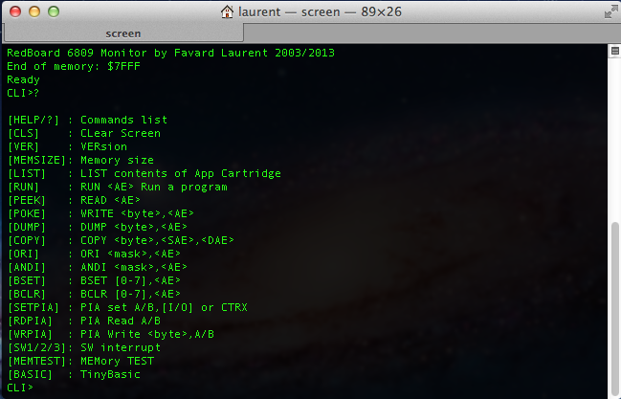

Screenshot of the Monitor started

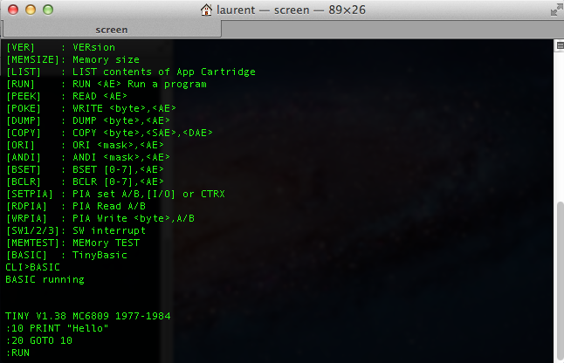

Screenshot of the tiny basic started

## Boot sequence and initialization

The monitor starts at **$E000** and immediately executes a **bra** to bypass the Monitor header:

org $E000

bra OSStart

fcc "6809" processor code

fcb 1,0 major,minor

fcb 20,12,01,16 date in BCD (YY,YY,MM,DD)

fdb FunctionsTable monitor functions table address

OSStart: *Boot code start here*

1. Initialize system stack pointer to temporary value
2. Initialize user stack pointer to temporary value
3. Mask all interrupts (IRQ and FIRQ)
4. Copy in RAM the addresses of all interrupts vectors
5. Reset the ACIA
6. Set the ACIA 9600 baud, 8 bits, no parity, 1 stop
7. Check for **Diagnostic** **Cartridge** if [$8000] = ‘D’ and [$8001] = ‘G’
   * If yes, load X with a return address
   * Jump at the address stored at $8002
8. Enable the interrupts (IRQ and FIRQ)
9. Check the memory from $0000 and compute the size
10. Store the RAM size at $0000
11. Store the end of RAM at $0002
12. Set the System stack point to the end of RAM
13. Set the User stack point to the below the system stack area
14. Set PIA port A and B in input mode
15. Check for **Automatic Cartridge** if [$8000] = ‘A’ and [$8001] = ‘T’
    * If yes, load X with a return address
    * Jump at the address stored at $8002
16. Check for **Applications** “cartridge” code if [$8000] = ‘A’ and [$8001] = ‘P’
    * If yes, through the list of descriptors and display each program available
17. Enter in the main CLI loop for await any user command

## Monitor header

$E000 bra OSStart

$E002 fcc "6809"

$E006 fcb 1,0 Major, minor

$E008 fcb 20,13,02,01 BCD date YY,YY,MM,DD

$E00C fdb FunctionsTable Monitor functions table

## RAM system variables

$0000 RamSize Size of the RAM

$0002 RamTop Top RAM address (last address)

$0004 Swi3Vector Vector address to SW3

$0006 Swi2Vector Vector address to SW2

$0008 FirqVector Vector address to FIRQ

$000A IrqVector Vector address to IRQ

$000C SwiVector Vector address to SWI

$000E NmiVector Vector address to NMI

## Monitor functions table

FunctionsTable + 0 fdb PutChar

FunctionsTable + 2 fdb PutHexChar

FunctionsTable + 4 fdb GetChar

FunctionsTable + 6 fdb GetCharUntil

FunctionsTable + 8 fdb WriteHexByte

FunctionsTable + 10 fdb WriteBinByte

FunctionsTable + 12 fdb WriteString

FunctionsTable + 14 fdb ReadString

FunctionsTable + 16 fdb ReadHexFromString

FunctionsTable + 18 fdb $0000 end of table

## ROM Expansion at $8000

The monitor considers the $8000 area as a possible expansion. For that it will check the both address $8000 and $8001 for a magic number. If nothing is found, nothing it’s done. The hardware set only this area to a size to 4kB in accordance to the 74HCT138 memory decoder. If more space is required, the hardware must be updated to change the default memory map decoding as done for example for the Monitor EEPROM at $E000 where two 74HCT138 outputs are combined via NAND gates.

The area isn’t exclusively an EEPROM, but can be a ROM with any additional hardware…

Diagnostic Cartridge

The monitor executes an automatic code with a JMP instruction. Monitor stores in X register a return address if the program executed wants to return to the monitor.

+0 +1

$8000 = ‘**D**’ ‘**G**’

$8002 = First 6809 instruction

Go back to Monitor: **jmp 0,x**

### Automatic Execution

The monitor executes an automatic code with a JMP instruction. Monitor stores in X register a return address if the program executed wants to return to the monitor.

+0 +1

$8000 = ‘**A**’ ‘**T**’

$8002 = First 6809 instruction

Go back to Monitor: **jmp 0,x**

### Applications Expansion

The monitor via the RUN command will perform a **JSR** sub-routine call. So a program must finish with a **RTS** to return to the Monitor.

+0 +1

$8000 = ‘**A**’ ‘**P**’

$8002 = First application descriptor

Descriptor format:

Descriptor1 + **CA_Next**  2 bytes, address of the next descriptor or NULL if the last

Descriptor1 + **CA_Run**  2 bytes, address of the program entry (first 6809 instruction)

Descriptor1 + **CA_Init**  2 bytes, address of the init code (first 6809 instruction)

Descriptor1 + **CA_Date**  2 bytes, GEMDOS format: DDDDDDDM.MMMDDDDD

Descriptor1 + **CA_Time**  2 bytes, GEMDOS format: HHHHHMMM.MMMSSSSS

Descriptor1 + **CA_Name** C string NULL terminated program name (Ended with ‘\0’).

The code pointed by CA_Run and CA_Init must be terminated by a RTS instruction. CA_Init can be Null.

See in Annexes a source example.

# Annexe: Oscilloscope screenshots

## E clock screenshot

## /CSROM waveform showing regular processor access

## 4060 Q4 signal: Crystal 2.457600 MHz / 16= 153600 Hz

# Annexe: Source examples

## Skeleton of Application Expansion ROM

RomCartidgeStart equ $8000

MonitorStart equ $E000

; ----------------------------------------------------------------------------------------------------

; Offsets in ROM header

CPUCode equ 2

Version equ 6

Date equ 8

OffTableRoutines equ 12

; ----------------------------------------------------------------------------------------------------

; Offsets of subroutines in functions's Monitor

PutChar equ 0

PutHexChar equ PutChar+2

GetChar equ PutHexChar+2

GetCharUntil equ GetChar+2

WriteHexByte equ GetCharUntil+2

WriteBinByte equ WriteHexByte+2

WriteString equ WriteBinByte+2

ReadString equ WriteString+2

ReadHexFromString equ ReadString+2

; ----------------------------------------------------------------------------------------------------

org RomCartidgeStart

fcc "AP" ; Applications Cartridge Header

; ----------------------------------------------------------------------------------------------------

CA_Next00: fdb CA_Next01

fdb CARun00

fdb $0000

fdb %0100001001110110 ; 2013/03/22

fdb %0111100000000000 ; 15h00:00

fcc "Example00\0"

CARun00: ldy #MonitorStart ; find adr of functions table

ldy OffTableRoutines,y ; Y = @ of functions table

ldy WriteString,y ; add offset to point WriteString

ldx #STRExample00 ; string to display

jsr 0,y

rts

STRExample00 fcc "Application 00 started\015\012\0"

; ----------------------------------------------------------------------------------------------------

CA_Next01: fdb $0000

fdb CA_Run01

fdb $0000

fdb %0100001001110110 ; 2013/03/22

fdb %0111100111100000 ; 15h15:00

fcc "Example01\0"

CA_Run01: ldy #MonitorStart

ldy OffTableRoutines,y

ldy WriteString,y ; add offset to point WriteString

ldx #STRExample01

jsr 0,y

rts

STRExample01 fcc "Application 01 started\015\012\0"

## Skeleton of Automatic Expansion ROM

RomCartidgeStart equ $8000

MonitorStart equ $E000

; ----------------------------------------------------------------------------------------------------

; Offsets in ROM header

CPUCode equ 2

Version equ 6

Date equ 8

OffTableRoutines equ 12

; ----------------------------------------------------------------------------------------------------

; Offsets of subroutines in functions's Monitor

PutChar equ 0

PutHexChar equ PutChar+2

GetChar equ PutHexChar+2

GetCharUntil equ GetChar+2

WriteHexByte equ GetCharUntil+2

WriteBinByte equ WriteHexByte+2

WriteString equ WriteBinByte+2

ReadString equ WriteString+2

ReadHexFromString equ ReadString+2

; ----------------------------------------------------------------------------------------------------

org RomCartidgeStart

fcc "AT" ;Automatic Cartridge Header

; ----------------------------------------------------------------------------------------------------

Startup: pshs x ;save return address

Ldy #MonitorStart ;find adr of functions table

ldy OffTableRoutines,y ;Y = @ of functions table

ldy WriteString,y ;add offset to point WriteString

ldx #STRExample00 ;string to display

jsr 0,y

puls x ;restore return address

jmp 0,x ;return to the monitor

STRExample00 fcc "Automatic Cartridge started\015\012\0"

## Skeleton of Diagnostic Expansion ROM

RomCartidgeStart equ $8000

MonitorStart equ $E000

; ----------------------------------------------------------------------------------------------------

; Offsets in ROM header

CPUCode equ 2

Version equ 6

Date equ 8

OffTableRoutines equ 12

; ----------------------------------------------------------------------------------------------------

; Offsets of subroutines in functions's Monitor

PutChar equ 0

PutHexChar equ PutChar+2

GetChar equ PutHexChar+2

GetCharUntil equ GetChar+2

WriteHexByte equ GetCharUntil+2

WriteBinByte equ WriteHexByte+2

WriteString equ WriteBinByte+2

ReadString equ WriteString+2

ReadHexFromString equ ReadString+2

; ----------------------------------------------------------------------------------------------------

org RomCartidgeStart

fcc "DG" ;Diagnostic Cartridge Header

; ----------------------------------------------------------------------------------------------------

Startup: pshs x ;save return address

ldy #MonitorStart ; find adr of functions table

ldy OffTableRoutines,y ; Y = @ of functions table

ldy WriteString,y ; add offset to point WriteString

ldx #STRExample00 ;string to display

jsr 0,y

puls x ;restore return address

jmp 0,x ;return to the monitor

STRExample00 fcc "Diagnostic Cartridge started\015\012\0"

; ---------------------------------------------------------------------------------------------------- Annex: Hardware screenshots

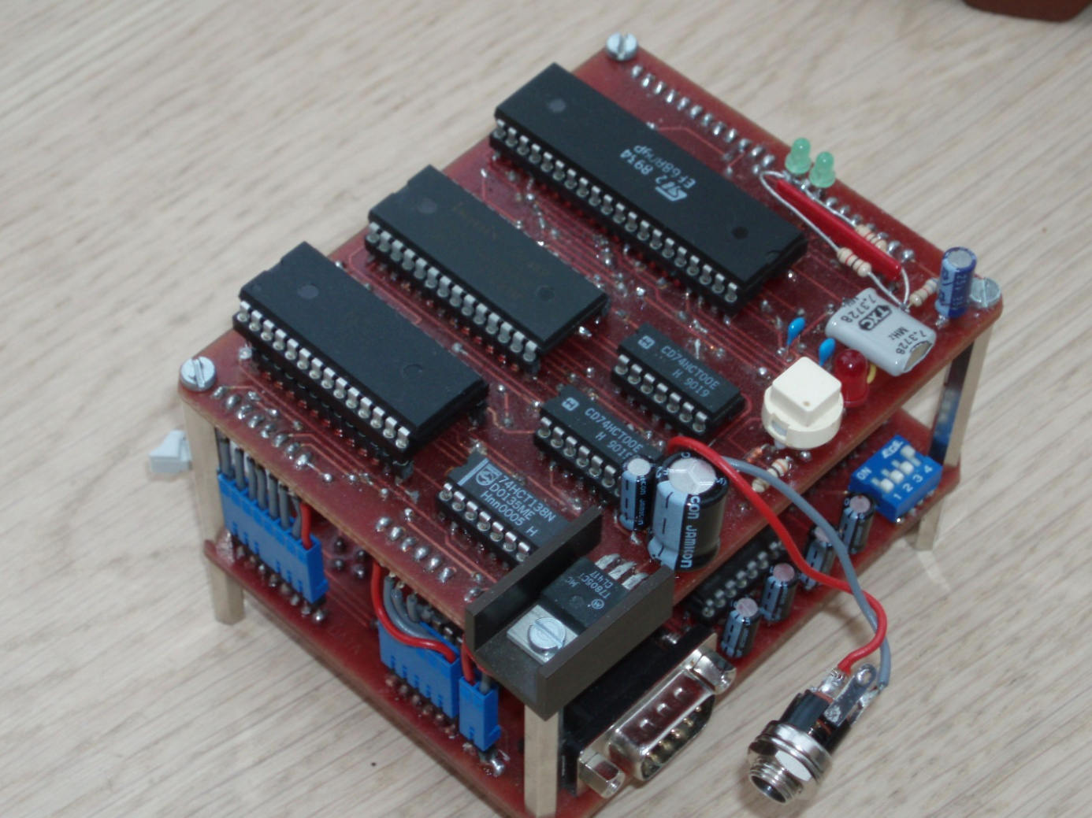

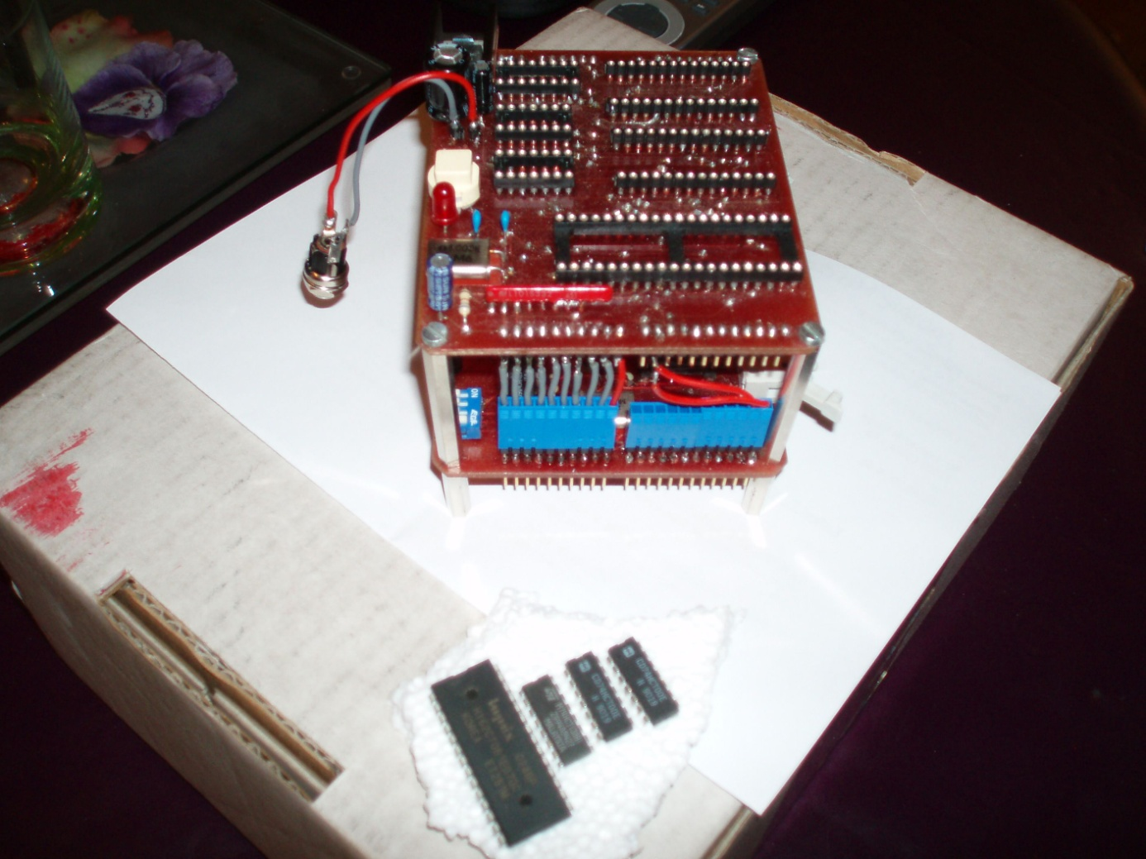

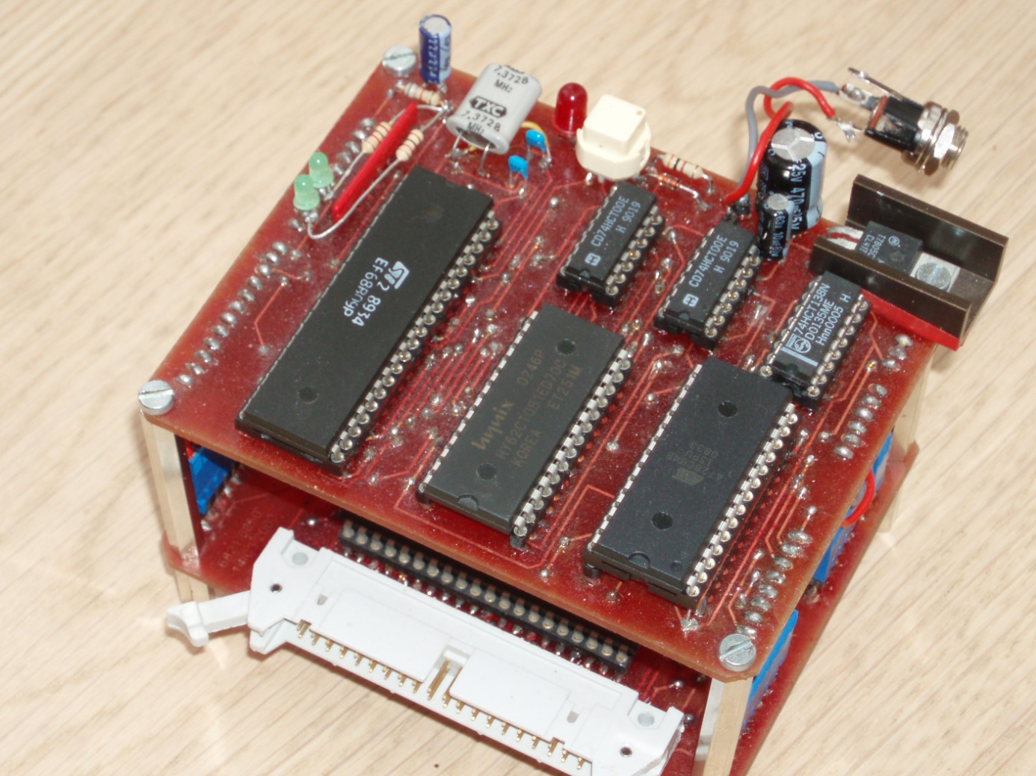

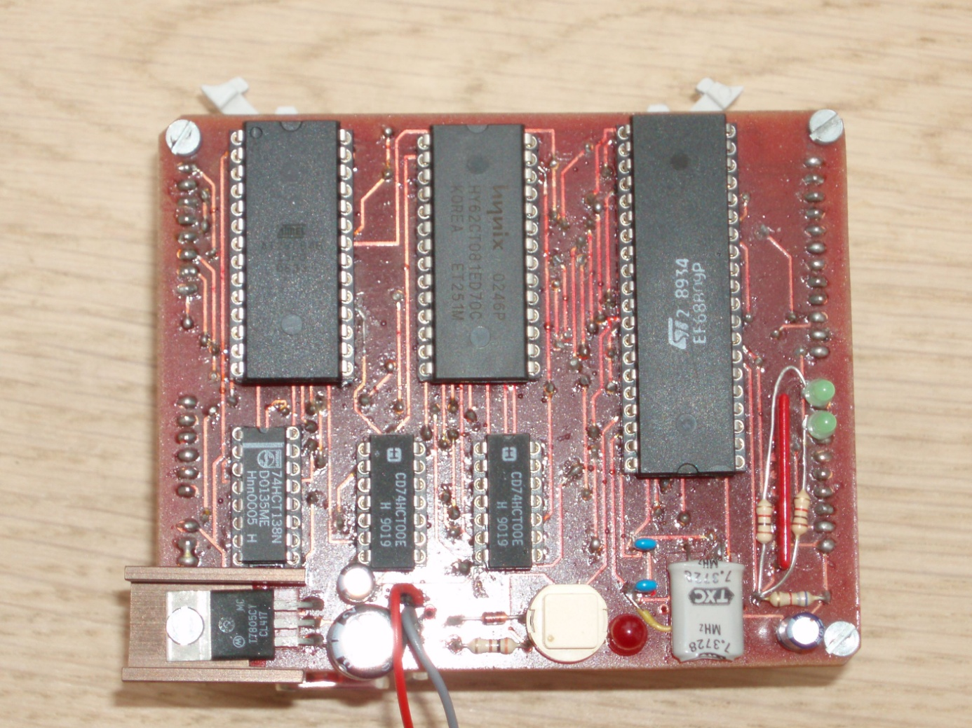

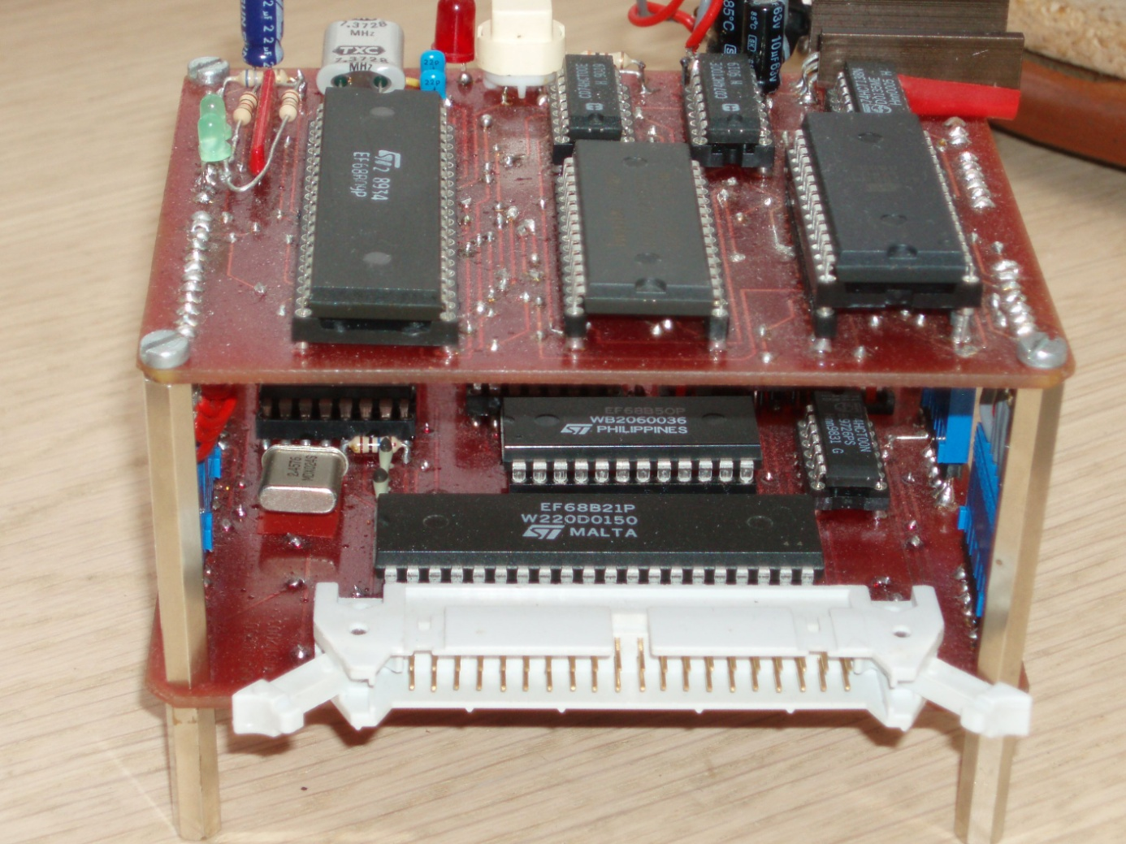

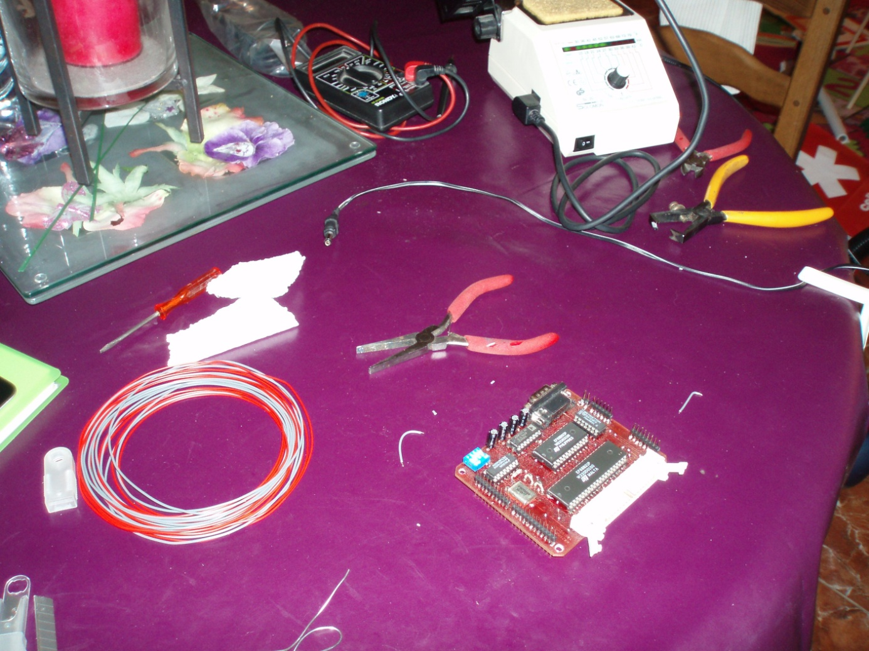

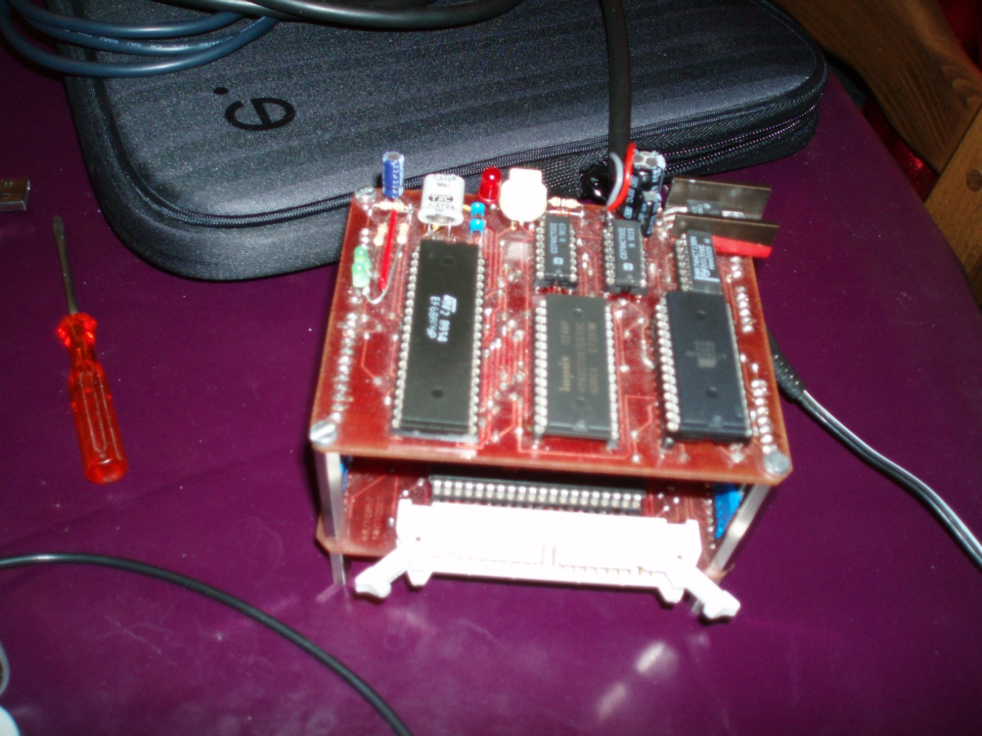

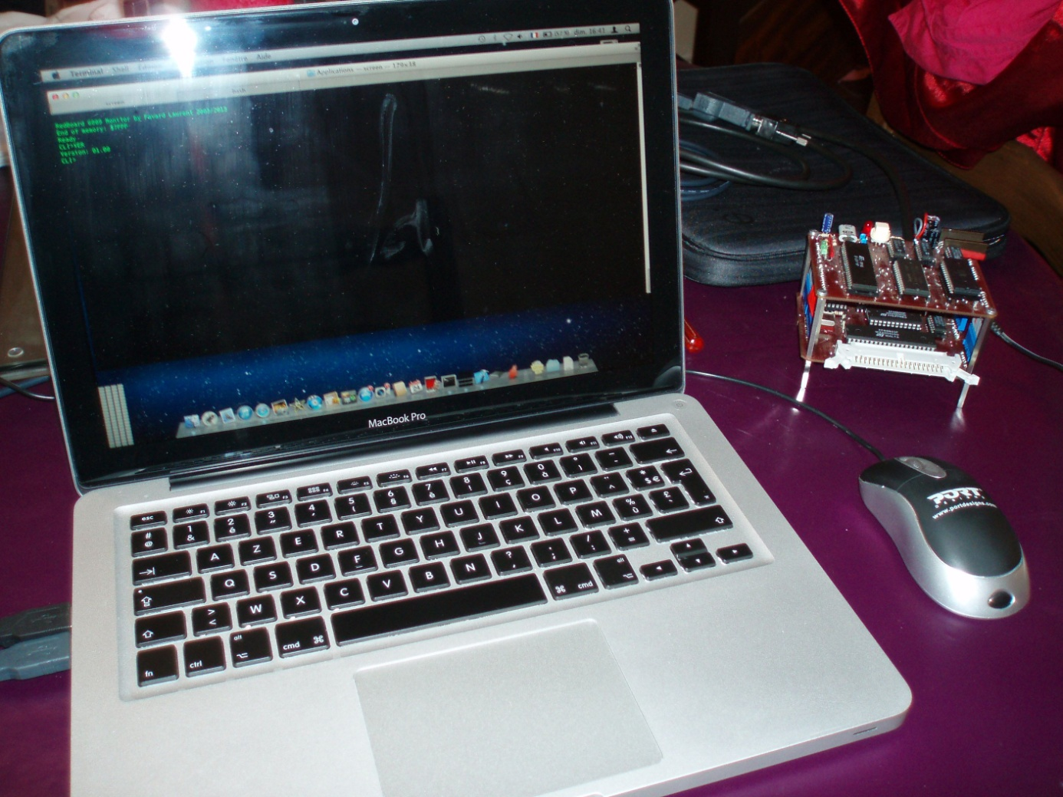

Annex: Monitor Screenshots

Main screen of the Monitor



Tiny Basic running

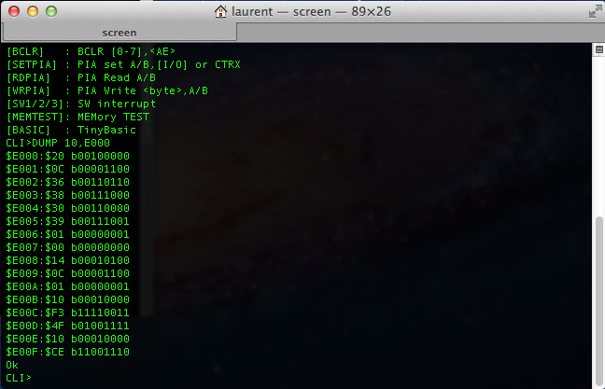

Dump command at $E000 for 16 values

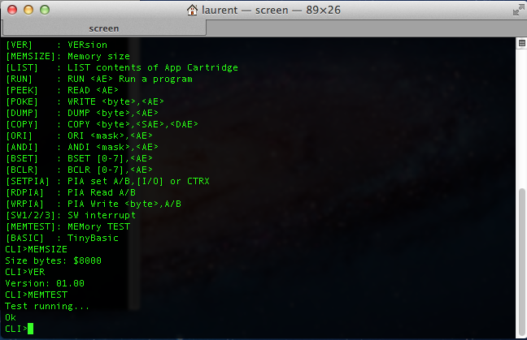

Some command executed