Nama: Laurenta Dini Aprinda
NPM: 23081010068
Kelas: Pemrograman Framework A

UTS
Membuat Sistem Manajemen Mahasiswa & Prodi

DATABASE:
CREATE TABLE prodi (
id INT AUTO_INCREMENT PRIMARY KEY,
nama_prodi VARCHAR(100)
);

CREATE TABLE mahasiswa (
id INT AUTO_INCREMENT PRIMARY KEY,
nama VARCHAR(100),
npm VARCHAR(20),
prodi_id INT,
alamat VARCHAR(255),
email VARCHAR(100),
FOREIGN KEY (prodi_id) REFERENCES prodi(id)
);
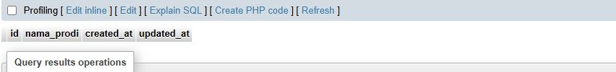
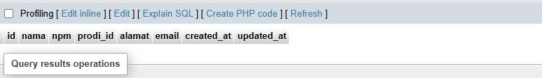
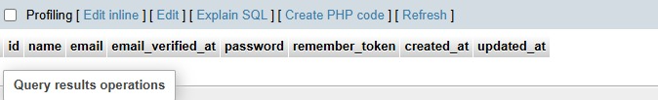
KODE PROGRAM:
Migration: digunakan untuk membuat tabel dan relasi di database.
- 2025_10_22_153409_create_prodi_table
<?php

use Illuminate\Database\Migrations\Migration;
use Illuminate\Database\Schema\Blueprint;
use Illuminate\Support\Facades\Schema;

return new class extends Migration
{
/**
* Run the migrations.
*/
public function up(): void
{
Schema::create('prodi', function (Blueprint $table) {
$table->id();
$table->string('nama_prodi');
$table->timestamps();
});
}

/**
* Reverse the migrations.
*/
public function down(): void
{
Schema::dropIfExists('prodi'); // ubah 'prodis' jadi 'prodi'
}
};
Penjelasan:
$table->id(); untuk membuat kolom id, $table->string('nama_prodi'); untuk menyimpan nama jurusan, $table->timestamps(); untuk menambah kolom created dan update.

- 2025_10_22_153423_create_mahasiswa_table
<?php

use Illuminate\Database\Migrations\Migration;
use Illuminate\Database\Schema\Blueprint;
use Illuminate\Support\Facades\Schema;

return new class extends Migration
{
/**
* Run the migrations.
*/
public function up(): void
{
Schema::create('mahasiswa', function (Blueprint $table) {
$table->id();
$table->string('nama');
$table->string('npm')->unique();
$table->foreignId('prodi_id')->constrained('prodi')->onDelete('cascade'); // ubah 'prodis' jadi 'prodi'
$table->string('alamat');
$table->string('email')->unique();
$table->timestamps();
});
}

/**
* Reverse the migrations.
*/
public function down(): void
{
Schema::dropIfExists('mahasiswa'); // ubah 'mahasiswas' jadi 'mahasiswa'
}
};
Penjelasan:
foreignId('prodi_id') kolom untuk hubungan ke tabel prodi, constrained('prodi') untuk menghubungkan ke kolom id tabel prodi, onDelete('cascade'); jika prodi dihapus , maka semua mahasiswa dalam prodi itu ikut terhapus, unique(); memastikan NPM dan email tidak sama.
Eloquent ORM
Model: untuk mengatur hubungan antar tabel
- Prodi
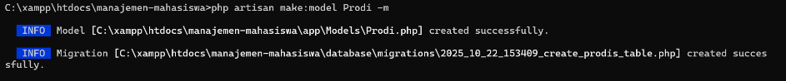
Model/Prodi.php
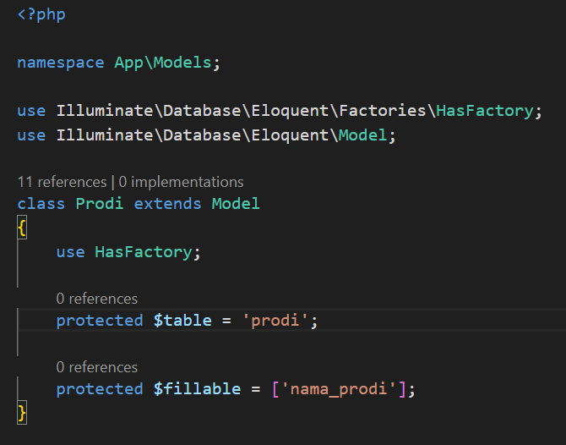
Penjelasan:
hasMany() mengartikan satu prodi memiliki banyak mahasiswa, $fillable kolom yang boleh diisi lewat form input.
- Mahasiswa
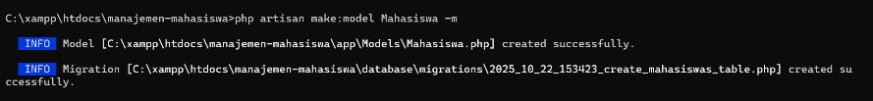
Model/mahasiswa.php
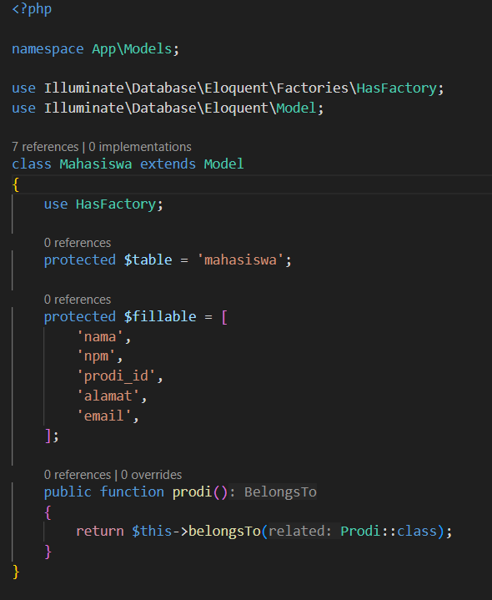
Penjelasan:
belongsTo() artinya setiap mahasiswa milik satu prodi
Membuat Routing dan Controller!
- prodiController
<?php

namespace App\Http\Controllers;

use Illuminate\Http\Request;
use App\Models\Prodi;

class ProdiController extends Controller
{
// Menampilkan semua data prodi
public function index()
{
$prodis = Prodi::all();
return view('prodi.index', compact('prodis'));
}

// Menampilkan form tambah prodi
public function create()
{
return view('prodi.create');
}

// Menyimpan data prodi baru
public function store(Request $request)
{
$request->validate([
'nama_prodi' => 'required|string|max:100',
]);

Prodi::create([
'nama_prodi' => $request->nama_prodi,
]);

return redirect()->route('prodi.index')->with('success', 'Data prodi berhasil ditambahkan');
}

// Menampilkan form edit
public function edit($id)
{
$prodi = Prodi::findOrFail($id);
return view('prodi.edit', compact('prodi'));
}

// Update data prodi
public function update(Request $request, $id)
{
$request->validate([
'nama_prodi' => 'required|string|max:100',
]);

$prodi = Prodi::findOrFail($id);
$prodi->update([
'nama_prodi' => $request->nama_prodi,
]);

return redirect()->route('prodi.index')->with('success', 'Data prodi berhasil diperbarui');
}

// Hapus data prodi
public function destroy($id)
{
$prodi = Prodi::findOrFail($id);
$prodi->delete();

return redirect()->route('prodi.index')->with('success', 'Data prodi berhasil dihapus');
}

// Menampilkan detail prodi
public function show($id)
{
$prodi = Prodi::findOrFail($id);
return view('prodi.show', compact('prodi'));
}
}

- mahasiswaController
<?php

namespace App\Http\Controllers;

use App\Models\Mahasiswa;
use App\Models\Prodi;
use Illuminate\Http\Request;

class MahasiswaController extends Controller
{
// Menampilkan daftar mahasiswa
public function index()
{
$mahasiswas = Mahasiswa::with('prodi')->get();
return view('mahasiswa.index', compact('mahasiswas'));
}

// Menampilkan form tambah mahasiswa
public function create()
{
$prodis = Prodi::all();
return view('mahasiswa.create', compact('prodis'));
}

// Menyimpan mahasiswa baru
public function store(Request $request)
{
$request->validate([
'nama' => 'required|string|max:100',
'npm' => 'required|string|unique:mahasiswa,npm',
'prodi_id' => 'required|exists:prodi,id',
'alamat' => 'required|string|max:255',
'email' => 'required|email|unique:mahasiswa,email'
]);

Mahasiswa::create($request->all());

return redirect()->route('mahasiswa.index')
->with('success', 'Mahasiswa berhasil ditambahkan.');
}

// Menampilkan form edit mahasiswa
public function edit($id)
{
$mahasiswa = Mahasiswa::findOrFail($id);
$prodis = Prodi::all();
return view('mahasiswa.edit', compact('mahasiswa', 'prodis'));
}

// Update data mahasiswa
public function update(Request $request, $id)
{
$request->validate([
'nama' => 'required|string|max:100',
'npm' => 'required|string|unique:mahasiswa,npm,' . $id,
'prodi_id' => 'required|exists:prodi,id',
'alamat' => 'required|string|max:255',
'email' => 'required|email|unique:mahasiswa,email,' . $id,
]);

$mahasiswa = Mahasiswa::findOrFail($id);
$mahasiswa->update($request->all());

return redirect()->route('mahasiswa.index')
->with('success', 'Mahasiswa berhasil diperbarui.');
}

// Hapus mahasiswa
public function destroy($id)
{
$mahasiswa = Mahasiswa::findOrFail($id);
$mahasiswa->delete();

return redirect()->route('mahasiswa.index')
->with('success', 'Mahasiswa berhasil dihapus.');
}

// Menampilkan detail mahasiswa
public function show($id)
{
$mahasiswa = Mahasiswa::with('prodi')->findOrFail($id);
return view('mahasiswa.show', compact('mahasiswa'));
}
}

- Route.php
<?php

use Illuminate\Support\Facades\Route;
use App\Http\Controllers\ProdiController;
use App\Http\Controllers\MahasiswaController;

Route::get('/', function () {
return redirect()->route('prodi.index');
});

// PRODI
Route::get('/prodi', [ProdiController::class, 'index'])->name('prodi.index');
Route::get('/prodi/tambah', [ProdiController::class, 'create'])->name('prodi.create');
Route::post('/prodi', [ProdiController::class, 'store'])->name('prodi.store');
Route::get('/prodi/edit/{id}', [ProdiController::class, 'edit'])->name('prodi.edit');
Route::put('/prodi/update/{id}', [ProdiController::class, 'update'])->name('prodi.update');
Route::delete('/prodi/hapus/{id}', [ProdiController::class, 'destroy'])->name('prodi.destroy');
Route::get('/prodi/show/{id}', [ProdiController::class, 'show'])->name('prodi.show');

// MAHASISWA
Route::get('/mahasiswa', [MahasiswaController::class, 'index'])->name('mahasiswa.index');
Route::get('/mahasiswa/tambah', [MahasiswaController::class, 'create'])->name('mahasiswa.create');
Route::post('/mahasiswa', [MahasiswaController::class, 'store'])->name('mahasiswa.store');
Route::get('/mahasiswa/edit/{id}', [MahasiswaController::class, 'edit'])->name('mahasiswa.edit');
Route::put('/mahasiswa/update/{id}', [MahasiswaController::class, 'update'])->name('mahasiswa.update');
Route::delete('/mahasiswa/hapus/{id}', [MahasiswaController::class, 'destroy'])->name('mahasiswa.destroy');
Route::get('/mahasiswa/show/{id}', [MahasiswaController::class, 'show'])->name('mahasiswa.show');

Tampilan Views
- layout/app.blade.php
<!DOCTYPE html>
<html lang="id">
<head>
<meta charset="UTF-8">
<meta name="viewport" content="width=device-width, initial-scale=1.0">
<title>Sistem Manajemen Mahasiswa & Prodi</title>
<link href="https://cdn.jsdelivr.net/npm/bootstrap@5.3.3/dist/css/bootstrap.min.css" rel="stylesheet">
</head>
<body class="bg-light">

{{-- HEADER --}}
<nav class="navbar navbar-expand-lg navbar-dark bg-primary mb-4">
<div class="container">
<a class="navbar-brand fw-bold" href="/">🎓 Sistem Manajemen Mahasiswa & Prodi</a>
</div>
</nav>

{{-- NAVBAR / MENU --}}
<div class="container mb-4">
<nav class="nav nav-pills">
<a class="nav-link {{ request()->is('prodi*') ? 'active' : '' }}" href="/prodi">Prodi</a>
<a class="nav-link {{ request()->is('mahasiswa*') ? 'active' : '' }}" href="/mahasiswa">Mahasiswa</a>
</nav>
</div>

{{-- KONTEN DINAMIS --}}
<div class="container">
@yield('content')
</div>

<footer class="text-center py-3 mt-4 bg-white border-top">
<small>© {{ date('Y') }} Sistem Manajemen Mahasiswa & Prodi</small>
</footer>

</body>
</html>
Penjelasan:
<a class="nav-link {{ request()->is('prodi*') ? 'active' : '' }}" href="/prodi">Prodi</a> link itu menuju /prodi, <a class="nav-link {{ request()->is('mahasiswa*') ? 'active' : '' }}" href="/mahasiswa">Mahasiswa</a> link itu menuju ke /mahasiswa, @yield('content' untuk menampilkan konten dari view lain
- Prodi
  - index.blade.php
@extends('layout.app')

@section('content')
<div class="card">
<div class="card-header bg-primary text-white">
<h4 class="mb-0">Daftar Program Studi</h4>
</div>
<div class="card-body">
<a href="{{ route('prodi.create') }}" class="btn btn-success mb-3">+ Tambah Prodi</a>

@if(session('success'))
<div class="alert alert-success">{{ session('success') }}</div>
@endif

<table class="table table-bordered table-striped">
<thead>
<tr>
<th>ID</th>
<th>Nama Prodi</th>
<th>Aksi</th>
</tr>
</thead>
<tbody>
@foreach ($prodis as $p)
<tr>
<td>{{ $p->id }}</td>
<td>{{ $p->nama_prodi }}</td>
<td>
<a href="{{ route('prodi.edit', $p->id) }}" class="btn btn-sm btn-warning">Edit</a>

{{-- Tombol hapus pakai form method DELETE --}}
<form action="{{ route('prodi.destroy', $p->id) }}" method="POST" style="display:inline;">
@csrf
@method('DELETE')
<button type="submit" class="btn btn-sm btn-danger" onclick="return confirm('Yakin ingin menghapus?')">
Hapus
</button>
</form>
</td>
</tr>
@endforeach
</tbody>
</table>
</div>
</div>
@endsection

  - create.blade.php
@extends('layout.app')

@section('content')
<div class="card">
<div class="card-header bg-success text-white">
<h4 class="mb-0">Tambah Program Studi</h4>
</div>
<div class="card-body">
{{-- Arahkan ke route bernama prodi.store --}}
<form action="{{ route('prodi.store') }}" method="POST">
@csrf
<div class="mb-3">
<label class="form-label">Nama Prodi</label>
<input type="text" name="nama_prodi" class="form-control" required>
</div>
<button type="submit" class="btn btn-success">Simpan</button>
<a href="{{ route('prodi.index') }}" class="btn btn-secondary">Kembali</a>
</form>
</div>
</div>
@endsection

  - edit.blade.php
@extends('layout.app')

@section('content')
<div class="card">
<div class="card-header bg-warning text-white">
<h4 class="mb-0">Edit Program Studi</h4>
</div>
<div class="card-body">
<form action="{{ route('prodi.update', $prodi->id) }}" method="POST">
@csrf
@method('PUT') {{-- penting! ini supaya POST dikonversi jadi PUT --}}

<div class="form-group">
<label for="nama_prodi">Nama Prodi</label>
<input type="text" name="nama_prodi" id="nama_prodi" value="{{ $prodi->nama_prodi }}" class="form-control" required>
</div>

<div class="form-group mt-3">
<button type="submit" class="btn btn-primary">Simpan Perubahan</button>
</div>
</form>
</div>
</div>
@endsection

  - show.blade.php
@extends('layout.app')

@section('content')
<div class="card">
<div class="card-header bg-info text-white">
<h4 class="mb-0">Detail Program Studi</h4>
</div>
<div class="card-body">
<h5><strong>Nama Prodi:</strong> {{ $prodi->nama_prodi }}</h5>
<p><strong>Dibuat pada:</strong> {{ $prodi->created_at->format('d M Y') }}</p>

<hr>
<h5>Daftar Mahasiswa:</h5>
@if ($prodi->mahasiswas->isEmpty())
<p class="text-muted">Belum ada mahasiswa di prodi ini.</p>
@else
<table class="table table-bordered">
<tr>
<th>Nama</th>
<th>NPM</th>
<th>Email</th>
<th>Alamat</th>
</tr>
@foreach ($prodi->mahasiswas as $mhs)
<tr>
<td>{{ $mhs->nama }}</td>
<td>{{ $mhs->npm }}</td>
<td>{{ $mhs->email }}</td>
<td>{{ $mhs->alamat }}</td>
</tr>
@endforeach
</table>
@endif

<a href="/prodi" class="btn btn-secondary mt-3">Kembali</a>
</div>
</div>
@endsection

- Mahasiswa
  - index.blade.php
@extends('layout.app')

@section('content')
<div class="card">
<div class="card-header bg-primary text-white">
<h4 class="mb-0">Daftar Mahasiswa</h4>
</div>
<div class="card-body">
<a href="{{ route('mahasiswa.create') }}" class="btn btn-success mb-3">+ Tambah Mahasiswa</a>

@if(session('success'))
<div class="alert alert-success">{{ session('success') }}</div>
@endif

<table class="table table-bordered table-striped">
<tr>
<th>Nama</th>
<th>NPM</th>
<th>Prodi</th>
<th>Alamat</th>
<th>Email</th>
<th>Aksi</th>
</tr>

@foreach ($mahasiswas as $m)
<tr>
<td>{{ $m->nama }}</td>
<td>{{ $m->npm }}</td>
<td>{{ $m->prodi->nama_prodi }}</td>
<td>{{ $m->alamat }}</td>
<td>{{ $m->email }}</td>
<td>
<a href="{{ route('mahasiswa.edit', $m->id) }}" class="btn btn-sm btn-warning">Edit</a>

// Tombol hapus pakai method DELETE
<form action="{{ route('mahasiswa.destroy', $m->id) }}" method="POST" style="display:inline;">
@csrf
@method('DELETE')
<button type="submit" class="btn btn-sm btn-danger"
onclick="return confirm('Yakin ingin menghapus?')">
Hapus
</button>
</form>
</td>
</tr>
@endforeach

</table>
</div>
</div>
@endsection
Penjelasan:
@foreach ($mahasiswas as $m melakukan looping semua data siswa yang dikirim dari controller, <td>{{ $m->prodi->nama_prodi }}</td> mengambil relasi dari tabel prodi berdasarkan kunci asing prodi_id pada siswa. Jadi, ini memanfaatkan relasi Eloquent one-to-man.

  - create.blade.php
@extends('layout.app')

@section('content')
<div class="card">
<div class="card-header bg-success text-white">
<h4 class="mb-0">Tambah Mahasiswa</h4>
</div>

<div class="card-body">
<form action="{{ route('mahasiswa.store') }}" method="POST">
@csrf

<div class="mb-3">
<label class="form-label">Nama</label>
<input type="text" name="nama" class="form-control" required>
</div>

<div class="mb-3">
<label class="form-label">NPM</label>
<input type="text" name="npm" class="form-control" required>
</div>

<div class="mb-3">
<label class="form-label">Program Studi</label>
<select name="prodi_id" class="form-select" required>
<option value="">-- Pilih Prodi --</option>
@foreach ($prodis as $p)
<option value="{{ $p->id }}">{{ $p->nama_prodi }}</option>
@endforeach
</select>
</div>

<div class="mb-3">
<label class="form-label">Alamat</label>
<input type="text" name="alamat" class="form-control" required>
</div>

<div class="mb-3">
<label class="form-label">Email</label>
<input type="email" name="email" class="form-control" required>
</div>

<button type="submit" class="btn btn-success">Simpan</button>
<a href="{{ route('mahasiswa.index') }}" class="btn btn-secondary">Kembali</a>
</form>
</div>
</div>
@endsection
  - edit.blade.php
@extends('layout.app')

@section('content')
<div class="card">
<div class="card-header bg-warning text-white">
<h4 class="mb-0">Edit Mahasiswa</h4>
</div>
<div class="card-body">
<form action="/mahasiswa/update/{{ $mahasiswa->id }}" method="POST">
@csrf
<div class="mb-3">
<label class="form-label">Nama</label>
<input type="text" name="nama" class="form-control" value="{{ $mahasiswa->nama }}" required>
</div>

<div class="mb-3">
<label class="form-label">NPM</label>
<input type="text" name="npm" class="form-control" value="{{ $mahasiswa->npm }}" required>
</div>

<div class="mb-3">
<label class="form-label">Program Studi</label>
<select name="prodi_id" class="form-select" required>
@foreach ($prodis as $p)
<option value="{{ $p->id }}" {{ $mahasiswa->prodi_id == $p->id ? 'selected' : '' }}>
{{ $p->nama_prodi }}
</option>
@endforeach
</select>
</div>

<div class="mb-3">
<label class="form-label">Alamat</label>
<input type="text" name="alamat" class="form-control" value="{{ $mahasiswa->alamat }}" required>
</div>

<div class="mb-3">
<label class="form-label">Email</label>
<input type="email" name="email" class="form-control" value="{{ $mahasiswa->email }}" required>
</div>

<button type="submit" class="btn btn-warning text-white">Perbarui</button>
<a href="/mahasiswa" class="btn btn-secondary">Kembali</a>
</form>
</div>
</div>
@endsection
  - show.blade.php
@extends('layout.app')

@section('content')
<div class="card">
<div class="card-header bg-info text-white">
<h4 class="mb-0">Detail Mahasiswa</h4>
</div>
<div class="card-body">
<table class="table table-striped">
<tr>
<th>Nama</th>
<td>{{ $mahasiswa->nama }}</td>
</tr>
<tr>
<th>NPM</th>
<td>{{ $mahasiswa->npm }}</td>
</tr>
<tr>
<th>Program Studi</th>
<td>{{ $mahasiswa->prodi->nama_prodi }}</td>
</tr>
<tr>
<th>Alamat</th>
<td>{{ $mahasiswa->alamat }}</td>
</tr>
<tr>
<th>Email</th>
<td>{{ $mahasiswa->email }}</td>
</tr>
<tr>
<th>Tanggal Ditambahkan</th>
<td>{{ $mahasiswa->created_at->format('d M Y') }}</td>
</tr>
</table>

<a href="/mahasiswa" class

HASIL PROGRAM:
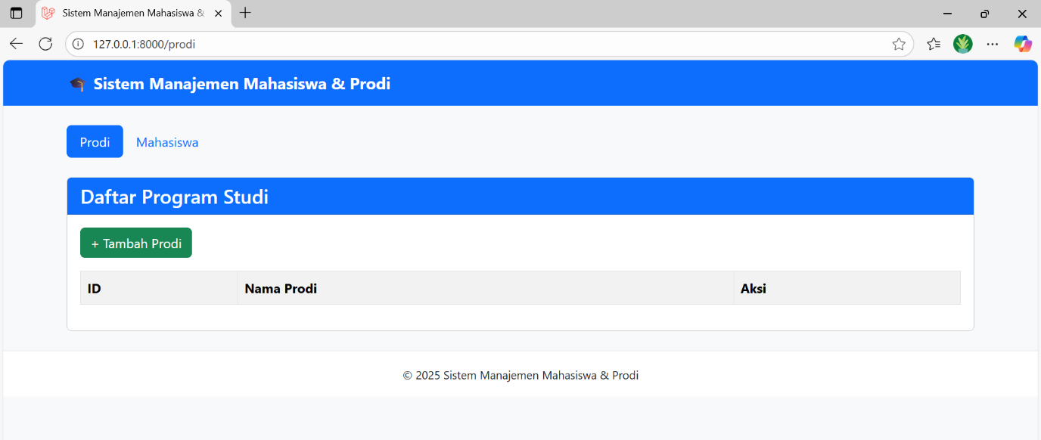
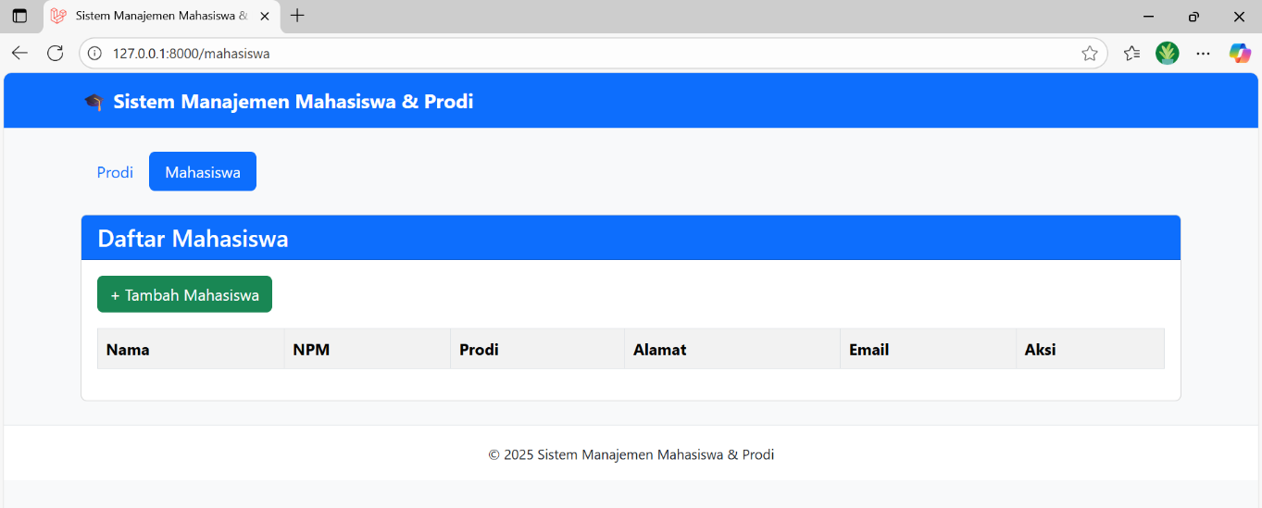
- Tampilan untuk tambah prodi
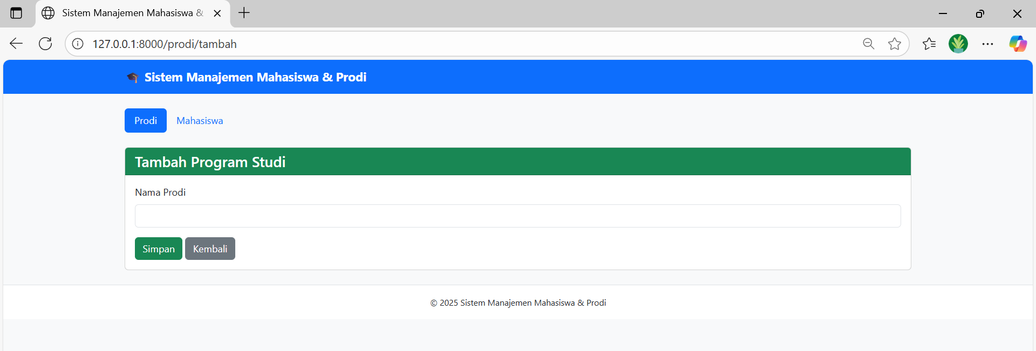
- Tampilan untuk tambah mahasiswa
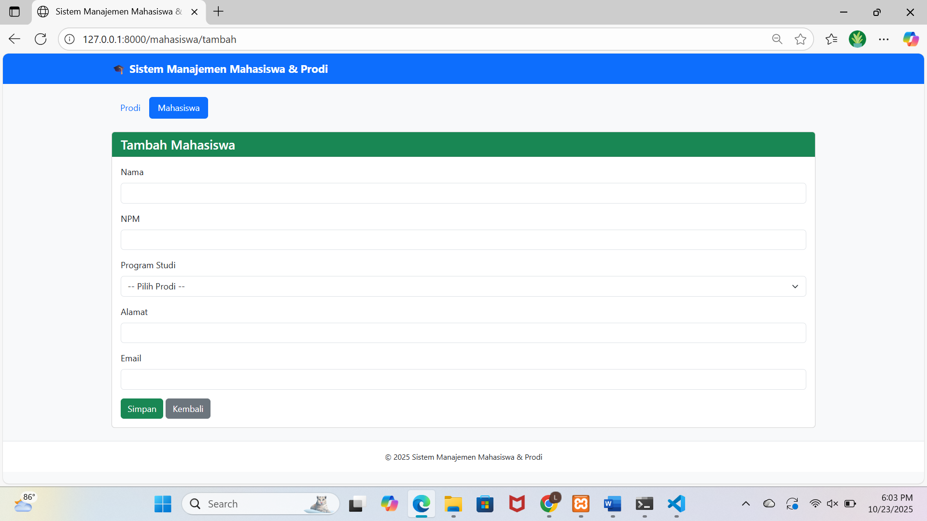
Tambah prodi:
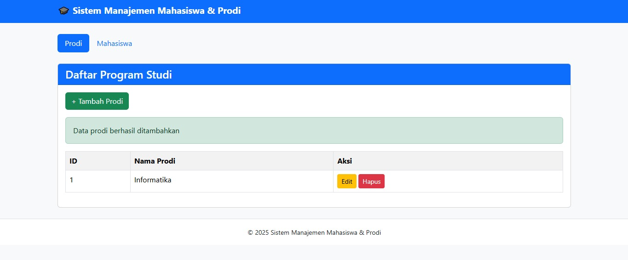
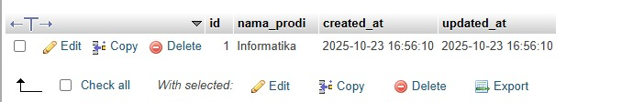
Edit:
