Rollout of the office tools
This document was written by the Open WebUI tool server from one call: no browser, no office application.

What ships
- a Word document from Markdown, in a template's styles;
- a PowerPoint deck from slides;
- diagrams drawn as pictures: structured exchange and Mermaid.
Part | Owner | State
Builders package | Laurent | done
Mermaid renderer | Laurent | done
Routes | Laurent | next

How a request flows
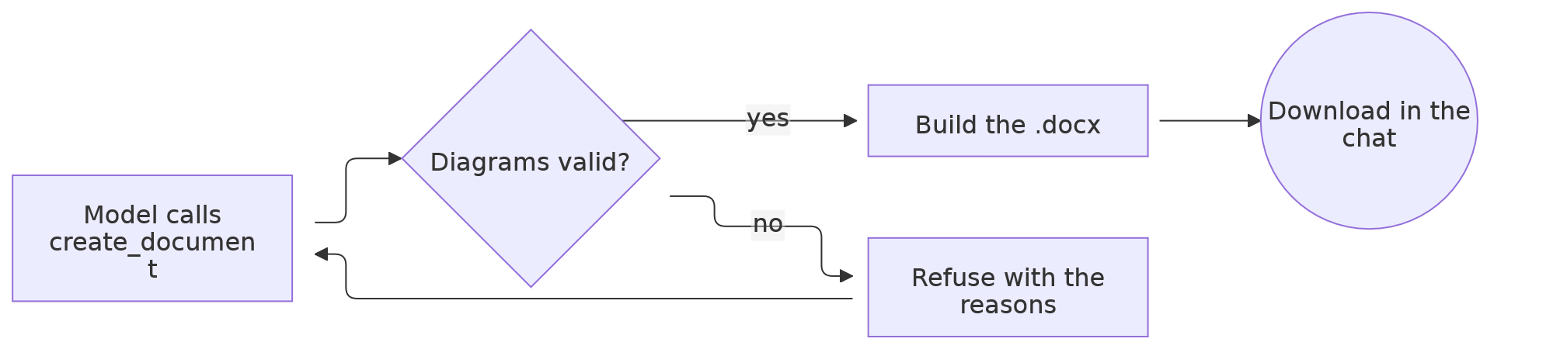

Who talks to whom
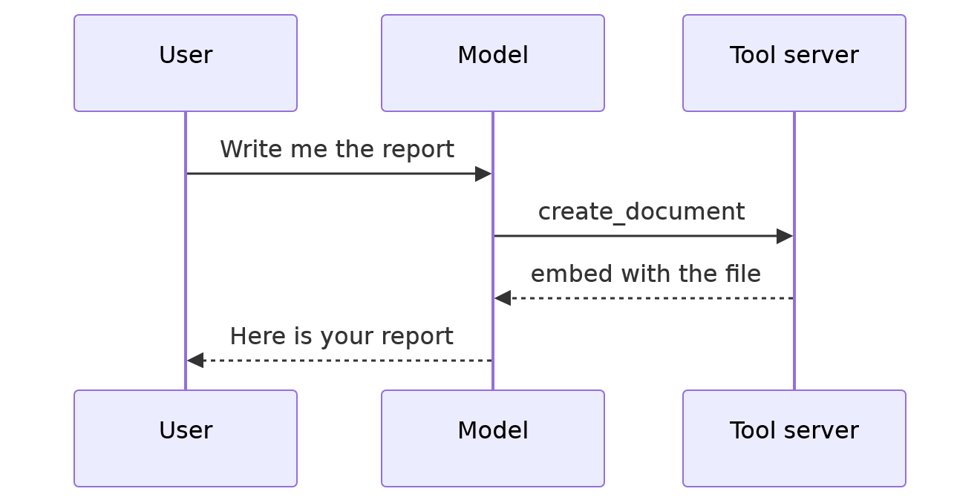

A picture given in the call

That banner travelled inside the call as a data: URI.

