Rollout of the office tools
This document was written by the Open WebUI tool server and for Claude Desktop from one call: no browser, no office application.

What ships
- a Word document from Markdown, in a template's styles;

- diagrams drawn as pictures: structured exchange and Mermaid.
Part | Owner | State
Builders package | Laurent | done
New package | Arthur | In progress
Mermaid renderer | Albert | done
Routes | Laurent | next

How a request flows
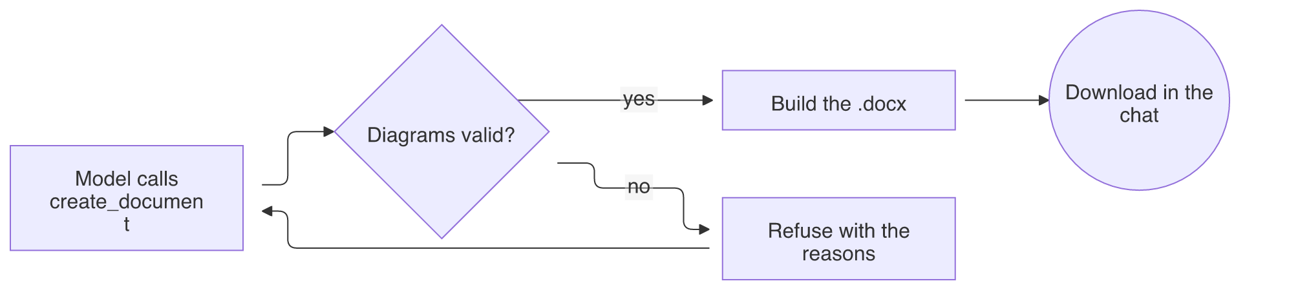

Who talks to whom
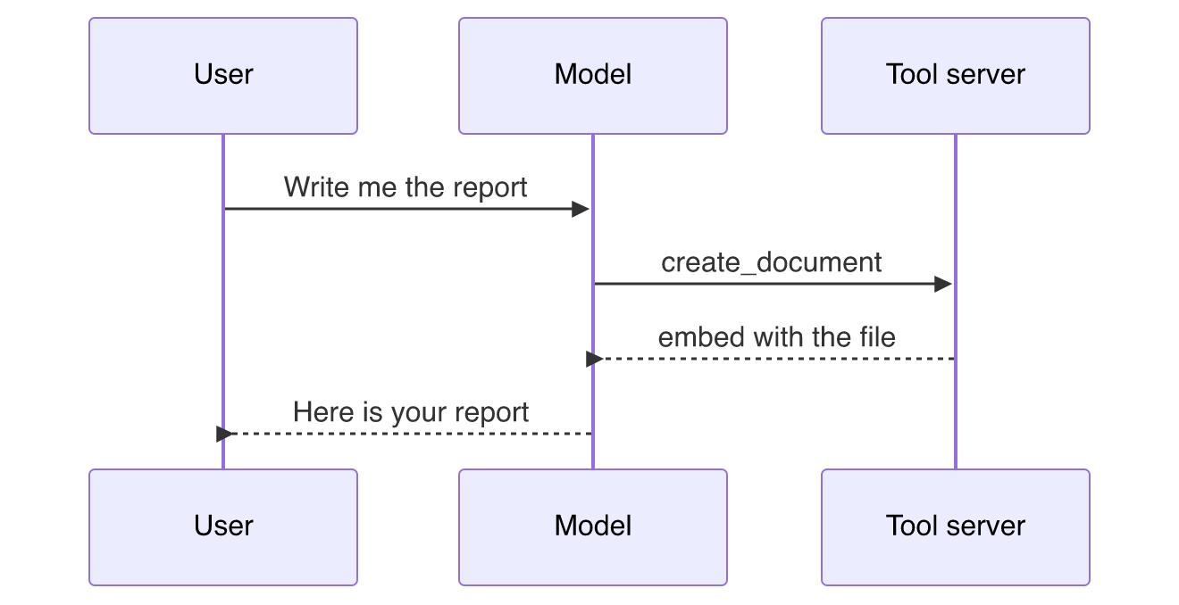

A picture given in the call

That banner travelled inside the call as a data: URI.

