FV-1040  DVC6000 AD
  HART Tag Name | 16891569
  Valve Style | ROTARY
  Actuator Style | Piston - Dbl w/o Spring
  Instrument S/N | 16891569
  Valve S/N | 16891569
  Firmware Revision | 5
  Hardware Revision | 1

Master Spec Sheet [FV-1040]
  Valve
  Manufacturer: | Kamyr
  Type: | Stem Ball
  Size: | 6 in
  Class:
  Rated Travel: | 90.0 deg
  Actual Travel: | 90.0 deg
  Shaft Diameter: | 2.0 in
  Packing Type: | TFE / Single
  Inlet Pressure:
  Outlet Pressure:
  Trim
  Seat Type: | Metal
  Leakage Class:
  Port Diameter:
  Actuator
  Manufacturer: | Neles
  Type: | B1CU17
  Size:
  Effective Area: | 88.5 in2
  Air: | Opens
  Bench Set: | -
  Nominal Supply Pressure:
  Spring Rate:
  Style: | Pivot Link
  Moment Arm: | 5.8 in

Total Scan [FV-1040]
22 Feb 2005 13:44:12  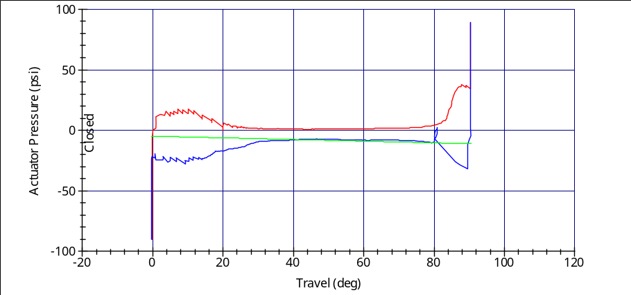  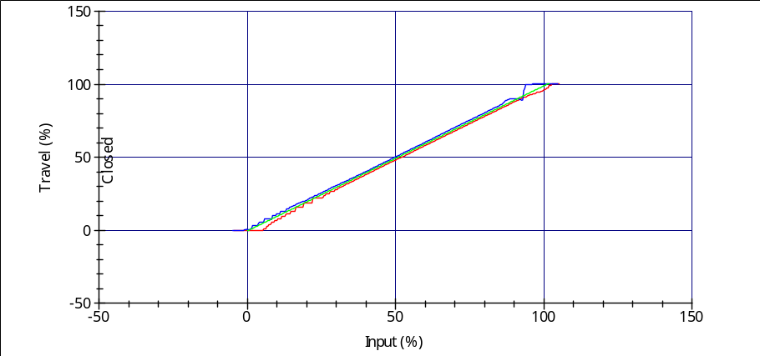  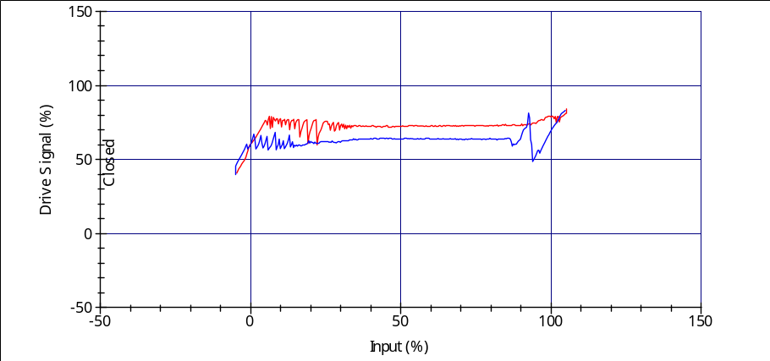
  Inputs
  Analyzed Data
  Avg. Dynamic Error: | 2.41%
  Min. Dynamic Error: | 0.22%
  Max. Dynamic Error: | 4.53%
  Dyn. Linearity (Ind.): | 1.89%
  Zero Ranged Travel at: | 4.06 mA
  Full Ranged Travel at: | 20.17 mA
  Average Torque: | 3207 lbf.in
  Minimum Torque: | 465 lbf.in
  Maximum Torque: | 9053 lbf.in
  Spring Rate: | 60.25 lbf/in
  Bench Set: | -11.06 - -4.86 psi
  Input Start:
  -5.0 %Input End: | 105.0 %
  Scan Time: | 50.0 sec
  Collection Interval: | 150.0 msec.
  Tuning Set
  Tuning Set: | User Adjusted
  Gains
  Proportional: | 14.40
  Velocity: | 6.20
  MLF: | 17.00
  Integral Control: | Disabled
  Integral Gain: | 9.4
  Notes
  Valve
  Manufacturer: | Kamyr
  Type: | Stem Ball
  Size: | 6 in
  Class:
  Rated Travel: | 90.0 deg
  Actual Travel: | 90.0 deg
  Shaft Diameter: | 2.0 in
  Packing Type: | TFE / Single
  Inlet Pressure:
  Outlet Pressure:
  Trim
  Seat Type: | Metal
  Leakage Class:
  Port Diameter:
  Actuator
  Manufacturer: | Neles
  Type: | B1CU17
  Size:
  Effective Area: | 88.5 in2
  Air: | Opens
  Bench Set: | -
  Nominal Supply Pressure:
  Spring Rate:
  Style: | Pivot Link
  Moment Arm: | 5.8 in

Step Response [FV-1040]
09 Jul 2004 11:14:47 test 4  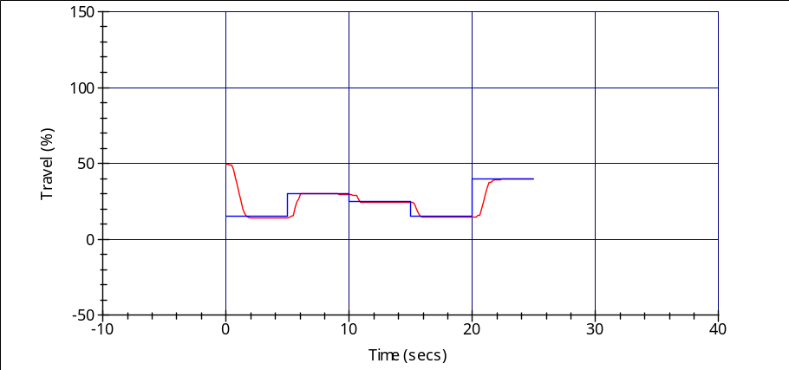
  Analyzed Data
  Tuning Set
  Tuning Set: | User Adjusted
  Gains
  Proportional: | 14.40
  Velocity: | 6.20
  MLF: | 17.00
  Integral Control: | Disabled
  Integral Gain: | 9.4
  Not A Performance Test
  Notes
Analyzed Data (all times in seconds)
Step | End Point (%): | Ramp Time | Collection Time | Dead Time | Time63 | Time86 | Stroke Time | OverShoot (%) | Error (%) | Gain
1 | 15 | 0 | 5 | 0.49 | 1.15 | 1.39 | 1.53 | - | 1.04 | 1.03
2 | 30 | 0 | 5 | 0.58 | 0.61 | 0.64 | 0.67 | 4.65 | 0.51 | 1.03
3 | 25 | 0 | 5 | 0.68 | 0.75 | 0.82 | 0.9 | 0.0 | 0.6 | 1.02
4 | 15 | 0 | 5 | 0.35 | 0.52 | 0.68 | 0.85 | 0.24 | 0.57 | 1.0
5 | 40 | 0 | 5 | 0.57 | 1.08 | 1.26 | 1.38 | - | 0.39 | 1.01

Status Monitor [FV-1040]
08 Jul 2004 09:07:41

  Monitor
  Travel Deviation | 0.43 %
  Act. Press. A | 11.33 psi
  Act. Press. B | 10.95 psi
  Act. Press. A-B | 0.38 psi
  Act. Press. B-A | -0.38 psi
  Supply Pressure | 79.66 psi
  Relay Adjustment | 13.98 %
  Drive Signal | 69.38 %
  Cycle Count | 42 cycles
  Travel Accumulator | 2616 %
  Temperature | 74.69 F
  Input Characteristic | Linear
  Control Mode | Analog (RSP)
  Instrument Mode | In Service
  Free Time | 51.23 %
  Run Time
  Max Recorded Temp | 0.00 F
  Burst Mode | No
  Travel Set Point | 49.94 %
  Travel | 49.51 %
  Input Current | 11.98 mA
  Device
  Message
  Descriptor | 16891569
  Instrument Serial Number | 16891569
  HART Universal Revision | 5
  Hardware Revision | 1
  Device Revision | 1
  Firmware Revision | 5
  Firmware Date | 21 Oct 2002
  Device ID | 4123267
  Instrument Level | AD
  Pressure Sensor | Yes
  Valve Serial Number | 16891569
  Valve Style | Rotary Shaft
  Actuator Style | Piston - Dbl w/o Spring
  Relay Type | Relay A
  Calibration Loc. | Field
  Calibration Date | 17May04
  Alerts
   | Alert | Enabled | Actual | Alert Point
  Alerts
  Travel Hi | OFF | No | 49.51 % | 125.00 %
  Travel Lo | OFF | No | 49.51 % | -25.00 %
  Travel Hi Hi | OFF | No | 49.51 % | 125.00 %
  Travel Lo Lo | OFF | No | 49.51 % | -25.00 %
  Travel Deviation | OFF | No | 0.43 % | 125.00 %
  Cycle Count | OFF | No | 42 cycles | 2147483646 cycles
  Travel Accumulator | OFF | No | 2616 % | 2147483646 %
  Aux Input | OFF | No | OPEN
  Drive Signal | OFF | No | 69.38 %
  Supply Pressure Alert | OFF | No | 79.66 psi | 0.00 psi
  Configuration Changed | OFF | Yes
  Analog Input Saturated | OFF | Yes
  Internal Sensor Out of Limits | OFF | Yes
  Variable Out of Range | OFF | Yes
  Calibration In Progress | OFF | Yes
  Auto Tvl Cal Failed | OFF | Yes
  Diagnostic In Progress | OFF | Yes
  Travel Sensor Fail | OFF | Yes
  Temp Sensor Fail | OFF | Yes
  Pressure Sensor Fail | OFF | Yes
  Drive Current Fail | OFF | Yes
  NVM Fail | OFF | Yes
  Flash Integrity Error | OFF | Yes
  Ref. Voltage Failure | OFF | Yes
  No Free Time | OFF | Yes
  Power Starvation Alert | OFF | Yes
  Alert Record Not Empty | OFF | Yes
  Alert Record Full | OFF | Yes
  Integrator Saturated High | OFF | Yes
  Integrator Saturated Low | OFF | Yes
  ESD Valve Stuck | OFF | No
  ESD Pressure Deviation | OFF | No |  | 5.00 psi

Instrument Configuration [FV-1040]
26 Jul 2005 08:31:01
  General
  HART Tag
  Message
  Descriptor | 16891569
  Date | 07/26/05
  Valve Serial Number | 16891569
  Instrument Serial Number | 16891569
  Polling Address | 0
  Initial Setup
  Control Mode | Analog (RSP)
  Restart Cont. Mode | Resume Last
  Zero Control Signal | Valve Closed
  Travel Cutoff Lo (%) | 0.5
  Valve Style | Rotary Shaft
  Actuator Style | Spring and Diaphragm
  Relay Type | Relay A
  Feedback Connection | Rotary-All/SS-Roller
  Travel Sensor Motion | Counter-clockwise
  Inputs
  Analog Input Units | mA
  Input Range Low | 4
  Input Range High | 20
  Temperature Units | F
  Self Test Shut Down
  Flash ROM Fail | No
  No Free Time | No
  Reference Voltage Fail | No
  NVM Fail | No
  Temp Sensor Fail | No
  Travel Sensor Fail | No
  Drive Current Fail | No
  Pressure
  Max Supply Pressure | 100 psi
  Pressure Units | psi
  Travel Control
  Travel Limit Lo (%) | -25
  Travel Limit Hi (%) | 125
  Travel Cutoff Lo (%) | 0.5
  Travel Cutoff Hi (%) | 99.5
  Dynamic Response
  Setpoint Filter Time (sec) | Filter Off
  Min Opening Time (sec) | 0
  Min Closing Time (sec) | 0
  Tuning
  Tuning Set | C
  Gains
  Proportional | 4.4
  Velocity | 3
  MLF | 35
  Integral Settings
  Enable Integral Control | No
  Integral Gain (reps/min) | 9.4
  Integral Dead Zone (%) | 0.25
  Cycle Count Alert
  Cycle Count Alert Enable | No
  Cycle Count Deadband (%) | 3
  Cycle Count Alert Point | 4294967295
  Cycle Count | 0
  Travel Accum Alert
  Trav Acc Alert Enable | No
  Tvl Accum Deadband (%) | 3
  Tvl Accum Alert Pt (%) | 4294967295
  Travel Accumulator (%) | 0
  Deviation & Other Alerts
  Travel Dev Alert Enable | No
  Travel Dev Alert Pt (%) | 125
  Travel Dev Time (sec) | 4
  Aux Terminal Mode | Aux Input Alert
  Aux Input Alert Enable | No
  Aux Input Alert State | Closed
  Drive Signal Alert Enable | No
  Supply Pressure Alert Point | 0 psi
  Travel Alerts
  Hi/Lo Enable | No
  Hi Hi / Lo Lo Enable | No
  Lo Point (%) | -25
  Hi Point (%) | 125
  Lo Lo Point (%) | -25
  Hi Hi Point (%) | 125
  Deadband (%) | 3
  Alert Record and Commands
  Instrument Clock | 26 JUL 2005 08:30
  Valve Alerts Enable | No
  Failure Alerts Enable | No
  Misc Alerts Enable | No
  Burst Mode Enable | No
  Burst Command | 3
  Cmd #3 (Trending) Pressure | A
  Input Characterization
  Input Characteristic | Linear

