Online Bookstore: Final Report
Madeline Shea: maddie.shea@richmond.edu
Lauren Toth: lauren.toth@richmond.edu

Project Overview

E-Commerce has exploded over the past twenty years. The goal of our project is to create an online bookstore so that customers can order books online to save time and avoid going to the store. In order to achieve this goal, we have built up a data-driven web-based application, since in modern world, computers and internet access points are available everywhere and have become an inevitable part of people’s lives. Our system is intended to provide customers with a catalog of books to choose from, an online shopping cart and customers’ information and order management.

Our system can make many people’s life easy to buy books. For book stores to carry out its daily operations, customers can search for books they need and purchase books through our website. In addition, new users need to be able to register in our system, search, delete and update the status of their information or accounts. To do so, members must be able to add, search (track), delete and update the status of the books which belong to their cart. For the bookstore members, they can view the books they have bought, view, update information regarding their accounts and search the library catalogue for books.

Using Azure Data Studio and Sublime Text Editor, we have built up the Web-based application. The primary languages we are using are PHP and SQL, since they are easy to implement. The main user we are considering now are the members of our online bookstore. A series of friendly graphic user interfaces are designed to navigate users to conduct various tasks, such as add, delete or modify customers’ information as well as search, add books to cart and checkout. In the following sections, we will describe what we have accomplished for this project.

Major Components of Online Bookstore Web Application
- Sign in Page
The first webpage of our web application is the sign in page as shown in Figure 1. The user can either login to their current account or create a new account. When new users want to sign up, the layout of signup page is illustrated in Figure 2. In the page, all the fields are required. Once users click on the sign me up button, user ID will be checked in the database’s table “member”. Then the validation of user information will be checked. If it all the information is valid, the user’s information will be written to the table “member” and a dialog will pop up to tell users that they have registered successfully. When users want to sign in, they just need to enter their user name and password. The credentials will be validated and if everything is correct, the user will be logged in.
2.2. Home Page
The first webpage of our web application is the home page as shown in Figure 1. A series of navigation buttons are listed on the top of the page to different functions, such as, browse by subject, search by author/title/subject, check order status, checkout and edit personal information. These buttons are made in the master page, so they are available for all pages.
- Placing an Order
- Searching for Books
After registration, the customers can search for books in a variety of ways. Once users fill out username and password and click on the login button, the validation of userID and password will be checked. If not, an error message will pop up. Otherwise, users will be navigated to a new page to search and buy books as shown in Figure 4.

Figure 1 Login Page

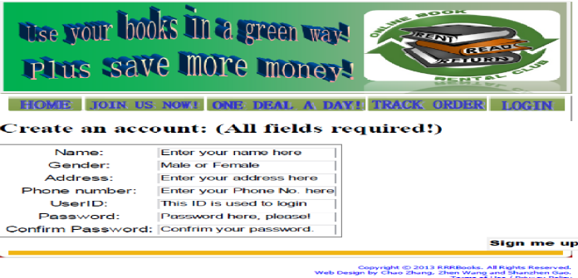

Figure 2 Home Page

Once customer login, they can search books by subject, author or title. Once customers click select the system will search for the results in the database system and show up in a table as shown in figure 6. Once customers enter click “add to cart”, system will create a new tuple in “cart” and in “orders” and show up the message in a table as shown in figure 6. After the books are added to the customers’ shopping cart, the customer can go ahead to check out by clicking the checkout button.

Figure 4 Book Search Page

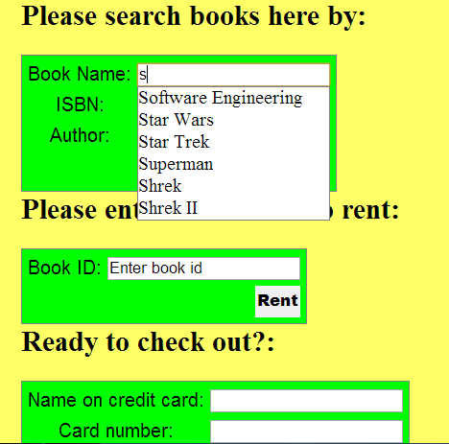

Figure 5 Book Search by Subject


Figure 6. Cart Information
- Adding to Databases

We have no web-administrator. In order to add to the database, the back-end must be updated by the developer. There are two parts of this project: the database, back-end, and the web-application.
Back-end database: this functionality involves five tables – books, members, orders, odetails and card.
- books: to store the information of books with unique ISBN, title, author, subject and price
- members: information of users' account including name, address, city, state, zip, phone, email, credit card, username and password.
- orders: to store the orders including userid, ono, dates shipped, ship city, ship state and ship zip
- odetails: to store the details of the orders including ono, ISBN, quantity and price
- cart: to store the contents of the cart including userid, ISBN and quantity
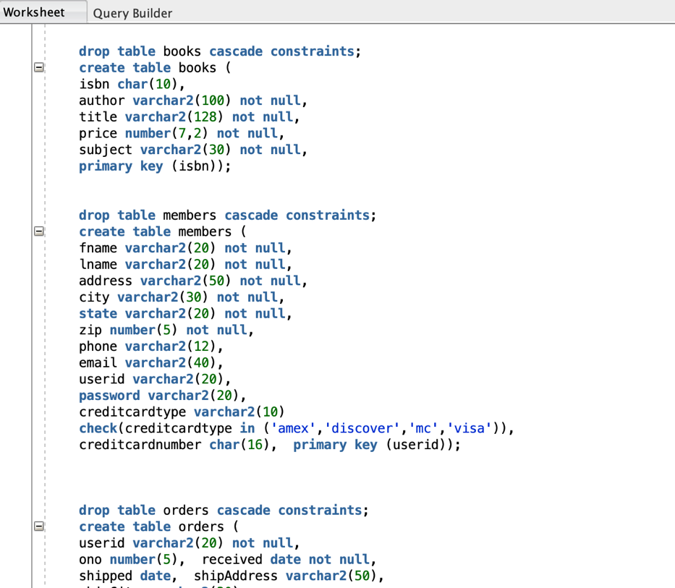
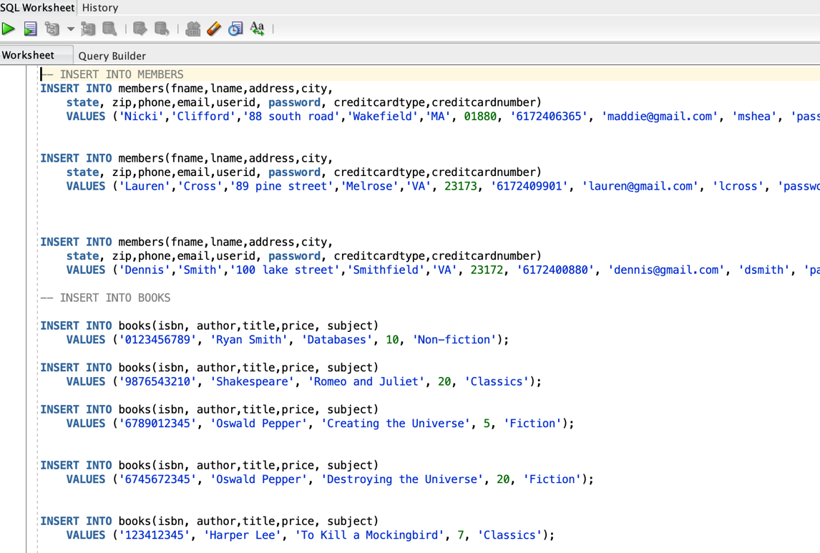
Figure 8 Creating the Database.

Figure 7 Adding to the Database.

- Check order status
Customers can track their orders by enter order number and click the check my order status button. The system will check the order’s status. If it does not exist, an error message will show up. Otherwise a message will tell customer either the books has been shipped or still in processing.

Figure 11 Check Order Status

Tables in the Database System
Basically, we are using five tables for the sake of our bookstore: books, members, order, odetails and cart. Book table holds all the information for books, such ISBN, Title, Price, Author and Subject. Primary key is ISBN. The second table is Members table holds the members’ information, such as UserID, Password, Name, Address, Credit Card Number and Phone Number. Here the UserID is the primary key. In the orders table, it stores UserID, Order Number, Date Received, Date Shipped and Ship Address. Here the Order Number is the primary key. UserID is a foreign key corresponding to the UserID in the members table. In the odetails table, it stores Order Number, ISBN, Quantity and Price. Here the Order Number and ISBN is the primary key. Order Number is a foreign key corresponding to the Order Number in the orders table. ISBN is a foreign key corresponding to the ISBN in the books table. In the cart table, it stores UserID, ISBN and Quantity. Here the UserID and ISBN is the primary key. UserID is a foreign key corresponding to the UserID in the members table. ISBN is a foreign key corresponding to the ISBN in the books table.

State if everything goes according to the plan and the designed sspecifications, if not, then why.
Overall, the web application is developed according to the plan. We have developed all the functions of customers. However, when implementing the AOL searching log, we use the ajax function to complete the autocomplete function using manually inputted strings due to the size of log file is too large.
According to the designed plan, administrator also need manage the user account information and order information. But when implementing, we consider the administrator's role, find it is not his responsibility to manage the user account and order information. To manage user account and order information, we need add some new roles and different responsibility scope for different roles. It's too complex to finish. So, we don't implement.

Division of Labor
Maddie Shea took care of SQL database creation, queries and this document.
Lauren Toth took care of web-application and integration with the SQL.

Comments on the Project: do you like the way it is organized? What do you want to change?
I like the way it is organized, because each team has enough flexibility to choose application domain and techniques to develop applications.
I would want to add an administrator page in order to update the books we are selling.
- Programs/Code and Many other related materials attached.
Attaching a zip file with all the code.
- References:

