**Design document**

**Java-group**

**Umls**

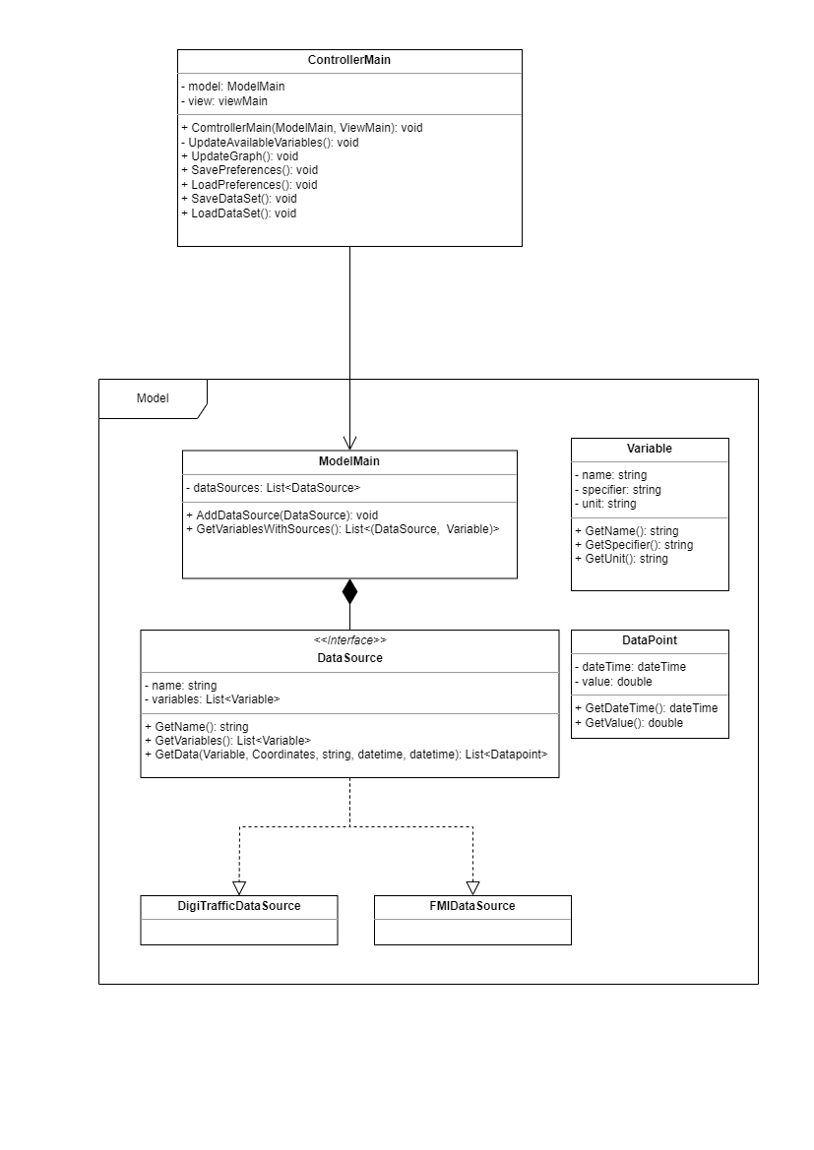

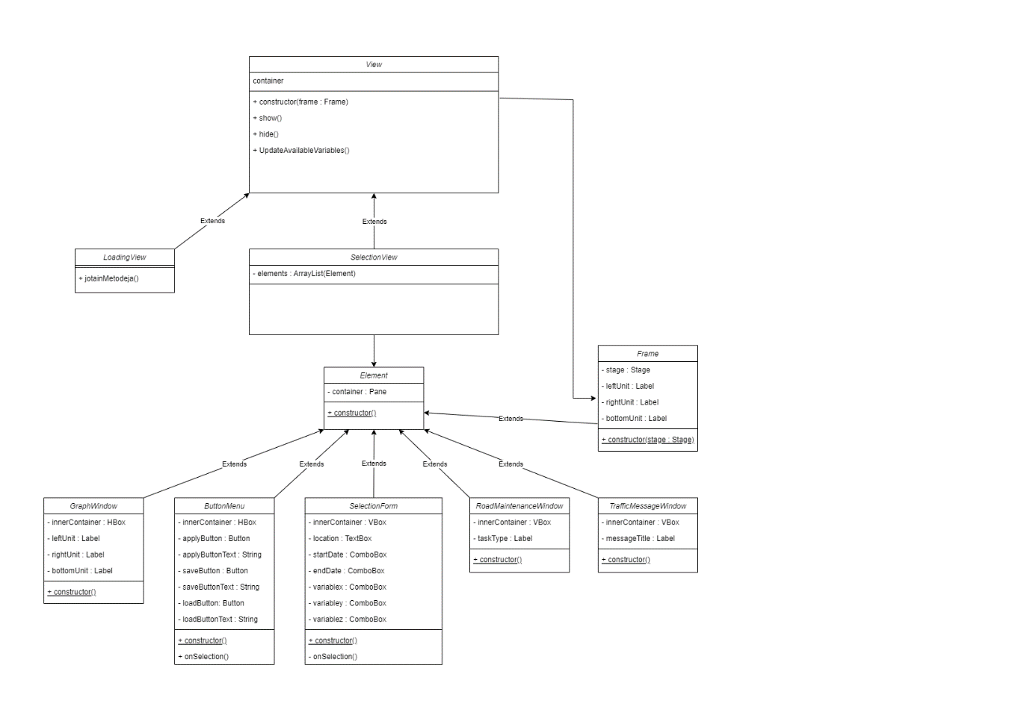

**Description**

The general structure of the program will follow mvc pattern as having separate parts for data handling and visuals makes sense based on the program requirements. Following the mvc pattern also facilitates sensible ways to divide work between the group members without too much interdependency during production.

The model will contain ModelMain class that contains available data source objects and provides interface for requesting data from the model. The data sources are done by data source specific implementations of a DataSource interface class. The DataSource interface provides methods for requesting specific data from a data source. The model also contains Variable and DataPoint classes for storing information.

The controller part of the program will be made of a single ControllerMain class which facilitates communication between the Model and View. The controller acts as listener to the view and whenever methods that require new data are called in the view, the controller reacts by calling the views methods for reading what data is selected, requesting said data from the model, and passing it back to the view.

The view is as shown in the view uml.

**Decisions**

The programs UI will be made using JavaFx as it is the only UI tool for java that several group members are familiar with.