Documentation for X X Decay Lepton Analysis

Abstract

In this project I looked at the feasibility of identifying decay events of the vector-like quark, X, by detecting two same sign leptons and measuring the angular distribution. I compared the angular distribution of the X X decay to background events of W+Jets and t t decay. I also considered the missing energy for these three types of events as this has also been used for identification.
I concluded that it would be possible to use angular distribution to help identify X X decays by using a likelihood fit on the distributions or by applying a cut between cosine values of -0.6 and +0.4.

Introduction

Vector like quarks are hypothetical spin ½ particles whose left and right handed chiralities have the same colour and electroweak quantum numbers. The X particle is an example of a vector-like quark which has a charge of 5/3.

We are looking at the decay of the exotic vector-like quarks X and X. The signature we are looking for is the two same sign leptons produced by one branch of the decay.
Here we are looking at simulations where the X X are create through
q q > X X and q g > X X and g g > X X
The decay chains we are looking at are.

X > W+ t, W+ > l+ ν_{l} , t > b W+ , W+ > l+ ν_{l} , (Net: X > l+ ν_{l} l+ ν_{l} b)
X > W- t, W- > l- ν_{l} , t> b W- , W- > l- ν_{l} , (Net: X > l- ν_{l} l- ν_{l} b)

The other decays of the X and X are

X > W+ u/c, W+ > l+ ν_{l} (Net: X > l+ ν_{l} u/c)
X > W- u/c, W- > l- ν_{l} (Net: X > l- ν_{l} u/c)

Other background decays that could be identified as producing two same sign leptons.

t t , t > W+ b, W+ > l+ ν_{l} , t > W- b, W- > l- ν_{l} , (Net t t > l+ ν_{l} l- ν_{l} b b)

where one of the leptons has its sign mid-identified, or

W+ jet > l+ ν_{l} jet and W+ jet jet > l+ ν_{l} jet jet
W- jet > l- ν_{l} jet and W- jet jet > l- ν_{l} jet jet

where one of the jets is misidentified as a lepton.

Coding
The programme used to analyse the LHE files is main.cc, which is found in /opt/ppd/scratch/qrj71241/Particles/trunk/main. This programme depending on what options it runs with will select the two same sign leptons (for XX), two leptons (for tt ) or a lepton and a jet ( for Wjets), then these particles with fill TwoBody class which calculates the properties of the composite particle. This TwoBody class structure as well as data about the input particles, the X whose decay has been analysed and the missing energy in the decay is outputted to a TTree structure which is then outputted as root file.
This root file can be plotted using plot.cc in /opt/ppd/scratch/qrj71241/Particles/trunk/main. This programme will use the TTree to plot analysis of the two-body. The key plots outputted are the angular and cosine distribution between the two components of the TwoBody class and the plots of the missing energy to compare with.

We used these programmes on LHE files of the three decays produced by Luca Panizzi which each contain 200,000 events, although in the case of the XX there are only 48,317 events that contain same sign lepton events.
These files are located in the directory /opt/ppd/scratch/qrj71241/Particles/trunk/main/LHE.

Plots

We produced plots for angular and cosine distribution and compared them to each other.
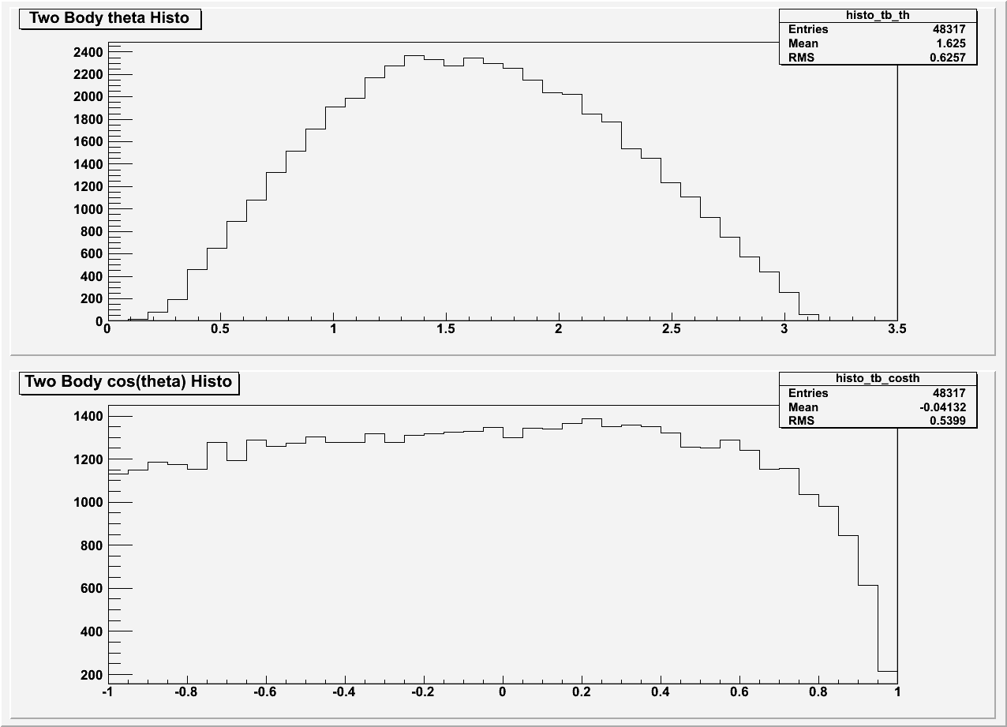Figure 1: Angular and Cosine Distribution for Same Sign Leptons from X and X Decay
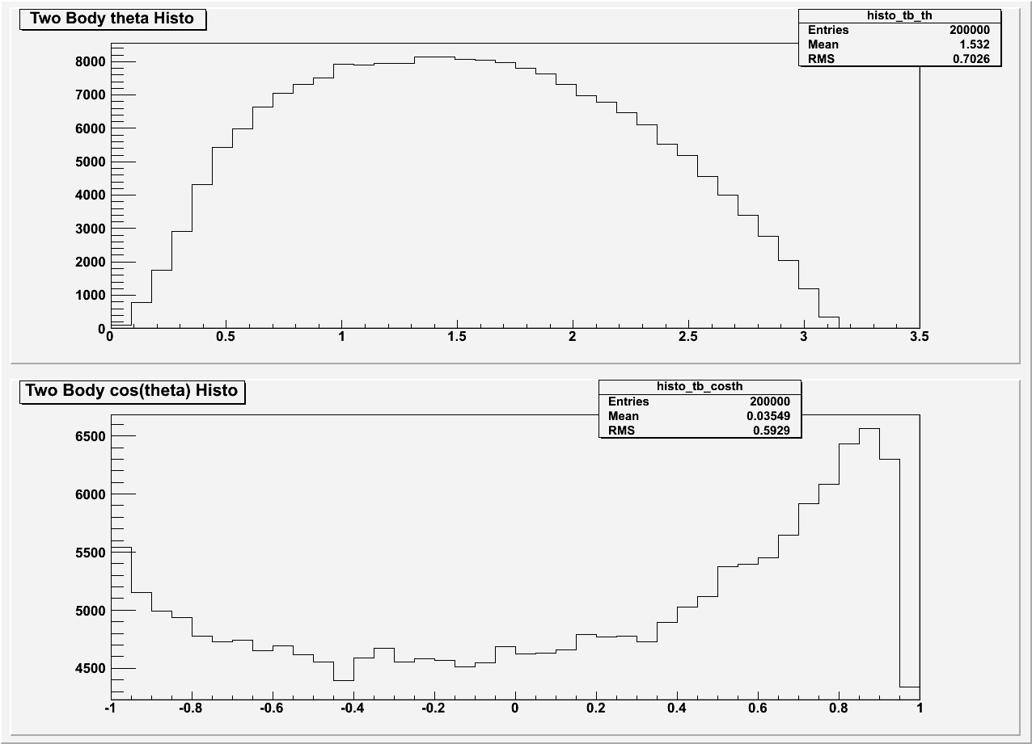Figure 2: Angular and Cosine Distribution for Leptons from t t Decay

We also produced plots of the missing-energy's mass, energy and transverse potential, as this is currently used to discriminate between signal and background decays.
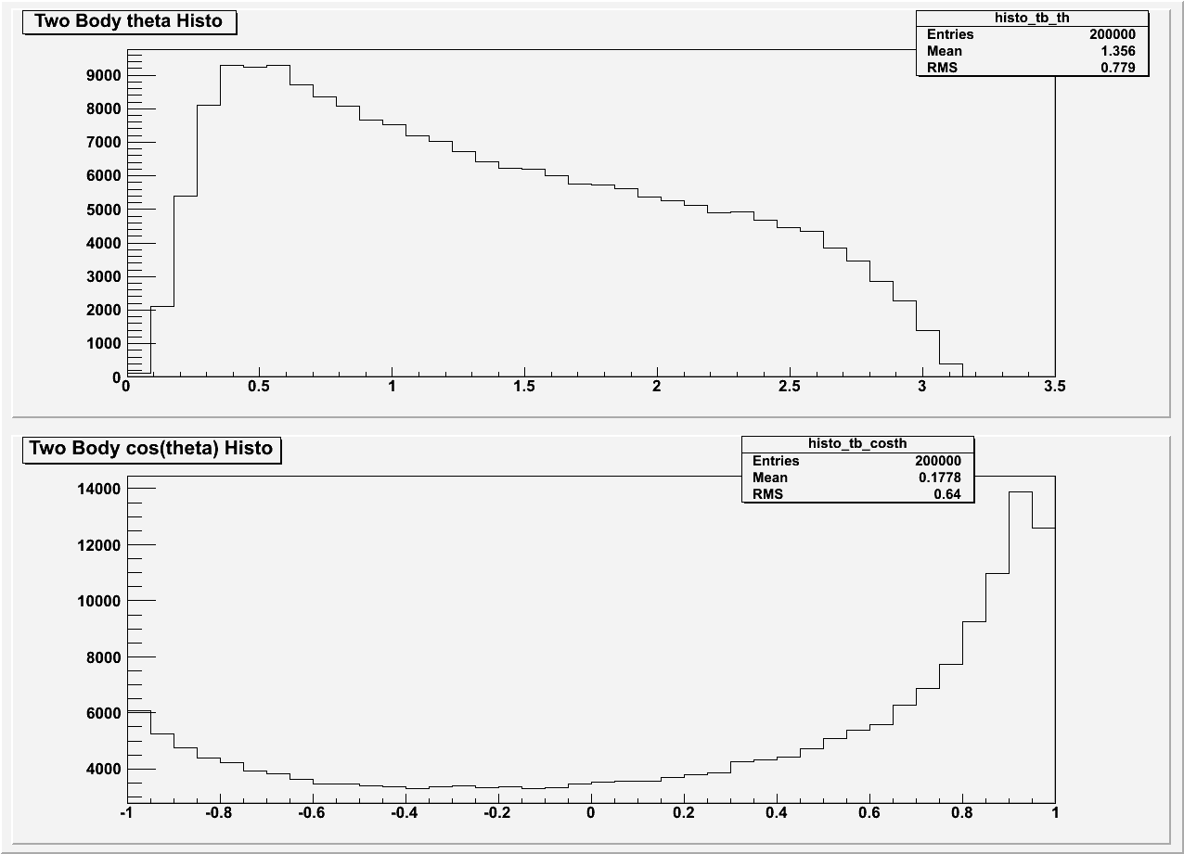Figure 3: Angular and Cosine Distribution of Lepton and a Jet from W + Jets Decay
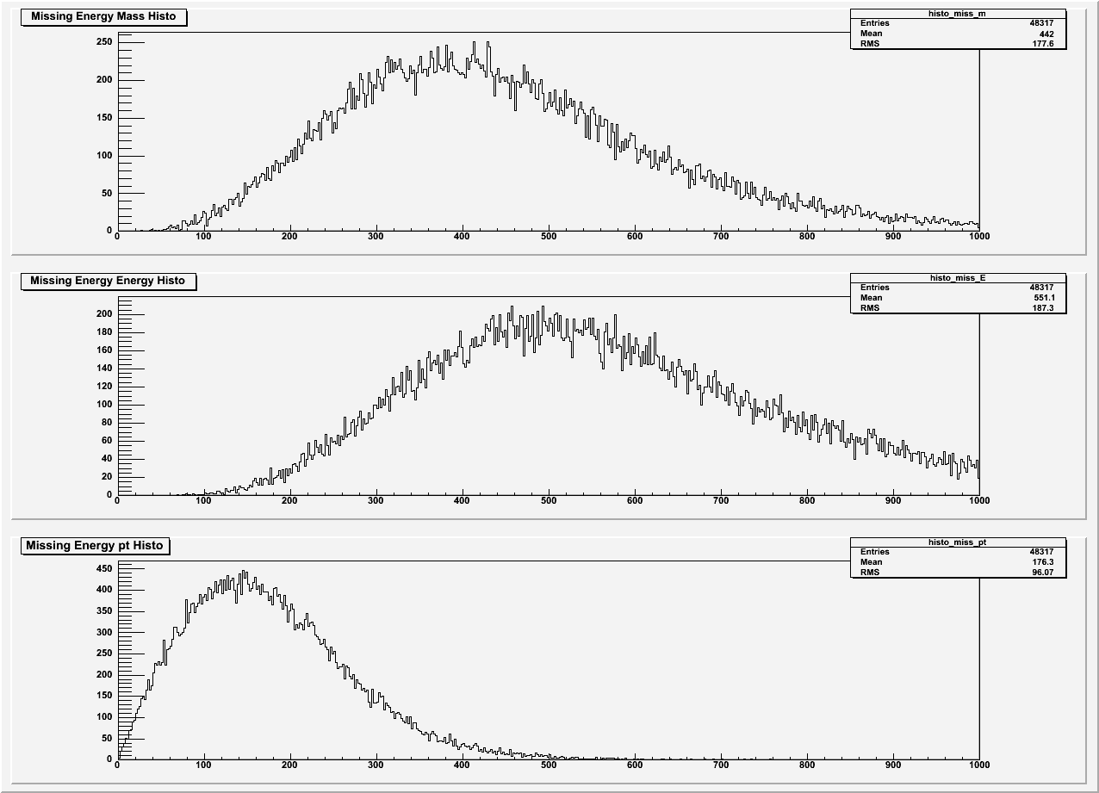Figure 4: Missing Energy's Mass, Energy and Transverse Momentum for X X Decay

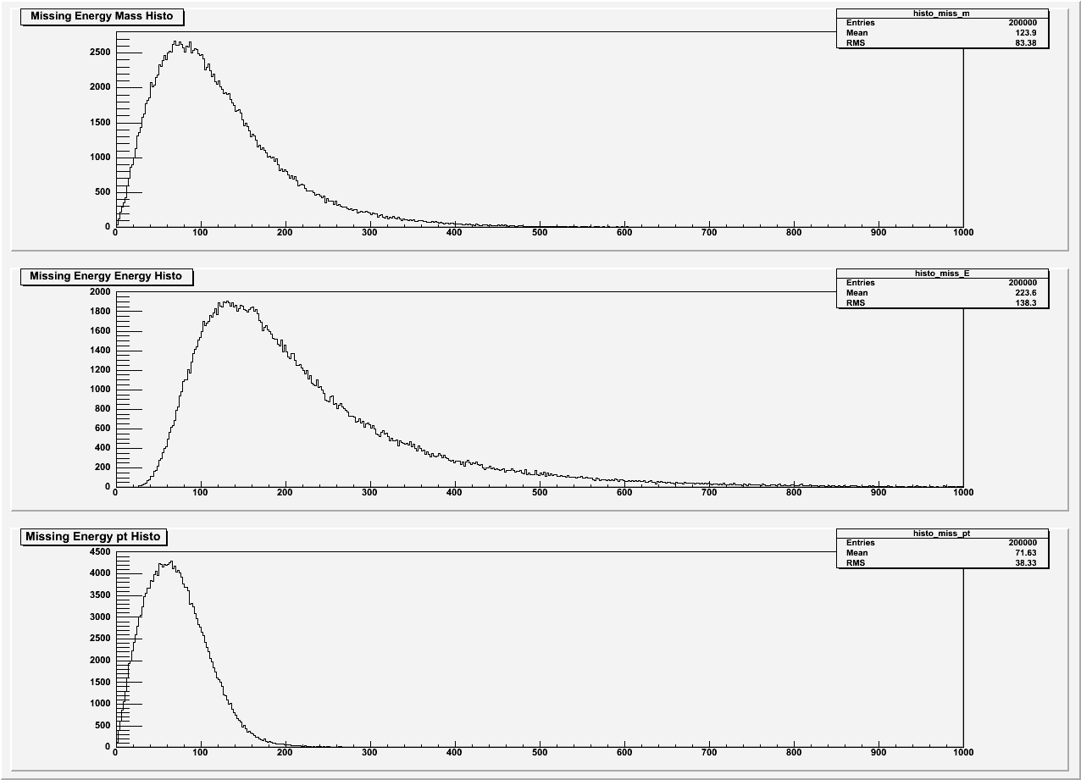Figure 5: Missing Energy's Mass, Energy and Transverse Momentum for t t Decay
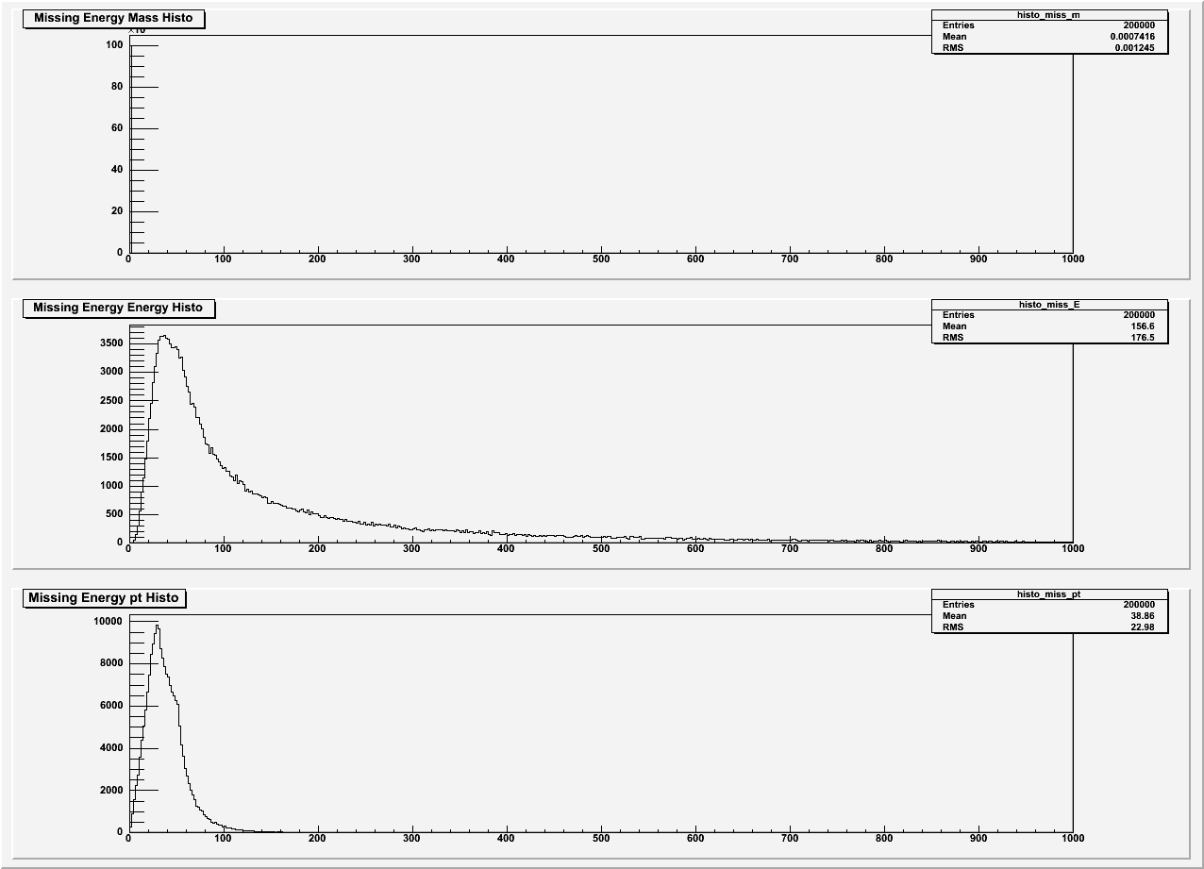Figure 6: Missing Energy's Mass, Energy and Transverse Momentum

Analysis

We can see from comparing figures 1, 2 and 3 that the angular and, in particular, cosine distribution can be used to differentiate between XX and background. Looking at the cosine distributions both tt and W+jets have peaks at just under a cos value of 1, where X X has a a deficit. As the distributions have different shapes it should be possible to either use a likelihood fitting of the three distributions to identify signal from background or one could use a cut between cos values of -0.6 and +0.4.
By looking at figures 4,5 and 6 we can also see that the missing energy plots are very distinct and hence are a good way of differentiating between the different decays. It is notable that for transverse momentum, neither the W + Jets nor the t t plots have a tail beyond ~200GeV, however X X decay has a substantial decay tail. However when using missing energy one has to be careful because by it's very nature it is an indirectly measured property and hence the errors associated with it can be quite large.
Conclusion
In this project I have looked at whether it is feasible to identify X X decays by using the angular distribution of the signature two same sign leptons. By comparing the angular distributions of the same sign leptons with possible background events of misidentified W+Jets and t t decay one can see that the distributions and, in particular, the cosine distribution of the leptons could be used to discriminate against background. One could use a likelihood fit with the distributions or a cut between cosine values of -0.6 and +0.4.

I have also looked at the missing energy properties of these decays as this is what has been currently used to discriminate between events. Although the missing energy's pt have distinct plots for background and X X decay events, concerns about errors in measuring missing energy may be a factor that causes one to use angular distribution.

