SCRS/2014/xxx

**Specifying and weighting scenarios for MSE robustness trials**

Levontin, P.1, Leach, A.W.[1], Kell L.T., Holt, J.1 and Mumford, J.D.1

*SUMMARY*

*The GBYP Bluefin tuna rebuilding plan uses stochastic projections that do not capture all the uncertainty associated with stock assessment/ management variables. This could mean that the outcomes predicted by the projections are more optimistic or pessimistic than those that will be achieved in practice. A methodology was sought to capture stakeholder perceptions of particular uncertainties that should be included in stock assessments of Bluefin tuna and then to provide preliminary quantification of their relative importance impact on achieving management objectives. Ultimately, this will allow risk-based scenarios to be specified for the Operating Models used as part of a Management Strategy Evaluation and enable the SCRS and the GBYP Steering Committee to prioritise research. Given that the combinations of scenarios for inclusion in an MSE can grow exponentially with each extra variable, it may not be possible to evaluate the quantitative impact of all sources of uncertainties identified, or even prioritised. Therefore discussions with assessment scientists were conducted to reduce the initial list to those variables most amenable for further evaluation using simpler quantitative modelling approaches such as elasticity or scenario-based sensitivity analysis. In elasticity analysis the proportional change of derived values relative to changes in the input parameters allows the relative impact of the different inputs to be evaluated. Having determined which of the uncertainties have greater impact on derived values, measured using a utility function, discussions can be initiated with the stakeholders to elicit which of the shortlisted uncertainties should have priority for further quantitative investigations. Finally, a representative ‘reference’ set of operating models can be selected based on analysis of interactions among uncertainties. The plausibility weights for this reference set of OMs provide another opportunity to engage stakeholders, and to elicit their views as to how robustness trials with the MSE should be ‘tuned’. Having thus established an MSE framework, other sources of uncertainty from the qualitative analysis stage can be quantitatively addressed but it is still unlikely that every single one can be given a quantitative treatment. Therefore, elicitation process will also serve to document what is missing from the quantitative risk assessment, giving a more transparent and comprehensive view of uncertainties in the scientific advice to managers and other stakeholders.*

*KEYWORDS: Bluefin tuna; Thunnus thynnus; GBYP; stock assessment; risk analysis; MSE; uncertainty.*

***1. Introduction***

Although several sources of uncertainty were considered when formulating the East Atlantic and Mediterranean Bluefin Tuna Recovery Plan, not all sources were explicitly considered. Therefore, a contract for a Risk Assessment was awarded under Phase III to identify the main sources of uncertainty and the legitimate concerns of a wide range of stakeholders. Subsequently the meeting on bluefin stock assessment methods (SCRS, 2013) endorsed this work and recommended that the major sensitivities for both separate and mixed stock assessments (e.g., M, fecundity schedule, SRR and alternative mechanism of population regulation) should be identified in a paper on a Risk Assessment. It was also recommended that this paper be used to inform the choice of Operating Model (OM) scenarios to be used in the bluefin Management Strategy Evaluation (MSE). Therefore in this study we turn this initial qualitative study into a quantitative one that can be used to identify the simulation trials (i.e., scenarios) used in the MSE.

When building an OM it is necessary to develop hypotheses about system dynamics that can be run as part of stochastic Monte Carlo simulations. However, Monte Carlo simulations are costly in terms of time and resource to conduct. Therefore there is benefit in first running deterministic (or a limited number of stochastic) simulations to identify main effects or important interactions. Following this, fully stochastic simulations can be run for the trials (i.e. scenarios) that are considered to be important.

To do this deterministic runs are conducted initially to explore the dynamics and the effect of model and value uncertainty. Stochastic simulations that include observation and process error and assessment procedures with feedback will be done later as part of the MSE. This approach means that rather than running all possible combinations of treatments, an experimental design can be used to run only main effects and selected interactions.

***2. Methods***

* 1. **As the first step, qualitative analysis identified and prioritized uncertainties based on stakeholder perceptions.**

In the previous phases of the Risk Assessment, Imperial College has identified, through literature review, a list of uncertainties relevant to the management of the Eastern bluefin tuna stock. This list was completed through interviews with stakeholders: GBYP scientists, managers and NGO observers. Semi-quantitative feedback was elicited from 28 stakeholders which allowed Imperial College to prioritise that list of 33 uncertainties in terms of urgency of being tested in fully quantitative manner. It was discovered that individual stakeholder opinions differed on all three dimensions in which uncertainties were analysed: 1). importance in the management context - what impact a source of uncertainty is anticipated to have on the probability of achieving management objectives; 2). how likely it is that a particular uncertainty could be reduced by investing in research; 3). to what extent it was already represented in the current GBYP assessment. In order to understand the reasons for disagreements and explore the possibility of achieving consensus in a larger group, a focus workshop group of five people (four scientists and an NGO representative) was conducted (Tenerife, Spain). Through a group discussion, we succeeded in achieving consensus opinion on the most relevant dimension of these uncertainties to risk management, Importance. Using both these consensus scores and the overall stakeholder responses, we compiled a ‘high value’ target list of 20 uncertainties that are most important candidates for the quantitative treatment (Table 1). Journal paper submitted to Ecological Applications: Identification and prioritisation of uncertainties for management of Eastern Atlantic Bluefin Tuna (*Thunnus thynnus*). Leach, A.W., Levontin, P., Holt, J., Kell, L. T. & Mumford, J.D.

**2.2** **The second step is to quantify individual uncertainties with the elasticity analysis.**

The list of priorities (Table 1) identified in the previous step is subject to computational constraints as some are more difficult than others to model. Thus following discussions with the modellers, an initial set of uncertainties was selected for the quantitative assessment. Each of these uncertainties was broken into scenarios or levels to characterise it prior to expressing these differences mathematically within a simpler model used to re-assess the importance of selected uncertainties by quantifying the impact it has on key model outputs. . It was proposed that, prior to inclusion in operating model scenarios, these are first evaluated with a simpler approach to gauge the quantitative impact each source of uncertainty is likely to have on the operating model. Further, each was measured against a base case scenario before looking at the interactive effects these uncertainties might produce.

2.2.1 Model description

Biological parameters are taken from the ICCAT assessment (Kell et al., 2011), i.e. average-at-age vectors for mass, proportion mature, natural mortality and selectivity derived from the Adapt-VPA stock assessment. These values can be changed to evaluate the sensitivity of the utility functions to the assumptions.

Table 1. Prioritised list of top 20 uncertainties that were agreed by the focus group to be either massively or majorly important.

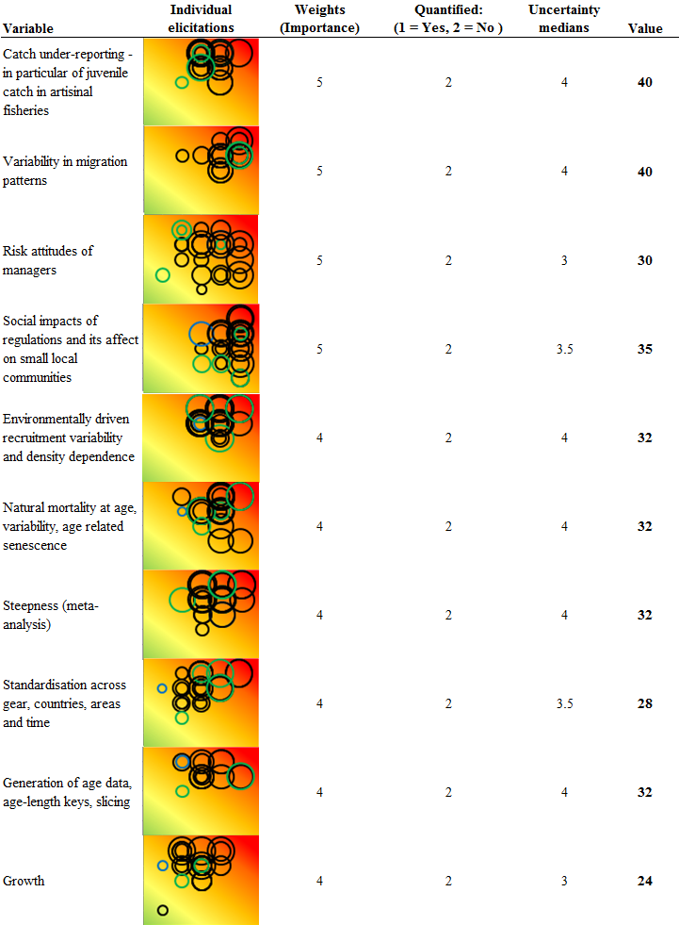

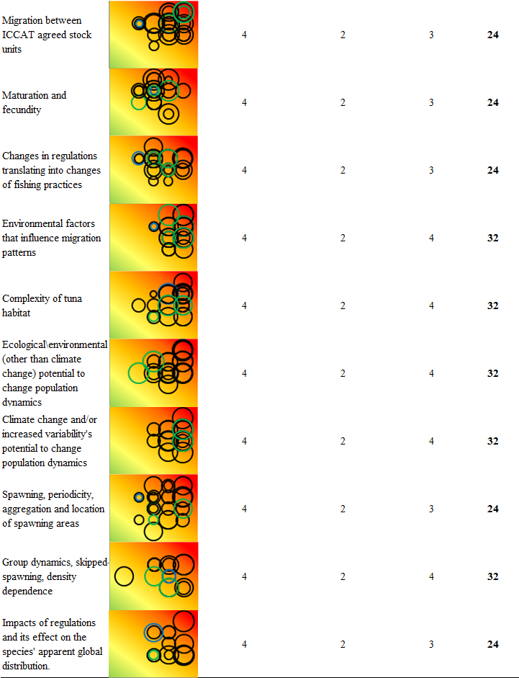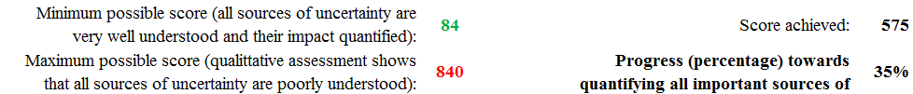

2.2.1.1 Model

Life-history traits are:

* annual spawning (1 cohort per year),
* 50% maturity at age 4, 100% maturity at ages 5+,
* fecundity is linearly proportional to weight,
* growth following the von-Berttalanffy equation used in the ICCAT working group (with the following parameters: L∞ = 318.85, k=0.093, tO=-0.97),
* length-weight relationship used in the ICCAT working group (W=2.95.10-5*L2.899),
* lifespan of 40 years.
* age-specific, but time-invariant, natural mortality based on tagging experiments on the southern bluefin tuna and used in the ICCAT working group (i.e. M=0.49 for age 1, M=0.24 for ages 2 to 5, M=0.2 for age 6, M=0.175 for age 7, M=0.15 for age 8, M=0.125 for age 9 and M=0.1 for ages 10 to 20).

Given the selection pattern (*s*) of a fishery, and the catchability (*q*) of a population for a given effort (*E*), the fishing mortality rate (*Fa,y,j*) for age *a*, year *y*, and population *j* is given by:

*Fa,y,j* = *Ey*qj*sa,j*

Through time, E is assumed to be constant over the first 10 years to lead to F = 0.5 FMSY, then to increase over the following 25 years to lead to F = 1.5 FMSY and finally to decrease to lead to F=0.5FMSY over the last 24 years. The effort can vary between the two sub-populations.

Catchability, *q*, is assumed to be constant among sub-population, age and time.

The selectivity pattern (*sa*) is assumed to vary by age and corresponds to the long-term average seen in the Bluefin tuna fisheries (Kell et al., 2011).

The abundance (*Nj*) at age *a+*1, at the start of year *y+*1*,* in sub-population *j*, is:

*Na+1,y+1,j* = *Na,y,j*exp(-Fa,y,j- Ma,y,j)*

The virgin biomass of a population can be of any relative size and differences in productivity can be modelled through the stock recruitment relationship. Two stock recruitment relationships were considered (i) recruitment is assumed to be independent of spawning stock biomass (*S)*, i.e.is environmentally driven so that R = RMAX or (ii) the recruitment is assumed to be dependent on *S* and follows a Beverton and Holt (1957) stock–recruitment relationship with fixed parameters α and β.

2.2.1.2 Alternative scenarios

Appendix 1 summarises the different sources of uncertainty, i.e. process, observation, estimation, implementation, model, value, translational or institutional. In this study only model and value uncertainty are considered and possible modelling approaches are summarised in the final column. These are summarised and factors and levels in Table 2. The 3rd column summarises the number of levels for each factor. The 4th column shows the cumulative number of scenarios if only the main effects are modelled, i.e. a single level is varied in the base case at a time.

Table 2. Scenarios. Bold text show parameter values used for the base case.

|  |  |  |  |
| --- | --- | --- | --- |
| Factor | Levels | N | Σ Main Effects |
| Historic Catch | **Reported**, Inflated | 2 | 2 |
| Future Recruitment | **Medium**, Low, High | 3 | 4 |
| Steepness | **1**, 0.7 | 2 | 5 |
| Natural Mortality | **SCRS**, Life History | 2 | 6 |
| Juvenile Mortality | M1 × (**1**, 1.5) | 2 | 7 |
| Plus Group Fratio | **SCRS**, 1.0 | 2 | 8 |
| Plus Group Mortality | MPG × (**1**, 2) | 2 | 9 |

The first two factors **Historic Catch** and **Future Recruitment** were the sources of uncertainty included in the assessment and projections used to calculate the K2SM. The values of steepness chosen were 1 (as assumed in the assessment) and 0.7 an arbitrary value to provide some contrast. Natural mortality was either that assumed by the working group (SCRS) or derived from weight-at-age (Lorenzen, 1996). To evaluate the effect of artisanal fisheries juvenile mortality was increased by a factor of 1.5. Plus group dynamics were evaluated for an increase in mortality and by setting the Fratio to 1. The working group had estimated the Fratio and that value (SCRS) was used for the base case.

**2.3 Utility function**

A decision is needed on how to evaluate model sensitivity because we are interested in a wide range of outputs, each of which could have a different sensitivity/elasticity to a given source of uncertainty. Examples of such model outcomes include time taken to rebuild the stock, risk of stock collapse and short verses long term yield; each of which may be assigned different importance (and weights) by different stakeholders. In economics Utility represents the satisfaction experienced by the consumer of a commodity. Different stakeholders may have different utilities, for example long term yield and time taken to rebuild the stock may be more important to some stakeholders than short term yield, although reducing the risk of stock collapse may be equally important to both groups. To have a measure of model sensitivity for each group we need to define a utility function (ICES, 2007) and then weight the different components. These utility functions can then be used to evaluate the impact of the different sources of uncertainty.

It has been highlighted in several studies that eliciting management objectives which are often ambiguous, conflicting or simply never made completely explicit is often an impediment to modeling or risk analysis in general (ICES, 2007; Leach *et al*., In prep).

To construct a utility function we first need to identify management objectives.

### 2.3.1 Objectives

First we summarise the “explicit” management objectives for bluefin i.e. those in the ICCAT Basic Texts and in the Commission Recommendations made when the bluefin recovery plan was implemented. We then discuss “implicit” objectives based on The Principles Of Decision Making For ICCAT Conservation And Management Measures consistent with the Precautionary approach and the Straddling stocks agreement and other conventions such as CITES and IUCN.

#### Explicit

The main management objective of ICCAT is to maintain the populations of tuna and tuna-like fishes at levels which will permit the maximum sustainable catch. Originally interpreted as using FMSY as a target, in 2007 a 15 year Recovery Plan was implemented with the goal of achieving *BMSY* with at least a 60% probability by 2022. *BMSY* was based on F0.1, a proxy for FMSY.  F0.1 is the point on the yield per F curve where the slope equals 10% of that at the origin, BMSY is estimated by multiplying the spawner-per-recruit at F0.1 by the assumed level of recruitment. The corresponding objectives are to achieve the maximum long-term yield and ensure that by 2022 the stock is greater than *BMSY* with a 60% probability.

#### Implicit

We also consider objectives based on a variety of agreements, that although not explicitly included in the recovery plan or in the Basic Text are included in recent conventions such as the United Nations Conference on Straddling Fish Stocks And Highly Migratory Fish Stock Agreement (UNFSA). The objective of UNFSA is to ensure the long-term conservation and sustainable use of straddling fish stocks and highly migratory fish stock consistent with the precautionary approach (see http://daccess-ods.un.org/TMP/8829557.8956604.html).

Both the Straddling Stocks agreement and the PA were signed after the Basic Text of ICCAT. However, the principles of decision making [Rec 11-13] note that management decisions should be based upon scientific advice consistent with the precautionary approach. Therefore although not explicitly stated in the bluefin recovery plan in this study we consider management objectives based on the PA and Straddling Fish Stocks agreements.

There are other Conventions which could potentially impact on the management of bluefin, e.g. CITES and the IUCN redlist. A proposal for listing Atlantic bluefin on CITES appendix I and II was made in 2009, the criteria for a CITES listing for a commercial species are given in footnote 2 in CITES Conf 9.24. Atlantic bluefin is also classied as ‘Endangered’ on the IUCN Red list (Collette et al., 2011; IUCN, 2013) based on a combination of factors including limited range, inferred low densities and presumed unsustainable interactions with fisheries.

2.3.2 Constructing a utility function

For a stochastic model, we can construct annual utility function considering four components (risk of overfishing, risk of being below biological reference point, a measure of yield relative to some desired level, and variability of recruitment), as follows:

However, this might reflect how satisfied we are with the stock in a particular year but more distant outcomes are less valuable to us than the current ones. Thus over a period of time we propose a utility function with built-in discount rates for each of the four component measures relating to objectives. So over the simulated time period the total utility will be:

Where UF,y means Utility with respect to F and is for each year equals to prob(F<FMSY).

This is just one possible representation of a utility function and will use several variations of this general form to assess the sensitivity of the base case model to alternative scenarios described in Table 2.

**2.5 Progress score with respect to incorporating the uncertainty**

We developed a measure of where we are with respect to including uncertainty relative to an ideal situation where we have quantified the impact of every source of uncertainty and using research reduced uncertainty itself as much as is possible. In our expert elicitations we considered the possibility of reducing uncertainty which is represented in table 1 by the size of the hoops. Small hoops corresponded to views that uncertainty could not be reduced further, large hoops reflected the view that a lot can be done still to reduce a particular source of uncertainty (through data collection, research, *etc*). The position of the hoops with respect to the Y-axis depicted the importance or the weight each source of uncertainty was believed to have in the assessment/management of the stock. Utility analysis supersedes expert opinion on the weight each source of uncertainty is believed to carry for the assessment because it could be demonstrated that the impact of such uncertainty on the utility function is of particular magnitude. Assuming that having a quantitative analysis is preferable to merely a qualitative one, we can now calculate how far are we from achieving a score of 100% of incorporating all important sources of uncertainty. A tentative score function is the follows:

Where:

P Progress

Wu Weight (Importance) of uncertainty

Vu Value of reducing uncertainty

Au Assessment level (binary function (qualitatively assessed = 2, quantitatively assessed = 1))

Given the weights we calculate the minimum score possible = Pmin, this is achieved when all ratings for the value of reducing uncertainty are 1 (implying that it could not be reduced further through research) and all sources have been quantitatively assessed. Pmax is the maximum score where all ratings for the value of reducing uncertainty are set a maximum and no variable had been quantitatively assessed.

The overall current score is then:

That is, when P=Pmin the score is 100%.

Using this method of measuring the progress towards reducing, quantifying and including uncertainty we are currently at 35% (footnote of Table 1). This score can be improved in two ways: conducting quantitative assessments and investing in research to reduce uncertainty if there is scope for those sources with high importance weightings.

***3. Results of Illustrative Trial***

Tables XX below compare three different ways to measure the ‘importance’ of a particular source of uncertainty. Eight scenarios are compared to the base case using three different utility functions each a combination of ‘Biological’, ‘Economic’ and ‘Social’ components. In the ‘Total’ column, the three components are simply added implying they have equal weights in the overall utility. The first ‘Absolute’ utility function uses absolute values for the biomass of fish, for yield and for fishing mortality which is a proxy for employment, hence the ‘social’ component, as maintaining employment is one of the management objectives, Table 3. The second utility function (Table 4) uses relative values, where historical averages presented in part a) of the table, are used to normalise biomass, yield and fishing mortality. In the third version of a utility function, the values are normalised using MSY reference points, (Table 5).

Using absolute values is inconvenient if we want to consider trade-off by combining different components, in that case adding biological and social components makes no sense even if quantitatively they were on the same scale (which is clearly not the case in Table 3) since they have incomparable units of measure. But normalising (dividing) values by either historically meaningful quantities (Table 4) or MSY based calculations (Table 5) makes all components of the utility function unit-less thus enabling us to make sense of the overall, or ‘Total’ utility, the last column of Table 4 and 5.

The percentage values show how each component of the overall utility and the total were affected by each scenario relative to the base case: the difference between utility of the scenario and the base case divided by the value of the utility function (component) for the base case

The last column shows how the overall utility function has changed with each scenario relative to the base case, and if had an agreed with the stakeholders form of the utility function these would be the primary numbers of interest. We can see that uncertainty over reported catches has a lot of influence, no matter which utility function is used. Recruitment and Steepness scenarios appear important when the utility function is constructed out of values normalised by MSY reference points which are allowed to change with the scenario. Clearly, the scenario influences the reference points and hence our perception of how satisfied we are with achieving management goals. It is suggested by the results that scenarios related to natural mortality are not important. This is in clear contradiction with the expert opinion which rated the importance of uncertainty related to natural mortality at age as ‘major’, Table 1.

The revenue component does not change in the first two variants of the utility function because the model uses constant catch projections, however in the utility function that evaluates scenarios relative to perceived MSY reference points (which themselves change depending on the scenario) the revenue component does vary, suggesting for instance that the fishery is underperforming from the economic standpoint in the ‘high recruitment’ scenario. This is because the high recruitment causes the estimated Yield at MSY to be higher and so the same level of catch looks worse in comparison with a higher standard.

All three utility functions use the same discount rate (5%) and equal weights for the components. However, we don’t know stakeholder preferences. Different stakeholders might give different weights to different components and also prefer different discounting factors for each component.

The tables below show how sensitive our conclusions about the importance of different sources of uncertainties are to the choice of the utility function, what would be vital to understand also is how robust the quantification of uncertainty is to the choice of the modelling approach. How do these results depend on the model itself and the modelling approach more generally?

Table 3. Utility function figures for scenarios ABSOLUTE

a)

b)

A description...

Table 4. Utility function figures for scenarios calculated against historical reference points

a)

b)

c)

A description...

Table 5. MSY version.

a)

b)

A description...

Figures 1-4 show the time series of SSB, Yield, Fishing mortality and Plus Group Biomass under all nine scenarios. The three panels in each Figure correspond to utility function’s specifications: the top presents absolute values (Table 3), the middle – values relative to a historical average (Table 4) and the bottom panel – values relative to calculated MSY reference points (Table 5).

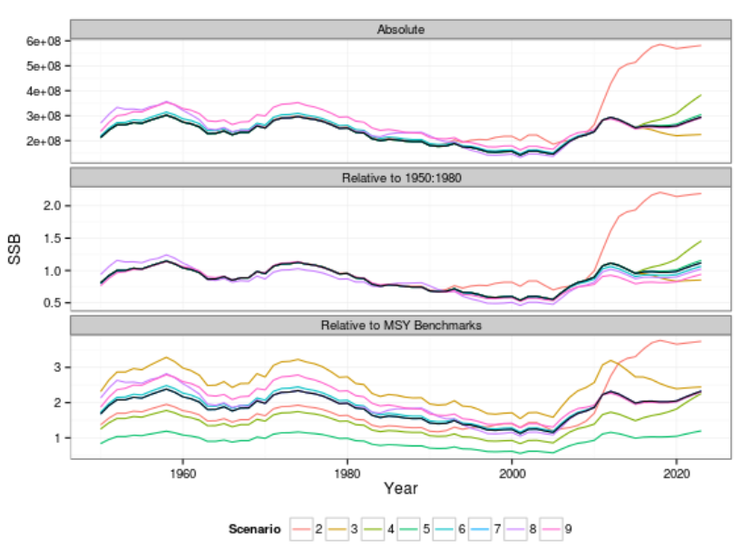

Figure 1. Spawning stock biomass in 9 scenarios from 1950-2023.

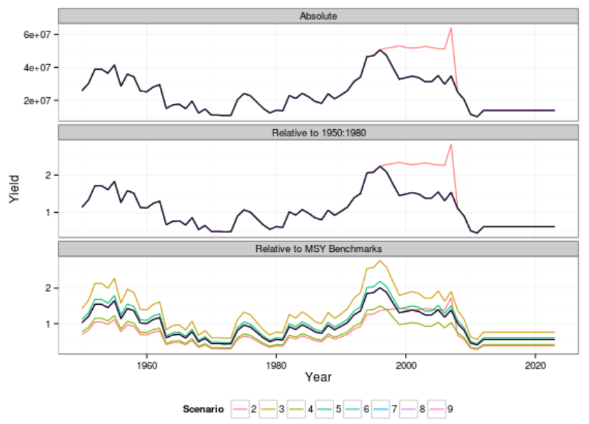

Figure 2 Yield in 9 scenarios from 1950-2023.

.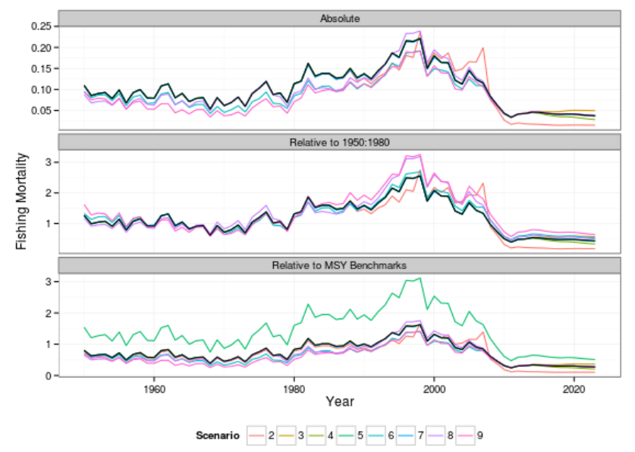

Figure 3. Fishing mortality in 9 scenarios from 1950-2023.

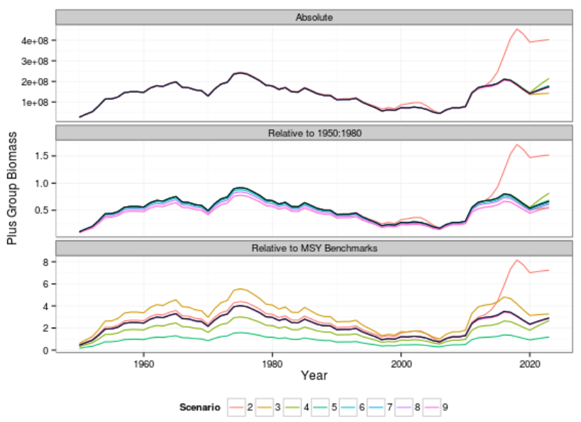

Figure 4 Plus Group Biomass in 9 scenarios from 1950-2023.

.

***4. Discussion***

The elasticity analysis is insufficiently informative about uncertainties since there is a potential, given the nature of non-linear models, that the combined impact of some scenarios is far more significant than singular deviations from the base-case can reveal. But in order to include all these combinations, we would need to consider an impractical number of model runs. So how do we choose which combinations to investigate?

Elasticity analysis can form a basis for the selection. For instance, those uncertainties to which the model was found not particularly sensitive could be fixed in the future analysis. Discussions with modelers and/or stakeholders can inform finalizing the list of scenario combinations to test. If we are interested in pursuing other uncertainties which were highlighted in the qualitative analysis, such as risk attitudes of managers or impacts of the regulations, we would need to reduce the list of OM models still further. This final reference set for the MSE framework could consist of 5 or fewer models chosen out of a larger list ranked according to utility function values so that the reference set covers the entire range of utility scores. If resources permit, expert views would be solicited and accounted for at this final stage of the analysis instead.

For bluefin, in common with many stocks, stock biomass, reference points, stock recruitment relationships and projections are based on spawning stock biomass (SSB) and spawner per recruit (SPR); which assumes that fecundity is proportional to mass-at-age irrespective of the demographic composition of adults[?] and that somatic growth is time-invariant. However, egg production is not necessarily related linearly to SSB. The growing literature describing maternal effects on different aspects of population dynamics including fecundity, viability of eggs and larvae, the temporal and spatial structure of spawning and possibly recruitment for these reasons Marshall (2009) argues that, rather than SSB, total egg production should be used.

Quantitative analysis is a step forward from the qualitative one. In this paper we update the qualitative assessments of importance for some variables using sensitivity analysis based on the calculated impact of uncertainty on the utility function relative to the base case scenario. But what size a difference would translate as ‘massive’ impact on a utility function vs. “major’ impact, if we want the two approaches qualitative and quantitative to be comparable? Moreover, the size of the perceived importance of a scenario depends on the specific choices made in defining a utility function. Different specifications of a utility function can imply contradictory quantitative assessments of the ‘importance’ of variables. Therefore, a consultation with the stakeholders is necessary in order to select a utility function which represents a consensus on the trade-offs between the objectives that are acceptable.

***5. Acknowledgements***

This work was funded by short-term contract for the Stock Assessment Modelling (GBYP 04/2011) of the Atlantic-Wide Research Programme on Bluefin Tuna (ICCAT GBYP – Phase 2). The authors would like to thank the respondents who took the time to fill out the questionnaire and all the ICCAT personnel for their kind hospitality during our visits to ICCAT in Madrid.

***6. References***

Beverton, R.J.H. and Holt, S.J. (1957) On the Dynamics of Exploited Fish Populations. London: Chapman and Hall, 533 pp.

CITES (2010). Proposal to include Atlantic Bluefin Tuna (Thunnus thynnus (Linnaeus, 1758)) on Appendix I of CITES in accordance with Article II 1 of the Convention. Consideration of Proposals for amendment of Appendices I and II. Convention on International Trade in Endangered Species of Wild Fauna And Flora, fifteenth meeting of the Conference of the Parties Doha (Qatar), 13-25 March 2010. CoP15 Prop. 19. pp. 34. http://www.cites.org/eng/cop/15/prop/E-15-Prop-19.pdf (last accessed 11 November 2013)

Collette, B., Amorim, A.F., Boustany, A., Carpenter, K.E., de Oliveira Leite Jr., N., Di Natale, A., Die, D., Fox, W., Fredou, F.L., Graves, J., Viera Hazin, F.H., Hinton, M., Juan Jorda, M., Kada, O., Minte Vera, C., Miyabe, N., Nelson, R., Oxenford, H., Pollard, D., Restrepo, V., Schratwieser, J., Teixeira Lessa, R.P., Pires Ferreira Travassos, P.E. & Uozumi, Y. 2011. Thunnus thynnus. In: IUCN 2013. IUCN Red List of Threatened Species. Version 2013.2. www.iucnredlist.org. Downloaded on 26 November 2013.

Kell, L.T., Fromentin, J.-M., Bonhommeau, S. 2011. An Evaluation of the Implications of Population Structure on the Current Bluefin Tuna Advice Framework. SCRS/2011/110.

Kell, L.T., Merino, G., De Bruyn, P., Ortiz de Urbinaz, J, Arrizabalaga., H., Santiago, J., Murua H. 2013. An Example Management Strategy Evaluation of a Harvest Control Rule. SCRS/2013/035

Leach, A.W., Levontin, P., Holt, J., Kell, L. T. & Mumford, J.D. Identification and prioritisation of uncertainties for management of Eastern Atlantic Bluefin Tuna (Thunnus thynnus). Submitted to Ecological Applications, 20/11/2013.

Lorenzen, K. 1996. The relationship between body weight and natural mortality in juvenile and adult fish: a comparison of natural ecosystems and aquaculture. Journal of fish biology 49.4: 627-642.

ICES. 2007. Report of the Study Group on Risk Assessment and Management Advice (SGRAMA), 5–9 February 2007, Cape Town, South Africa. RMC:02. 68 pp.

IUCN 2013. The IUCN Red List of Threatened Species. Version 2013.2. http://www.iucnredlist.org. Downloaded on 21 November 2013

Marshall, T., (2009). Implementing information on stock reproductive potential in fisheries management: The motivation, challenges and opportunities. In Jakobsen, T., Fogarty, M.J., Megrey, B. A., Monksness, E., (Eds), Fish reproductive biology. Implications for assessment and management. Wiley-BlackWell. JohnWiley & Sons, Ltd. Oxford, UK. pp. 395-420.

SCRS. 2013. Report of the 2013 Meeting on Bluefin Stock Assessment Methods. Gloucester, Massachusetts, United States – July 20 to 22, 2013.

Appendix 1. Possible modelling Approaches to variable short-listed as important by group elicitation

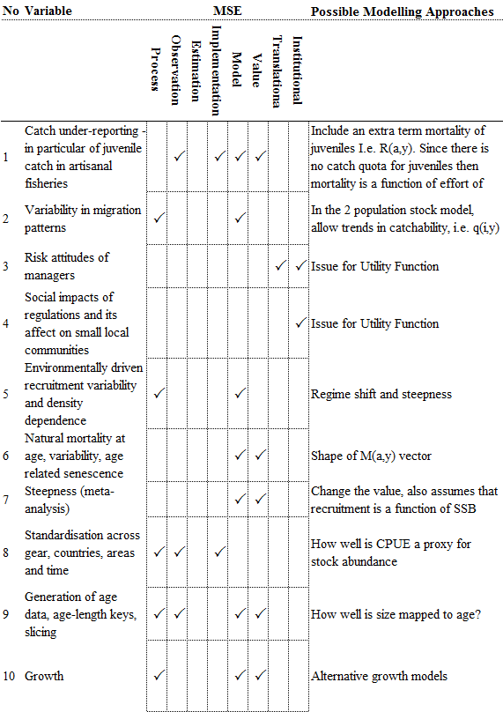

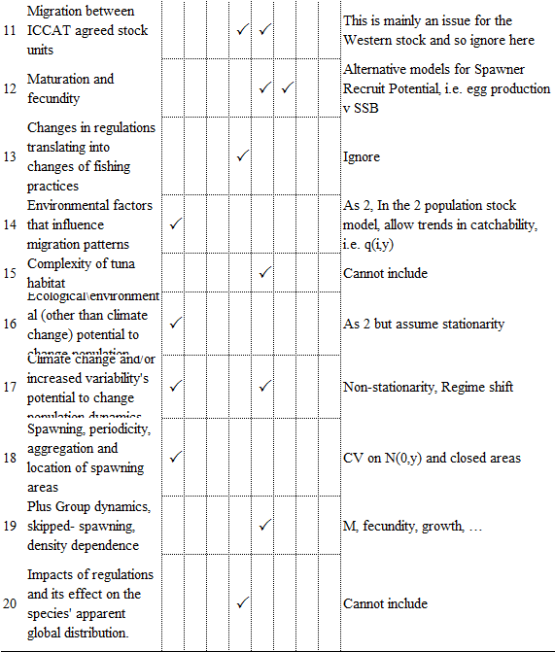

1. Centre for Environmental Policy, Imperial College London, Silwood Park, Buckhurst Road, Ascot, Berkshire, SL5 7PY, United Kingdom. [j.mumford@imperial.ac.uk](mailto:j.mumford@imperial.ac.uk)