SC-ECO

Population growth rate (r)

L Kell

15 March, 2020

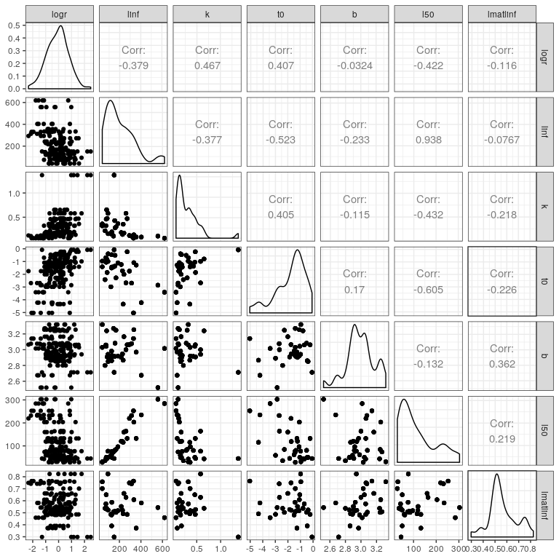

**Figure 1** Relationship between population growth rate ($r$) and life history parameters

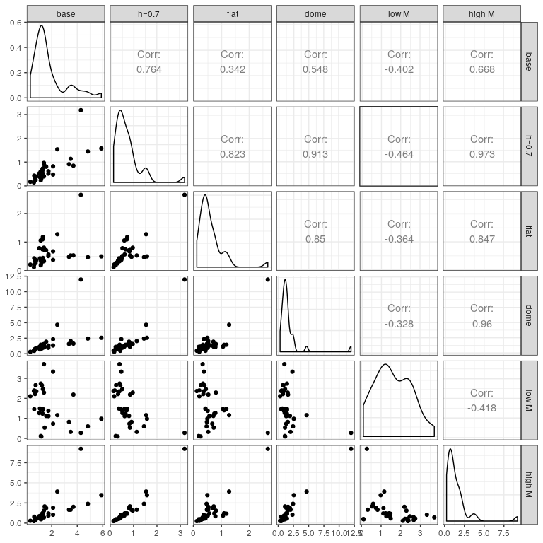

**Figure 2** Correlations between “r” under different assumptions.

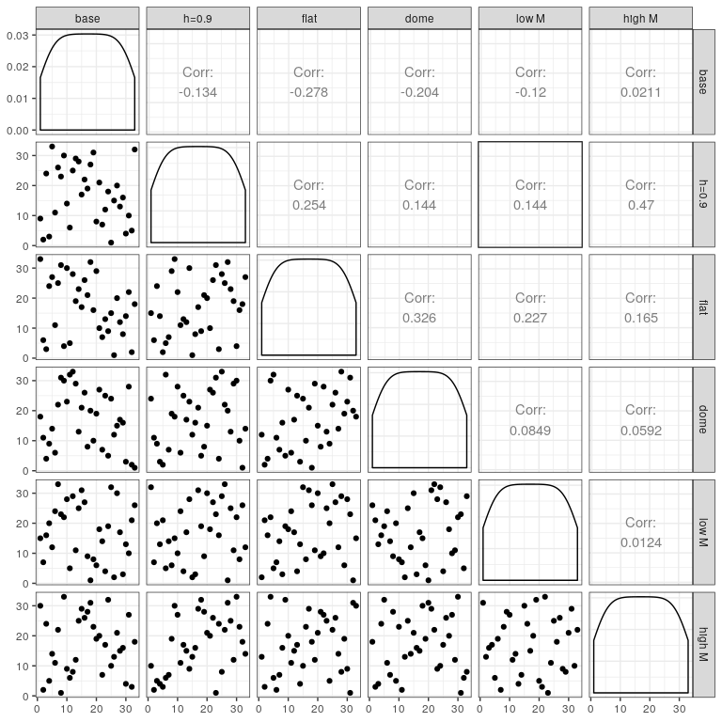

**Figure 3**

## Software Versions

* R version 3.6.3 (2020-02-29)
* FLCore: 2.6.14
* FLBRP: 2.5.4
* FLasher: 0.6.0
* FLife: 3.3.1
* mydas: 1.1.6
* **Compiled**: Sun Mar 15 10:01:33 2020

## Author information

**Laurence Kell**. [laurie@seaplusplus.es](mailto:laurie@seaplusplus.es)

# References