SC-ECO

Productivity Analysis

L Kell

16 March, 2020

## Objective

Compare different ways to estimate productivity for **data poor** stocks and compare with estimates from **data rich** assessments.

## Data Rich Assessments

* Use data rich assessments from the Myers legacy database to sumarise reference points, i.e. $MSY$, $F_{MSY}$, $B_{MSY}$, and $K$.
* Use the reference points to estimate the Pella-Tomlinson production functions and hence $r$ and the shape of the production function ($p$).

### Life History characteristics

* A number of life history characteristics have been used as proxies for productivity, i.e.
  + Maximum Size ($L_{max}$) <110 cm 110–200 >200 cm
  + von Bertalanffy growth coefficient ($k$) >0.36 0.27–0.36 <0.27
  + Size at first maturity ($L_{50}$) <54 54–105 >105
  + Maximum age ($T_{max}$) <8 8–14 >14
  + $L_{50}/L_{max}$ <0.51 0.51–0.55 >0.55
  + Fecundity (Fec) >2.88 1.03–2.88 <1.03
  + $r$ >0.48 0.26–0.38 <0.38
* Use life history parameters from Fish Base, and identify cases where $L_{∞}$, $k$, $L_{mat}$, and $b$ from the length weight relationship are available and then calculate $r$ under a variety of assumptions and compare to $F_{MSY}$ and $r$ from the data rich case studies.
* Scenarios corresponding to steepness ($h$), selection pattern (dome shaped, flat) and $M$.

### Productivity Proxies

* Compare life history parameters and estimates of $r$ with **Data Rich** estimates to develop a robust proxy for productivity.

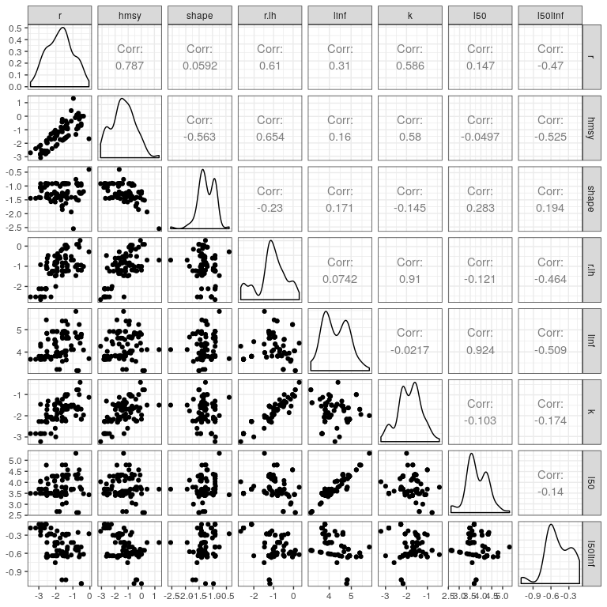

**Figure 1** Relationships between $r$, $H_{MSY}$, and the shape of the Pella-Tomlinson production function from data rich assessments, with data poor estimates of $r$ (r.lh) and life history parameters $L_{\nfty}$, $k$ and $L_{50}/L_{∞}$.

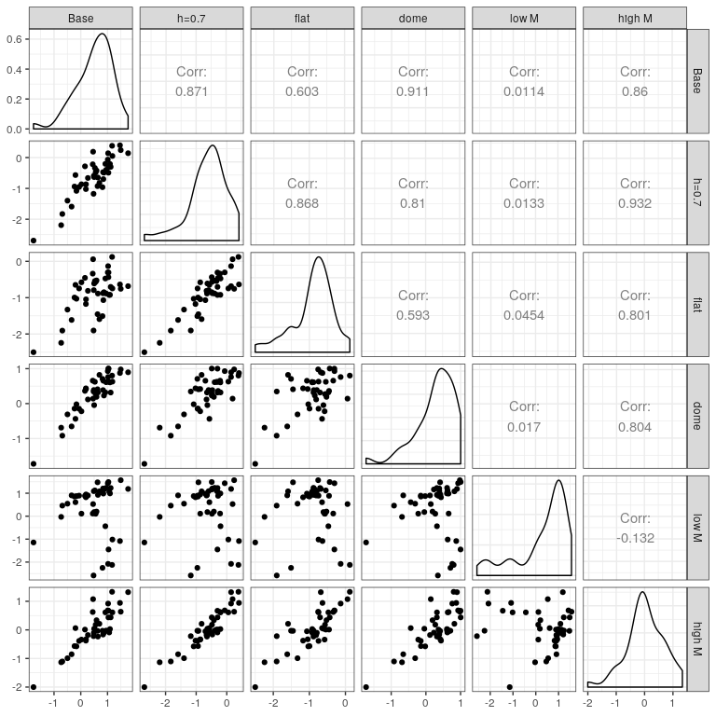

**Figure 2** Relationship between data poor estimates population growth rate ($r$) under the different scenarios.

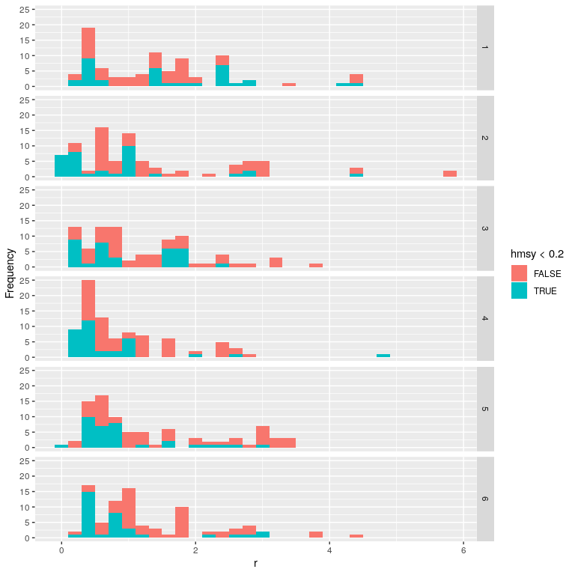

**Figure 3** Estimates of $r$ for data poor scenarios, colours compare with $H_{MSY}$.

## Software Versions

* R version 3.6.3 (2020-02-29)
* FLCore: 2.6.14
* FLBRP: 2.5.4
* FLasher: 0.6.0
* FLife: 3.3.1
* mydas: 1.1.6
* **Compiled**: Mon Mar 16 11:12:33 2020

## Author information

**Laurence Kell**. [laurie@seaplusplus.es](mailto:laurie@seaplusplus.es)

# References