Data poor validation

JABBA MP: ICCAT SS & JABBA OM

Laurence Kell

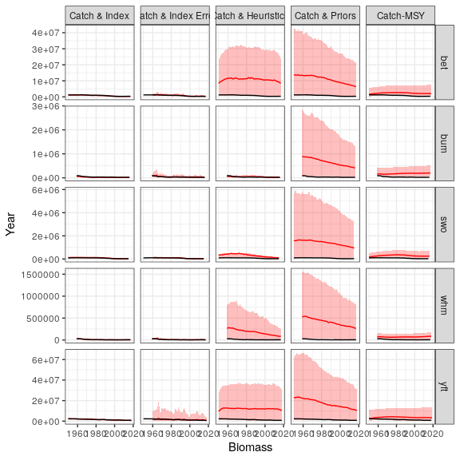

**Figure 1** Absolute trends in abundance for all stocks and methods (black line are the true values).

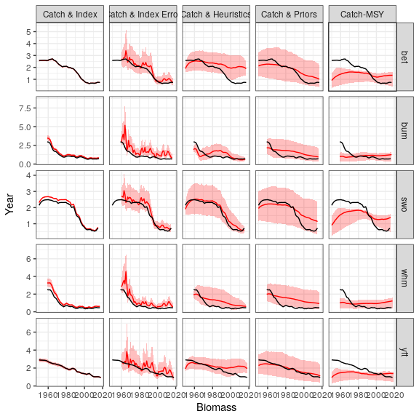

**Figure 2** Trends in abundance relative to $B/B_{MSY}$ for all stocks and methods (black line are the true values).

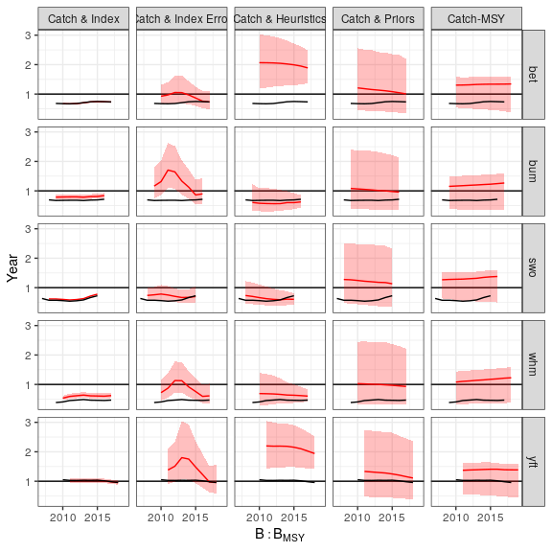

**Figure 3** Trends relative to $B/B_{MSY}$ in last 10 years using all the data.

## 10 Years

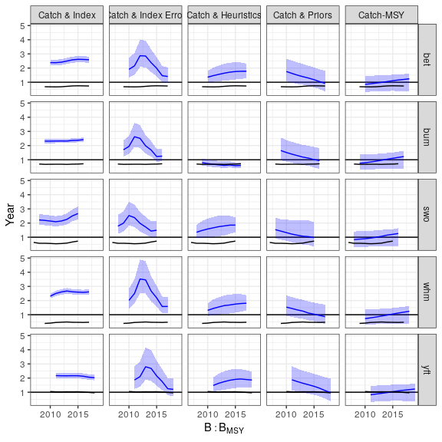

**Figure 4** Trends relative to $B/B_{MSY}$ in last 10 years using truncated data.

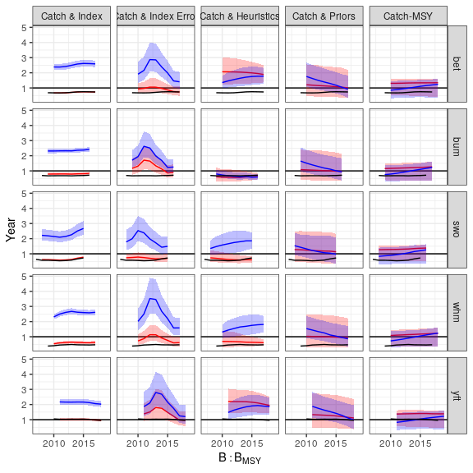

**Figure 5** Trends relative to $B/B_{MSY}$ in last 10 years compared for all and truncated data.

## Indicators

, , Yrs = 10  
  
 stk  
variable-Model bet bum swo whm yft  
 t23-Catch & Index 1.0000 1.000 1.1000 1.00000 0.980  
 t23-Catch & Index Error 0.8600 0.840 0.8700 0.84000 0.810  
 t23-Catch & Heuristics 1.2000 1.200 1.2000 1.20000 1.200  
 t23-Catch & Priors 1.1000 1.100 1.2000 1.10000 1.100  
 t23-Catch-MSY 1.1000 1.200 1.2000 1.20000 1.100  
 t23-CMSY NA NA NA NA NA  
 t23-OM 1.0000 1.000 1.1000 1.00000 0.980  
 t5-Catch & Index 0.0081 0.010 0.0650 -0.00620 -0.018  
 t5-Catch & Index Error -0.1900 -0.190 -0.1300 -0.21000 -0.210  
 t5-Catch & Heuristics 0.0088 -0.033 -0.0028 0.00018 -0.017  
 t5-Catch & Priors -0.0460 -0.036 -0.0280 -0.03600 -0.038  
 t5-Catch-MSY 0.0420 0.058 0.0600 0.06000 0.041  
 t5-CMSY NA NA NA NA NA  
 t5-OM 0.0075 0.013 0.0780 -0.01000 -0.020  
  
, , Yrs = All  
  
 stk  
variable-Model bet bum swo whm yft  
 t23-Catch & Index 1.0000 1.000 1.100 1.0000 0.9800  
 t23-Catch & Index Error 0.9000 0.850 0.950 0.8700 0.8400  
 t23-Catch & Heuristics 1.2000 1.200 1.200 1.2000 1.2000  
 t23-Catch & Priors 1.2000 1.200 1.200 1.2000 1.2000  
 t23-Catch-MSY NA NA NA NA NA  
 t23-CMSY 1.0000 1.000 1.000 1.0000 1.0000  
 t23-OM 1.0000 1.000 1.100 1.0000 0.9800  
 t5-Catch & Index 0.0077 0.014 0.077 -0.0074 -0.0190  
 t5-Catch & Index Error -0.0970 -0.170 -0.020 -0.1700 -0.1600  
 t5-Catch & Heuristics -0.0310 -0.017 -0.026 -0.0180 -0.0280  
 t5-Catch & Priors -0.0190 -0.020 -0.022 -0.0210 -0.0310  
 t5-Catch-MSY NA NA NA NA NA  
 t5-CMSY 0.0017 0.013 0.015 0.0150 -0.0044  
 t5-OM 0.0075 0.013 0.078 -0.0100 -0.0200