North Atlantic Swordfish

Prediction Residuals

Laurence Kell

24 junio, 2017

/home/laurie/Desktop/flr/mpb/vignettes/predictionResiduals.Rmd

# Bugs

library(mpb)  
library(plyr)  
  
## Example dataset  
data(swon)  
  
## problem with only 1 flQuant in FLQuants  
jk=jackknife(swon,FLQuants("1"=jackknife(swon@indices[[1]])))  
  
#should return an FLQuantJK  
"FLQuantJK"%in%is(catch(jk)[,1:10]%/%stock(jk)[,1:10])  
  
#should return an FLParJK  
"FLQuantJK"%in%is(refpts(jk))   
  
## would be nice if it were an FLPar  
rbind(params(jk))  
  
(params(jk)%-%orig(params(jk)))%/%params(params(jk))  
  
## not working  
orig(params(jk))=orig(params(jk))  
  
## not working  
indices(jk)<-indices(bds[[1]])  
  
## not working  
stock(jk)<-stock(jk)  
  
#wht not 1 yearx   
orig(stock(jk)[,ac(dims(catch(jk))$maxyear)])  
  
#res=as.data.frame(FLQuants(b=b,f=f,bbmsy=bbmsy,ffmsy=ffmsy,ymsy=ymsy),drop=T)[,c("iter","data","qname")]  
  
#bug  
#res=as(res,"FLPar")  
  
# lots of @ in biodyn

Here is an example for mpb that runs

* Jackknife
* leave-one-out crossvalidation, this is the same algorithm as the jackknife the post processing is different.
* hindcast, i.e. retrospective tail cutting with projection for cut years. This could be for 1 year in which case the outputs are in the jackknife results.
* If n>1 then need to run projections

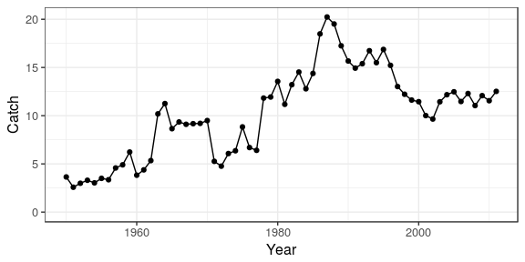 **Figure 1.** Time series of catch.

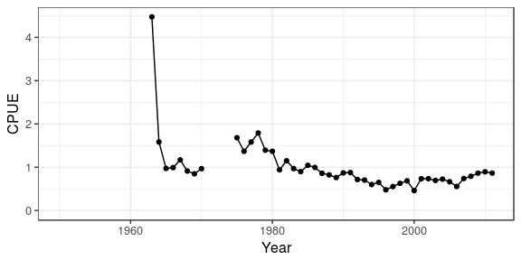 **Figure 2.** Time series of catch per unit effort.

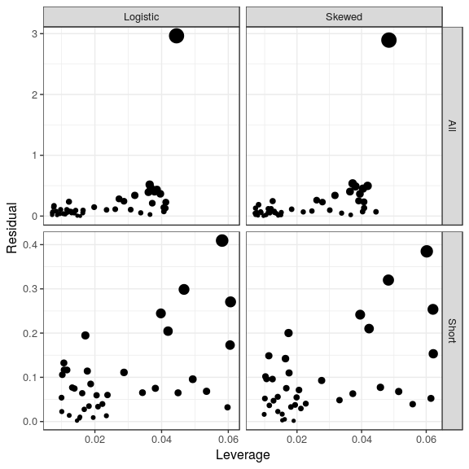 **Figure 3.** Influence diagrams showing the residual plotted against leverage, the size of points is equal to Cook's D statistic, a measure of the influence of a point.

.id variable iter value.x value.y influential params year  
1 Logistic b 1 7.72506781 3.301328 TRUE b 1964  
2 Logistic b 25 -0.29185602 3.301328 FALSE b 1992  
3 Logistic b 17 -0.75724147 3.301328 FALSE b 1984  
4 Logistic b 5 -0.53428868 3.301328 FALSE b 1968  
5 Logistic b 37 -0.16517773 3.301328 FALSE b 2004  
6 Logistic b 41 0.06617782 3.301328 FALSE b 2008  
 data value func series  
1 68.14968 0.1133544288 Logistic All  
2 68.14968 -0.0042825737 Logistic All  
3 68.14968 -0.0111114461 Logistic All  
4 68.14968 -0.0078399296 Logistic All  
5 68.14968 -0.0024237492 Logistic All  
6 68.14968 0.0009710657 Logistic All

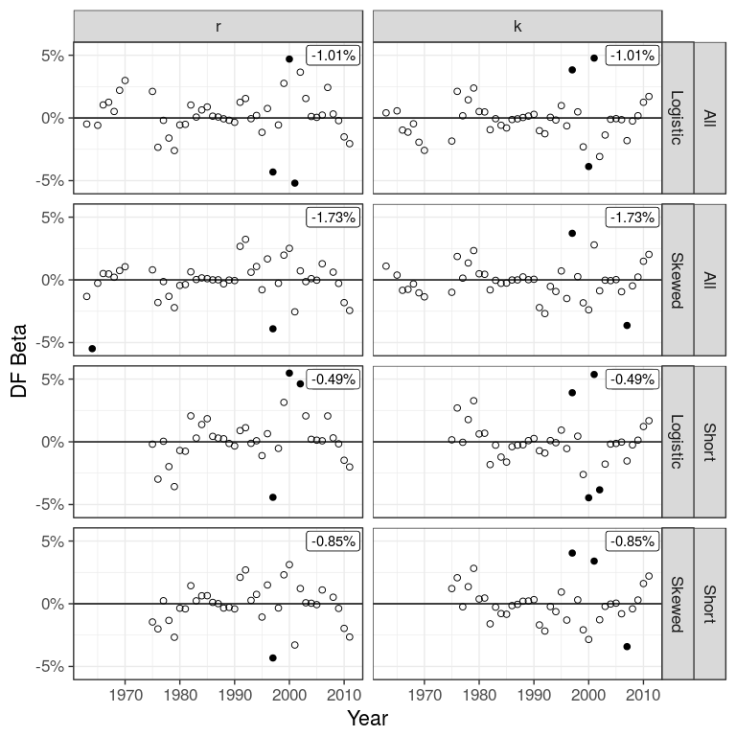 **Figure 4.** DFBetas from jackknife, by estimated parameters (r and K) for each scenario.

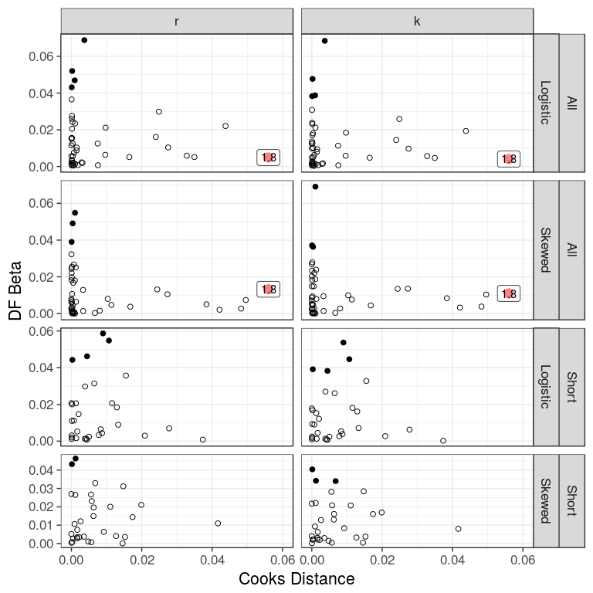 **Figure 5.** Plots of DF Beta against Cook´s D for the estimated parameters (r and K) for each scenario.

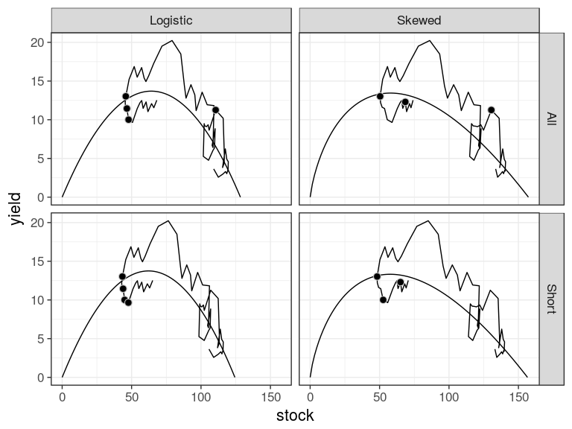 **Figure 6.** Production function for the logistic and skewed production functions, historic trajectory also shown.

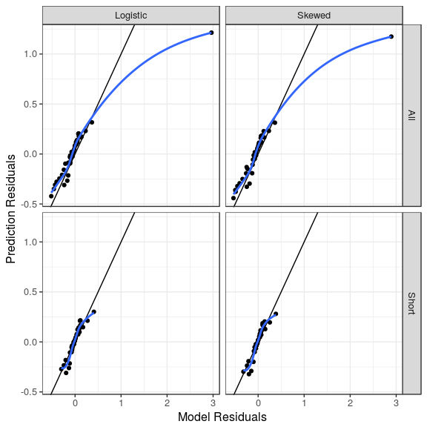 **Figure 7.** Comparison of model and prediction residuals.

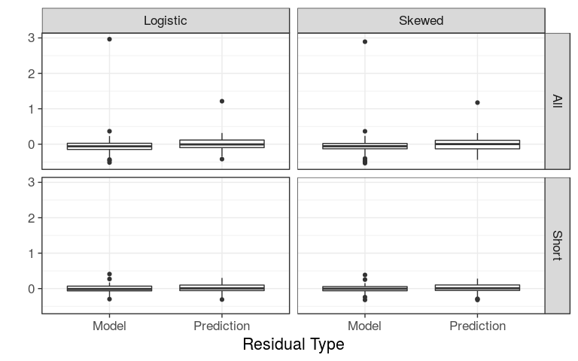 **Figure 8.** Comparison of model and prediction residuals.

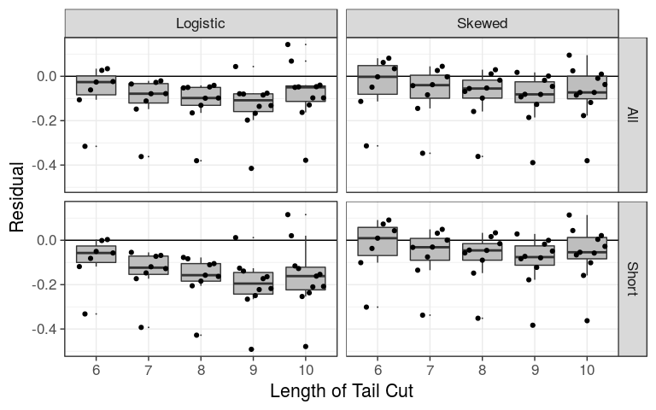 **Figure 9.** Comparison of prediction residuals, by CPUE series and production function shape, for different lengths of tail cutting.