EMFF Operational Programme 2014-2020

Marine Biodiversity Scheme

**Lead Partner:** Galway-Mayo Institute of Technology

**Partners:** Sea ++, Marine Institute

**Authors:** Laurence Kell and Cóilı́n Minto

Tender for the Supply of Research Services to establish MSY proxies for data-limited stocks (2017-18)

to the

Marine Institute, Rinville,

Oranmore, Co. Galway.

(Ref: ITT17-015)

MSY proxies for Data-limited stocks (MyDas)

|  |  |
| --- | --- |
| **Operational Programme** | European Maritime and Fisheries Fund (EMFF) Operational Programme 2014-2020 |
| **Priority** | Union Priority 1 Sustainable Development of Fisheries  Union Priority 6 Fostering the implementation of the Integrated Maritime Policy |
| **Thematic Objective** | TO 6 - Preserving and protecting the environment and promoting resource efficiency |
| **Specific Objective** | UP1 SO1 - Reduction of the impact of fisheries and aquaculture on the marine environment, including the avoidance and reduction, as far as possible, of unwanted catch.  UP1 SO2 - Protection and restoration of aquatic biodiversity and ecosystems.  UP6 SO1 - Development and implementation of the Integrated Maritime Policy |
| **Measure** | Marine Biodiversity Scheme |
| **EMFF Certifying Body** | Finance Division, Department of Agriculture, Food and the Marine |
| **Managing Authority** | Marine Agencies & Programmes Division, Department of Agriculture, Food and Marine |
| **Specified Public Beneficiary Body** | Marine Institute |
| **Grant Rate** | 100% |
| **EU Co-Financing Rate** | 50% |
| **Legal Basis** | Article 29, 40 & 80 EMFF |

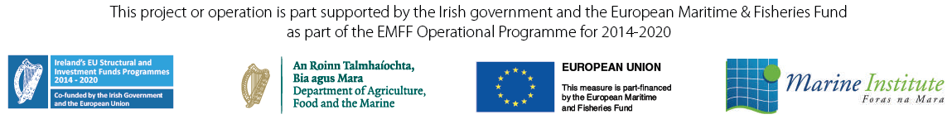

Report content

­­

Further details available on www.emff.marine.ie

|  |  |
| --- | --- |
| **Managing Authority EMFF 2014-2020** | **Specified Public Beneficiary Body** |
| Department of Agriculture Food & the Marine  Clogheen, Clonakilty, Co. Cork. P85 TX47  Tel: (+)353 (0)23 885 9500  www.agriculture.gov.ie/emff | Marine Institute  Rinville, Oranmore, Co. Galway, H91 R673  Phone: (+)353 (0)91 38 7200  www.marine.ie |