North Atlanic Albacore: Stock Assessment Procedure

Laurence Kell

20/02/2016

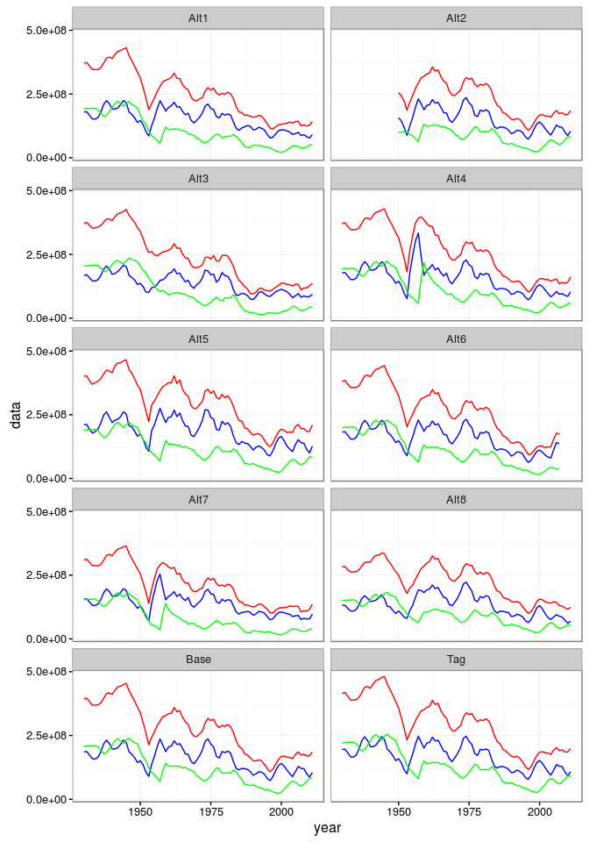

**Figure 1.** Simulated CPUE Series

## Total biomass index

Warning in .Method(..., deparse.level = deparse.level): number of columns  
of result is not a multiple of vector length (arg 2)

Warning in pmax(ld1, ld2): an argument will be fractionally recycled

Warning in .Method(..., deparse.level = deparse.level): number of columns  
of result is not a multiple of vector length (arg 2)

Warning in pmax(ld1, ld2): an argument will be fractionally recycled

Warning in sqrt(diag(cov.bounded)): NaNs produced

Warning in .Method(..., deparse.level = deparse.level): number of columns  
of result is not a multiple of vector length (arg 2)

Warning in pmax(ld1, ld2): an argument will be fractionally recycled

Warning in .Method(..., deparse.level = deparse.level): number of columns  
of result is not a multiple of vector length (arg 2)

Warning in pmax(ld1, ld2): an argument will be fractionally recycled

Warning in .Method(..., deparse.level = deparse.level): number of columns  
of result is not a multiple of vector length (arg 2)

Warning in pmax(ld1, ld2): an argument will be fractionally recycled

Warning in sqrt(diag(cov.bounded)): NaNs produced

Warning in .Method(..., deparse.level = deparse.level): number of columns  
of result is not a multiple of vector length (arg 2)

Warning in pmax(ld1, ld2): an argument will be fractionally recycled

Warning in .Method(..., deparse.level = deparse.level): number of columns  
of result is not a multiple of vector length (arg 2)

Warning in pmax(ld1, ld2): an argument will be fractionally recycled

Warning: replacing previous import by 'grid::unit' when loading 'kobe'

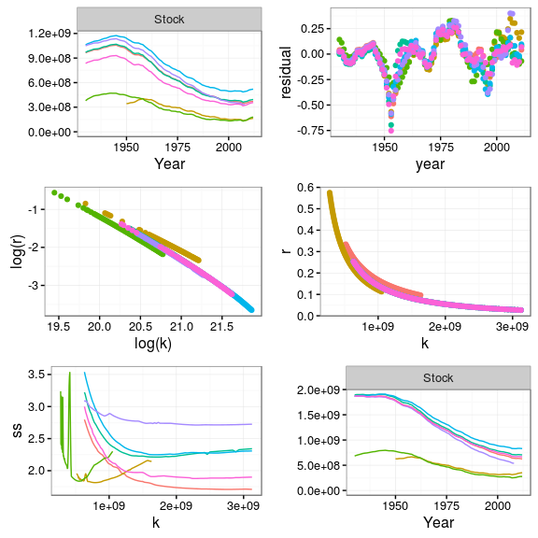

## Juvenile index

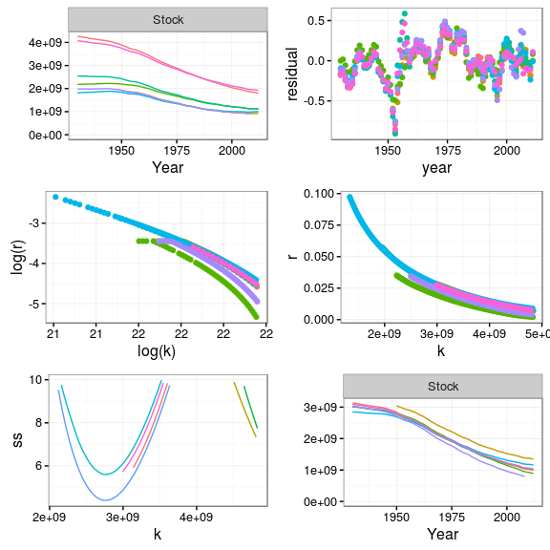

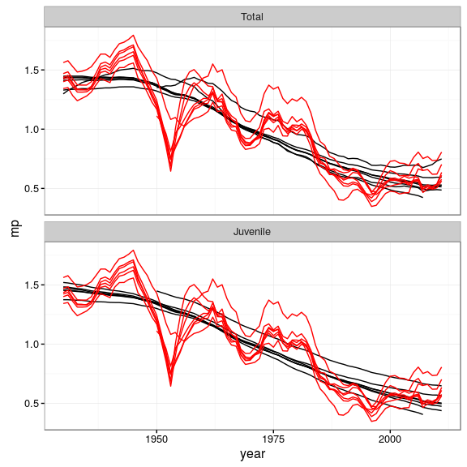

**Figure 2.** Simulated stock time series