AN OBJECTIVE PROCEDURE FOR THE VALIDATION OF OPERATING MODELS CONDITIONED ON STOCK ASSESSMENT DATASETS

The goal is to develop an objective transparent method for the validation of Operating Models (OMs) conditioned on stock assessment datasets

Model validation examines if a model family should be modified or extended, and is complementary to model selection and hypothesis testing. In contrast model selection searches for the most suitable model within a family, whilst hypothesis testing examines if the model structure can be reduced.

Participants

Toshihide Kitakado, Ai Kimoto, Laurence Kell, Rishi Sharma.

The work will also be open to the participation of others (e.g. members of the tRFMO scientific comittees) using web based tools.

Budget request

Travel and subsistence for 2 meetings
University of Tokyo, January 2018: 2 return airfares from from Europe and West Coast of the US to Tokyo, Per Diem for 4 times 7 nights in Tokyo
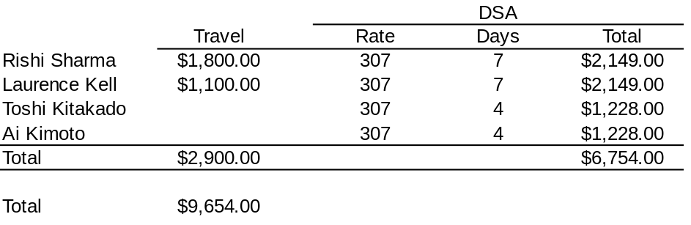

Background

When conducting Management Strategy Evaluation (MSE) an important step is the development of the Operating Model (OM); since once the OMs and objectives have been agreed there is a “best” management procedure (MP) and the task of MSE is to find it. The OM has to be conditioned on data, knowledge and hypotheses that reflect uncertainty about the dynamics. This requires developing scenarios for alternative model structures and datasets, validation of the OM and rejection and weighting of the scenarios.

Often OM and stock assessment models are compared by comparing estimates of quantities that can not be actually compared, i.e. time series of fishing mortality and biomass. In contrast in Oceanography and other disciplines models are validated using cross-validation, a technique for evaluating the predictive error of a model by testing it on a set of data not used in fitting. There is often insufficient data, however, in stock assessment datasets to allow some of it to be kept back for testing. A more sophisticated way to create test datasets is, like the jackknife, to leave out one (or more) observation at a time. Cross validation then allows prediction residuals to be calculated, i.e. the difference between an observation and its out-of-sample predicted value.

If the data are regarded as being representative of the dynamics of the resource then they can be used as a model-free validation measure. This allows examination of prediction errors to be used for validation, rejection of models and indicating useful directions in which the model could be improved. Cross-validation can also help to identify which data series are appropriate for use as empirical indicators in a model free MP and for specifying measurement error for generating resource monitoring data by the Observation Error Model (OEM) when projecting forward.

Proposal

In the absence of formal validation methods instead when conditioning OMs they are often compared to the stock assessment which means that the OM can not be used to evaluate the stock assessment. Cross-validation is an objective way to reject models amd to weight hypotheses.

To devlop a cross-validation procedure and to show how it can be used to validate assessment and operating models a small WG will convene to in order to
- Validate models and scenarios
- Show how to extend model structure
- Propose how to develop scenarios based on alternative data weighting schemes and model structures
- Condition an OEM, i.e. by identifying the error structure of CPUE series

This requires two meetings to agree the model structures and scenarios to use and the diagnostics to compare them. These procedure will then be run before a second small meeting to synthesise the results.

As a case study of conditioning OMs using fisheries dependent datasets using a stock assessment paradigm the 2017 Atlantic bluefin assessment will be used. This is because a variety of assessment models were used, i.e virtual population analysis, state-space and integrated models, a variety of new datasets are available and an OM is being developed. In 2017 the stock assessment and OM scenarios were compared mainly by reference to historical trends of SSB and F from the stock assessment. Although a number of stock assessments models and scenarios were run, it was not possible to select scenarios using AIC as datasets and both model structures varied across the scenarios. This is important since OM scenarios were mainly compared to historical stock assessment trends

Workplan

The main activities are to propose, implement and run the validation procedure, make the code available to others, document the work and it present to the scientific community.

There are therefore three main tasks, 1) Develop the cross-validation procedure; 2) implement the code and run the procedure; and 3) synthesis results.
Tasks

Task 1: Procedure
Propose a procedure for conducting validation of different stock assessment models and scenarios, including operating models conditioned on stock assessment datasets.
Workplan | The work for this task will be conducted at the first meeting where the models and the scenarios based on alternative model structures, datasets and assumptions will be agreed.
Activities | - The datasets and model code will be collated and web based tools setup to allow collaboration across the tRFMOs.  - A wiki will be created to document the work the and a code repository established using github.
Outputs | - Specification of scenarios  - Code repository  - Wiki documenting activities  - Paper for scientific committees of tRFMOs summarising the approach taken
Outcomes | Discussion amongst tRFMO scientific committees of improved ways of validating stock assessment models and ways to weight and reject Operating Model hypotheses
Leader | Toshi Kitakado
Resources | International travel and subsistence for L. Kell & R. Sharma. Local travel and subsistence for T. Kitakado and A. Kimoto
Duration | 1 week physical meeting

Task 2: Implementation
Implement the code required to run the procedure developed in Task 1, and validate, document and publish the code.
Workplan | The procedure will be implemented and run for a range of models and scenarios using web based tools.
Activities | Use the github repository to
Outputs | - Cross-validation procedure that can be used by a range of assessment and operating models  - Vignette that documents the procedures  - Results
Outcomes | Web based tools to run, document and to summarise cross-validation results
Leader | Rishi Sharm
Resources | Web based tools to allow wide collaboration
Duration | Six months inter-sessional work.

Task 3: Synthesis
Write up the results as papers for the tRFMO scientific committees and prepare manuscripts for submission to peer journals.
Workplan | Hold a meeting to develop 1st draft of papers, then finalise these intersessionally
Activities | Synthese results and draft papers
Outputs | - SCRS and other papers  - Peer review paper
Outcomes | A transparent and objective way to validate stock assessment and operating models showing how model should be modified or extended.
Leader | Laurence Kell
Resources | Travel and subsistence for main authors.
Duration | 1 week meeting plus intersessional work to finalise

References

