Crossvalidation I

Jackknifes

L Kell

08 febrero, 2018

# Estimate and compare four different forms of error i.e.

* Model errors: from model fits
* Prediction errors: based on leave-one-out jackknife procedure
* Hindcast: Retrospective with projection and then compare predictions with observations
* One-step: Retrospective with leave-one-out for final year

# VPA

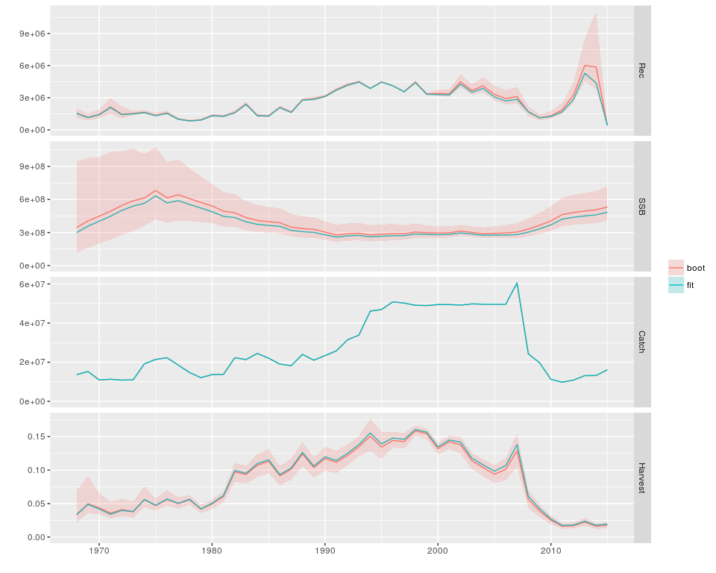 **Figure 1** VPA used for 2017 assessment advice, blue best fit, pink bootstrap with CIs.

## Ratio between prediction error and model error

name p.error m.error ratio  
1 FR_AER1 0.4980502 0.3585680 1.388998  
2 FR_AER2 0.6361619 0.4552087 1.397517  
3 JPN_LL1_NEA 0.3796662 0.3493075 1.086911  
4 JPN_LL2_NEA 0.6047935 0.4325259 1.398283  
5 JPN_LL_EastMed 0.4222885 0.3870491 1.091046  
6 MOR_POR_TP 0.4232314 0.3164995 1.337226  
7 MOR_SP_TP 0.4463026 0.4228840 1.055378  
8 SP_BB1 0.5685878 0.5588083 1.017501  
9 SP_BB2 0.7085452 0.6208208 1.141304  
10 WMED_LARV 0.9846305 0.8758269 1.124230

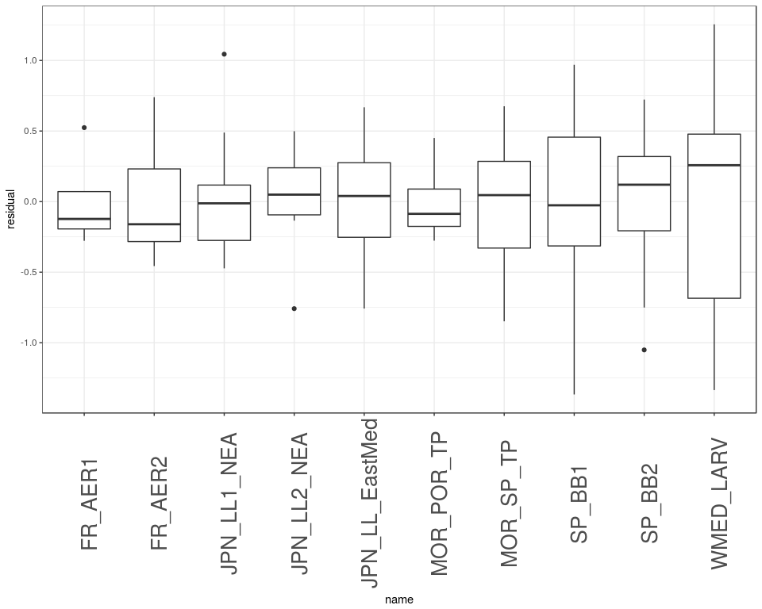 **Figure 2** Distribution of model error.

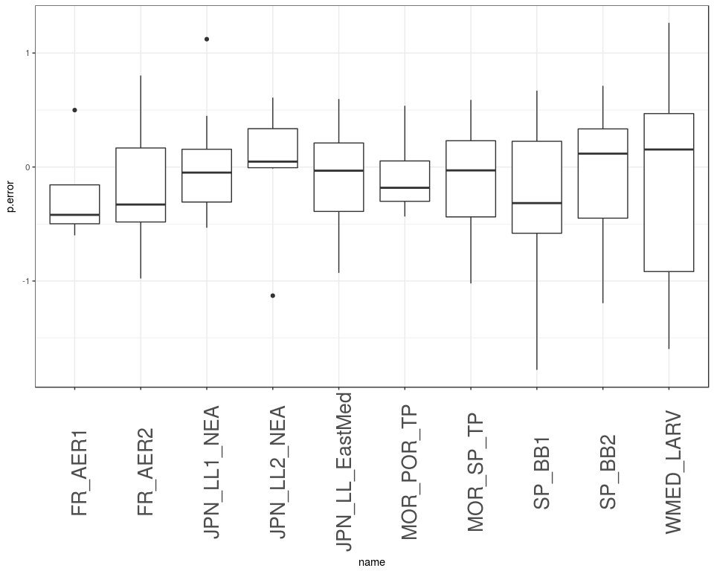 **Figure 3** Distribution of prediction error.

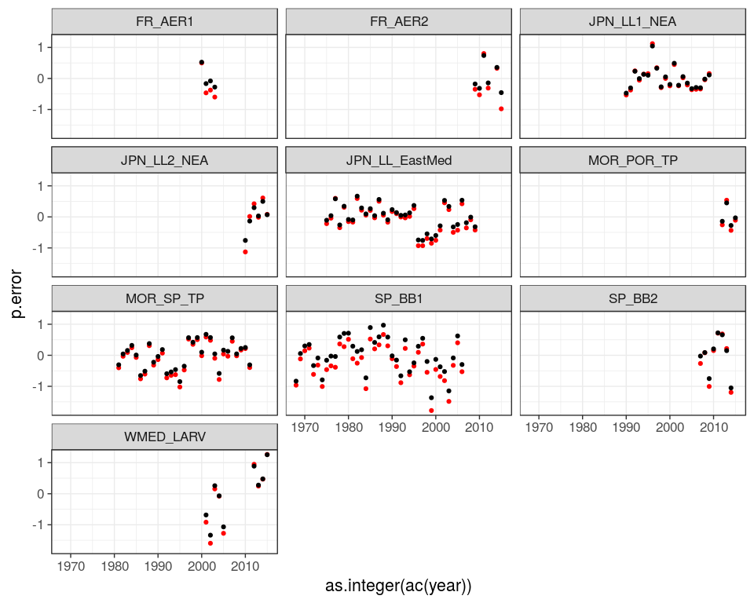 **Figure 4** Comparison of prediction (red) and model error.

# SS

## Ratio between prediction error and model error

name p.error m.error ratio  
1 FR_AER1 0.4197728 0.3162442 1.327369  
2 FR_AER2 0.8374389 0.6991523 1.197792  
3 JPN_LL1_NEA 0.3769581 0.3289527 1.145934  
4 JPN_LL2_NEA 0.3662893 0.3090323 1.185279  
5 JPN_LL_EastMed 0.3996374 0.2733721 1.461881  
6 WMED_LARV 1.0478583 0.8610649 1.216933  
7 MOR_POR_TP 0.4946715 0.4226317 1.170455  
8 MOR_SP_TP 0.3603705 0.2829560 1.273592  
9 SP_BB1 0.5809196 0.2535085 2.291519  
10 SP_BB2 0.5431435 0.3268830 1.661584

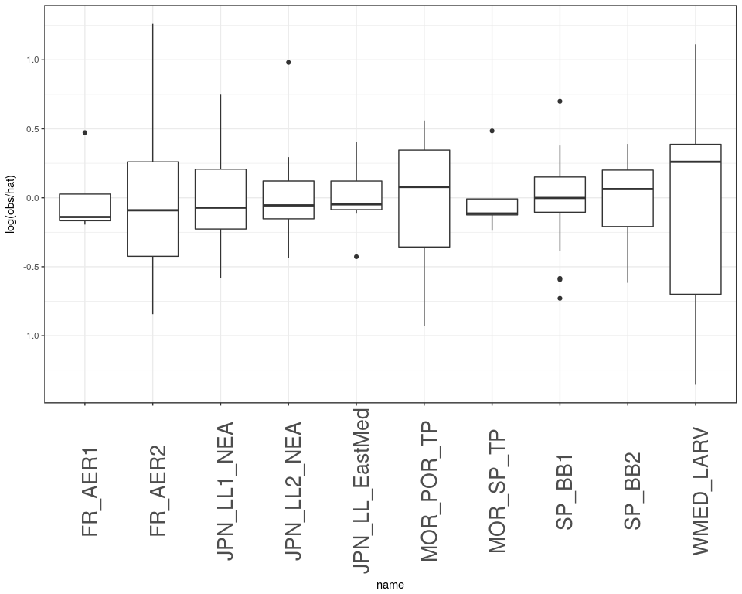 **Figure 5** Distribution of model error.

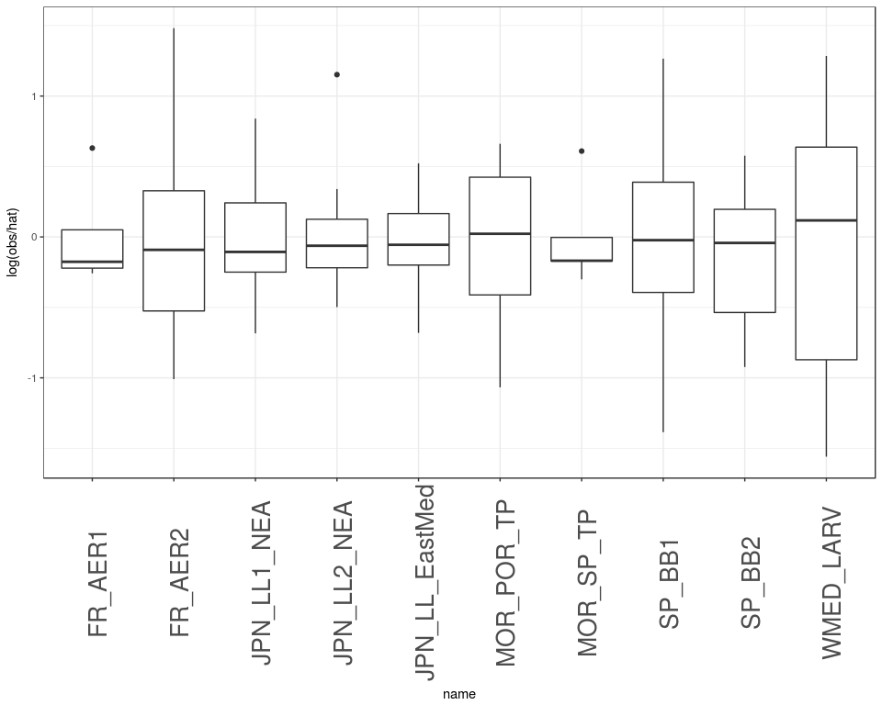 **Figure 6** Distribution of prediction error.

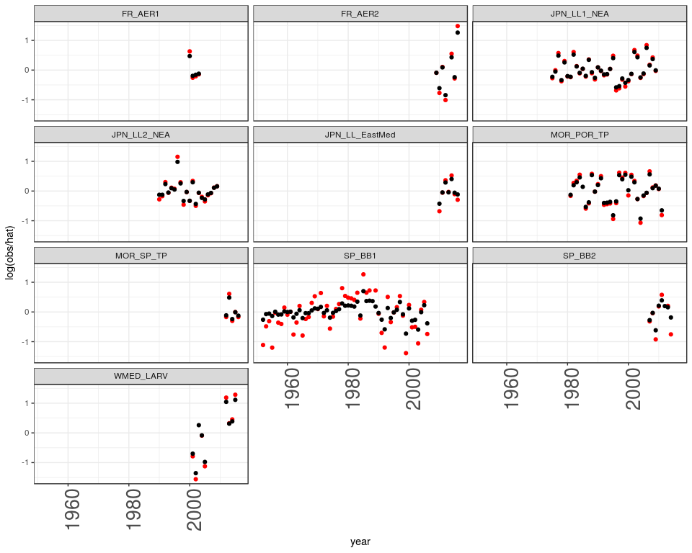 **Figure 7** Comparison of prediction (red) and model error.

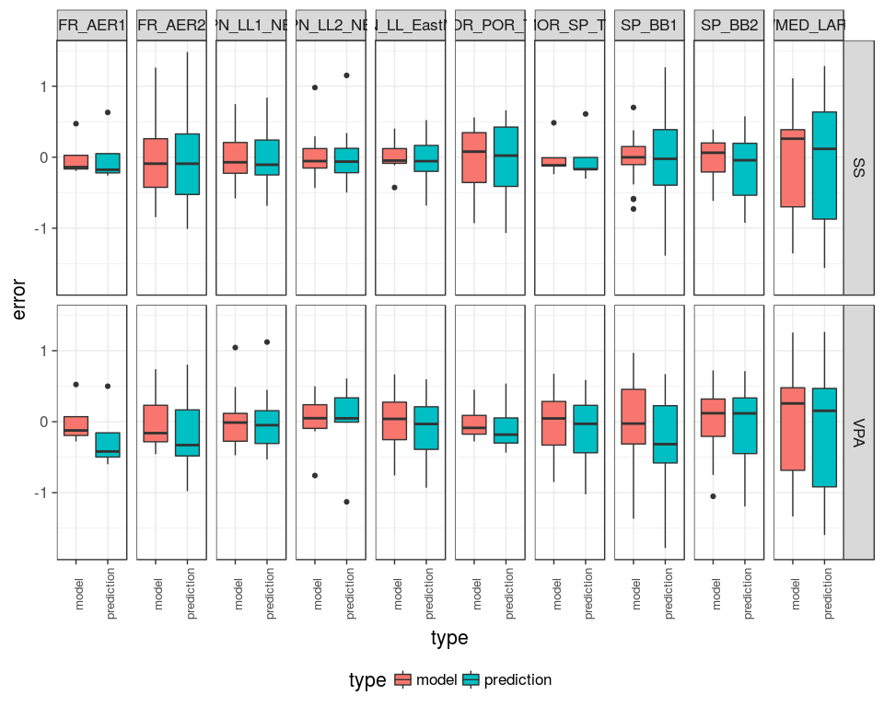 **Figure 8** Comparison of prediction (red) and model error by series for SS and VPA.

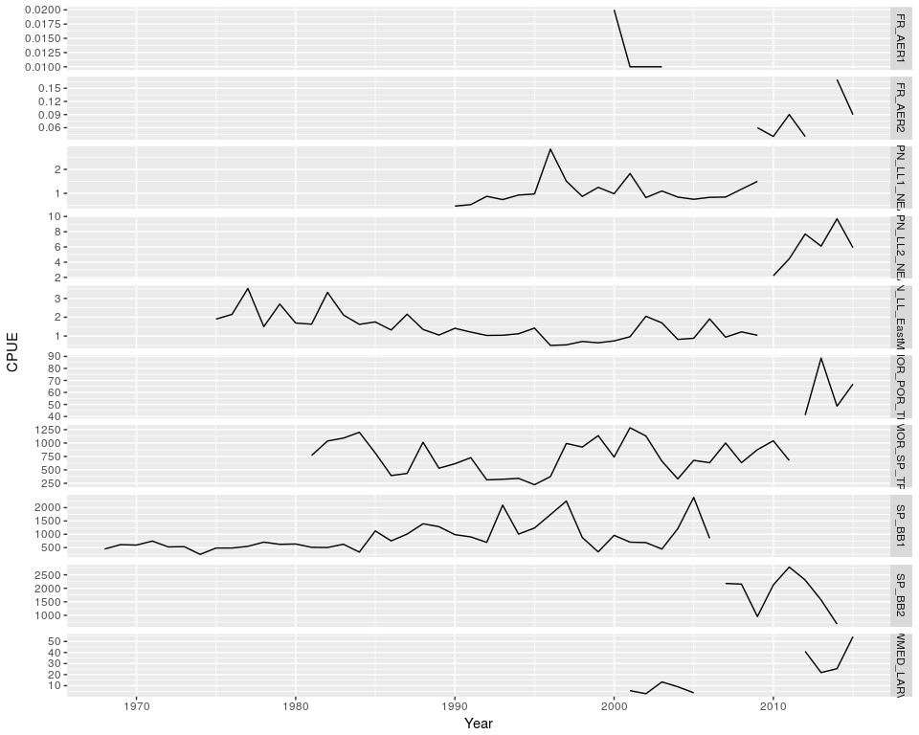 **Figure 9** CPUE series

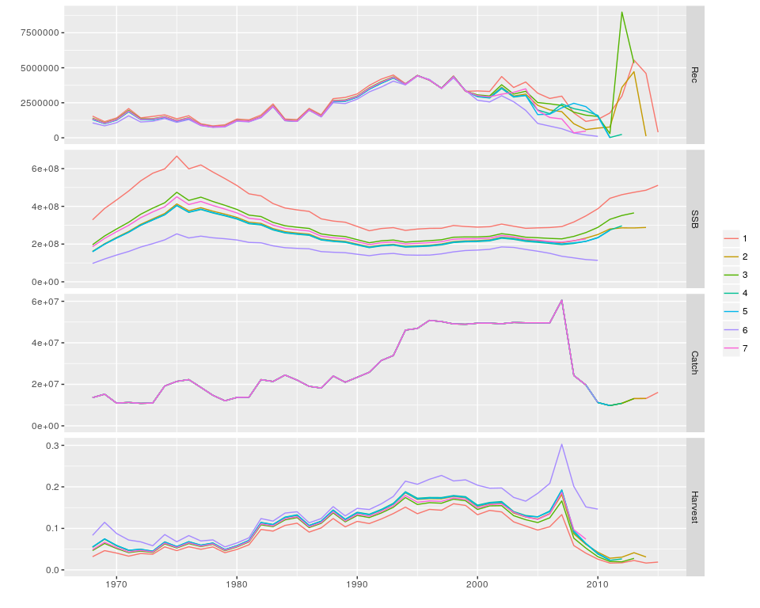 **Figure 10** Retrospectives