Performance of model selection and diagnosis by cross-validation: evaluation by simulation

Operation Model

L Kell

07 febrero, 2018

# Operating model to simulate 3 contrasting stocks

* Atlantic bigeye tuna
* North East Atlantic Skate
* Irish Sea sprat
* Plaice

## Life history parameters

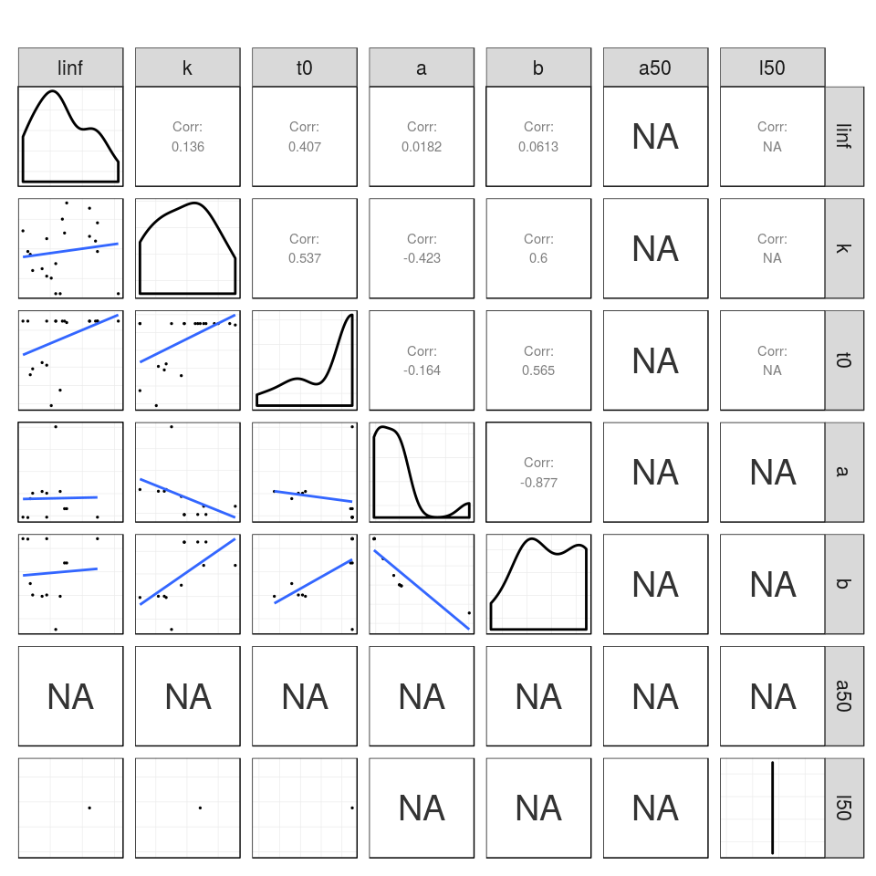

**Figure 1** Pairwise scatter plots of sprat life history parameters.

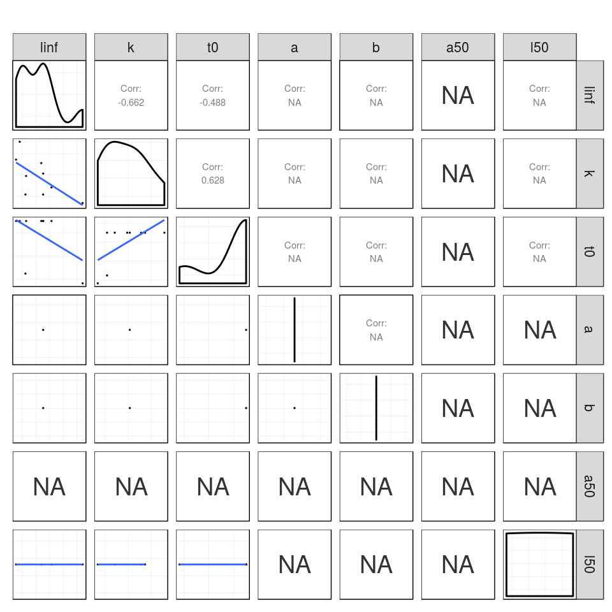

**Figure 2** Pairwise scatter plots of bigeye life history parameters.

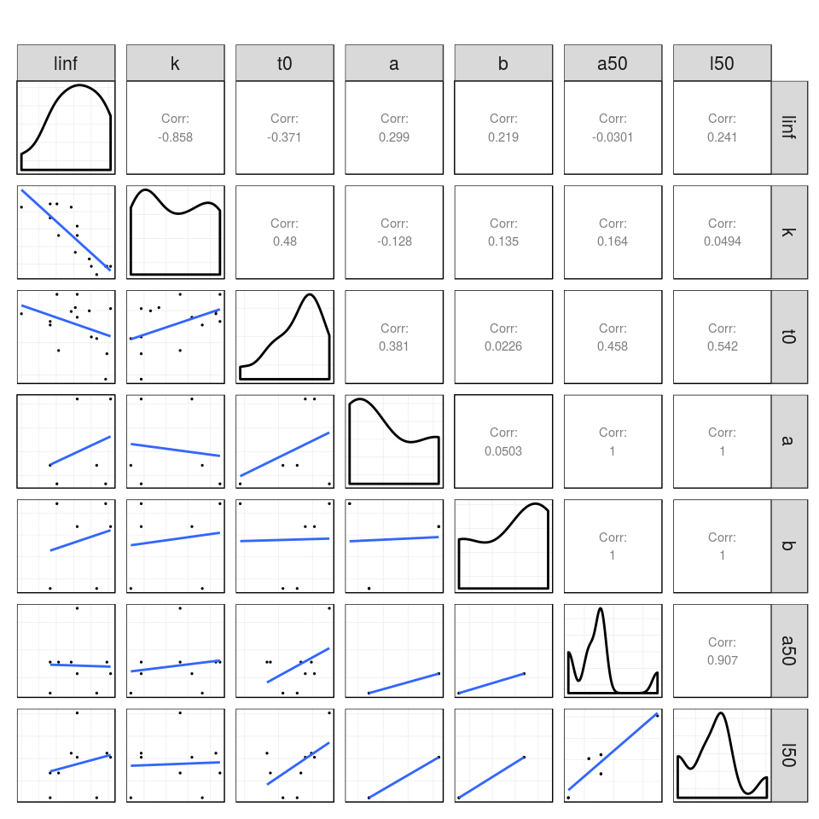

**Figure 3** Pairwise scatter plots of thornback ray life history parameters.

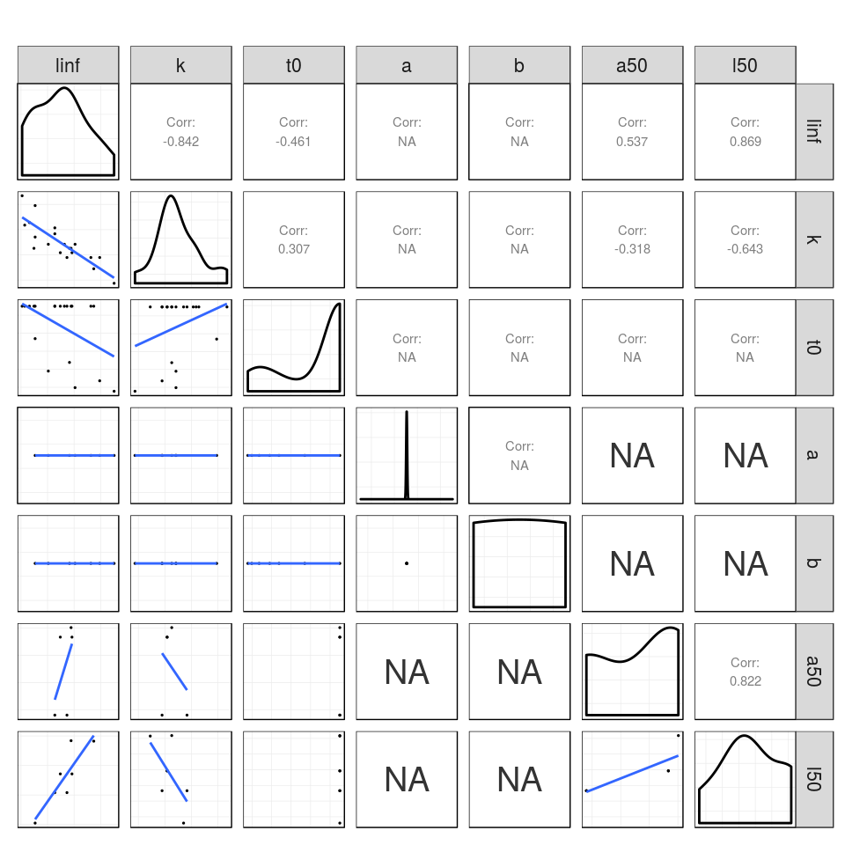

**Figure 4** Pairwise scatter plots of plaice life history parameters.

## Equilibrium dynamics

The parameters are then used by lhEql to simulate the equilibrium dynamics by combining the spawner/yield per recruit relationships with a stock recruiment relationship.

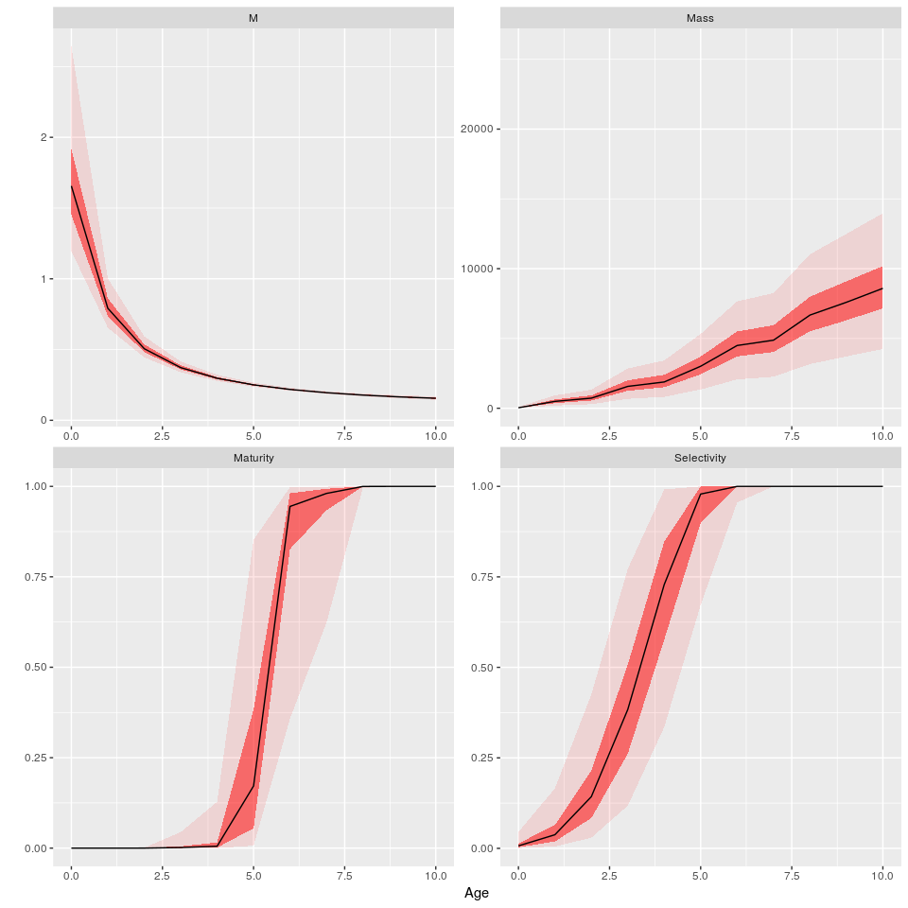

**Figure 5** Vectors for thornback ray.

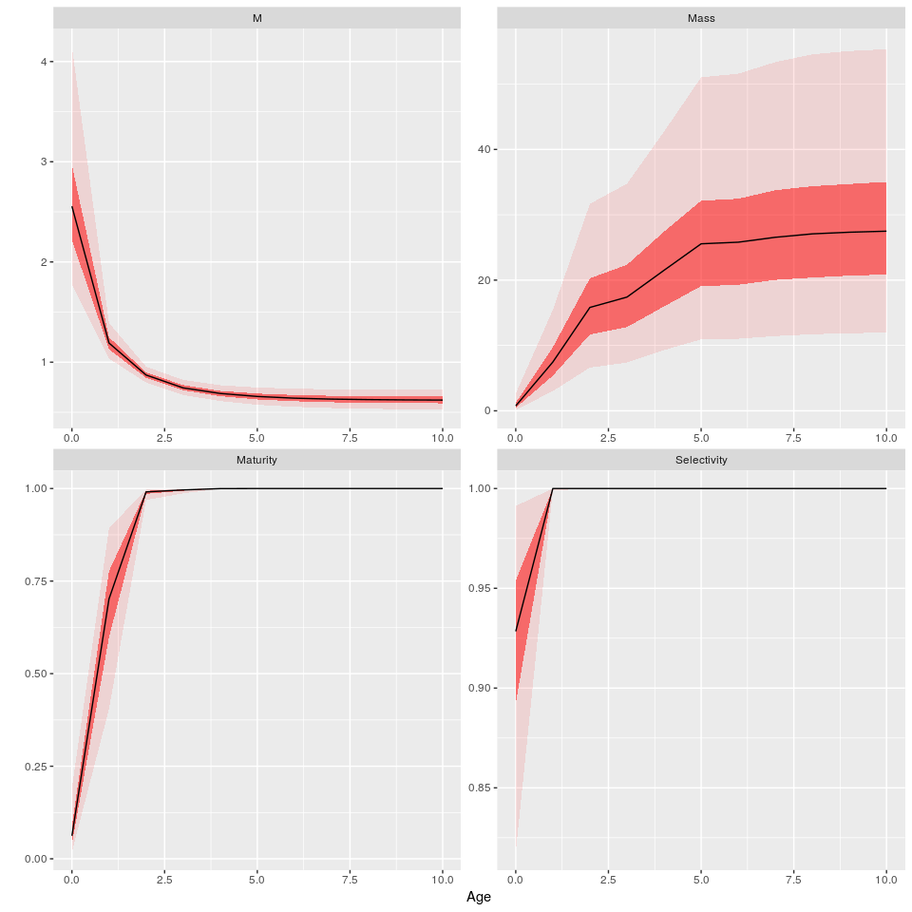

**Figure 6** Vectors for sprat.

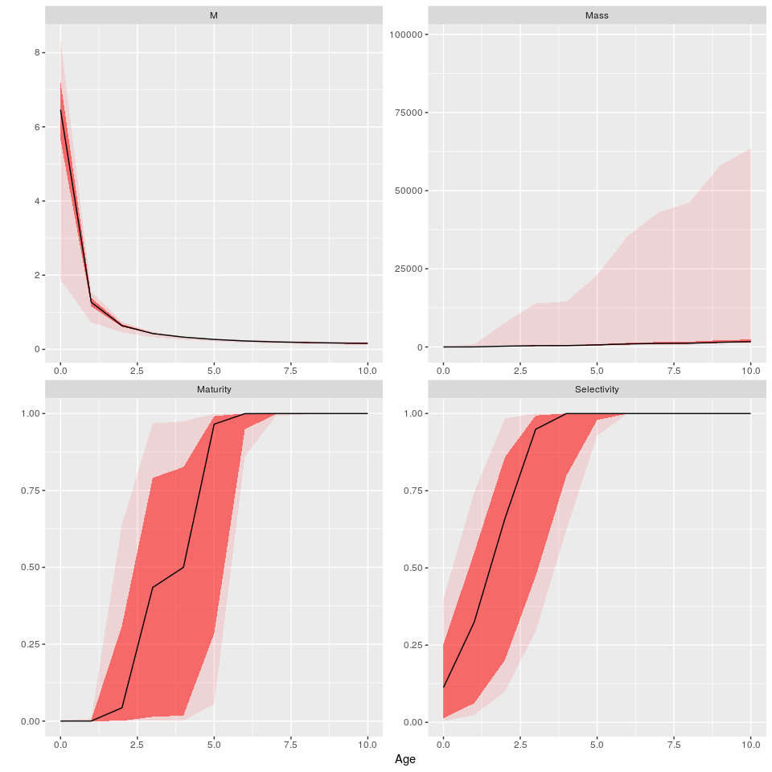

**Figure 7** Vectors for bigeye.

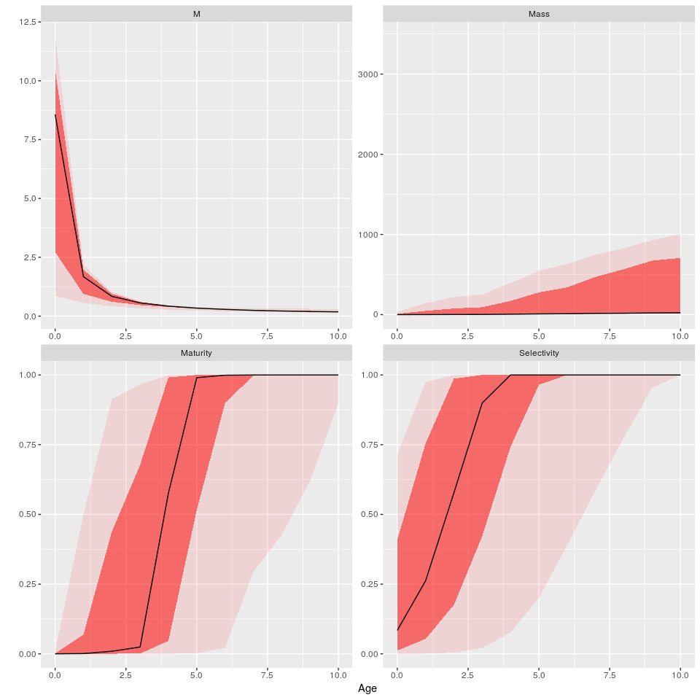

**Figure 8** Vectors for Plaice.

## Population dynamics

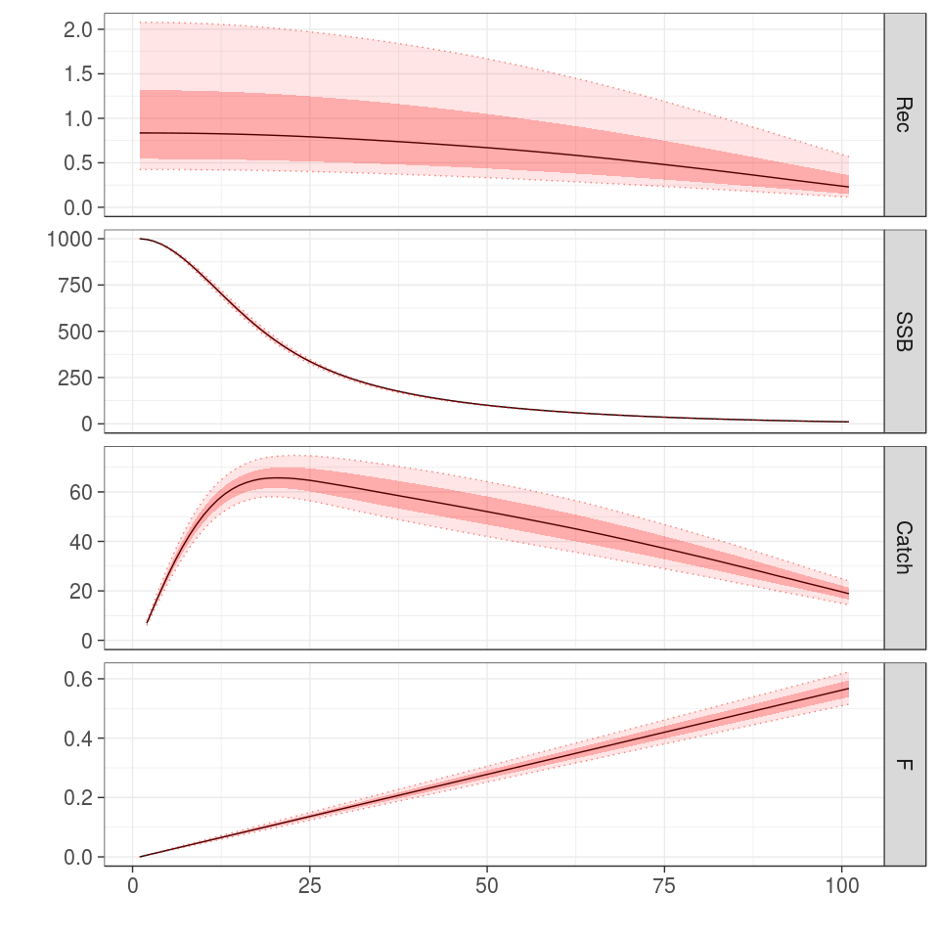

**Figure 9** Time series for thornback ray.

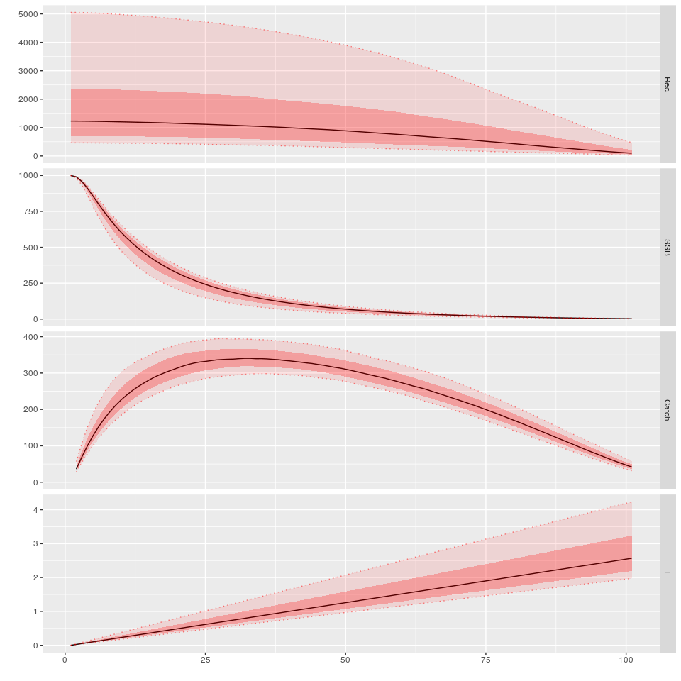

**Figure 10** Time series for sprat.

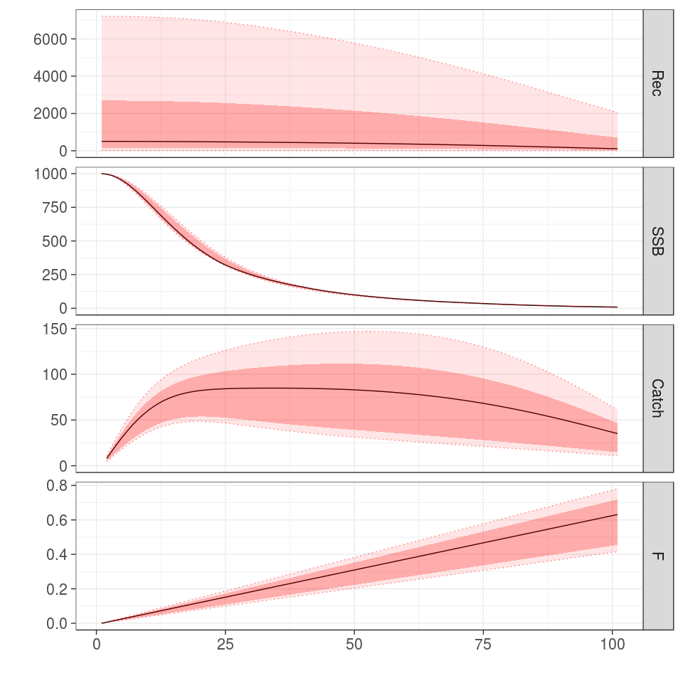

**Figure 11** Time series for bigeye.

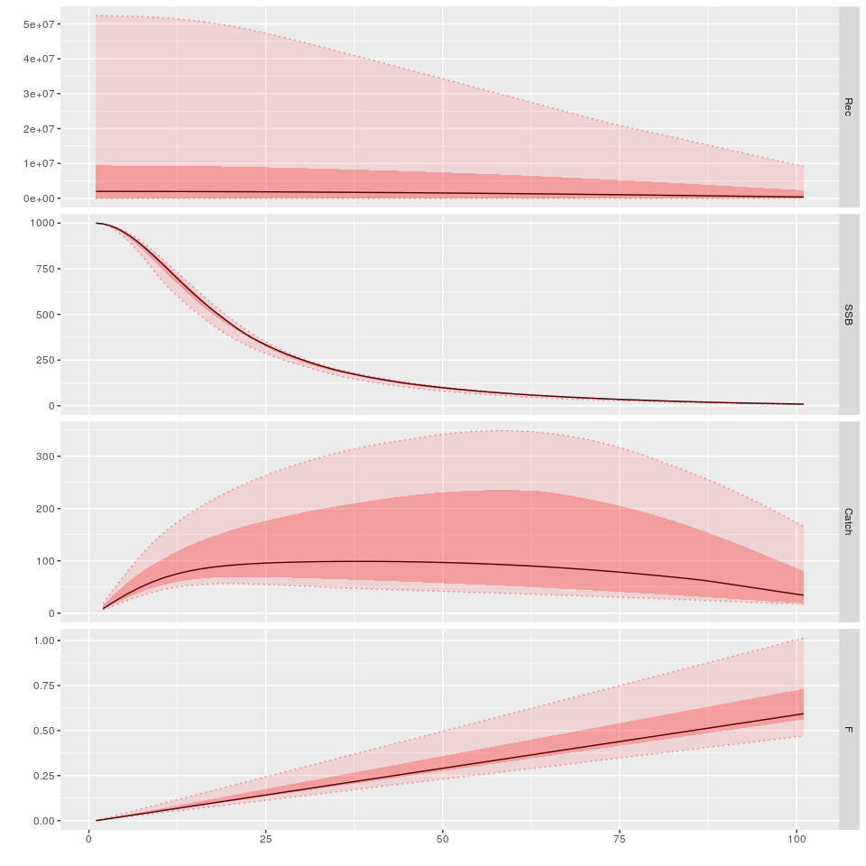

**Figure 12** Time series for plaice.

## Fleets

## Scenarios

## Projections