EXPLORATION OF SOCIOECONOMICAL DATASETS TO MODEL THE DEMOCRATIC LEVEL OF COUNTRIES
BROSSET FLORIAN¹, DUSSERE LAURIE², SANTRISSE MANON³
INSA TOULOUSE, 4GMM
¹brosset@insa-toulouse.fr ²dussere@insa-toulouse.fr ³santriss@insa-toulouse.fr

Spelling or grammatical errors(e.g., subject-verb agreements, -s, articles, prepositions, tenses).

Concise text errors: avoid redundancy, long sentences, overuse of linking words/phrases, complicated words/phrases, nominalisation (use nouns not verbs).

Clear text errors: use correct word order SVO and avoid segmented sentences; use precise, unambiguous and rich language; use active verbs; check for false friends and uncountable nouns; only use synonyms for non-keywords; avoid noun strings; avoid starting sentences with ‘it is’, avoid vague pronouns

Other: Incorrect verb/noun ; ‘I don’t understand what you mean = rephrase; add detail?

Abstract.
Nowadays, many countries are considered as democracies but the exact conditions which define a country to be democratic remain unknown. Defining what a democracy really is has become increasingly important with the actual complex geopolitical context. Past studies identified several criteria describing democracy such as voting rights, freedom, gender inequalities or corruption but did not quantify precisely their importance. Our aim was to take these new variables into account and to determine which ones were the most relevant to explain the democratic index published by The Economist in 2020. We used statistical tools such as principal component analysis, clustering and linear and logistic regression to select the most important variables. Our results showed that democratic level was correlated to education, corruption, health and media freedom. We aim to deepen our work by collecting new datasets and by conducting interdisciplinary work with Political Science Researchers and incorporating their latest discussions on the subject.
Key words. democracy, principal component analysis, clustering, logistical regression, corruption, education

Introduction. include background context, previous studies, missing gap, research aim, outline of paper (optional)
The invention of Democracy is often associated with ancient Greece but new evidence suggest that forms of democracy have been existing before, in prehistorical era. Its modern form has its roots in 17th century England with the idea of representation. The United States of America then expended on the concept with Alexis de Tocqueville, following its visit there in 1831-32, calling it the first representative democracy. As Robert A. Dahl puts it in his article on democracy for the Britannica dictionary: “Representation, in other words, was the solution to the ancient dilemma between enhancing the ability of political associations to deal with large-scale problems and preserving the opportunity of citizens to participate in government.“ The 20th century then showed a large number of countries turning to democracies. This was mostly accompanied by the globalization of a market economy. Democracy today though faces a broad spectrum of dilemmas and the growth of democracy is now each year fading.
The Stanford Encyclopedia of Philosophy defines democracy as such : “The term “democracy” [. . . ] refers very generally to a method of collective decision making characterized by a kind of equality among the participants at an essential stage of the decision-making process.“ This definition could be used for any type of groups and obviously also countries. The concept being ,in this case, consistent with some sort of electoral system. It is important to note that this definition doesn’t put democracy as a global desirable norm as it can sometimes not be compatible with particular contexts. The Europe Councel expresses his idea of democracy on his websites with two main principles: Individuals autonomy and egality. It states that there exists as much democracies as countries having one.

Democracy has ,according to the economist, now reached a “new low” with alarming signs such as only “10.4
Democracy has been widely studied by History and political science but has seen few approaches by statistical analyses. Different Indexes have been created such as the Freedom House index, The Economist Intelligence Unit, Polity IV, Varieties of Democracy, Global State of Democracy (GSOD) to attribute a score of democracy to country governments. Those have been compared and studied statistically by Claire Durand (source). Marie Le Chev`ere and Younes Radi, based on The Economist Unit, proposed synthetic variables to distinguish and classify the countries in terms of democracy. Our aim is to expand on that research by using different datasets and introducing regression and classification tools to the study.
Outline ?
In your last paragraph in the introduction discuss the previous studies. State the results/limitations of previous reseach – state the missing gap – state a clear aim of your study to show how your research will advance the subject.

Materials and Methods.
  - Datasets.

Democracy index from the Economist.
]
Each year, The Economist publishes a ranking of 167 countries according to their democratic level. Countries are classified depending on their general score (We name this variable Gscore) which varies between 0 and 10. It is the mean of 5 variables concerning political aspects :

      - Electoral process and Pluralism
      - Functioning of government
      - Political Participation
      - Political culture
      - Civil liberties
Depending on the Gscore, the Economist identifies four categories of political regime :

      - full democracy (Gscore over 8)
      - flawed democracy (Gscore between 6 and 8)
      - Hybrid regime (Gscore between 4 and 6)
      - Authoritarian regime(Gscore below 4)

Wikipedia dataset.
]
The dataset contains 21 variables on 186 countries :

GDP (Per capita gross domestic product) : It measures the monetary value of final goods and services produced in a country in a given period of time.

National power : It uses an average of percentages of world totals in six different components representing demographic, economic, and military strength.

Population : List of countries and other inhabited territories by total population.

HDI (Human Development Index) : Statistic index composed by life expectancy, level of education (mean years of schooling completed and expected years of schooling when entering the education system), and per capita income indicators. A country scores a higher level of HDI when the components mentioned above are high.

Emigrants : List of countries by number of native-born persons living in a foreign country.

Corruption : Index which ranks countries by their perceived levels of public sector corruption, as determined by expert assessments and opinion surveys. The score varies from 0 to 99, 0 being a country perceived as the most corrupt, 99 being a country perceived as the least corrupt.

Ethnic, Linguistic, Religious: It is used to compare the levels of ethnic, linguistic and religious fractionalization in different countries. It varies from 0 to 1 (low to important fractionalization).

Science and Technology : Criterion based on number of foreign students studying in the country, number of scientific journals, newspaper and articles published in international journals, number of Nobel prize winners and number of International Patent Cooperation Treaty applications.

Poverty percentage : percentage of population living below national poverty line.

Gender Gap : It measures gender inequalities in life expectancy, education.

Suicide men and suicide women : Number of suicide for men and women.

Terrorism : The score for a country is based on the impact of incidents in a given year. Four indicators are considered : Total number of terrorist incidents, total number of fatalities caused by terrorism, total number of injuries caused by terrorism and the approximate level of total property damage from terrorist incidents.

Culture : It is based on the number of exports of creative goods and services relative to GDP, UNESCO dues in arrears as percentage of contribution, number of countries and territories that citizens can enter without a visa, and freedom of the press.

International Peace and Security : It takes into account the number of peacekeeping troops sent overseas relative to GDP, dues in arrears to financial contribution to UN peacekeeping missions as percentage of contribution, attributed number of casualties of international organised violence relative to GDP, exports of weapons and ammunition relative to GDP and Global Cyber Security Index score.

World order : It takes into consideration the percentage of population that gives to charity as proxy for cosmopolitan attitude, the number of refugees hosted relative to GDP, the tumber of refugees overseas relative to GDP, the population growth rate, the number of treaties signed as proxy for diplomatic action and peaceful conflict resolution.

Planet and Climate relative to GDP: It measures National Footprint Accounts Bio capacity reserve, exports of haz- ardous waste, organic water pollutant emissions, CO2 emissions relative to GDP, greenhouse gas emissions.

Prosperity and Equality relative to GDP : It considers trading across borders, number of aid workers and volunteers sent overseas, fairtrade market size, foreign firect investment outflow and development cooperation contributions.

Health and Well being relative to GDP : Amount of wheat tonnes equivalent food aid shipments, Exports of pharma- ceuticals, Voluntary excess contributions to World Health Organisation, Humanitarian aid contributions, International Health Regulations Compliance.

We added to this dataset the variable Gscore from the Economist.

Our World in Data (OWD) dataset.
]
In order to describe the democratic level of countries we selected randomly 15 variables on Our World in Data website without any prejudice. We collected those variables on 147 countries.

The variables are the following :

Human rights: The scores capture the extent to which citizens’ physical integrity is protected from government killings, torture, political imprisonments, extrajudicial executions, mass killings and disappearances. Higher scores mean fewer such abuses.

Economic Freedom: The index measures the degree of economic freedom present in five major areas: [1] Size of Govern- ment; [2] Legal System and Security of Property Rights; [3] Sound Money; [4] Freedom to Trade Internationally; [5] Regulation. Within the five major areas, there are 42 distinct variables, which are averaged to derive the summary rating for each country. Scores are on a scale of 0-10, where 10 represents maximum economic freedom.

Gender inequalities: This Index is based on the Human Development Index. It shows the loss in potential human de- velopment due to disparity between female and male achievements in tree dimensions : reproductive health, empowerment and economic status. Gender inequalities index ranges between 0 and 1. Higher index values indicate higher inequalities and thus higher loss to human development.

Proportion of bullied children: Percentage of children aged 13-15 who reported being bullied at least once in the past couple of months.

Corruption: Annual ranking of countries by their perceived levels of corruption, as determined by expert assessments and opinion surveys. Scale is from 100 (very clean) to 0 (highly corrupt).

Literacy rate: Estimates correspond to the share of the population older than 14 years that is able to read and write.

Human Development Index (HDI): The HDI is a summary measure of key dimensions of human development: a long and healthy life, a good education, and having a decent standard of living.

Mean years of schooling:Average number of years of total schooling across all education levels, for the population aged 25+.

Life expectancy: Shown is period life expectancy at birth, the average number of years a newborn would live if the pattern of mortality in the given year were to stay the same throughout its life.

Military expenditure as share of Gross domestic product (GDP): Military expenditures include military and civil personnel; operation and maintenance; procurement; military research and development; and military aid. Civil defense and current expenditures for previous military activities are excluded. GDP quantify the total value of the annual “wealth produc- tion” carried out by economic agents by countries

Undernourishment: It measures the share of the population which has a caloric (dietary energy) intake which is insuffi- cient to meet the minimum energy requirements defined as necessary for a given population.

Proportion of individuals using the internet:All individuals who have used the Internet in the last 3 months are counted as Internet users. The Internet can be used via a computer, mobile phone, personal digital assistant, gaming device, digital TV etc.

Proportion of the population with access to electricity: Share of the population with access to electricity. The definition used in international statistics adopts a very low cutoff for what it means to ‘have access to electricity’. It is de- fined as having an electricity source that can provide very basic lighting, and charge a phone or power a radio for 4 hours per day.

Urban and Rural population: Total estimated population living in rural or urban areas.

As we saw before, HDI gathers 3 criteria. However, we encounter those criteria in other variables in the OWD dataset : Proportion of bullied children, life expectancy and undernourishment for the long and healthy life criterion Literacy rate and Mean year of schooling for the good education
•
•
Proportion of the population with access to electricity for the decent standard of living In this way, we chose to delete the HDI variable from our analysis.
•

Statistical tools.
]
This section gives an overview of the different methods used all along the project.

Descriptive statistics and Principal Component Analysis (PCA).
]
In the case of problems with many variables, it is reasonable to think that the data contains a lot of correlation.PCA performs then a change of basis on the data and allows to create metavariables. Those are easy to interpret and give a good understanding of data dispersion.

Clustering.
]
Cluster analysis is the task of grouping a set of objects in such a way that objects in the same group (called a cluster) are more similar (in some sense) to each other than to those in other groups (clusters).
We used the Kmean clustering method wich classifies the data in k clusters. Each observations belongs then to the cluster with the nearest mean.

Linear and Logistic models.
(. refbiblioagarder : https : //irma.math.unistra.fr/ fbertran/enseignement/Master1₂010₂/Master2Cours3.pdf )
The linear regression is a linear model which establishes a relationship between a scalar and one or more explanatory vari- ables. The link between scalar and the explanatory variables is modeled by linear functions whose unknown parameters are estimated from the data.

The logistic regression is a special case of the generalized linear models. It establishes a relationship, thanks to the logit function, between a binary dependent variable and one or more explanatory variables. The dependent variable is coded by 0 or 1.
Then, sub-model can be created by selecting some of the explanatory variables thanks to criterion. There are the Akaike information criterion (AIC) and the Bayesian information criterion (BIC):

AIC criterion is a compromise between the bias, decreasing the parameters number, and the parsimony, the will of keeping a few parameters. The best model is the one with the smallest AIC.
•

BIC criterion is more parsimony than the AIC one because it selects less variables. It depends not only on parameters’ numbers but also to the sample’s size.
•
Those sub-models can be assessed by computing the coefficient of determination also called R-squared (R²) which measures the degree model fit. R² is between 0 and 1; the biggest R² is the better it is.

Classification and Regression trees.
]
The Classification and Regression trees also called CART is a predictive model. It predicts the output value (the dependent variable) based on values from other variables. The plot of such tree is a decision tree which split in different branches and leaves. The goal of each division (in two branches) is to create subgroups where the homogeneity in each one is bigger than is the previous one. In that case, the first division is the one making the biggest distinction between two groups of individuals. To finish, each branch is a path toward a predictive value and each leaf is a final value for the dependent variable.
In classification, the final leaves are class labels whereas in regression they are continuous variables.

Random Forest.
]
Random Forest is used to make the classification and regressions trees more independents and so to reduce the variance. It consists in randomly drawing N datasets with replacement from the original sample. Then, for each dataset created, we estimate a tree with randomization of the variables, meaning that for each node of the tree, we randomly choose a reduce number of variables which are then used to search the optimal division. In the case of regression, the final prediction is obtained by computing the mean of the predictions of the N trees. As for classification, it is obtained with a majority vote.
Even if Random Forests are difficult to interpret, it is possible to estimate the importance of each explanatory variables which allow us to select the most relevant variables of the model.

Handling of missing data.
]
It is common that datasets have missing data, but some methods such as linear regression require a complete dataset. To solve this problem, we used a missforest algorithm which is a completion method. The first step consists in replacing the missing data by a first naive imputation corresponding to the mean of the variable. Then, for each variable we use a random forest to predict the missing values.

Results and Analysis.
  - An overview of the Data and correlations.

Analysis of the complete datasets.
    - Comparison between the most and the least democratic countries.
]
  - Modeling the democratic level (Gscore).
    - Gscore as a quantitative variable.
]
As we saw previously, we tried to find a linear relationship the democratic level of a country,Gscore and the different variables from Wikipedia dataset then with the variables from OWD dataset.
When we explained Gscore according to Wikipedia dataset, we obtained R² = 0.77. Whereas, using the OWD dataset, R² was
0.75. Both R-squared are high, that means, the democratic level of a country is well explained by both datasets.
Then, we selected variables thanks to AIC then BIC criterion. We noticed that both methods gave close R² for each dataset(; with a difference of 0.05 and 0.03.) However, BIC criterion kept two times less variables than AIC criterion. Thus, we retained variables selected by BIC criterion.
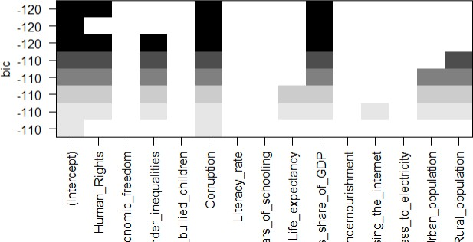
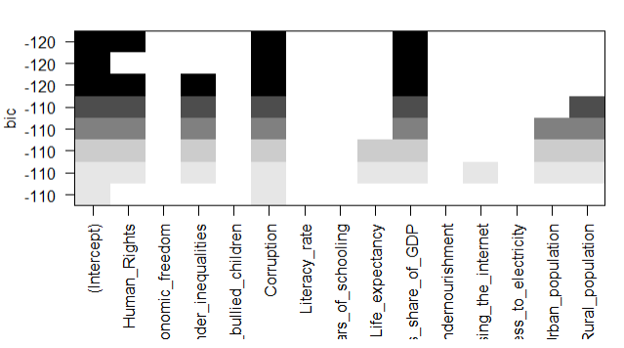

Figure 2.1: BIC selection on wikipedia dataset Figure 2.2: BIC selection on OWD dataset

For Wikipedia dataset, the variables which explain the most Gscore are GPD, Science and Technology, Culture,Corruption and Well-Being and for the OWD dataset the democratic level is explain by Corruption, Proportion of the population with access to electricity and Military expenditure as share of GDP. Then, Corruption is the only variable present
in both datasets and its is kept in each selection, that means we can be certain that the Corruption of a country influence the democratic level of a country.
    - Gscore as a binary variable.

Highlighting the features which significantly explain the democratic level.
]

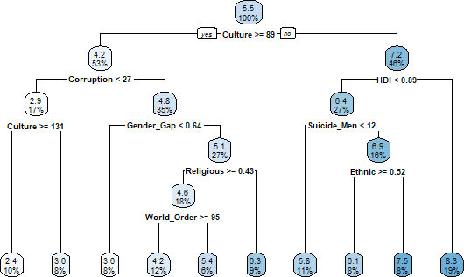

    - Regression Tree on dataset from Wikipedia

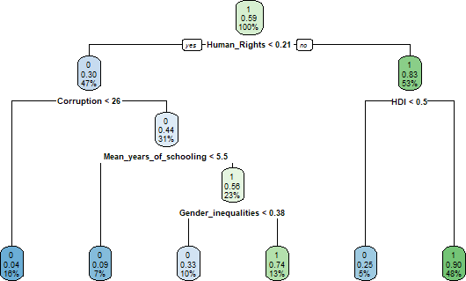

    - Classification Tree on dataset from OWD

Figure 2.3: Classification and Regression Trees

As explained in section 1.2.4 and 1.2.5, we implemented Classification and Regression trees and Random Forest to highlight the importance of the variables which explain Gscore. As shown in Figure 2.1 (a), in the dataset from Wikipedia the variables Culture, Corruption, HDI and Gender Gap are the ones that make the best distinction between democratic and non demo- cratic countries. 19% of countries from this dataset have a variable Culture below 89 and HDI above 0.89, which make them the most democratic with a mean Gscore of 8.3. On the contrary, 10% of the dataset, which corresponds to the least democratic countries have respectively a variable corruption and culture respectively below 27 and 131.

As for Figure 2.1 (b), it shows similarities between the two datasets because it also highlights the importance of Corruption
and HDI, but additionally we notice that Human Rights is an essential criterion to define democracy.
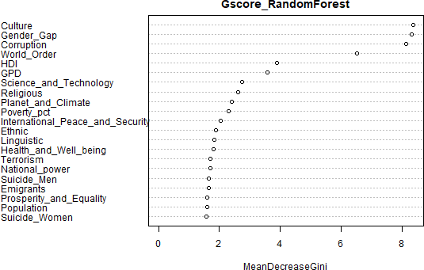

      - Regression on dataset from Wikipedia
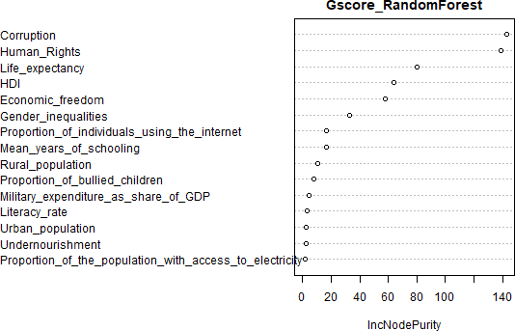

      - Classification on dataset from OWD

Figure 2.4: Importance of variables evaluated by Random Forest

Random Forest do not allow us to obtain easily readable representations of the variables. However, Figure 2.2 permits to understand the variables that the algorithm considers as the most important. We can see that the Random Forest method is coherent with the trees implemented before because it also shows that Corruption, Gender Gap, Culture, Human Rights and HDI are relevant to explain the democratic level.

Conclusion.
Aknowledgment. We would like to acknowledge our tutors, Mr Bernard Garel and Sebastien Dejean, for answering our questions, providing us the adequate tools and their guidance all along the project.
References. Le Chev`ere, M., Radi, Y. (May 2021). Breaking Down the Characteristics of Democracy by Exploratory Data Analysis
Albert, M., Besse, P., Laurent, B., & Roustant, O. (2021) Machine Leaning [Handout]

List of countries by percentage of population living in poverty (2022, April 16). WIKIPEDIA. https : //en.wikipedia.org/wiki/List of countries

Global Terrorism Index 2020: Measuring the Impact of Terrorism, Sydney. (November 2020). https://www.visionofhumanity.org/wp- content/uploads/2020/11/GTI-2020-web-1.pdf
  - In-text citations. This journal uses a style based on the APA system (see here). The following are some basic citation commands in LATEX:
\citet → jensetmcgil
\citet → shree-a
\citep → fabricius-hansen2012b
\citealp → (eckhoff2018a; fabricius-hansen2012b; shree-a)

