# Terminology and definitions:

* **Main Appendices Map slide**

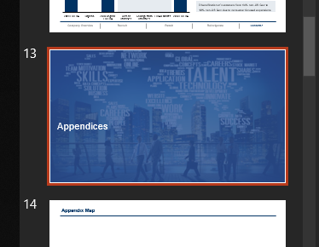

*(extra appendices map slide must always follow the main appendices map slide. For example, if main appendices slide is #14, then extra appendices slide must be #15)*

* **Bucket 1 cover slide**

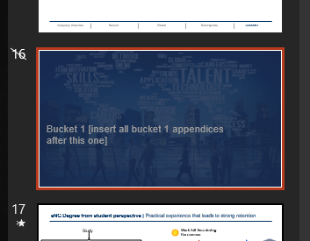

* **Bucket 2 cover slide**

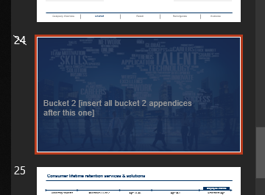

* **Bucket 3 cover slide**

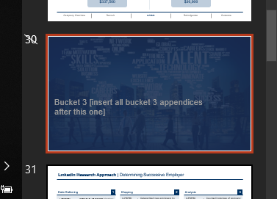

* **Financials cover slide**



* **Extras cover slide**

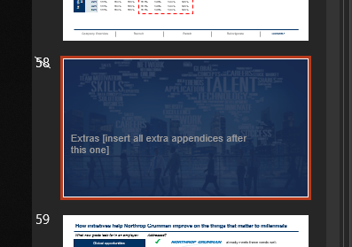

# How to use PowerPoint linker

1. Make all your appendix slides.
2. Open the base deck, make sure to use .pptm file instead of .pptx. Also, make sure to “Enable Editing” and “Enable Content” before using the linker.
3. Insert slides into the base deck after appropriate cover slides. This step is important because the *when linking happens links are categorized based on the cover slide that proceeds them*. (For example, all slides that follow bucket 1 slide will be in bucket 1 category in the appendices map) There is a total of five categories:
   1. Bucket 1
   2. Bucket 2
   3. Bucket 3
   4. Financials
   5. Extras
4. Ensure that all your appendix slides have a title
5. Once you inserted all the appendix slides in appropriate locations in the deck, note down the numbers of all divider slides. For example (based off the screenshots above):
   * Main Appendices Map slide number 🡪 13 (*extra appendices map slide* must follow *the main appendices map slide*)
   * *Bucket 1* cover slide 🡪 16
   * *Bucket 2* cover slide 🡪 24
   * *Bucket 3* cover slide🡪 30
   * Financials cover slide 🡪 38
   * Extras cover slide🡪 58
6. Follow the steps to run the linker
   1. Open available macros

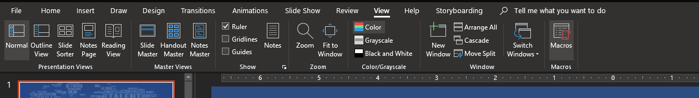

* 1. Select linker macro and run it

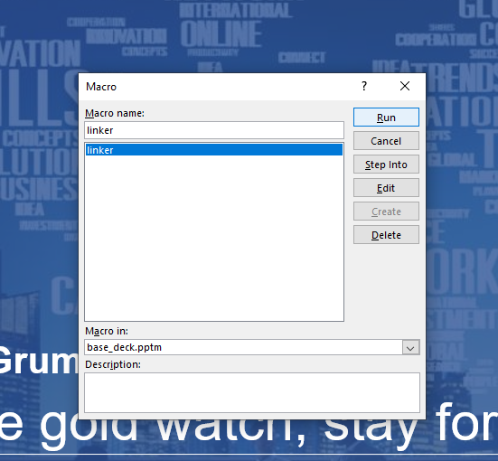

* 1. Fill out input boxes with numbers that you noted in step 5 *(You will have to fill a total of 5 input boxes)*

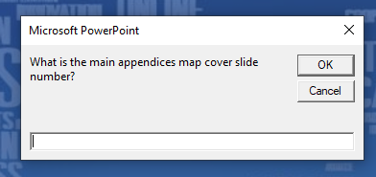

* 1. When the script is done, you will see this message

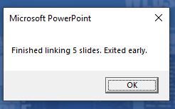

1. A total of two appendix slides will be created, one for main appendices for each bucket and second for financials and extra appendices that don’t belong to any buckets. Here is an example:

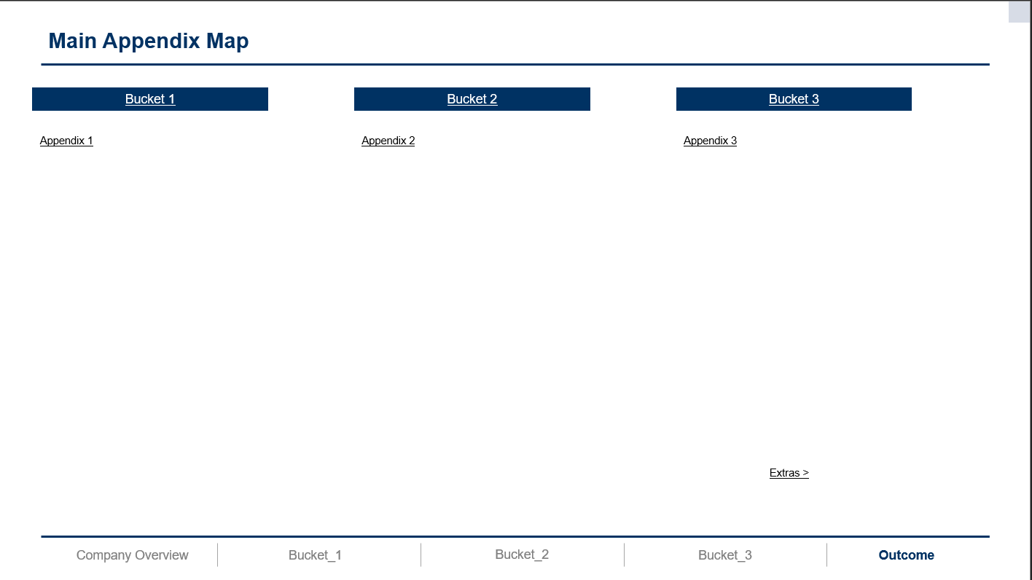 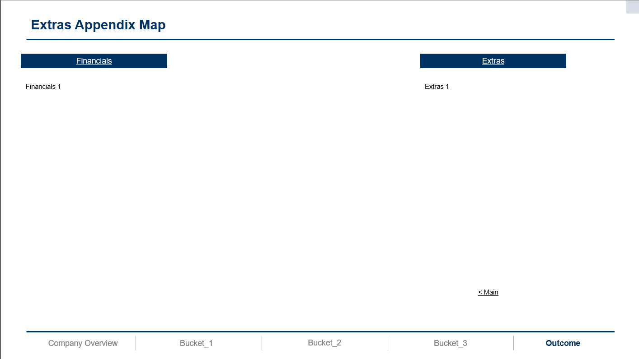

1. When the linker is done, you will need a good 5 minutes to check all the links and finalize formatting. Make sure to leave $≥$ 20 mins to link all slides at the end of resolution. Also, if you want to link the main deck as well, save extra 5 mins for that.
2. Save final deck as .pptx file to remove macros linker script.