Raspberry pi sensor setup (BMP180, Si7021, TSL2561) and LED thermometer

With BMP180 and multi LEDs you can see temperature in one °C accuracy in LEDs and more accuracy in python3 shell. You also get more data when you connect Si7021 and TSL2561 to your raspberry pi.

First you need to check that your raspberry pi has 40 GPIO Pins because the LED setup is made for 40 pins and doesn’t work in 26 pins. Then you need to check that your raspberry is using python 3 and you have raspbian newest version(Rasbian GNU/Linux 9.4 stretch) installed in your raspberry (check it using by code “sudo apt-get update and sudo apt-get upgrade”)

Then you can start connecting sensors and LEDs to GPIO pins by following these instructions:
- First you need to connect sensors in the way that this picture shows (you can connect all sensors in same ports):
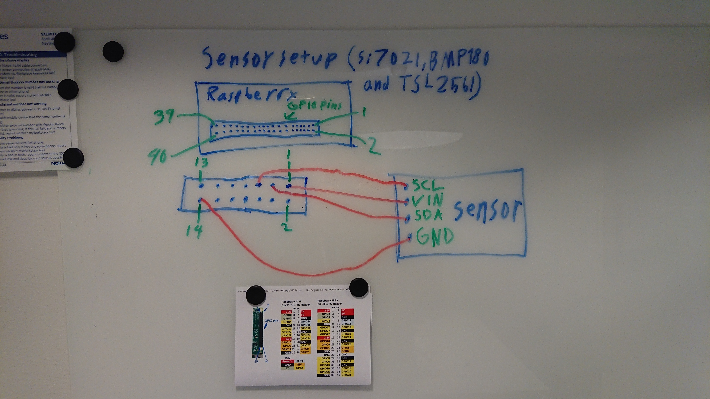

- Then you need to connect LEDs longer parts to GPIO pins in this way:

- Then you need connect LEDs other parts together and then with one cable to pin 39 (GND).

Then you need to enable I2C and SPI and instructions are in links.
Once you're done with both and have rebooted, verify you have the I2C and SPI devices with the command
ls /dev/i2c* /dev/spi*

You should see the response
/dev/i2c-1 /dev/spidev0.0 /dev/spidev0.1

Then you need to install some libraries by using these codes:
- sudo apt-get install git build-essential python-dev python-smbus
- git clone https://github.com/adafruit/Adafruit_Python_BMP.git
- cd Adafruit_Python_BMP
- sudo python setup.py install
- cd
- mkdir ~/BMP180Code
- cd ~/BMP180Code
- sudo pip3 install --upgrade setuptools
- pip3 install adafruit-blinka
- sudo pip3 install adafruit-circuitpython-tsl2561
- sudo pip3 install adafruit-circuitpython-si7021

Then you can just load python3 code from this link and then you can run it.

Links:
https://thepihut.com/blogs/raspberry-pi-tutorials/18025084-sensors-pressure-temperature-and-altitude-with-the-bmp180

https://learn.adafruit.com/tsl2561/python-circuitpython

https://learn.adafruit.com/adafruit-si7021-temperature-plus-humidity-sensor/circuitpython-code

https://maker.pro/raspberry-pi/tutorial/how-to-interface-a-pir-motion-sensor-with-raspberry-pi-gpio

