HeLa Adaptability

Richard R. Evans

May 15, 2017

# Study Description

From Adam Lauring:

We examined the dynamics of adaptive evolution by passage of both wild type (WT) and 3D G64S virus populations on HeLa or PVR-3T3 cells.

Starting from the same stock of either WT or 3D G64S, we passed 5 replicate lineages of each virus for 20 passages (HeLa) or 12 passages (PVR-3T3).

We measured the fitness of the passage 0 stocks and every 4th and 5th passage of the evolved lineages for the HeLa experiment and PVR-3T3 experiments, respectively, by competition against a tagged WT reference in triplicate.

For the HeLa experiment, then there are 5 replicate lineages, 4 time points per lineage (in addition to the starting passage 0 stock), and 3 replicate fitness measurements per lineage-time point.

For the PVR-3T3 experiment, then there are 5 replicate lineages, 3 time points per lineage (in addition to the starting passage 0 stock), and 3 replicate fitness measurements per lineage-time point.

# Libraries

library(tidyverse)  
library(magrittr)  
library(lme4)  
library(lmerTest)  
library(pander)  
library(reshape2)  
library(sjPlot)

# Load Data

# setwd("~/Documents/R/hela_adaptability/")  
hela <- read.table(file = "HeLa_Adaptability_20.txt", header = TRUE)  
cell_3t3 <- read.table(file = "3T3_Adaptability_P12_05302017.txt", header = TRUE)

# Data Processing

hela_clean <- hela %>%  
 select(-fitness) %>%  
 mutate(virus = factor(virus, levels = c(0, 1),  
 labels = c("Virus 0"," Virus 1")),  
 repID = factor(repID, levels = 1:5,  
 labels = paste(rep("repID:", 5), 1:5, sep = "")),  
 measID = factor(measID)) %>%  
 arrange(virus, time)  
  
cell3t3_clean <- cell_3t3 %>%  
 select(-fitness) %>%  
 mutate(virus = factor(virus, levels = c(0, 1),  
 labels = c("Virus 0"," Virus 1")),  
 repID = factor(repID, levels = 1:5,  
 labels = paste(rep("repID:", 5), 1:5, sep = "")),  
 measID = factor(measID)) %>%  
 arrange(virus, time)

## HeLa data preview

head(tbl_df(hela_clean))

## # A tibble: 6 x 5  
## virus time repID measID logfitness  
## <fctr> <int> <fctr> <fctr> <dbl>  
## 1 Virus 0 0 repID:1 1 -0.2164537  
## 2 Virus 0 0 repID:1 2 -0.2163822  
## 3 Virus 0 0 repID:1 3 -0.2160250  
## 4 Virus 0 0 repID:1 4 -0.1733422  
## 5 Virus 0 0 repID:1 5 -0.1418841  
## 6 Virus 0 0 repID:1 6 -0.1389438

.

.

.

tail(tbl_df(hela_clean))

## # A tibble: 6 x 5  
## virus time repID measID logfitness  
## <fctr> <int> <fctr> <fctr> <dbl>  
## 1 Virus 1 20 repID:4 1 0.8280860  
## 2 Virus 1 20 repID:4 2 0.9166855  
## 3 Virus 1 20 repID:4 3 0.8409087  
## 4 Virus 1 20 repID:5 1 0.8168111  
## 5 Virus 1 20 repID:5 2 0.8183381  
## 6 Virus 1 20 repID:5 3 0.7811951

## 3T3 Cell Preview

head(tbl_df(cell3t3_clean))

## # A tibble: 6 x 5  
## virus time repID measID logfitness  
## <fctr> <int> <fctr> <fctr> <dbl>  
## 1 Virus 0 0 repID:1 1 -0.3421795  
## 2 Virus 0 0 repID:1 2 -0.2680086  
## 3 Virus 0 0 repID:1 3 -0.3352640  
## 4 Virus 0 0 repID:2 1 -0.3421795  
## 5 Virus 0 0 repID:2 2 -0.2680086  
## 6 Virus 0 0 repID:2 3 -0.3352640

# Data Exploration

## HeLa Cells

pander(sapply(hela_clean[,c(1:4)], table))

* **virus**:

|  |  |
| --- | --- |
| * Virus 0 | * Virus 1 |
| * 119 | * 117 |

* **time**:

|  |  |  |  |  |
| --- | --- | --- | --- | --- |
| * 0 | * 5 | * 10 | * 15 | * 20 |
| * 120 | * 30 | * 27 | * 30 | * 29 |

* **repID**:

|  |  |  |  |  |
| --- | --- | --- | --- | --- |
| * repID:1 | * repID:2 | * repID:3 | * repID:4 | * repID:5 |
| * 46 | * 46 | * 48 | * 48 | * 48 |

* **measID**:

|  |  |  |  |  |  |  |  |  |  |  |  |
| --- | --- | --- | --- | --- | --- | --- | --- | --- | --- | --- | --- |
| * 1 | * 2 | * 3 | * 4 | * 5 | * 6 | * 7 | * 8 | * 9 | * 10 | * 11 | * 12 |
| * 48 | * 50 | * 48 | * 10 | * 10 | * 10 | * 10 | * 10 | * 10 | * 10 | * 10 | * 10 |

There are 119 and 117 . The missing two are from missing values during lab testing, they have been removed from the analysis.

Likewise, there are 3 time points missing from t=10 and 1 time point missing from t=20. Two time points are missing from and . Two time points are missing from and

By replicate measure and virus type, the effect of measurement at time point 0 is always the same for a particular type of virus. I don't think the intercept matters at all in assessing virus 1 vs virus 0. This can be seen in the following plot.

hela_clean %>%  
 filter(as.numeric(measID) <= 3) %>%  
 ggplot(aes(x = time, y = logfitness, color = measID)) %>%  
 add(geom_point(stat = "identity", position = "identity",  
 alpha = 0.7, size = 3)) %>%  
 add(geom_smooth(method = "lm", formula = y ~ x, se = FALSE)) %>%  
 add(facet_wrap(~virus + repID, nrow = 2)) %>%  
 add(labs(x = "time",  
 y = "log(Fitness)")) %>%  
 add(theme_bw())

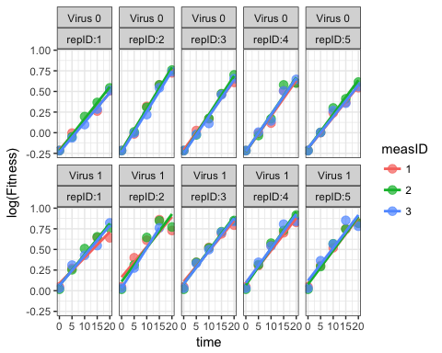

hela_clean %>%  
 ggplot(aes(x = time, y = logfitness, color = measID)) %>%  
 add(geom_point(stat = "identity", position = "identity",  
 alpha = 0.7, size = 3)) %>%  
 add(geom_smooth(method = "lm", formula = y ~ x, se = FALSE)) %>%  
 add(facet_wrap(~virus + repID, nrow = 2)) %>%  
 add(labs(x = "time",  
 y = "log(Fitness)")) %>%  
 add(theme_bw())

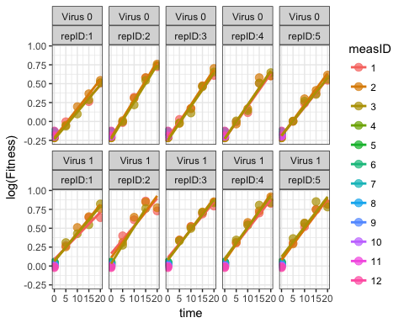

Without t = 0

hela_clean %>%  
 filter(as.numeric(measID) <= 3 & time != 0) %>%  
 ggplot(aes(x = time, y = logfitness, color = measID)) %>%  
 add(geom_point(stat = "identity", position = "identity",  
 alpha = 0.7, size = 3)) %>%  
 add(geom_smooth(method = "lm", formula = y ~ x, se = FALSE)) %>%  
 add(facet_wrap(~virus + repID, nrow = 2)) %>%  
 add(labs(x = "time",  
 y = "log(Fitness)")) %>%  
 add(theme_bw())

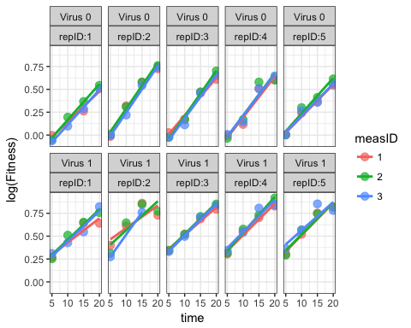

## 3T3 Cells

pander(sapply(cell3t3_clean[,c(1:4)], table))

* **virus**:

|  |  |
| --- | --- |
| * Virus 0 | * Virus 1 |
| * 60 | * 59 |

* **time**:

|  |  |  |  |
| --- | --- | --- | --- |
| * 0 | * 4 | * 8 | * 12 |
| * 30 | * 29 | * 30 | * 30 |

* **repID**:

|  |  |  |  |  |
| --- | --- | --- | --- | --- |
| * repID:1 | * repID:2 | * repID:3 | * repID:4 | * repID:5 |
| * 24 | * 24 | * 24 | * 24 | * 23 |

* **measID**:

|  |  |  |
| --- | --- | --- |
| * 1 | * 2 | * 3 |
| * 40 | * 39 | * 40 |

cell3t3_clean %>%  
 filter(as.numeric(measID) <= 3) %>%  
 ggplot(aes(x = time, y = logfitness, color = measID)) %>%  
 add(geom_point(stat = "identity", position = "identity",  
 alpha = 0.7, size = 3)) %>%  
 add(geom_smooth(method = "lm", formula = y ~ x, se = FALSE)) %>%  
 add(facet_wrap(~virus + repID, nrow = 2)) %>%  
 add(labs(x = "time",  
 y = "log(Fitness)")) %>%  
 add(theme_bw())

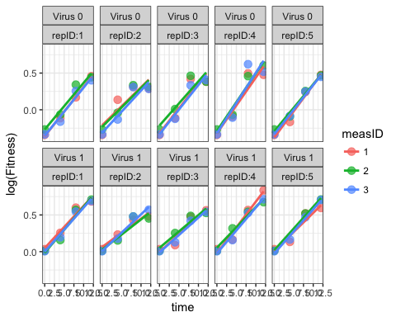

# Models

## Naive Model (HeLa Cell)

naive.mod <- glm(logfitness ~ virus + time + virus * time,  
 data = hela_clean)  
  
summary(naive.mod)

##   
## Call:  
## glm(formula = logfitness ~ virus + time + virus * time, data = hela_clean)  
##   
## Deviance Residuals:   
## Min 1Q Median 3Q Max   
## -0.25305 -0.03695 -0.01049 0.04056 0.17909   
##   
## Coefficients:  
## Estimate Std. Error t value Pr(>|t|)   
## (Intercept) -0.1795023 0.0078431 -22.887 <2e-16 ***  
## virus Virus 1 0.2235596 0.0111006 20.139 <2e-16 ***  
## time 0.0401772 0.0008103 49.586 <2e-16 ***  
## virus Virus 1:time 0.0023033 0.0011552 1.994 0.0473 *   
## ---  
## Signif. codes: 0 '***' 0.001 '**' 0.01 '*' 0.05 '.' 0.1 ' ' 1  
##   
## (Dispersion parameter for gaussian family taken to be 0.004299116)  
##   
## Null deviance: 26.17334 on 235 degrees of freedom  
## Residual deviance: 0.99739 on 232 degrees of freedom  
## AIC: -610.34  
##   
## Number of Fisher Scoring iterations: 2

This is a very silly model. There is no nesting involved and clearly a lot of duplicated values. This would severely reduce our standard errors and that is why you see very small p-values.

naive.mod <- glm(logfitness ~ virus + time + virus * time,  
 data = distinct(hela_clean, virus, time, logfitness))  
  
summary(naive.mod)

##   
## Call:  
## glm(formula = logfitness ~ virus + time + virus * time, data = distinct(hela_clean,   
## virus, time, logfitness))  
##   
## Deviance Residuals:   
## Min 1Q Median 3Q Max   
## -0.23621 -0.05300 -0.00420 0.05275 0.17909   
##   
## Coefficients:  
## Estimate Std. Error t value Pr(>|t|)   
## (Intercept) -0.193869 0.016936 -11.447 <2e-16 ***  
## virus Virus 1 0.288441 0.023889 12.074 <2e-16 ***  
## time 0.041138 0.001343 30.621 <2e-16 ***  
## virus Virus 1:time -0.002025 0.001909 -1.061 0.291   
## ---  
## Signif. codes: 0 '***' 0.001 '**' 0.01 '*' 0.05 '.' 0.1 ' ' 1  
##   
## (Dispersion parameter for gaussian family taken to be 0.006149966)  
##   
## Null deviance: 14.04303 on 138 degrees of freedom  
## Residual deviance: 0.83025 on 135 degrees of freedom  
## AIC: -307.29  
##   
## Number of Fisher Scoring iterations: 2

This version, with distinct values of logfitness, time, and virus is not really a good idea either but it would reflect the actual experiment while ignoring the hierarchical structure of the experiment.

## Hierarchical Models

### HeLa Cell

#### Frequentist

This is a three-level model with time nested within measID nested within repID.

mod.1 <- lmer(logfitness ~ virus * time + (time|measID/repID),  
 data = hela_clean,  
 REML = FALSE)  
  
summary(mod.1)

## Linear mixed model fit by maximum likelihood t-tests use Satterthwaite  
## approximations to degrees of freedom [lmerMod]  
## Formula: logfitness ~ virus * time + (time | measID/repID)  
## Data: hela_clean  
##   
## AIC BIC logLik deviance df.resid   
## -635.8 -597.7 328.9 -657.8 225   
##   
## Scaled residuals:   
## Min 1Q Median 3Q Max   
## -4.2502 -0.6555 -0.0301 0.6430 3.0169   
##   
## Random effects:  
## Groups Name Variance Std.Dev. Corr   
## repID:measID (Intercept) 6.959e-07 0.0008342   
## time 1.101e-05 0.0033175 1.00   
## measID (Intercept) 3.065e-05 0.0055365   
## time 4.361e-07 0.0006604 -1.00  
## Residual 3.194e-03 0.0565156   
## Number of obs: 236, groups: repID:measID, 60; measID, 12  
##   
## Fixed effects:  
## Estimate Std. Error df t value Pr(>|t|)   
## (Intercept) -1.799e-01 6.958e-03 3.903e+01 -25.856 < 2e-16 ***  
## virus Virus 1 2.234e-01 9.568e-03 2.095e+02 23.344 < 2e-16 ***  
## time 4.016e-02 1.141e-03 1.459e+01 35.201 1.78e-15 ***  
## virus Virus 1:time 2.505e-03 9.986e-04 2.102e+02 2.509 0.0129 *   
## ---  
## Signif. codes: 0 '***' 0.001 '**' 0.01 '*' 0.05 '.' 0.1 ' ' 1  
##   
## Correlation of Fixed Effects:  
## (Intr) vrsVr1 time   
## virusVirus1 -0.687   
## time -0.420 0.278   
## virsVrs1:tm 0.437 -0.638 -0.428

# plot(mod.1)

For comparison we will run a model without the measID/repID to include only an interaction between measID:repID and a main effect for measID. The former reduces to virus + time + virus * time + (time|measID) + (time|repID) + (time|measID) * (time|repID).

mod.2 <- lmer(logfitness ~ virus * time + (time|repID:measID),  
 data = hela_clean,  
 REML = FALSE)  
  
summary(mod.2)

## Linear mixed model fit by maximum likelihood t-tests use Satterthwaite  
## approximations to degrees of freedom [lmerMod]  
## Formula: logfitness ~ virus * time + (time | repID:measID)  
## Data: hela_clean  
##   
## AIC BIC logLik deviance df.resid   
## -641.7 -614.0 328.9 -657.7 228   
##   
## Scaled residuals:   
## Min 1Q Median 3Q Max   
## -4.2637 -0.6476 -0.0020 0.6692 3.0113   
##   
## Random effects:  
## Groups Name Variance Std.Dev. Corr  
## repID:measID (Intercept) 5.560e-07 0.0007457   
## time 1.113e-05 0.0033355 1.00  
## Residual 3.213e-03 0.0566852   
## Number of obs: 236, groups: repID:measID, 60  
##   
## Fixed effects:  
## Estimate Std. Error df t value Pr(>|t|)   
## (Intercept) -0.179823 0.006782 220.620000 -26.52 <2e-16 ***  
## virus Virus 1 0.223369 0.009597 220.700000 23.27 <2e-16 ***  
## time 0.040129 0.001116 26.600000 35.94 <2e-16 ***  
## virus Virus 1:time 0.002504 0.001002 221.350000 2.50 0.0131 *   
## ---  
## Signif. codes: 0 '***' 0.001 '**' 0.01 '*' 0.05 '.' 0.1 ' ' 1  
##   
## Correlation of Fixed Effects:  
## (Intr) vrsVr1 time   
## virusVirus1 -0.706   
## time -0.395 0.285   
## virsVrs1:tm 0.449 -0.638 -0.439

anova(mod.1, mod.2)

## Data: hela_clean  
## Models:  
## ..1: logfitness ~ virus * time + (time | repID:measID)  
## object: logfitness ~ virus * time + (time | measID/repID)  
## Df AIC BIC logLik deviance Chisq Chi Df Pr(>Chisq)  
## ..1 8 -641.72 -614.01 328.86 -657.72   
## object 11 -635.79 -597.69 328.90 -657.79 0.0709 3 0.9951

There is essentially no difference between the two. To simplify you could take mod.2.

Plotting frequentist mixed models can be dubious. You can use the visreg package but it shouldn't be trusted for inference since you can't easily estimate a standard error from predictions (fuzzy p-values again.)

visreg::visreg(mod.1, "time", by = "virus", overlay = TRUE)

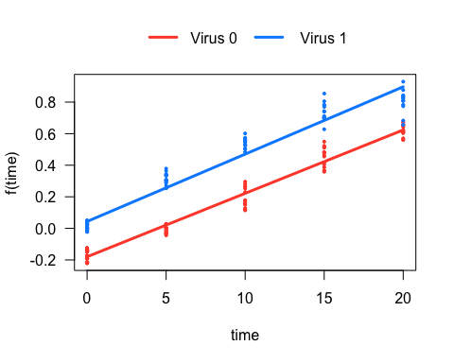

visreg::visreg(mod.1, "repID", by = "virus")

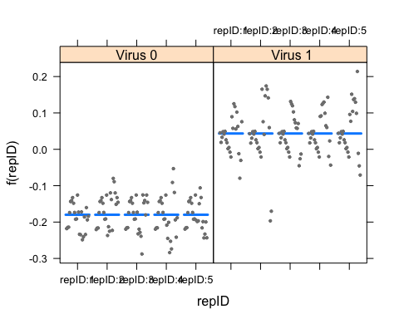

visreg::visreg(mod.1, "measID", by = "virus")

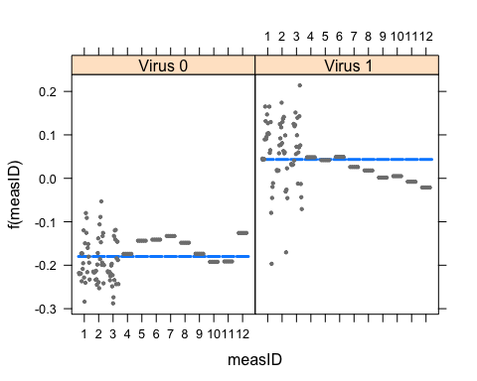

Measure ID looks very strange because of the 12 measurements at t = 0 causing imbalance.

You can see this more easily in the new sjPlot package:

sjp.lmer(mod.1)

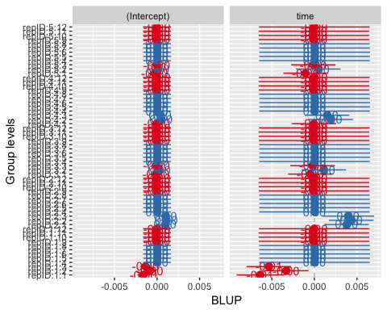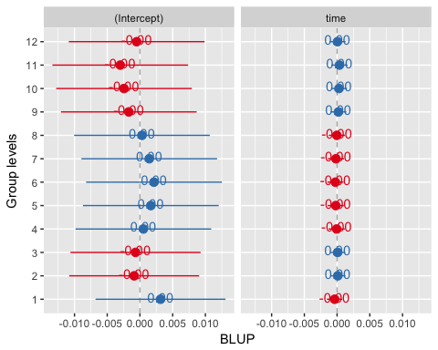

These are the BLUPs, the "Best Linear Unbiased Predictors" for every level of the random effects. at any of the you can see the predictons vary, however at every value of they are almost identical.

sjp.lmer(mod.1, type = "fe", sort = TRUE)

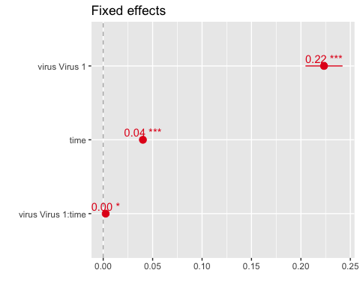

The virus by time interaction is really only marginally significant but that is mostly due to the differing intercept.

sjp.lmer(mod.1, type = "rs.ri",   
 vars = "virus", sample.n = 12, show.legend = TRUE)

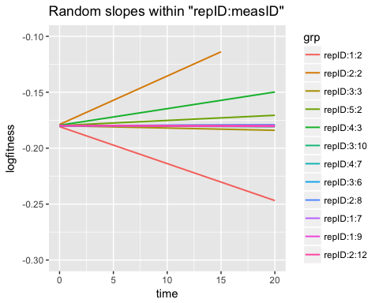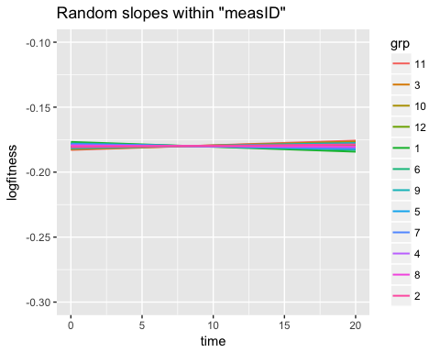 These are the random slopes for time by measure ID, where they basically don't vary for measID 4:12 but do vary for 1:3, sort of.

sjp.lmer(mod.1, type = "rs.ri",   
 vars = "virus", sample.n = c(1,2,3), show.legend = TRUE)

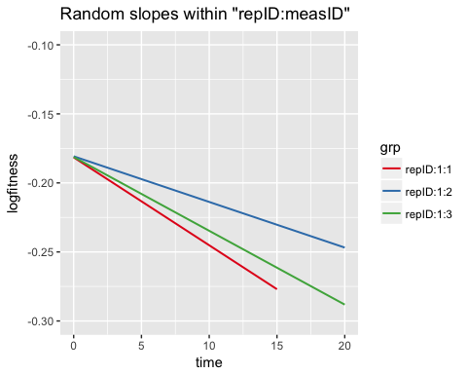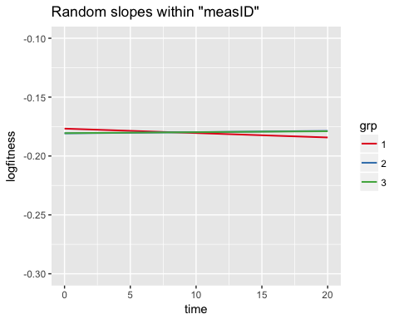

#### Bayesian

I ran the following MCMC model and then saved it for markdown rendering purposes. I use BRMS here for ease of use, if you want to try it yourself it may take some time to set-up. First you must install Rtools, then STAN and then brms. It's a process.

library(brms)  
# brm.1 <- brm(logfitness ~ virus * time + (time|measID/repID),  
# data = hela_clean)  
#   
# saveRDS(brm.1, file = "~/Documents/R/hela_adaptability/brm.rds")  
brm.1 <- readRDS(file = "brm.rds")  
  
summary(brm.1)

## Family: gaussian(identity)   
## Formula: logfitness ~ virus * time + (time | measID/repID)   
## Data: hela_clean (Number of observations: 236)   
## Samples: 4 chains, each with iter = 2000; warmup = 1000; thin = 1;   
## total post-warmup samples = 4000  
## ICs: LOO = Not computed; WAIC = Not computed  
##   
## Group-Level Effects:   
## ~measID (Number of levels: 12)   
## Estimate Est.Error l-95% CI u-95% CI Eff.Sample Rhat  
## sd(Intercept) 0.01 0.01 0.00 0.03 1338 1.00  
## sd(time) 0.00 0.00 0.00 0.02 365 1.01  
## cor(Intercept,time) -0.08 0.58 -0.96 0.94 2286 1.00  
##   
## ~measID:repID (Number of levels: 60)   
## Estimate Est.Error l-95% CI u-95% CI Eff.Sample Rhat  
## sd(Intercept) 0.00 0.00 0.00 0.01 1993 1.00  
## sd(time) 0.00 0.00 0.00 0.01 1369 1.00  
## cor(Intercept,time) 0.05 0.59 -0.95 0.95 161 1.01  
##   
## Population-Level Effects:   
## Estimate Est.Error l-95% CI u-95% CI Eff.Sample Rhat  
## Intercept -0.18 0.01 -0.20 -0.16 4000 1.00  
## virusVirus1 0.22 0.01 0.20 0.24 4000 1.00  
## time 0.04 0.00 0.03 0.05 379 1.01  
## virusVirus1:time 0.00 0.00 0.00 0.00 4000 1.00  
##   
## Family Specific Parameters:   
## Estimate Est.Error l-95% CI u-95% CI Eff.Sample Rhat  
## sigma 0.06 0 0.05 0.06 4000 1  
##   
## Samples were drawn using sampling(NUTS). For each parameter, Eff.Sample   
## is a crude measure of effective sample size, and Rhat is the potential   
## scale reduction factor on split chains (at convergence, Rhat = 1).

plot(brm.1)

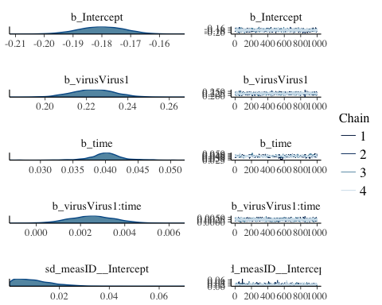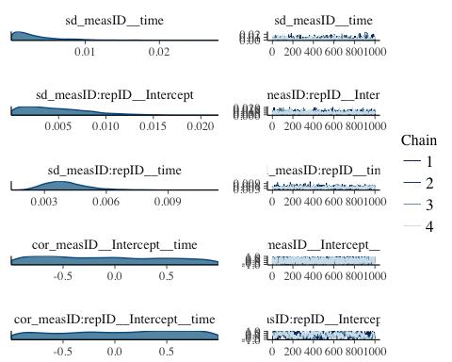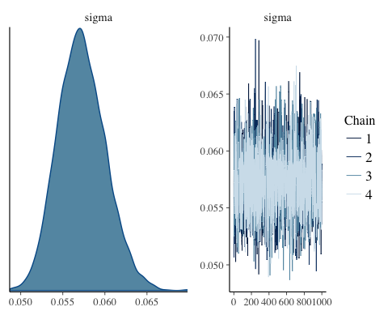

marginal_effects(brm.1)

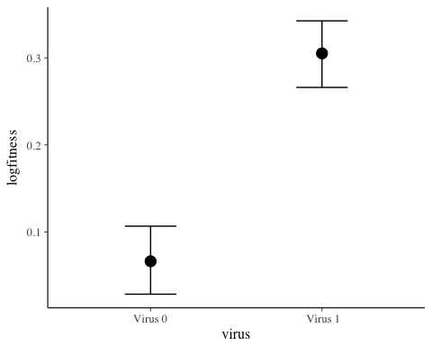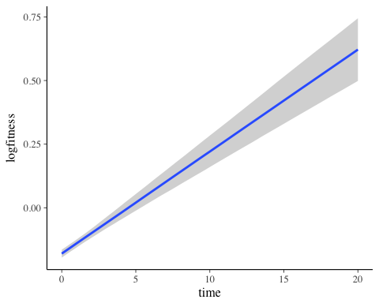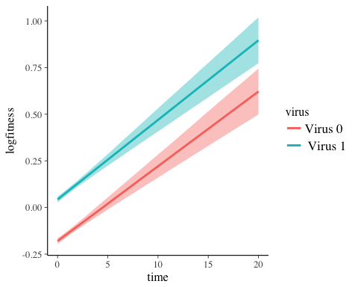

Bayesian modelling of the same experiment arrives at a very similar conclusion, namely there is a difference between virus 1 and virus 2 over time but only in starting point, they exhibit the same growth patterns (slopes).

### 3T3 Cell

#### Frequentist

This is a three-level model with time nested within measID nested within repID.

mod.1 <- lmer(logfitness ~ virus * time + (time|measID/repID),  
 data = cell3t3_clean,  
 REML = FALSE)  
  
summary(mod.1)

## Linear mixed model fit by maximum likelihood t-tests use Satterthwaite  
## approximations to degrees of freedom [lmerMod]  
## Formula: logfitness ~ virus * time + (time | measID/repID)  
## Data: cell3t3_clean  
##   
## AIC BIC logLik deviance df.resid   
## -203.9 -173.4 113.0 -225.9 108   
##   
## Scaled residuals:   
## Min 1Q Median 3Q Max   
## -1.8253 -0.6573 -0.0571 0.4149 3.9828   
##   
## Random effects:  
## Groups Name Variance Std.Dev. Corr   
## repID:measID (Intercept) 5.727e-05 0.0075677   
## time 2.552e-05 0.0050520 -1.00  
## measID (Intercept) 9.615e-06 0.0031009   
## time 4.431e-08 0.0002105 -1.00  
## Residual 8.020e-03 0.0895527   
## Number of obs: 119, groups: repID:measID, 15; measID, 3  
##   
## Fixed effects:  
## Estimate Std. Error df t value Pr(>|t|)   
## (Intercept) -0.302414 0.019526 14.620000 -15.488 1.79e-10 ***  
## virus Virus 1 0.313800 0.027466 101.250000 11.425 < 2e-16 ***  
## time 0.066165 0.002898 41.780000 22.830 < 2e-16 ***  
## virus Virus 1:time -0.012088 0.003659 101.220000 -3.304 0.00132 **   
## ---  
## Signif. codes: 0 '***' 0.001 '**' 0.01 '*' 0.05 '.' 0.1 ' ' 1  
##   
## Correlation of Fixed Effects:  
## (Intr) vrsVr1 time   
## virusVirus1 -0.698   
## time -0.757 0.504   
## virsVrs1:tm 0.561 -0.802 -0.630

# plot(mod.1)

visreg::visreg(mod.1, "time", by = "virus", overlay = TRUE)

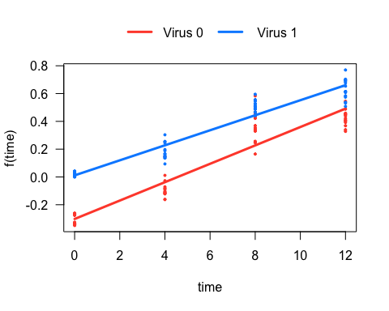

visreg::visreg(mod.1, "repID", by = "virus")

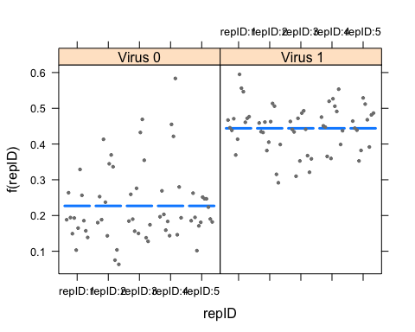

visreg::visreg(mod.1, "measID", by = "virus")

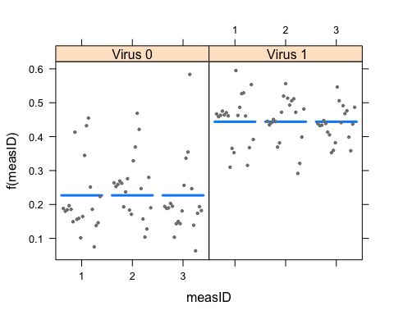

#### Bayesian

# brm.3t3 <- brm(logfitness ~ virus * time + (time|measID/repID),  
# data = cell3t3_clean)  
#   
# saveRDS(brm.3t3, file = "~/Documents/R/hela_adaptability/brm_3t3.rds")  
brm.3t3 <- readRDS(file = "brm_3t3.rds")  
  
summary(brm.3t3)

## Family: gaussian(identity)   
## Formula: logfitness ~ virus * time + (time | measID/repID)   
## Data: cell3t3_clean (Number of observations: 119)   
## Samples: 4 chains, each with iter = 2000; warmup = 1000; thin = 1;   
## total post-warmup samples = 4000  
## ICs: LOO = Not computed; WAIC = Not computed  
##   
## Group-Level Effects:   
## ~measID (Number of levels: 3)   
## Estimate Est.Error l-95% CI u-95% CI Eff.Sample Rhat  
## sd(Intercept) 0.08 0.13 0.00 0.60 26 1.13  
## sd(time) 0.01 0.01 0.00 0.04 167 1.02  
## cor(Intercept,time) -0.08 0.60 -0.98 0.94 944 1.00  
##   
## ~measID:repID (Number of levels: 15)   
## Estimate Est.Error l-95% CI u-95% CI Eff.Sample Rhat  
## sd(Intercept) 0.02 0.01 0.00 0.05 1828 1.00  
## sd(time) 0.01 0.00 0.00 0.01 542 1.01  
## cor(Intercept,time) -0.18 0.55 -0.97 0.92 456 1.01  
##   
## Population-Level Effects:   
## Estimate Est.Error l-95% CI u-95% CI Eff.Sample Rhat  
## Intercept -0.29 0.06 -0.39 -0.11 104 1.08  
## virusVirus1 0.31 0.03 0.26 0.37 1557 1.01  
## time 0.07 0.01 0.05 0.08 104 1.04  
## virusVirus1:time -0.01 0.00 -0.02 0.00 730 1.01  
##   
## Family Specific Parameters:   
## Estimate Est.Error l-95% CI u-95% CI Eff.Sample Rhat  
## sigma 0.09 0.01 0.08 0.11 2299 1  
##   
## Samples were drawn using sampling(NUTS). For each parameter, Eff.Sample   
## is a crude measure of effective sample size, and Rhat is the potential   
## scale reduction factor on split chains (at convergence, Rhat = 1).

plot(brm.3t3)

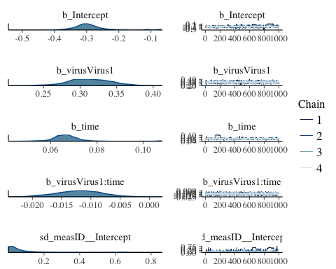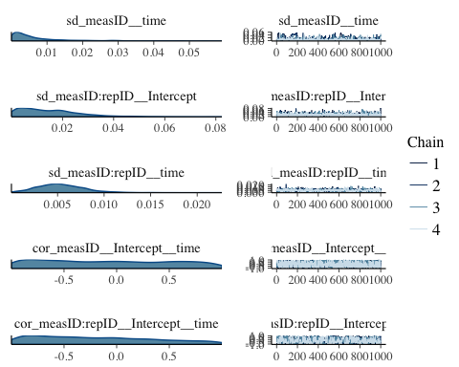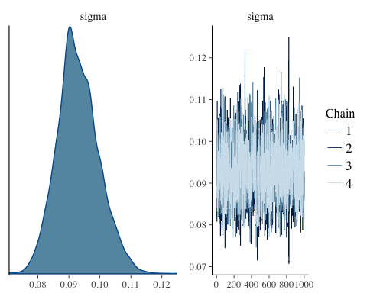

marginal_effects(brm.3t3)

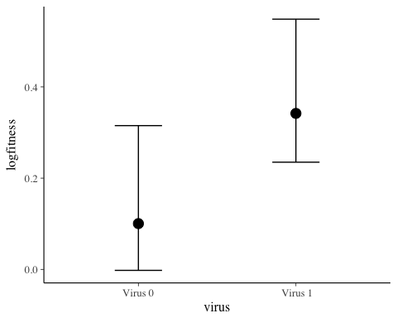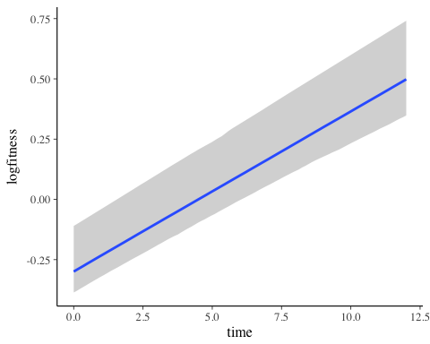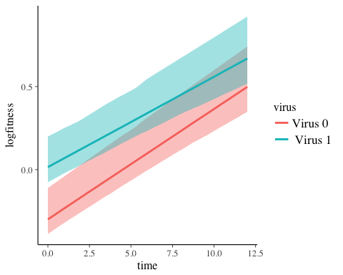

# Session Info

sessionInfo()

## R version 3.4.1 (2017-06-30)  
## Platform: x86_64-apple-darwin15.6.0 (64-bit)  
## Running under: macOS Sierra 10.12.5  
##   
## Matrix products: default  
## BLAS: /Library/Frameworks/R.framework/Versions/3.4/Resources/lib/libRblas.0.dylib  
## LAPACK: /Library/Frameworks/R.framework/Versions/3.4/Resources/lib/libRlapack.dylib  
##   
## locale:  
## [1] en_US.UTF-8/en_US.UTF-8/en_US.UTF-8/C/en_US.UTF-8/en_US.UTF-8  
##   
## attached base packages:  
## [1] stats graphics grDevices utils datasets methods base   
##   
## other attached packages:  
## [1] brms_1.7.0 Rcpp_0.12.11 bindrcpp_0.2 sjPlot_2.3.1   
## [5] reshape2_1.4.2 pander_0.6.0 lmerTest_2.0-33 lme4_1.1-13   
## [9] Matrix_1.2-10 magrittr_1.5 dplyr_0.7.1 purrr_0.2.2.2   
## [13] readr_1.1.1 tidyr_0.6.3 tibble_1.3.3 ggplot2_2.2.1   
## [17] tidyverse_1.1.1  
##   
## loaded via a namespace (and not attached):  
## [1] TH.data_1.0-8 minqa_1.2.4 colorspace_1.3-2   
## [4] modeltools_0.2-21 sjlabelled_1.0.1 rprojroot_1.2   
## [7] htmlTable_1.9 base64enc_0.1-3 glmmTMB_0.1.1   
## [10] rstan_2.16.2 DT_0.2 mvtnorm_1.0-6   
## [13] lubridate_1.6.0 coin_1.2-0 xml2_1.1.1   
## [16] codetools_0.2-15 splines_3.4.1 mnormt_1.5-5   
## [19] knitr_1.16 sjmisc_2.5.0 effects_3.1-2   
## [22] bayesplot_1.2.0 Formula_1.2-1 jsonlite_1.5   
## [25] nloptr_1.0.4 broom_0.4.2 cluster_2.0.6   
## [28] shiny_1.0.3 compiler_3.4.1 httr_1.2.1   
## [31] sjstats_0.10.2 backports_1.1.0 assertthat_0.2.0   
## [34] lazyeval_0.2.0 acepack_1.4.1 htmltools_0.3.6   
## [37] tools_3.4.1 coda_0.19-1 gtable_0.2.0   
## [40] glue_1.1.1 merTools_0.3.0 cellranger_1.1.0   
## [43] visreg_2.4-1 nlme_3.1-131 psych_1.7.5   
## [46] lmtest_0.9-35 stringr_1.2.0 rvest_0.3.2   
## [49] mime_0.5 stringdist_0.9.4.4 MASS_7.3-47   
## [52] zoo_1.8-0 scales_0.4.1 hms_0.3   
## [55] parallel_3.4.1 sandwich_2.3-4 inline_0.3.14   
## [58] TMB_1.7.10 RColorBrewer_1.1-2 yaml_2.1.14   
## [61] gridExtra_2.2.1 loo_1.1.0 StanHeaders_2.16.0-1  
## [64] rpart_4.1-11 latticeExtra_0.6-28 stringi_1.1.5   
## [67] blme_1.0-4 checkmate_1.8.3 matrixStats_0.52.2   
## [70] rlang_0.1.1 pkgconfig_2.0.1 arm_1.9-3   
## [73] evaluate_0.10.1 lattice_0.20-35 bindr_0.1   
## [76] rstantools_1.2.0 htmlwidgets_0.9 labeling_0.3   
## [79] plyr_1.8.4 R6_2.2.2 Hmisc_4.0-3   
## [82] multcomp_1.4-6 haven_1.0.0 foreign_0.8-69   
## [85] survival_2.41-3 abind_1.4-5 nnet_7.3-12   
## [88] modelr_0.1.0 rmarkdown_1.6 grid_3.4.1   
## [91] readxl_1.0.0 data.table_1.10.4 forcats_0.2.0   
## [94] digest_0.6.12 xtable_1.8-2 httpuv_1.3.5   
## [97] stats4_3.4.1 munsell_0.4.3