**TransitBuddy API**

**Laslău Râpă Toma**

**Laurențiu Mihaela Lucian**

**Description**

The TransitBuddy API is a websockets-based API designed to offer real-time location data on various public transport vehicles.

**Cloud Services:**

* Financial:

- Google AdWords: Widespread, robust ad-revenue source

- MashApe: The most well-known API management and distribution platform

* Customer contact:

- Google MyBusiness: Free, large-coverage business management service

- MashApe: Listing this API on Mashape greatly increases its chances of being found

* Contracting:

- MashApe:

- RapidApi: Famous service for finding APIs, increases chances of being found by potential customers

* Marketing:

- Google AdWords

- Goole Analytics: The data offered by Google Analytics is a great way of understanding our customers’ way of using our API, and also their needs.

**Developed Service**:

Real time public transport data and ticket pricing.

**USP of our service:**

Real time and free information

Full coverage of routes.

**How turnover will be achieved?** By:

Add revenue - to unlock more usages

Persistent ads

Pro account purchase

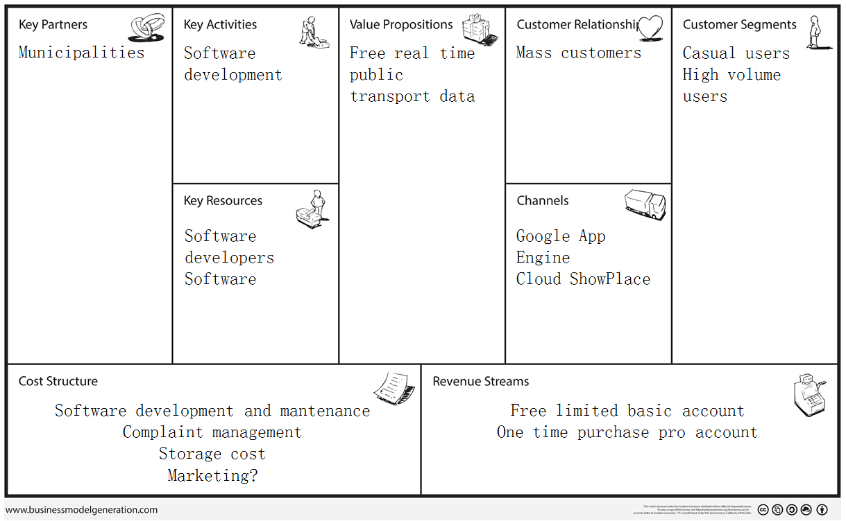**Business Model Canvas**