Logic Programming and Prolog: A First Glimpse
You shall learn to write computer programs in a non-procedural way. The primary objective of this course is to open your mind to a new way of looking at computing.
Procedural programming basically views the computer as a device characterized by a large uniform store of memory cells and a processing unit which is able to access the memory cells and to perform - in a strictly sequential way - some arithmetic and logical operations on their contents. A program for such a von Neumann machine is a sequence of instructions to perform such operations, and an additional set of control instructions (If, While, Goto, ...) which can affect the next instruction to be executed, possibly depending on the content of some memory cell. Procedural programs describe in detail, how a given set of variables (= memory cells) should be manipulated in order to get a solution of the given problem.
On the other hand, declarative (or definitional or non-procedural) programming expresses the knowledge about the problem and formulates the objective (or the goal). From a complete description of the facts and rules of a problem situation, the computer should then be able to find the solution using logical deduction. Ideally, a declarative program specifies what is to be solved and not how it should be done.
A simple first example may explain the difference between the two programming paradigms. You have certainly worked with a build tool like Jakarta Ant. A short excerpt from a fictitious build file is the following (explanations will be given in the course):
<project name="MyProject" default="dist" basedir=".">
<!-- set global properties for this build -->
<property name="src" location="src"/>
<property name="build" location="build"/>
<property name="dist" location="dist"/>

<target name="init">
<tstamp/>
<mkdir dir="${build}"/>
</target>

<target name="compile" depends="init" description="compile the source ">
<!-- Compile the java code from ${src} into ${build} -->
<javac srcdir="${src}" destdir="${build}"/>
</target>

<target name="dist" depends="compile">
<!-- Create the distribution directory -->
<mkdir dir="${dist}/lib"/>
<!-- Put everything in ${build} into the MyProject-${DSTAMP}.jar file -->
<jar jarfile="${dist}/lib/MyProject-${DSTAMP}.jar" basedir="${build}"/>
</target>

<target name="clean" description="clean up">
<!-- Delete the ${build} and ${dist} directory trees -->
<delete dir="${build}"/>
<delete dir="${dist}"/>
</target>
</project>
In the above example the depends attributes specify "the rules of the game", whereas the default="dist" attribute defines the goal of the build process. The execution order of the ant tasks is the derived from this information by the build tool automatically.
Of course, build tools are not the only components where declarative programming is used in computer science. Other important examples are schema specifications for XML documents, syntax definitions for programming languages, configuration files for web servers, and data definition statements in SQL.
There are several different approaches to declarative programming. The two most important ones are logic programming and functional programming. Typical functional programming languages are Lisp and its successor Scheme.
The main idea behind logic programming is that deduction (i.e. the construction of logical consequences) can be viewed as a form of computation, and that the declarative statement of the form
P if Q and R and S
can also be interpreted procedurally as:
To solve P, solve Q and R and S.
We shall start with some simple examples of logic (and Prolog) programs and return to some more theoretical considerations later.

First Steps: Facts, Queries, and Rules
A logic database is comprised of a set of facts and rules. Facts can define relations just as in relational databases.
We start with an example of a hypothetical family which we define using two relations between persons, parent-child and husband-wife, and the attribute male. We shall then declare rules for other relationships. Refer to the separate document Family.pdf for details.
The facts of our family database are stored - one fact per line - in a source-text file named family.pl. You should now launch your Prolog interpreter and import this source file into its program store. In Prolog slang, this is called consulting the file.
There are several ways to do this. The most convenient way is to instruct the operating system to open all files with the extension .pl with the Prolog interpreter. Under Windows you do this as follows:
Start -> Settings -> Control Panel -> Folder Options -> File Types
You can then start the interpreter and consult a program file just by double-clicking on the respective file.
Another way is to launch the Prolog interpreter from within the directory where the file family.pl is located. You can then consult the file with the command:

?- [family].

Note the dot (.) at the end of the command; this is a remnant of the old days of COBOL. Every command given to the Prolog interpreter has to be terminated with a dot, followed by an end-of-line character. The square brackets are a short form for the consult command and the file extension .pl is used as default.
When the facts file is consulted (loaded) successfully, we can ask questions (queries) about the family, like the following. Find out what the answers of the interpreter are:
?- parent(eva,bruno).

?- parent(georg,otto).

?- parent(silvia,X).

Silvia has two children. The first solution to the above query is X = otto. You accept this solution by pressing the Newline key. If you want to see more solutions, you press the semicolon key (;). Remember that in Prolog the semicolon stands for "more" or "or".

?- parent(Y,ida).

?- husband(U,V).

?- husband(_,irma).

The underscore character (_) stands for a "don't know" or "don't care" variable. In the above query we are not interested in the name of irma's husband, we just want to know whether there is one.
?- husband(M,_).

Note that facts and queries are syntactically identical: they are both terms. They are distinguished by their context only.
Queries can always be interpreted as goals: Instead of asking "Is there an X such that parent(silvia,X) is true?" we can also put it imperatively: "Try to find an X such that you can prove parent(silvia,X)!". Therefore, we shall use the terms "query" and "goal" interchangeably.
The following is called a conjunctive goal:
?- parent(eva,X), male(X).

In logic programs (and also in goals), the comma (,) denotes logical "and". In the above conjunctive goal, X is a shared variable. The query reads: "Is there an X such that both parent(eva,X) and male(X) are true?". Evidently, this is the case for X = bruno, the son of eva. Let us consider some other conjunctive goals:
?- parent(X,Y), parent(Y,peter).

?- parent(W,Z), husband(Z,irma).

?- parent(X,Y), male(X).

The last query apparently returns all pairs of persons (X,Y) for which X is the father of Y. This brings us to the third and most important statement class, the rules.
A rule is a statement of the form:
A :- B1, B2, .... Bn.
where n ≥ 0. A is the head of the rule, and the Bi's are its body.
A rule expressing the father relationship is:

The special symbol :- means "if". Thus, the above rule is read as follows: "X is the father of Y if X is parent of Y and X is a male person".

Similarly, the grandfather relationship can be described as:

Note how we have used the rule for father within the rule for grandfather.
Let us develop some more rules:
% brother(X,Y) :- X is the brother of Y.

% uncle(X,Y) :- X is the uncle of Y.

% female(X) :- X is a female person.

% sister(X,Y) :- X is the sister of Y.

% has_son(X) :- the person X has a son.

% married(X,Y) :- X and Y are married (to each other).

% brother_in_law(X,Y) :- X is the brother-in-law of Y.

The last example shows, that there are two different ways in which a man X can be the brother_in_law of another person Y. Give an example (from our family) for each way:

Facts and rules are collectively called Horn clauses, or clauses, for short. It should be noted that a fact is just a special case of a rule, the case where n = 0. If a relation is declared with more than one clause, these clauses are to be considered as alternatives. In our example this is the case for parent, male, and husband, but also for the rules of married and brother_in_law.
The following relations are even more interesting and some of them give an idea of more advanced concepts of logic programming.
% ancestor(X,Y) :- X is an ancestor of Y.

% relatives(X,Y) :- X and Y are relatives.

% ancestors(As,X) :- As is the set of all ancestors of X.

% descendants(Ds,X) :- Ds is the set of all descendants of X

A Short Side-trip to Predicate Logic
If you have studied the basics of discrete mathematics you might have seen the notation for predicate logic. How would our Prolog rules compare to this notation? We shall explain this with the Prolog rule for grandfather:
grandfather(X,Y) :- father(X,P), parent(P,Y).

Given the following predicates:  F(x,y) : x is father of y  P(x,y) : x is parent of y  G(x,y) : x is grandfather of y | In predicate logic notation the rule for grandfather would be:
Note that the variables x and y in predicate logic, which correspond to the Prolog variables X and Y, are universally quantified , whereas the variable p ( corresponding to P in Prolog) is existentially quantified . What is the difference between X and Y on one hand, and P on the other? We shall discuss this in more detail later.

An Arithmetic Puzzle
Although Prolog has not been invented primarily as a programming language for doing arithmetic, it can be used to do mathematics just like any other programming language. The next example, taken from recreational mathematics, should give a first impression on how to achieve this. Details shall be treated later in the course.
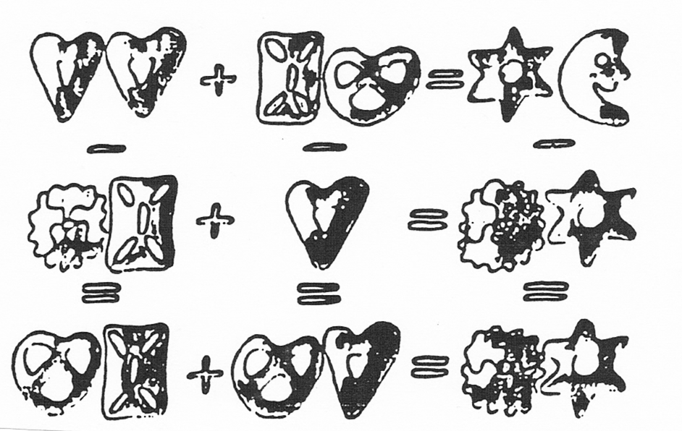 | digit(1).  A₁ A₂  + B1 B2  = S1 S2  digit(2).  digit(3).  digit(4).  digit(5).  digit(6).  digit(7).  digit(8).  digit(9).  digit(0).

% sum(A1,A2,B1,B2,S1,S2) :-
% (S1,S2) is the sum of (A1,A2) and (B1,B2).

% diff(A1,A2,B1,B2,D1,D2) :-
% (D1,D2) is the difference of (A1,A2) and (B1,B2).

% puzzle(He,Le,Br,St,Mo,Ma) :-
(He,Le,...,Ma) is a solution of the puzzle

Summary
• Logic programming consists of defining relations and querying about relations.
• A program consists of facts and rules, which we collectively call clauses. A set of facts and rules about the same relation is called a predicate.
• Querying about relations, by means of goals, resembles querying a database. Prolog's answer to a query consists of a set of objects that satisfy the question (query).
• In Prolog, to establish whether an object satisfies a query is often a complicated process that involves logical inference and exploring among alternatives. All this is done automatically by the Prolog system and is, in principle, hidden from the user.
• Two types of interpretation (or meaning) of Prolog programs are distinguished: declarative and procedural.
• The following concepts have been discussed: Clause, fact, rule, query, goal, head and body of a rule, recursive rule, predicate, variable, a goal succeeds or fails.
• Special built-in predicates allow for arithmetic calculations, with a notation similar to the one of well-established procedural programming languages (e.g. Java). Arithmetic assignment is achieved by the is predicate.

