CS3071 Lab 2

Name: Laura Murphy

Student ID: 13326075

STATES

0 – Starting state

1 – Have seen one or more leading zeros.

2 – Have seen a sign, followed by one or more leading zeros.

3 – Have only seen one or more digits from 0-7, so all bases are still possible.

4 – Have seen at least an 8 or a 9, so the constant is **not octal.**

5 - Just saw a b or B, so if we’ve reached the end, the number is octal. Otherwise it may be hexadecimal (but is definitely **not decimal**).

6 – We’ve seen at least one letter that isn’t a b/B, or we’ve seen a b/B that wasn’t the octal indicator (we know that since it wasn’t followed by the end marker). This means the constant is hexadecimal, but is missing the hex indicator.

7 – Just saw the hex indicator.

8 – Just saw a sign (still needs to be followed by a digit to be valid)

9 – Have seen digits following a sign.

There are states for acknowledging leading zeros separately since the program needs to keep count of them. The count is then used when the program is calculating whether overflow will occur or not.

INPUTS

I decided to map the different input types to numbers. We are not particularly concerned whether an input is a “5” or a “6”, once we know that is a digit between 1 and 7 (i.e. its “input type”). To make it easier to look up the next state in the table, I created a function (***get_input_type***) that will take in a char and output the input number/type that it corresponds to. Having the types as numbers allows me to use them as the indexes for the table columns in the code.

The inputs are mapped to numbers as follows:

0 -> 0

1-7 -> 1

8, 9 -> 2

b, B -> 3

h, H -> 4

a, A, c, C, d, D, e, E, f, F -> 5

-, + -> 6

TRANSITION TABLE

Inputs

|  |  |  |  |  |  |  |  |  |
| --- | --- | --- | --- | --- | --- | --- | --- | --- |
|  | **0** | **1** | **2** | **3** | **4** | **5** | **6** | **End** |
| **0** | 1 | 3 | 5 | 6 |  | 6 | 8 |  |
| **1** | 1 | 3 | 5 | 4 | 7 | 6 |  | “DEC” |
| **2** | 2 | 9 | 9 |  |  |  |  | “DEC” |
| **3** | 3 | 3 | 5 | 4 | 7 | 6 |  | “DEC” |
| **4** | 6 | 6 | 6 | 6 | 7 | 6 |  | “OCT” |
| **5** | 5 | 5 | 5 | 6 | 7 | 6 |  | “DEC” |
| **6** | 6 | 6 | 6 | 6 | 7 | 6 |  |  |
| **7** |  |  |  |  |  |  |  | “HEX” |
| **8** | 2 | 9 | 9 |  |  |  |  |  |
| **9** | 9 | 9 | 9 |  |  |  |  | “DEC” |

States

All empty entries are transitions to the error state.

I kept the translation from transition table to code as literal as possible, giving a clear and concise program. In the image below, you can see the table in the code. The structure of the table is immediately obvious, so it is very readable.

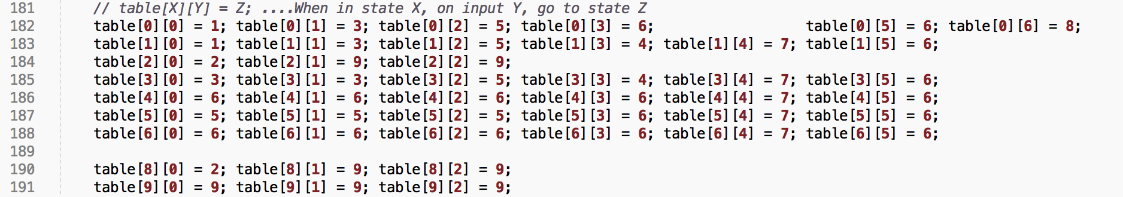As I mentioned above, the input type is used to index the column of the table. The current state is used to index the row. The content of the element gives you the next state that you must transition to (see line 181).

HOW THE PROGRAM WORKS

The user inputs one or more space-separated constants as command line arguments to the program. The program works on each constant one by one and outputs the results as it goes along.

The program first evaluates whether or not the constant is a valid Hexadecimal, Octal or Integer value. Then it calculates whether or not overflow will occur if we try to store the constant as a 32-bit decimal value. If overflow will occur, the program prints an error and moves on to the next constant (or ends, if there are no more constants). Otherwise, it converts the constant to its decimal equivalent and prints a description of its corresponding lexical token.

To work out whether the constant is a valid hex, oct or int value, we transition through the table. ***get_next_state*** is called on each char in the input. The function is very simple – it just updates the current state to the next state given by accessing the table. If the new state happens to be the error state, ***get_next_state*** will return a 0 so we know that the constant is invalid. If the new state indicates that we have just seen a leading zero, the function increments the relevant counter.

When it reaches the end of the constant, the program checks that it is in a valid end state for at least one of the bases (hex, oct, int). If it is, ***print_lexical_token*** is called. This function checks for overflow and converts the constant to decimal.

To check for overflow with a hex number, we simply have to make sure the number of digits (not including leading zeros) is not greater than 8.

For octal numbers, if there are greater than 11 digits (not including leading zeros) overflow will occur. If there are exactly 11 digits, overflow will occur if the most significant digit is greater than 3.

For integers, if there are greater than 10 digits (not including leading zeros) overflow will occur. If there are exactly 11 digits, we must compare our value with the max and min ints to ensure it lies between them. Otherwise, overflow will obviously occur.

TESTING