Computer Networking

Assignment 10

# Homework 10

## Problems of Chapter 5:

P3

Consider the following network. With the indicated link costs, use Dijkstra’s

shortest-path algorithm to compute the shortest path from x to all network nodes.

Show how the algorithm works by computing a table similar to Table 5.1.

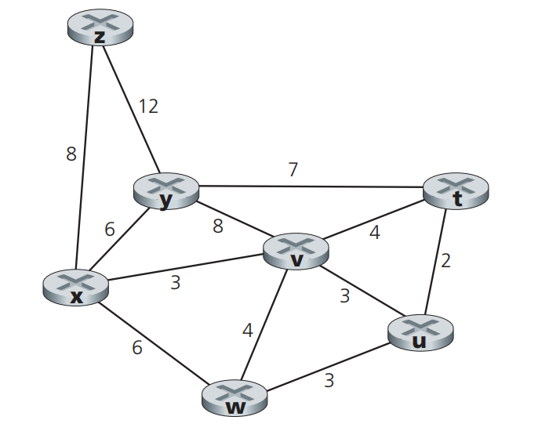

P5

Consider the network shown below, and assume that each node initially

knows the costs to each of its neighbors. Consider the distance-vector algorithm and show the distance table entries at node z.

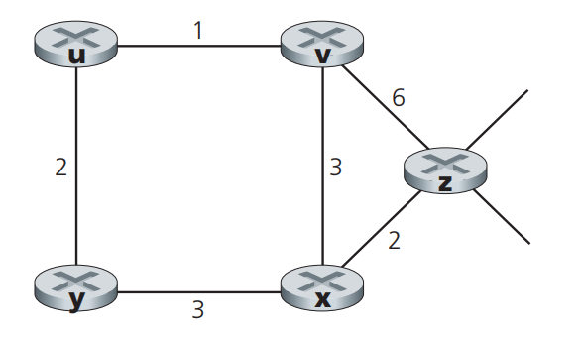

P9

Consider the count-to-infinity problem in the distance vector routing. Will

the count-to-infinity problem occur if we decrease the cost of a link? Why?

How about if we connect two nodes which do not have a link?